**TRIADS**

A **chord** is a simultaneous sounding of more than 2 notes.

A **triad** is a chord that contains 3 notes and is a **tertian** chord -- a chord built in thirds.

Chords Triads

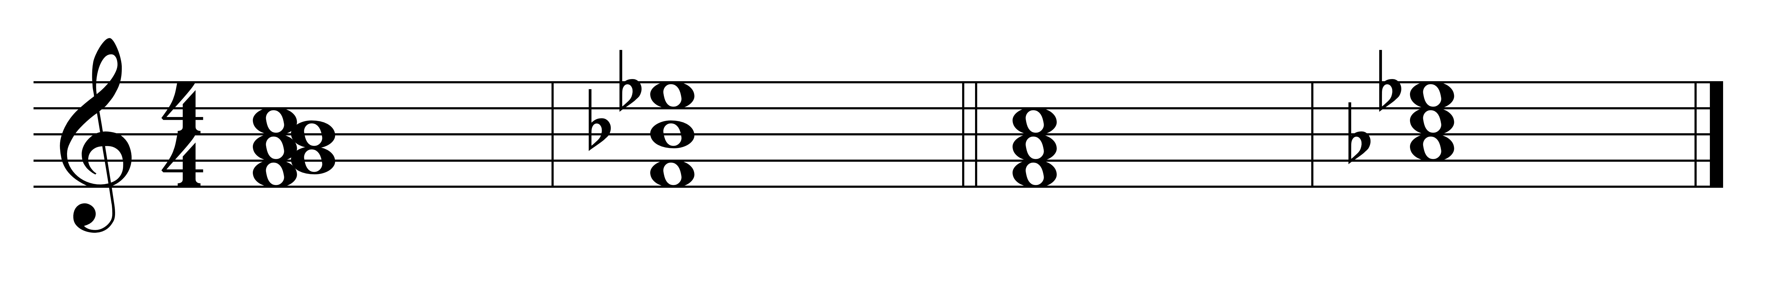

*Qualities:*

Any triad is one of **4 qualities** -- major, minor, diminished, augmented.

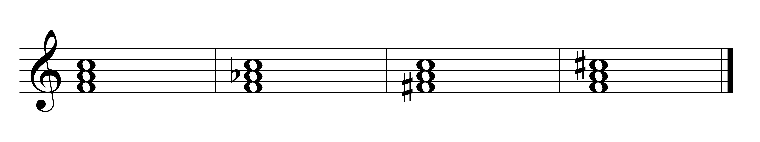

Major minor diminished augmented

Each quality triad contains a unique set of intervals.

Triads occur in root position, first and second inversion, depending on what note of the chord is in the **bass – the bottom-most voice**.

*Root Position:*

A triad is said to be in root position when the root of the chord is in the bass.

**Root position** is also known as position, since there is always an interval of a third and 5th above the root.

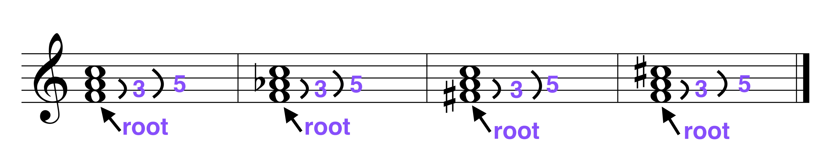

Major minor diminished augmented

*Inversion:*

A triad is said to be inverted if the bottom-most note -- the bass -- is not the root of the chord.

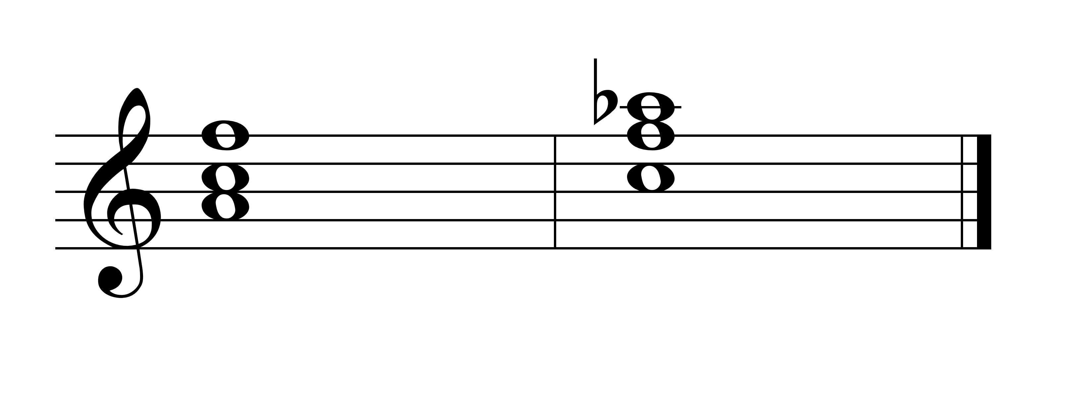

*First inversion:*

A triad is said to be in first inversion if the third of the chord is in the bass (the bottom-most voice).

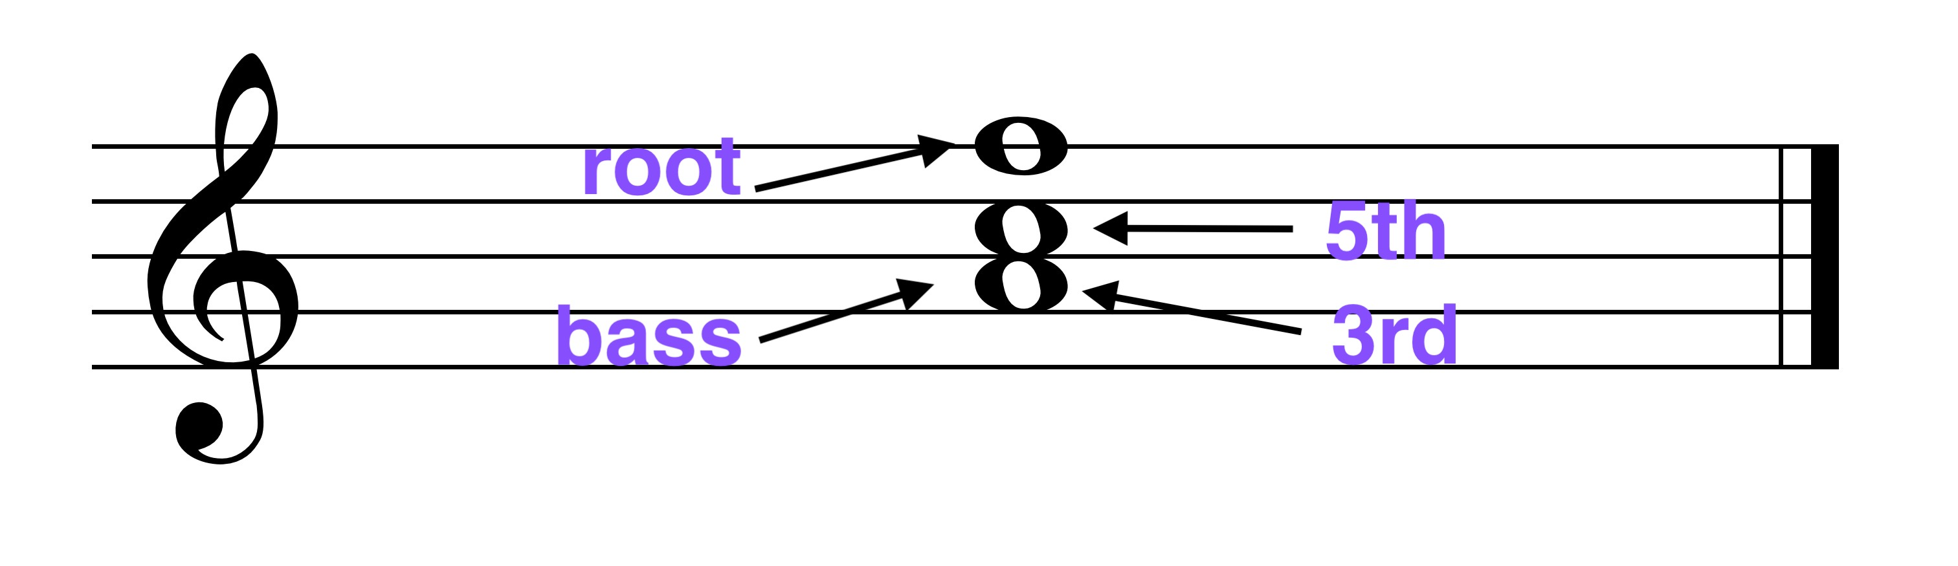

Each quality triad may occur in first inversion.

In first inversion all triads will contain the interval of a 3rd and a 6th above the bass. Therefore, a first inversion chord is said to be in position.

The quality of the 3rds and 6ths will be different for each quality of chord.

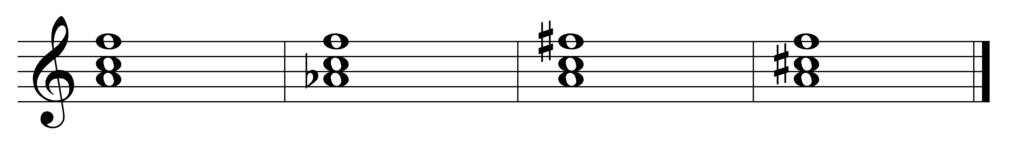

M m d A

contains: m6 M6 M6 m6

m3 M3 m3 M3

*Second inversion:*

A triad is said to be in second inversion if the fifth of the chord is in the bass (the bottom-most voice).

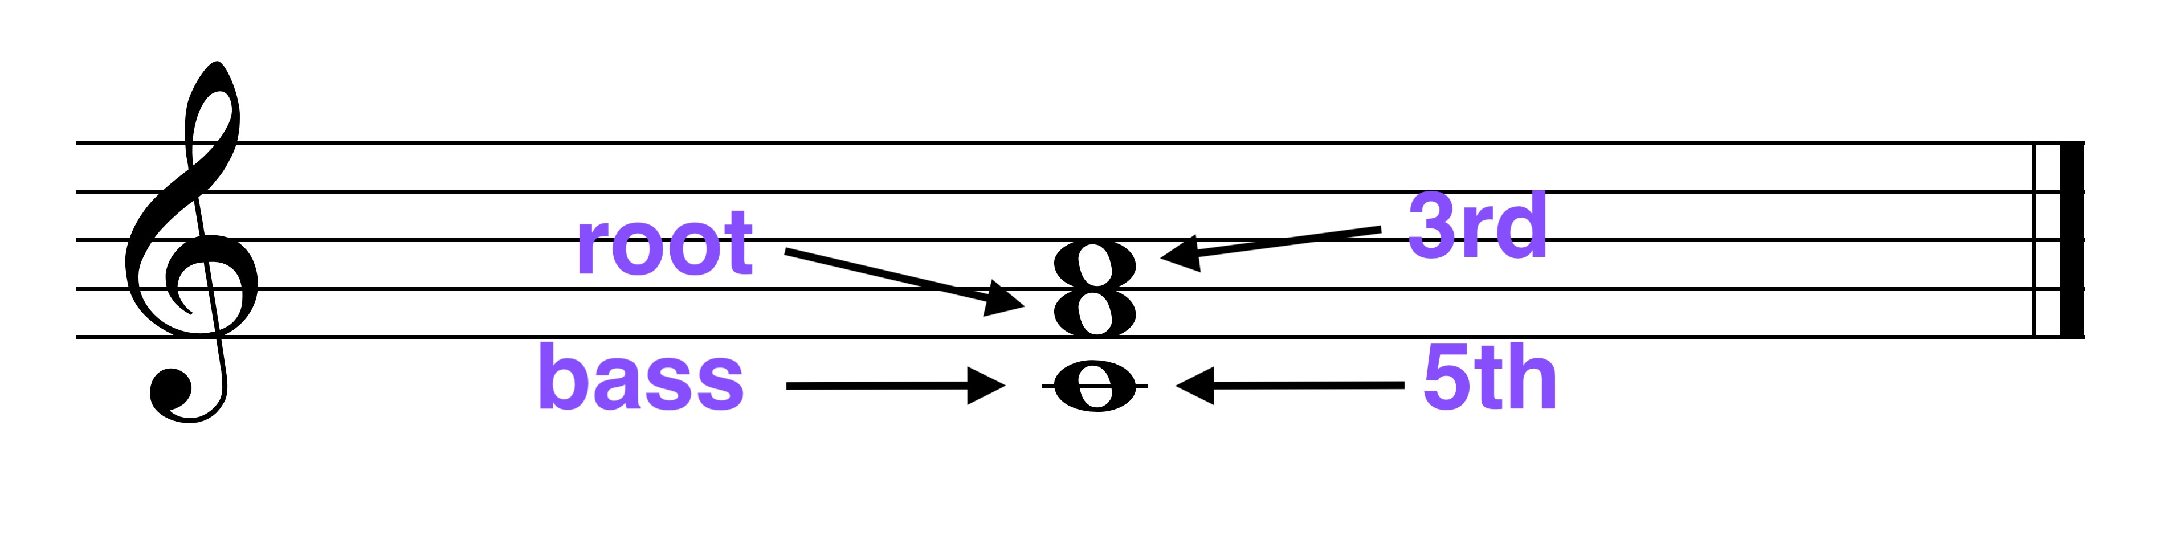

Each quality triad may occur in second inversion.

In second inversion all triads will contain the interval of a 4th and a 6th above the bass. Therefore, a first inversion chord is said to be in position.

The quality of the 4ths and 6ths will be different for each quality of chord.

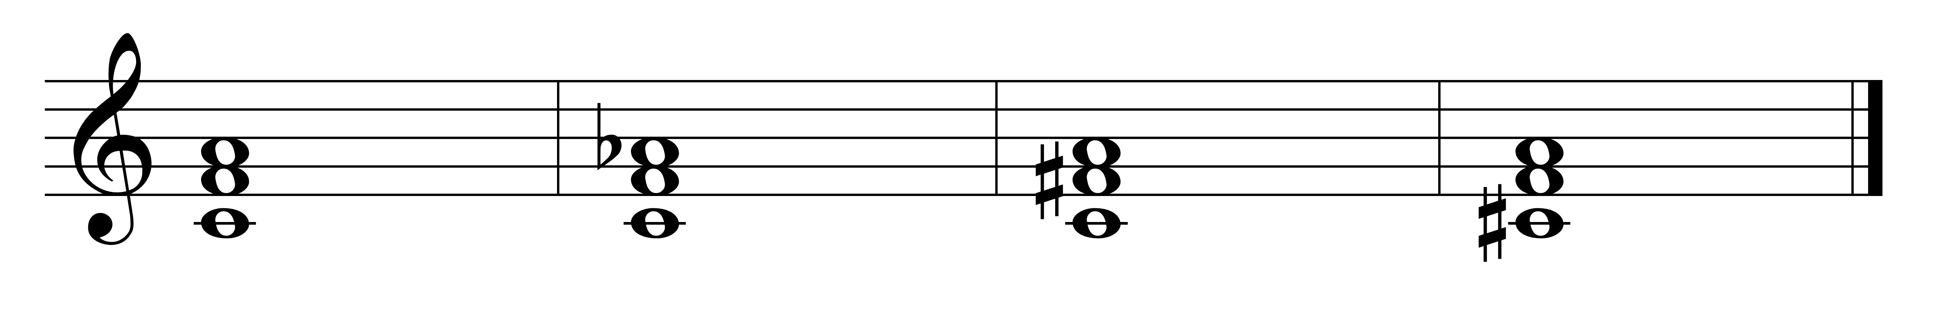

M m d A

contains: M6 m6 M6 m6

P4 P4 A4 d4

*Triads in keys:*

A triad can be built on each note of a scale. The resulting triads will have particular qualities and these qualities will differ according to the type of scale used.

Example: In G major:

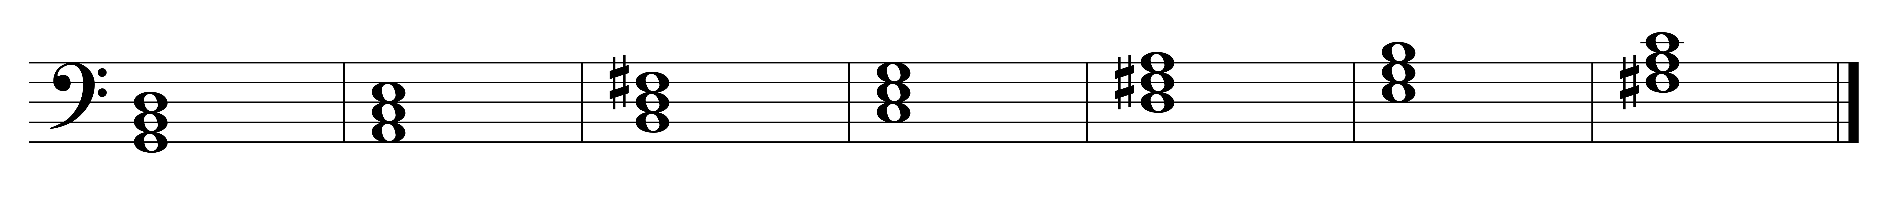

I ii iii IV V vi viio

*Chord Designations:*

Chords are designated by **Roman and Arabic numerals**.

*Roman Numerals:*

The Roman numeral tells the root of the chord (what scale degree it is)

You may also see different types of Roman numeral designations such as:

upper case = major (V, I)

lower case = minor (ii, vi)

upper case with + = augmented (III+)

lower case with o = diminished (viio, iio)

*Arabic numeral*

The Arabic numeral tells you the position or inversion of the chord:

= root position

= first inversion

= second inversion

*Triads in a major key:*

Triads built on the degrees of a major scale will have the following qualities and designations:

1 2 3 4 5 6 7



M m m M M m d

I ii iii IV V vi viio

*Triads in Minor keys*

Triads built on the notes of a **natural minor scale** will have the following qualities and designations:

1 2 3 4 5 6 7

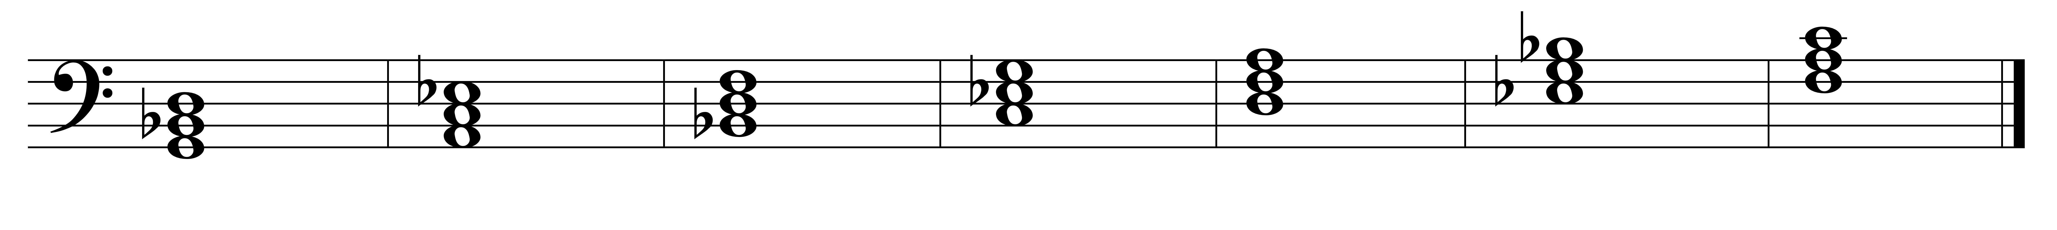

m d M m m M M

i iio III iv v VI VII

If you use the chords of a natural minor scale, the i-v-i progression will sound incomplete.

To make this progression sound more ‘natural’ [i-V-i], always use the leading tone in the scale -- use a harmonic minor scale.

The triads built from the notes of a **harmonic minor scale** will have the following qualities and designations:

1 2 3 4 5 6 7

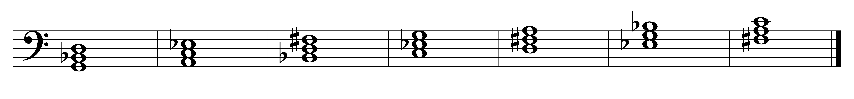

m d A m M M d

i iio III+ iv V VI viio

We can also use the triads built from the notes of a **melodic minor scale**. These triads will have the following qualities and designations:

Ascending:

1 2 3 4 5 6 7

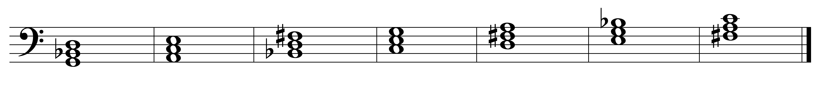

m m A M M d d

i ii III+ IV V vio viio

Descending: (same as natural minor)



m d M m m M M

i iio III iv v VI VII

In minor keys the most commonly used chords (and the ones you should memorize) are:

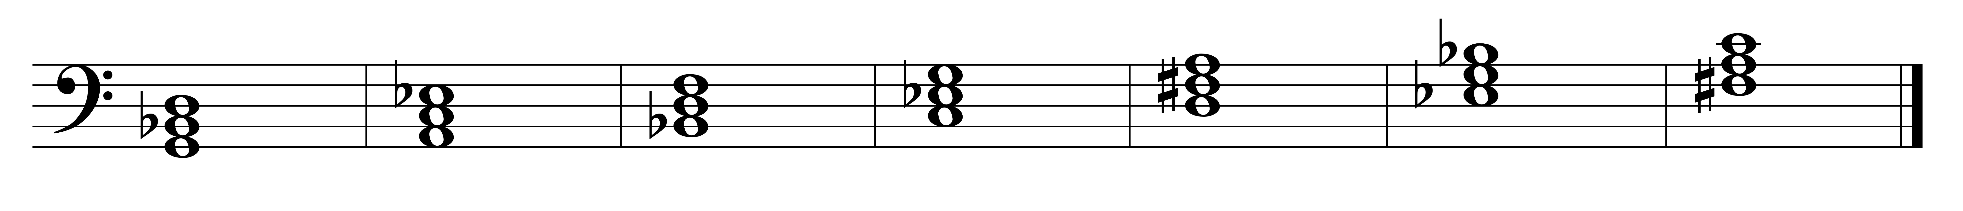

i iio III iv V VI viio

III+ VII