***Musical Terminology***

**Music** is an aural art.

**Music theory** is the study of music; it is the analysis and composition of music.

Other fields for the study of music include **Musicology** -- the study of music, usually thought of as study of music history; and **ethnomusicology** -- the study of ethnic (world) musics.

**Music comes from a sound source**, usually a vibrating object (e.g., column of air, a vibrating string or membrane). The vibration produces **sound waves** -- vibrational disturbances transmitting energy. A single **cycle** of a sound wave is shown below.

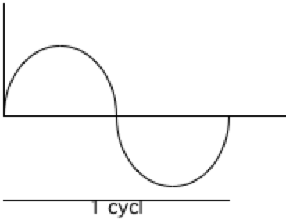

The **amplitude** is the height of wave and creates/affects the sound's **intensity** -- the loudness/softness of the sound.

The **frequency** of the wave -- the number of times it repeats per second -- affects the **pitch** -- the highness or lowness of the sound. The frequency is also referred to as the number of cycles per second (Hertz). The A that we usually tune to in the orchestra (the A above middle C) has a frequency of 440 cycles per second (A 440). Every octave doubles or halves the frequency (e.g., A220 is an octave lower and A880 is an octave higher).

The wave shown above is a **sine wave** and will produce a **pure sound**. Sine waves are only produced by electronic instruments and tuning forks; most instruments do not produce pure sounds. Instruments produce sounds that are combinations of many sine waves, each having a different frequency and therefore a different pitch.

The combination is different for each instrument, so each instrument has a different tone color, or **timbre**. The pitches that can be produced are the members of a tone's **harmonic series**. The harmonic series on C is shown below:

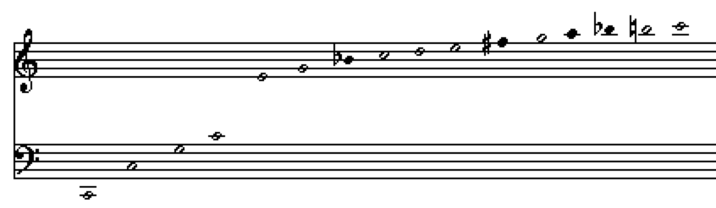

[Notes shown with black note-heads will be out of tune.]

A pitch also has an **envelope**. The envelope consists of the note's attack, sustain and decay.