**Secondary Dominants**

**(Applied Dominants)**

**Definition**:

A secondary dominant is an altered chord having a dominant or leading tone relationship to a chord in the key other than the tonic.

An altered chord is a chord containing at least one tone that is foreign to the key.

Using secondary dominants results in the **tonicization** of the chord of resolution.

Tonicization is the process of emphasizing a chord by making it seem like the tonic for a relatively short period of time. Usually this is accomplished by embellishing the chord with a chord that has a dominant or leading tone relationship to it (a secondary dominant).

**Analysis**:

Secondary dominants are analyzed as 'x/y' where:

x is one of : V, V7, viio, vii7, viio7

y is a major or minor triad in the key. y can be one of:

Major key: ii, iii, IV, V, vi

minor key: iv, V, VI

y can not be a diminished or augmented triad since diminished and augmented triads do not act as tonic triads.

Examples: V7/IV, viio7/ii, V/V, vii7/III

**Resolution**:

1. **Normal resolution**: x/y resolves normally to y.

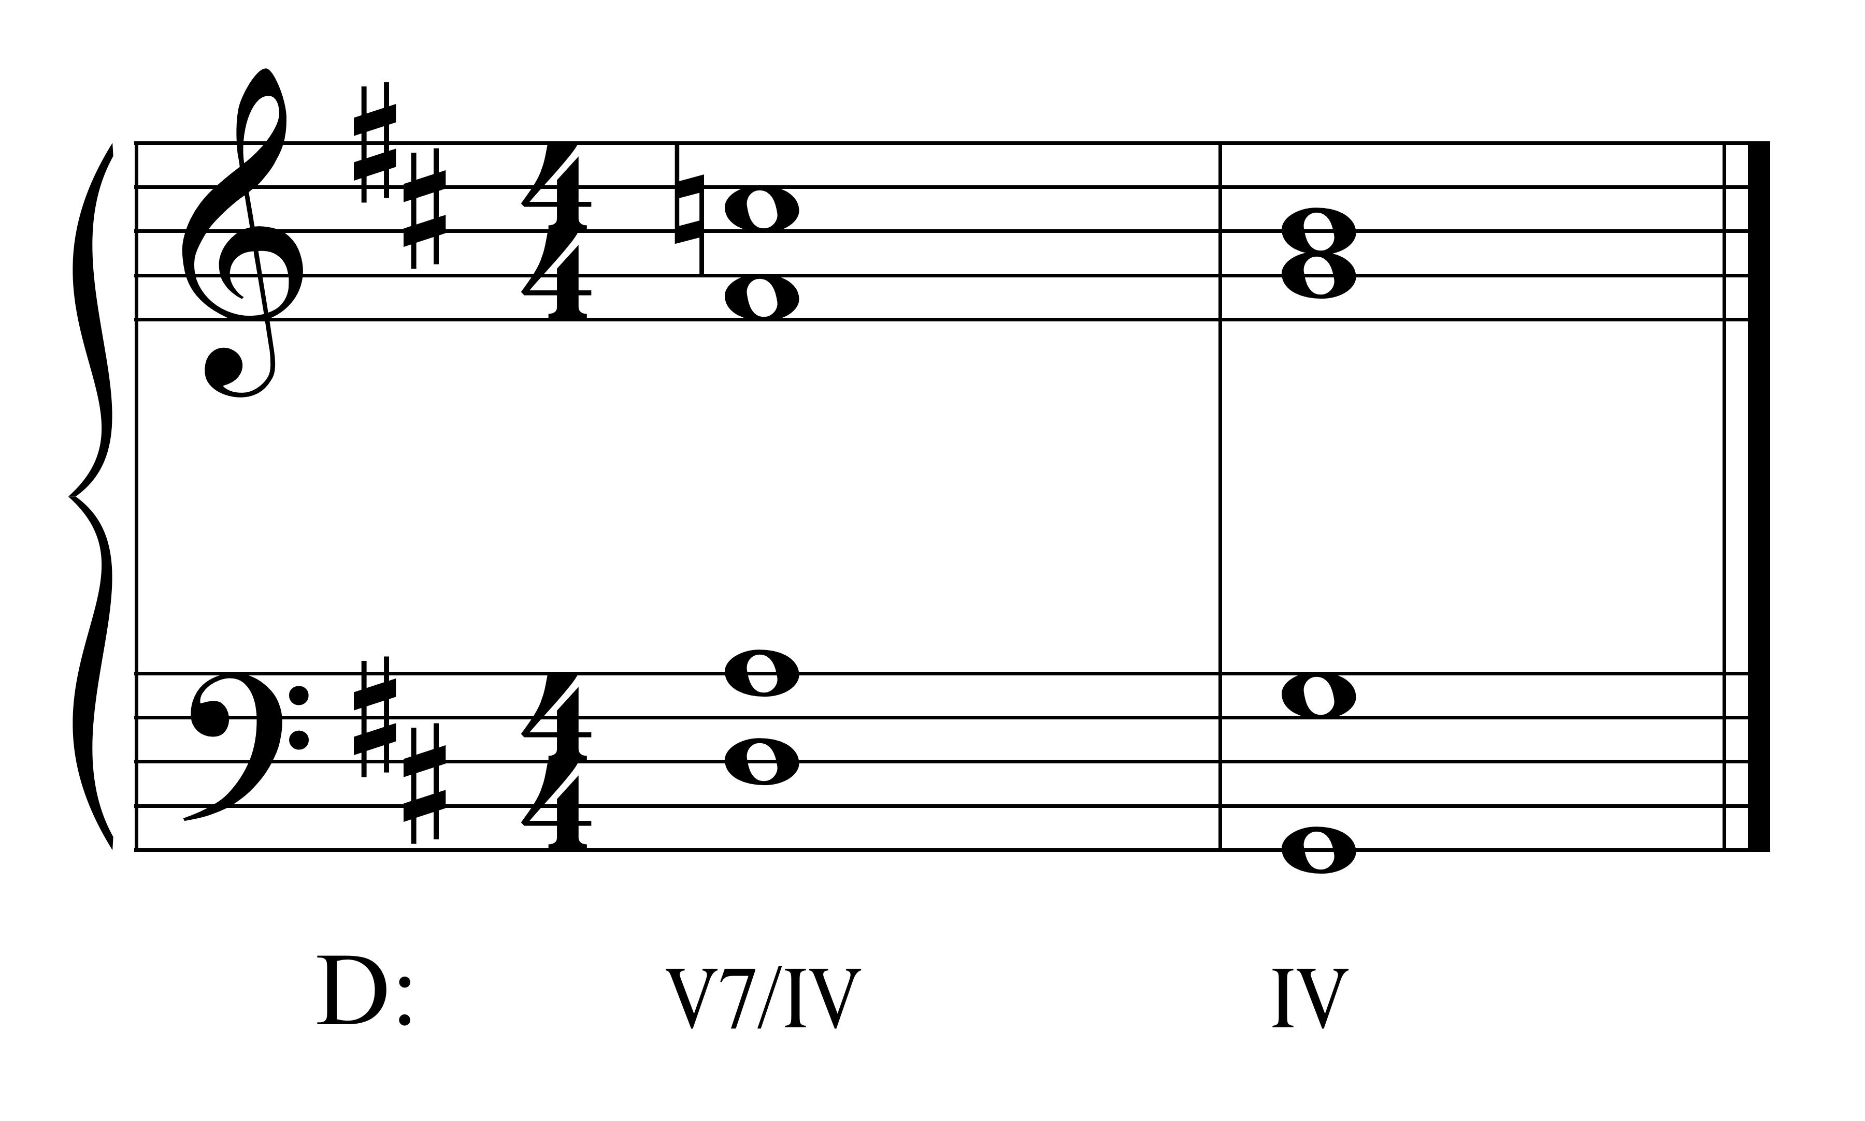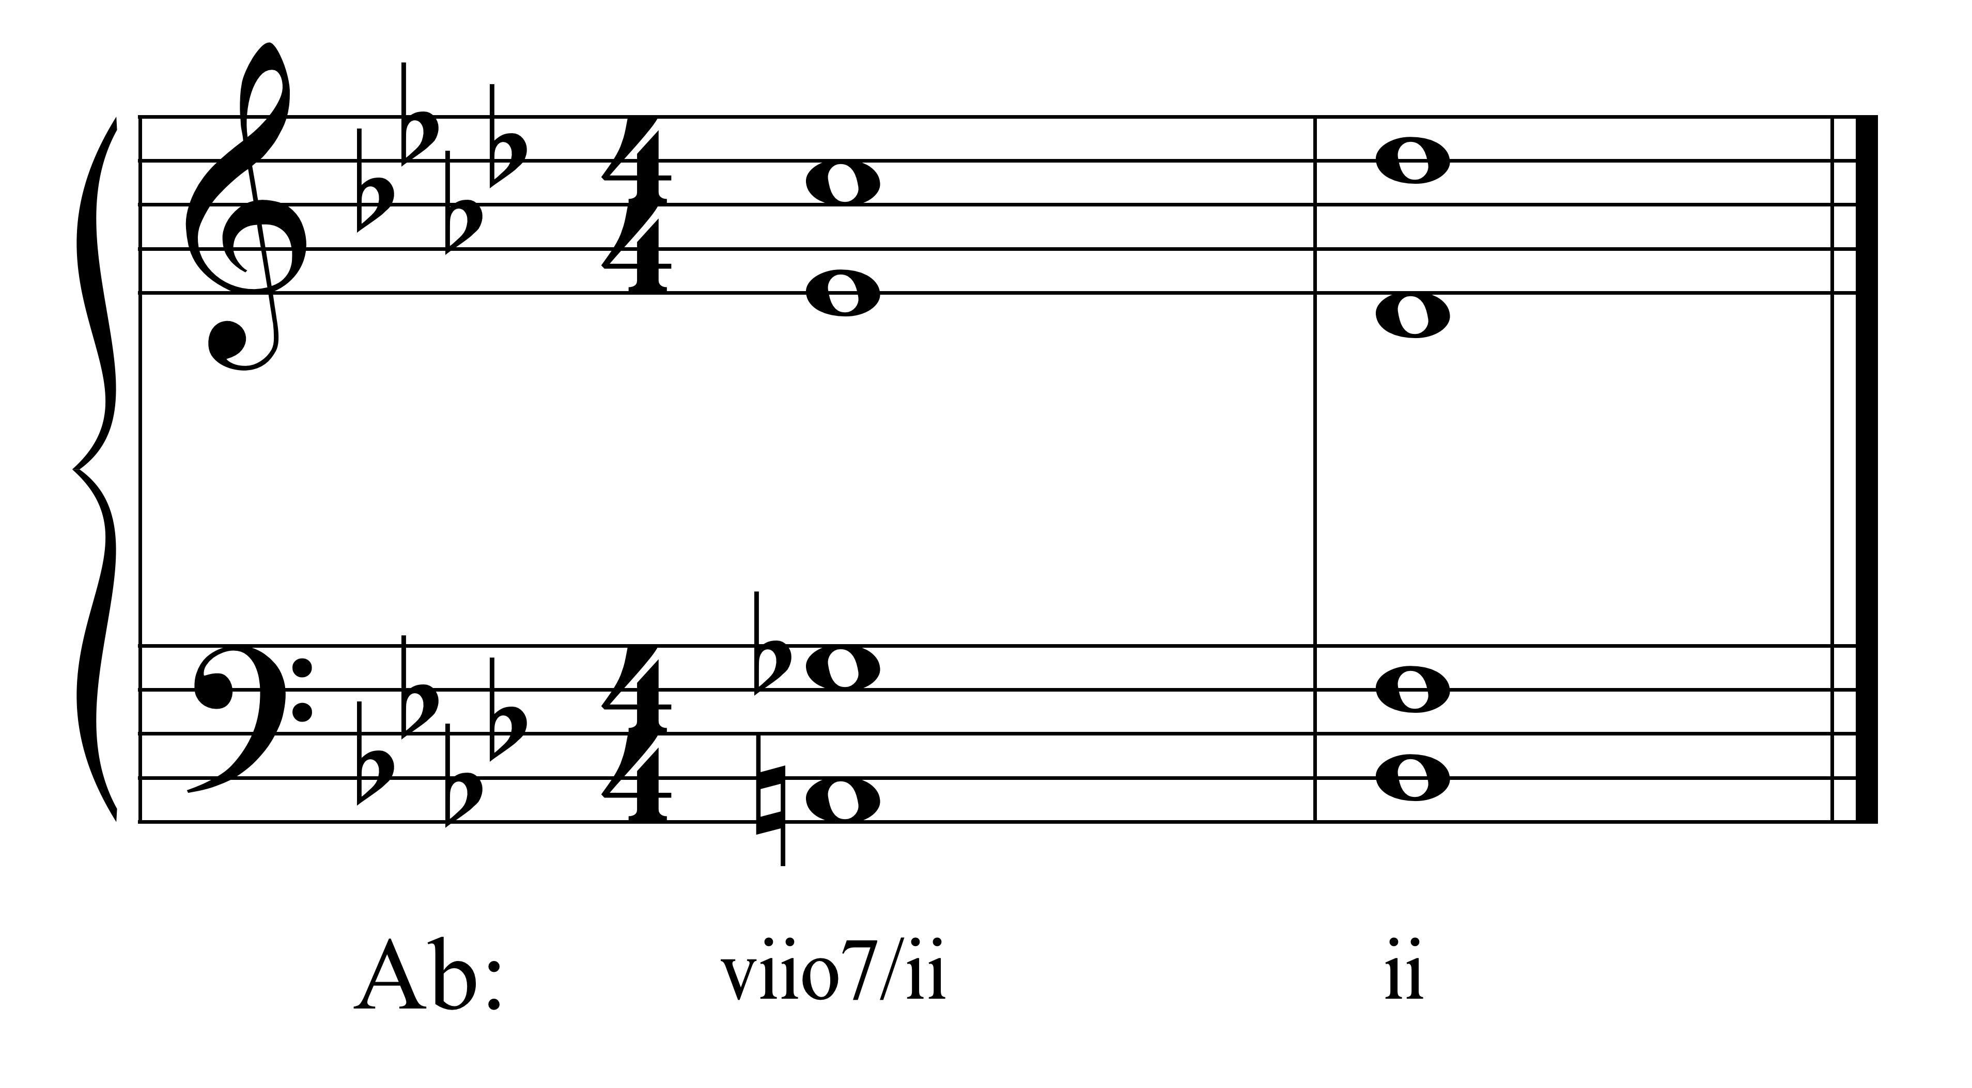

2. **Irregular resolution**: x/y may resolve to a chord that is a substitution (primary or secondary) for y.

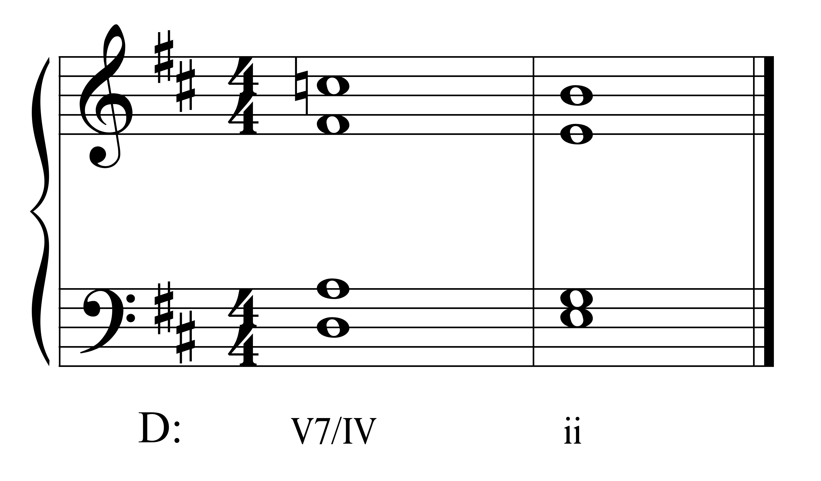

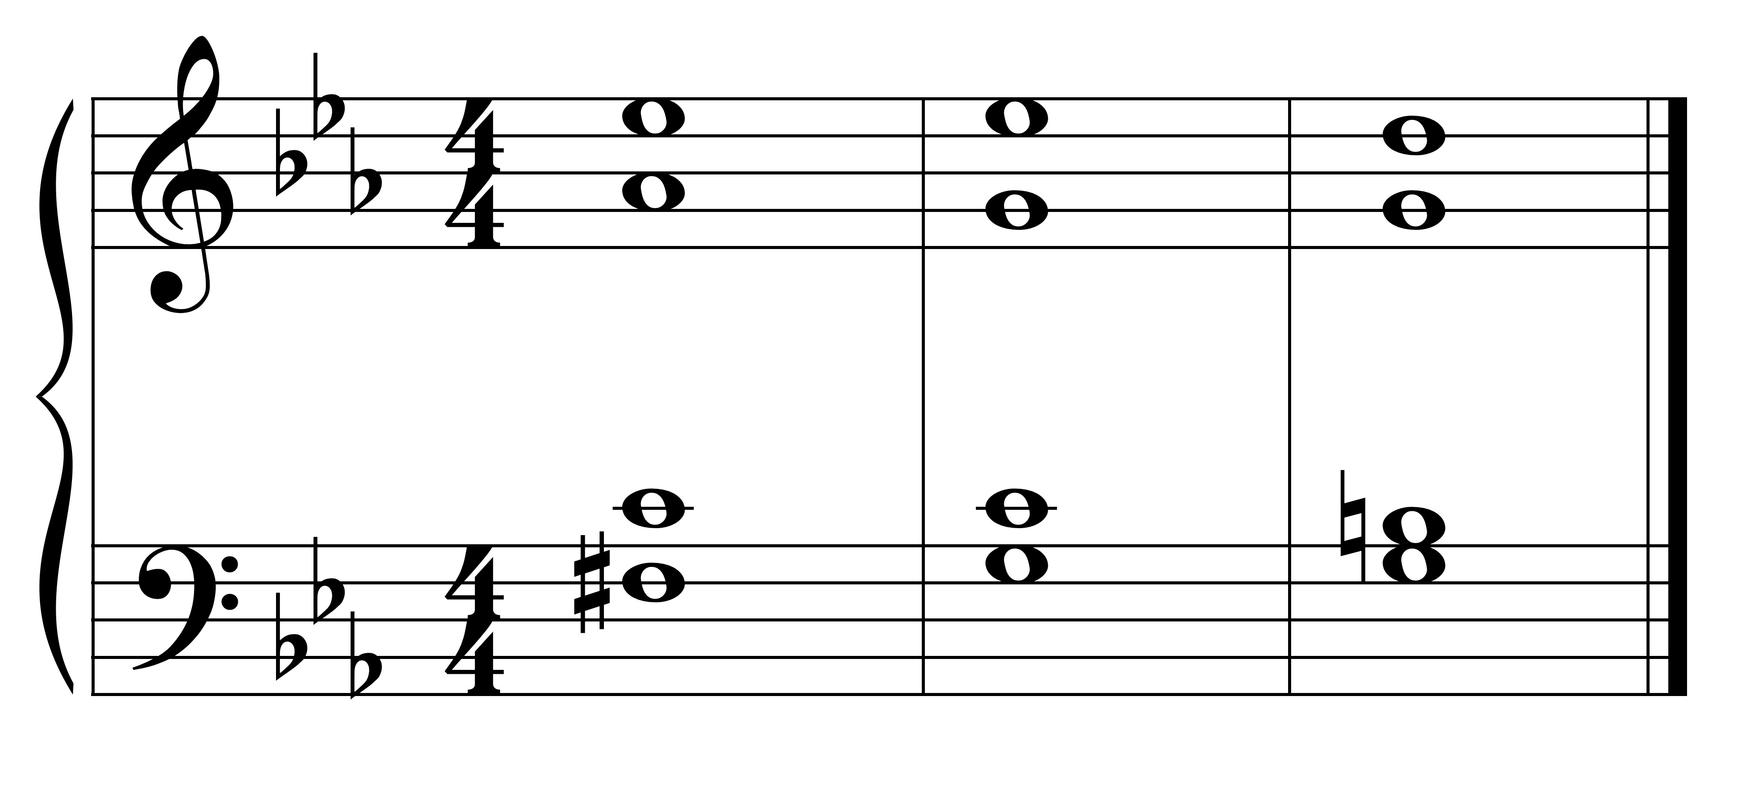

c minor: viio7/V V

3. **Deceptive resolution**: x/y may resolve to the chord whose root is a third below the root of the y chord.

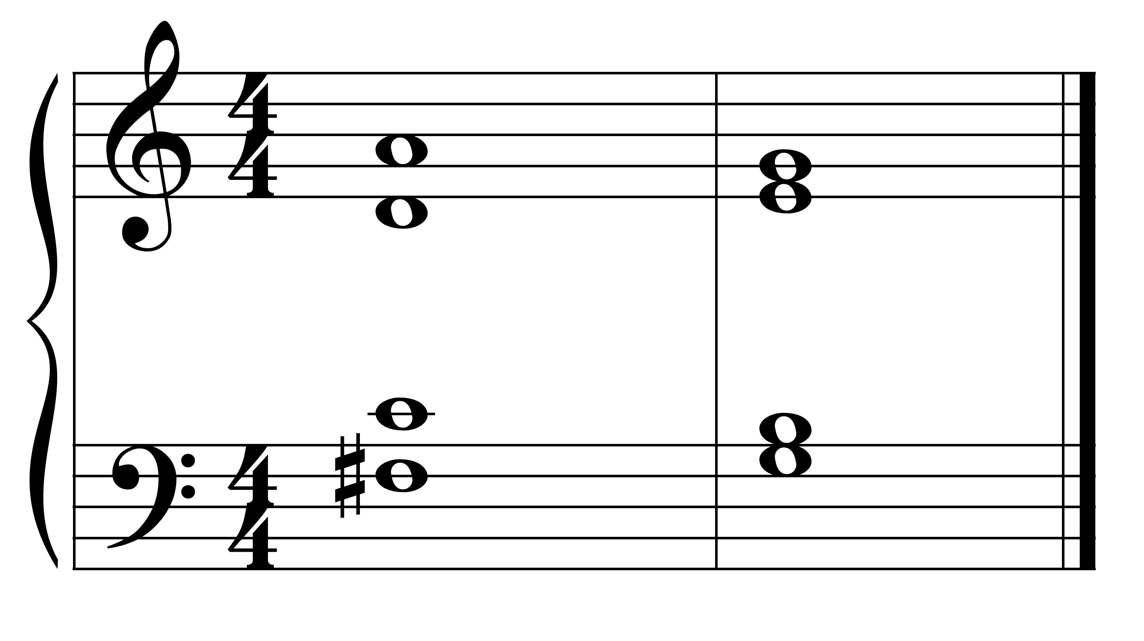

C: V $\begin{matrix}6 \\ 5\end{matrix}$/V iii6

**Part-Writing**:

The part-writing of a secondary dominant is essentially the same as for the diatonic dominant or leading tone chords:

**For V and V7**:

1. root resolves down a fifth to the root of the next chord (normal resolution).

2. seventh resolves down by step.

3. 'leading tone' (the third of the chord) resolves up by step (to the 'tonic').

4. complete V7's may resolve to an incomplete y (3 roots and 1 third).

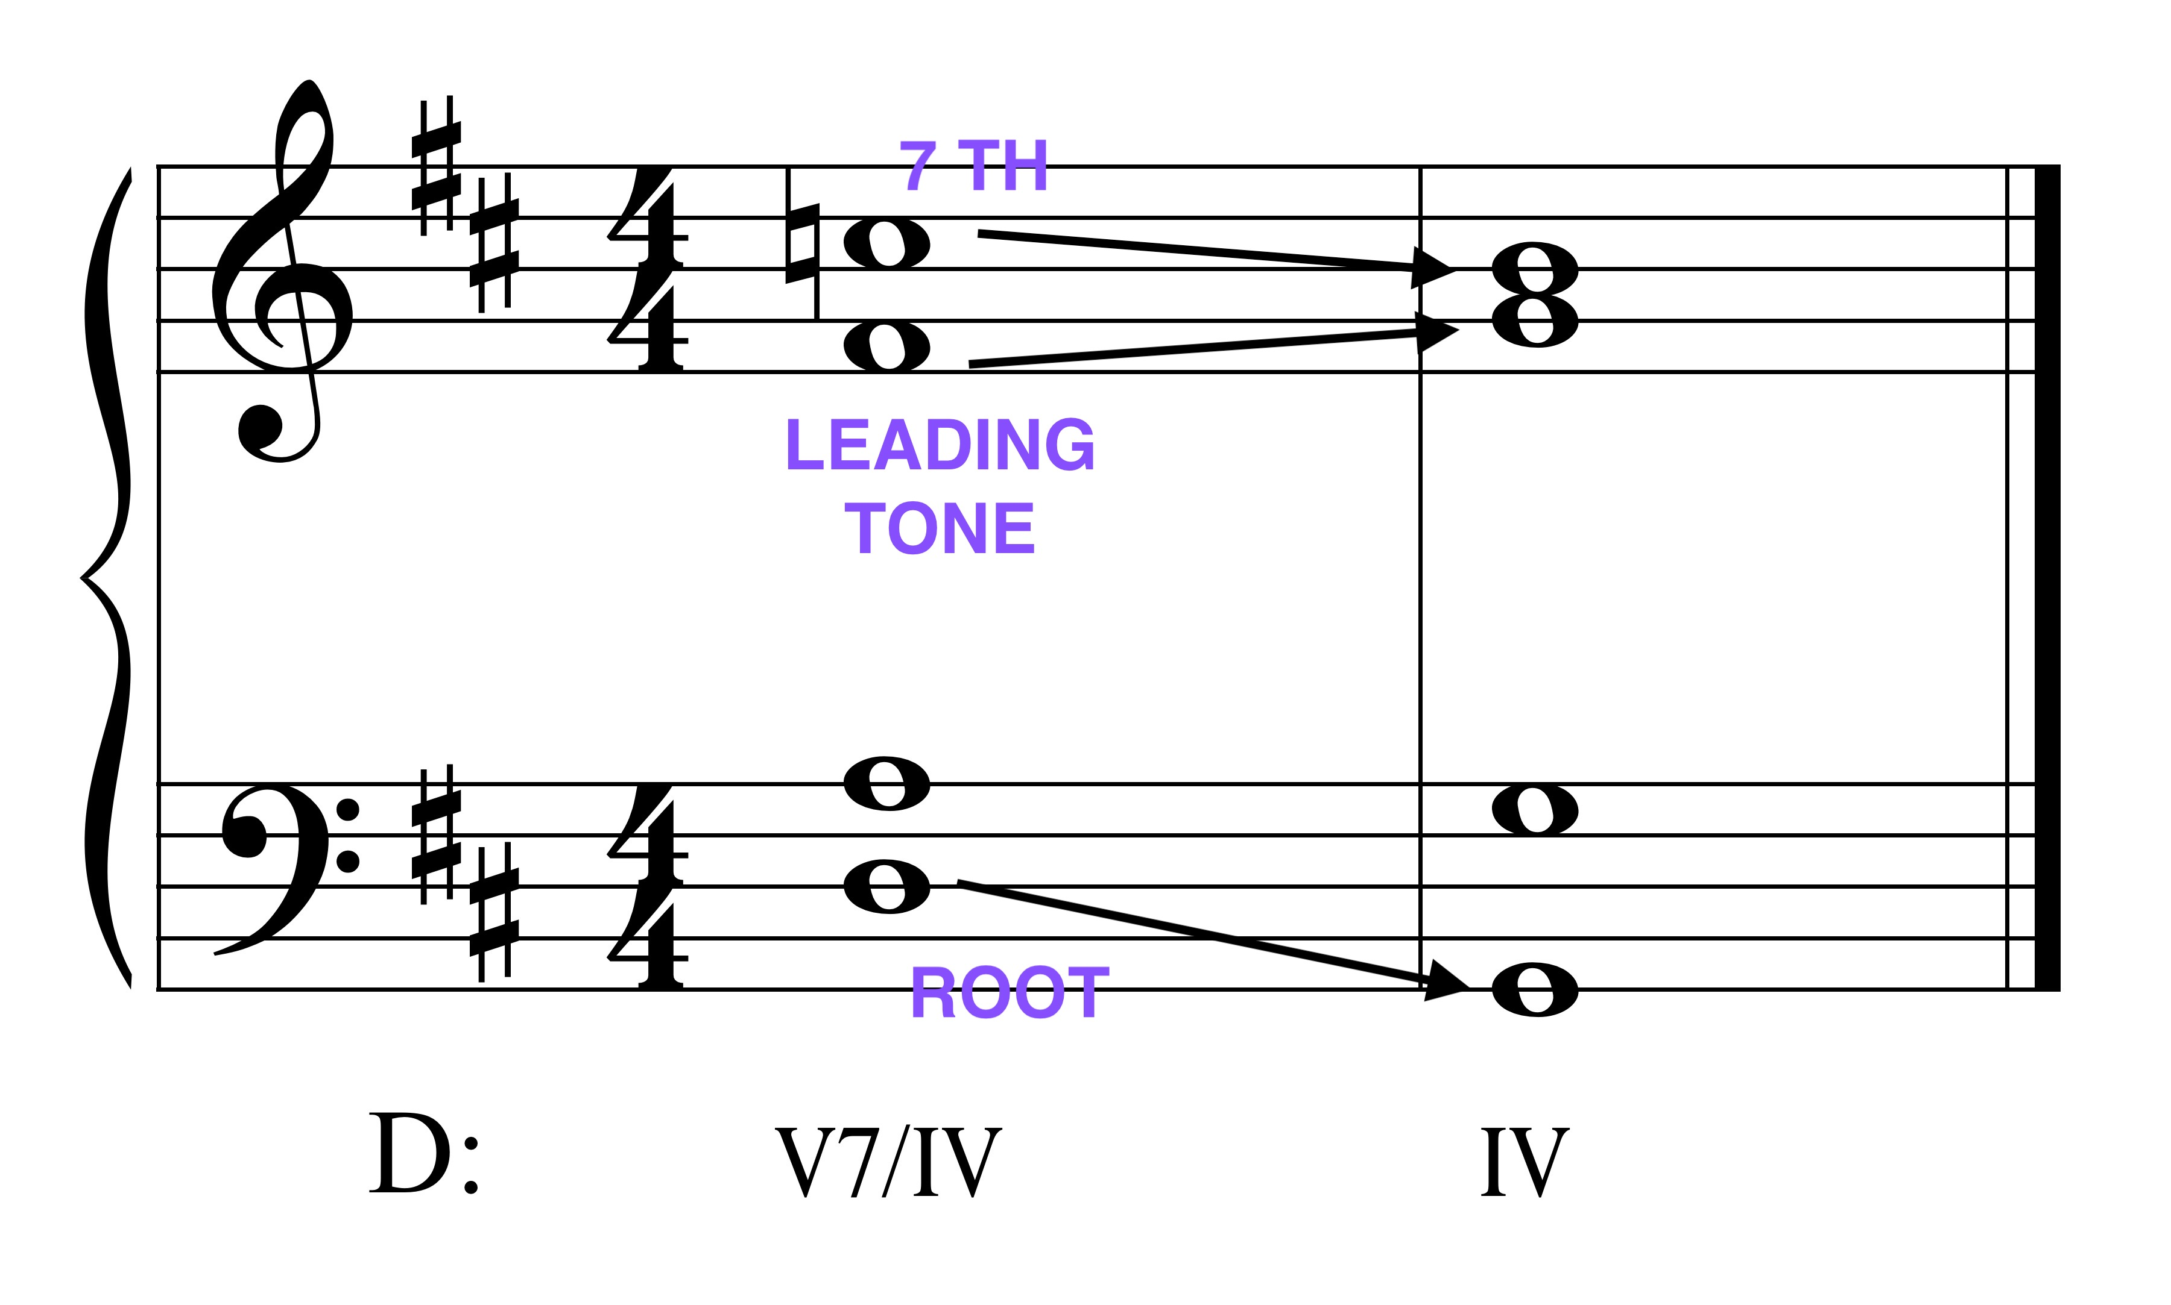

**For viio, vii7, and viio7**:

1. the root of the leading tone chord resolves up a second the root of the chord of resolution.
2. seventh of the chord (if present) resolves down by step.

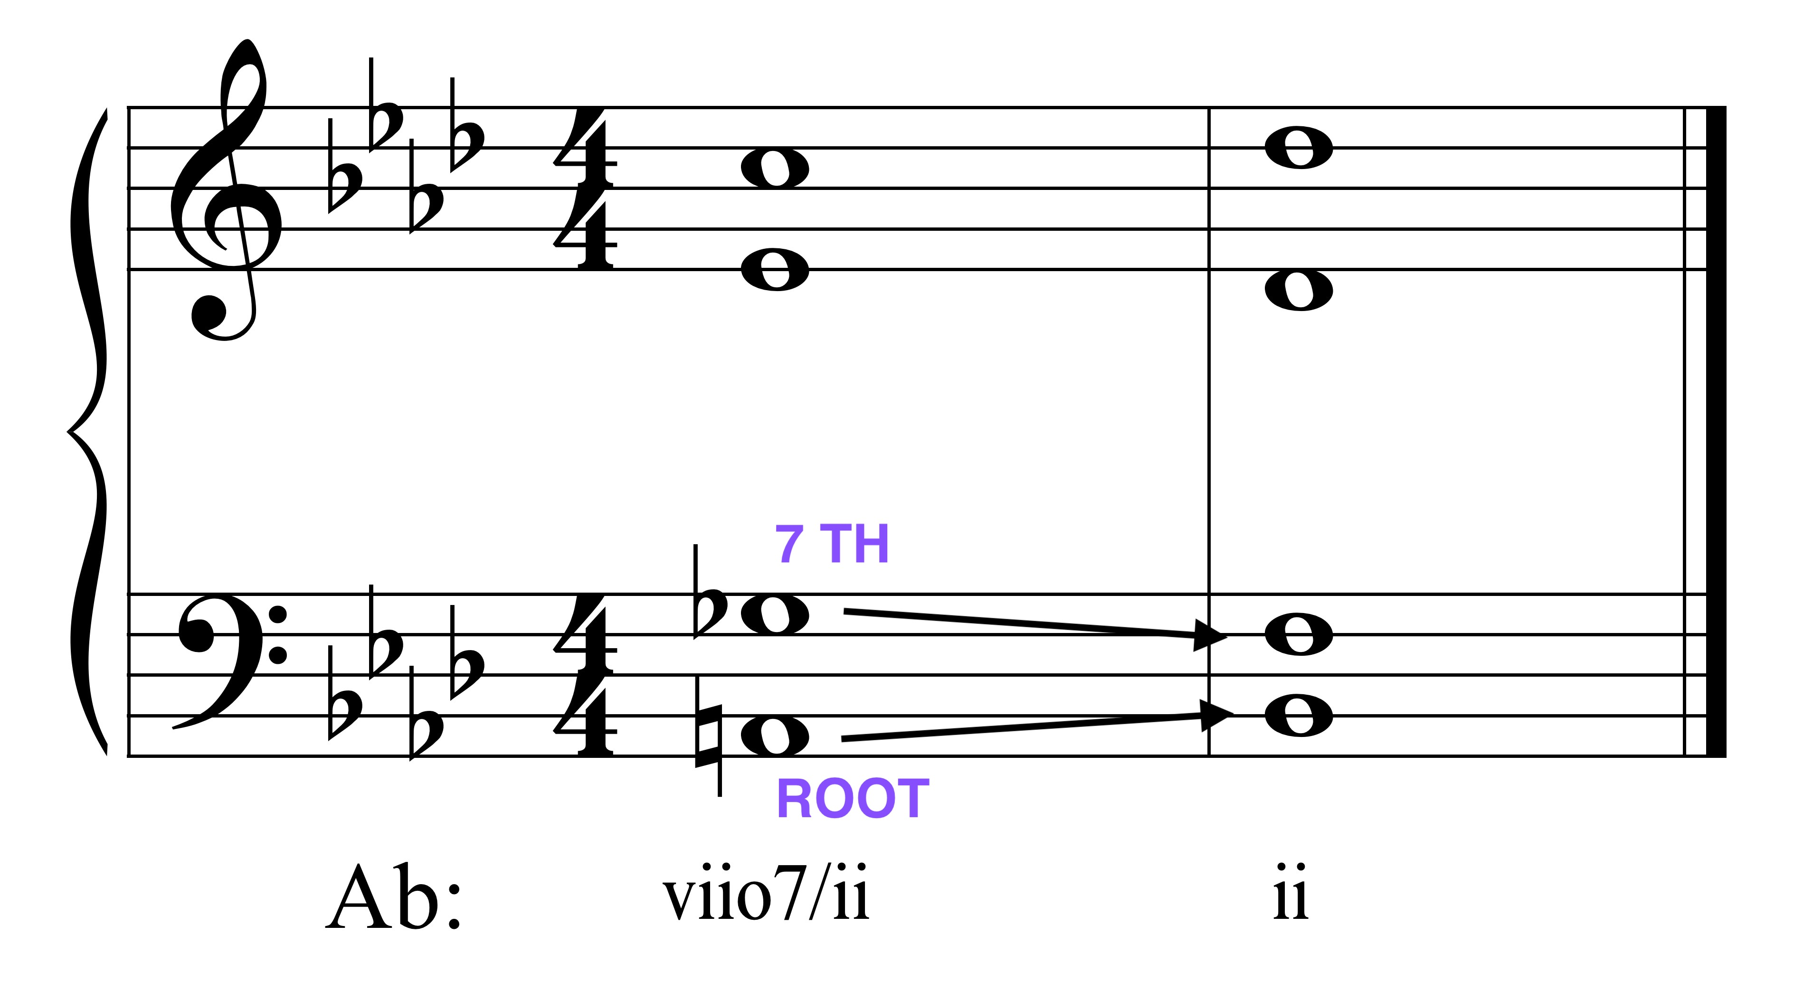

1. resolve the tritone(s) (i.e., A4 resolves out, d5 resolves in). Doing so in a fully diminished 7th chord will result in a doubled third in the chord of resolution; in most cases, this doubling is fine.

