**Notes, Rhythm, and Meter**

*Notes:*

Notes represent a duration or length of a sound. Notes consist of the head the stem and the flag or beam.

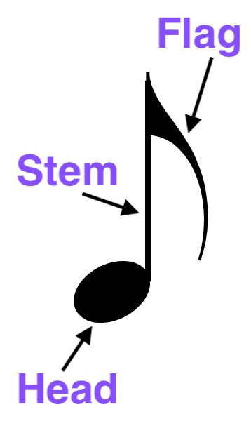

*Note heads:*

The head of the note should be written as an oval (not a round circle) and should be centered on the line or space of the staff that represents the note.

*Stems:*

Stems are notated on the right side of the note head and are ascending if the note head is on the 3rd line of the staff or below that line.

Stems are notated on the left side of the note head and are descending if the note is on the 3rd line of the staff or above that line.

Stems for notes on the middle line of the staff can go either up or down.

Stems should be about 1 octave in length and should be straight up and down (not slanted).

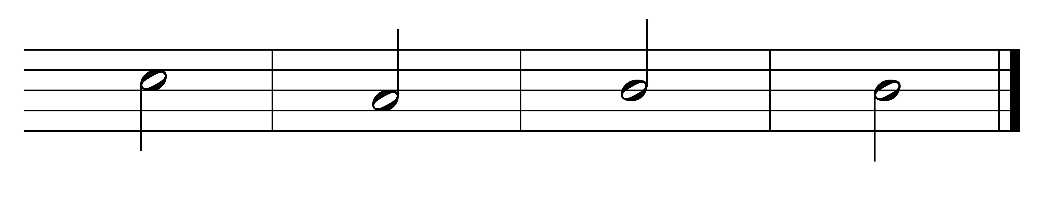

*Flags:*

Flags are notated to the right of the stem whether the stem is on the right or left side of the note head.

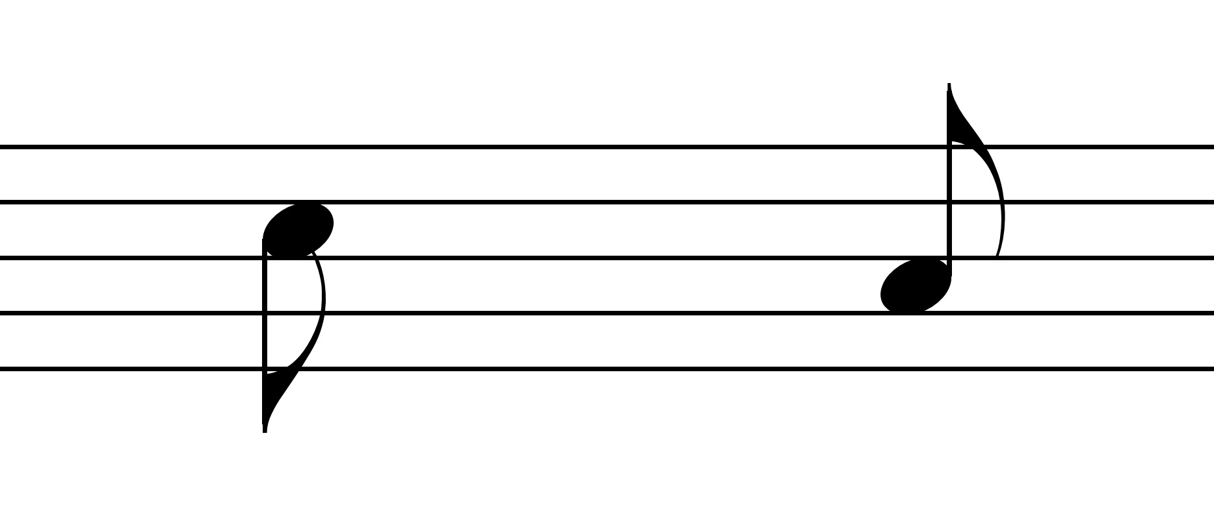

*Beams:*

Notes should be beamed together to show the beat. Beams should therefore not cross beats.

Beams should be straight lines, not curves. Beams may be slanted ascending or descending according to the contour of the notes.

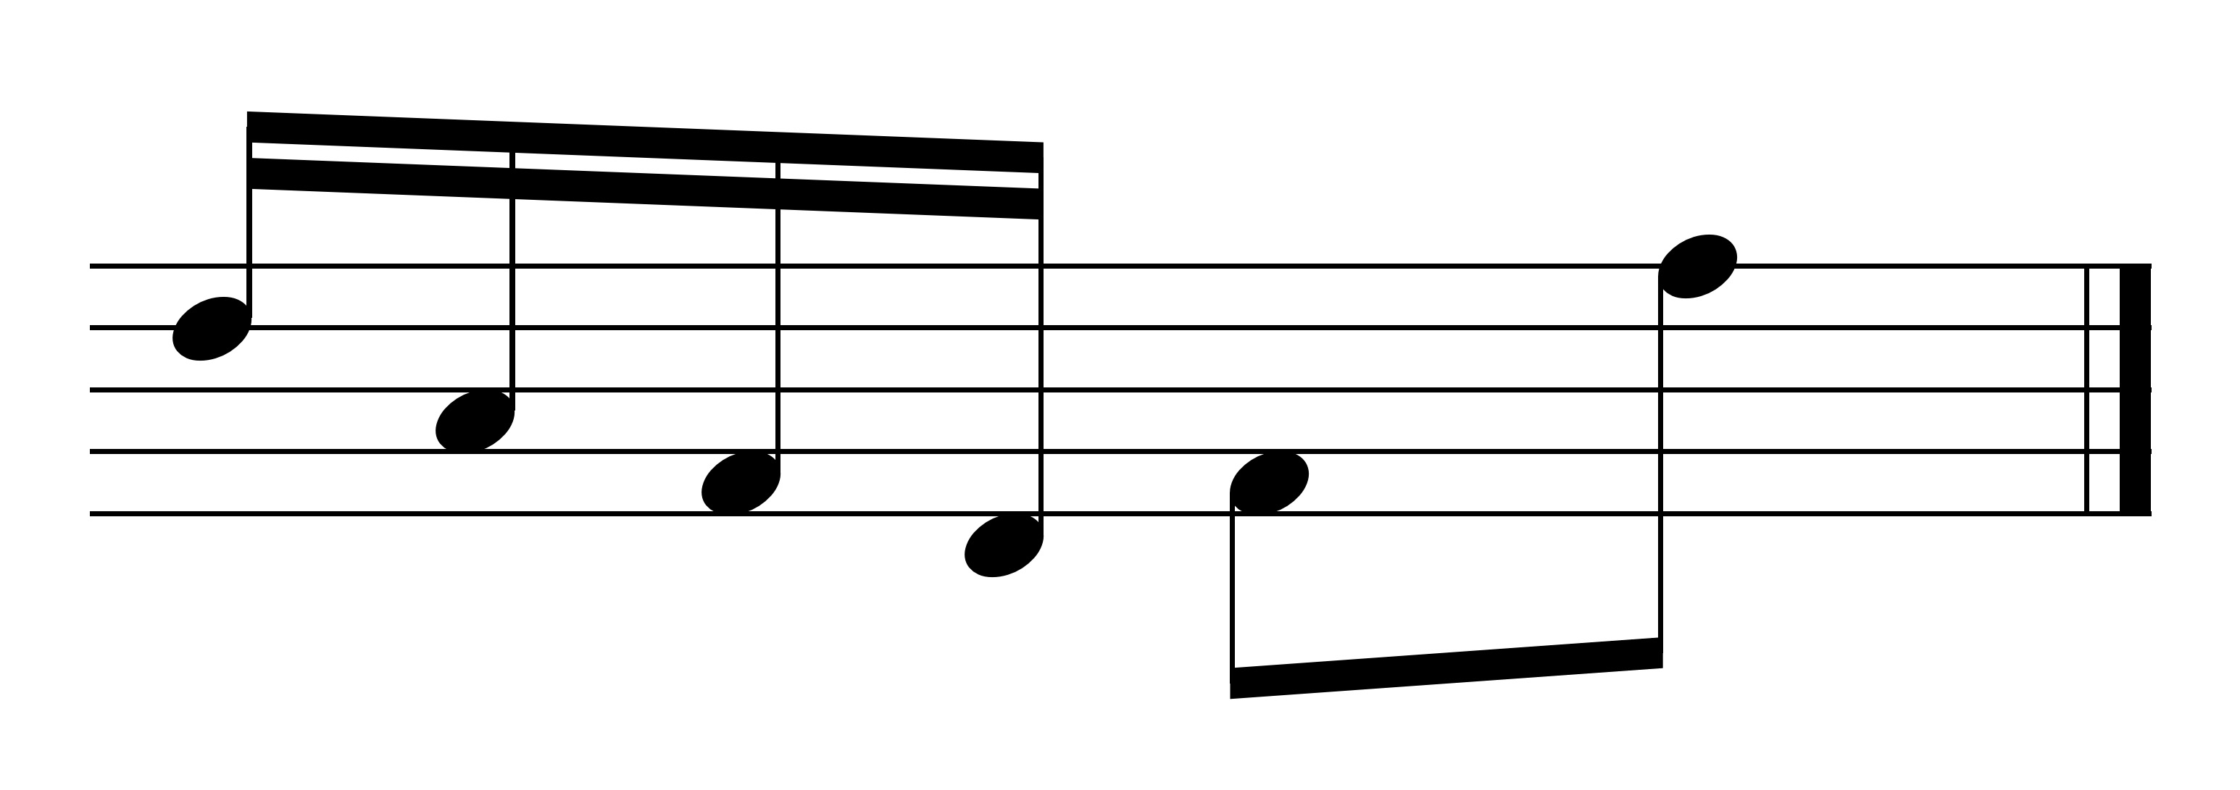

Beaming notes together may result in shortened or elongated stems on some notes.

If beaming eighth notes and sixteenth notes together, sixteenth note beams should always go inside the beginning and ending stems.

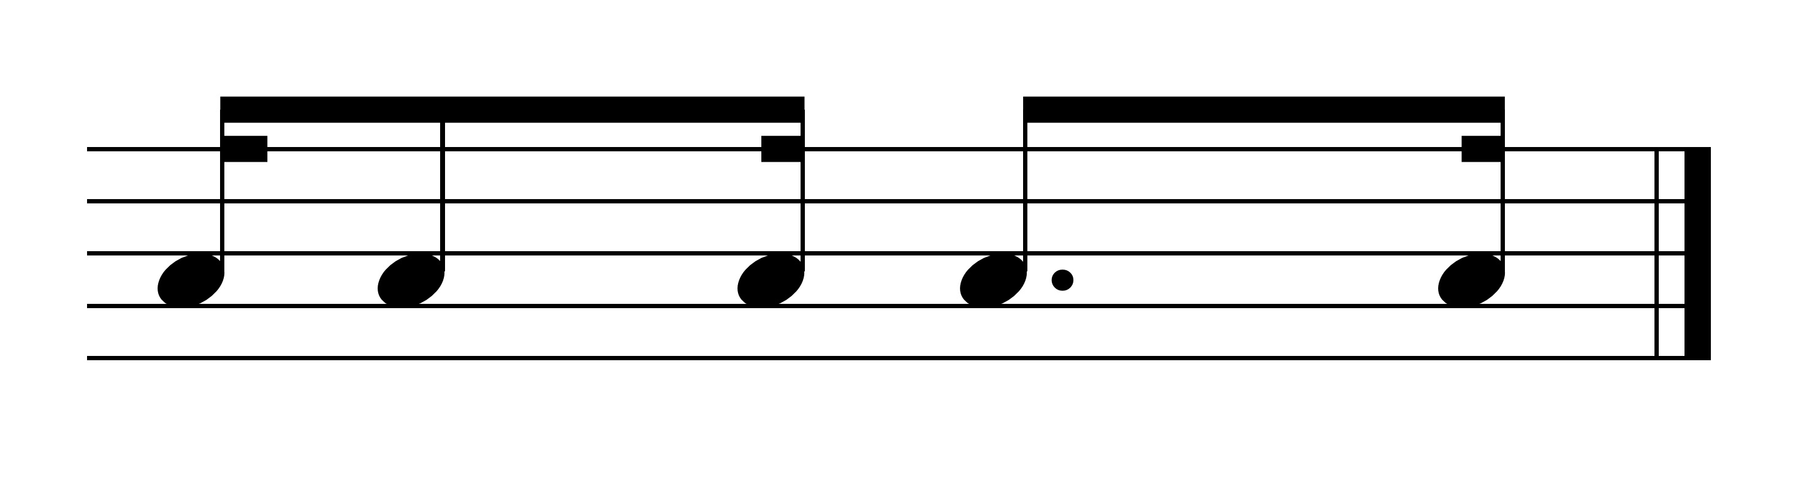

*Durations:*

Notes can have various durations and various names:

|  |  |
| --- | --- |
| **American** | **British (older version)** |
| double-whole | breve |
| whole | semi-breve |
| half | minim |
| quarter | crotchet |
| eighth | quaver |
| sixteenth | semi-quaver |
| thirty-second | demi-semi-quaver |
| sixty-fourth | hemi-demi-semi-quaver |

These notes look like the following:

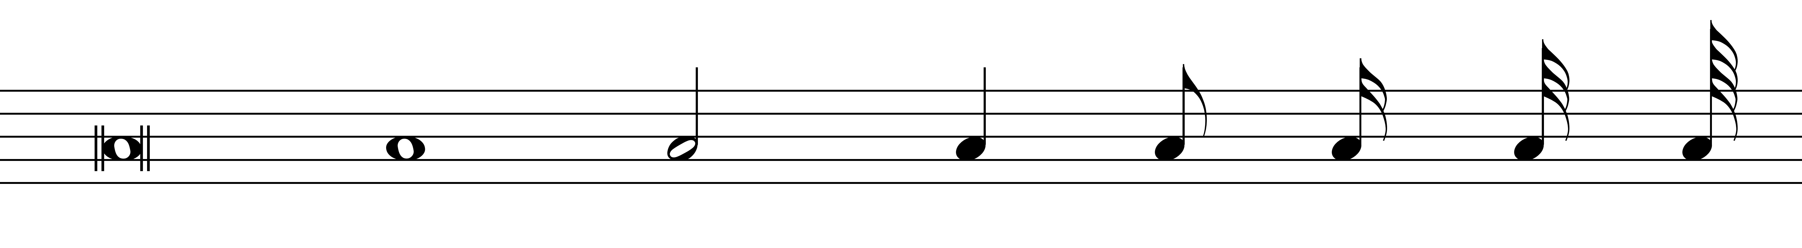

double whole half quarter 8th 16th 32nd 64th

whole

In the above list, each note duration is one-half the duration of the preceding note duration. Thus, one double-whole note = 2 whole notes, 1 whole note = 2 half notes, 1 half note = 2 quarter notes, etc.

Rests represent durations of silence instead of sound. Rests can have various durations as well.

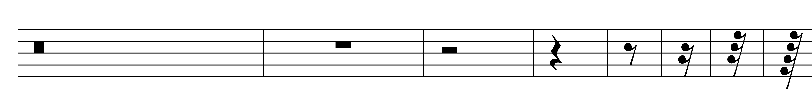

double whole half quarter 8th 16th 32nd 64th

whole

*DOTS:*

Dots alter the duration of a note by adding half the value of the note onto the note (e.g., a dotted half note = the duration of a half note + a quarter note). A second dot adds half the value of the first dot (e.g., a double dotted half = the duration of a half note + a quarter note + an eighth note).

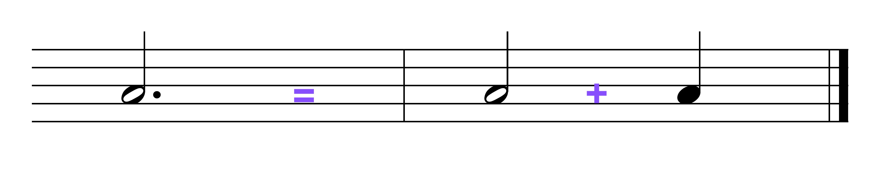

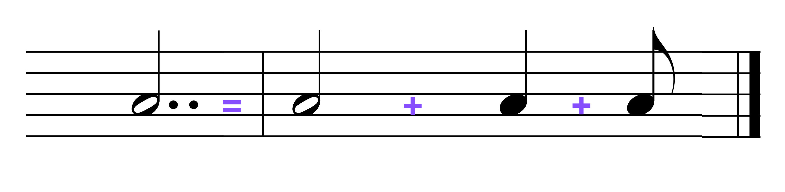

*TIES:*

Ties extend the length or duration of a note by holding the note for the value of the two notes that are connected by the tie without a break or breath.

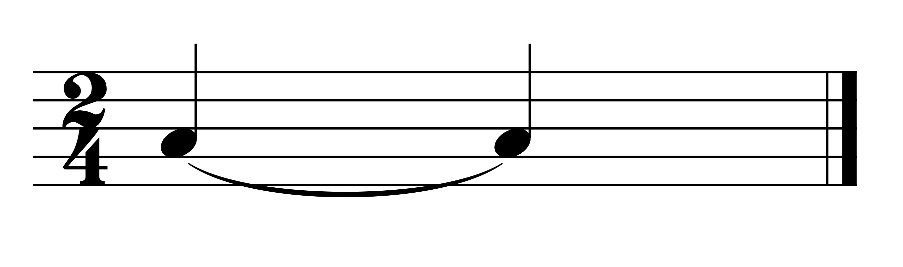

*RHYTHM AND METER:*

**Rhythm** is a pattern of durations.

Some music is purely rhythmic such as percussion pieces, some African music, rap music.

Rhythm is divided into **beats** -- a span of time that recurs regularly. Beats can be both strong (S) or **accented** (emphasized), and weak (W) or unemphasized.

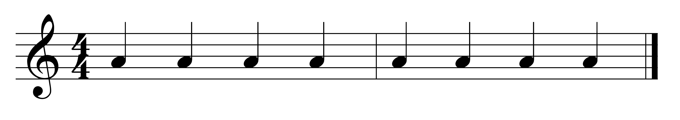

S w s w S w s w

**bar lines** -- vertical lines drawn in the staff -- are used to separate music into measured divisions of recurring patterns of strong and weak beats.

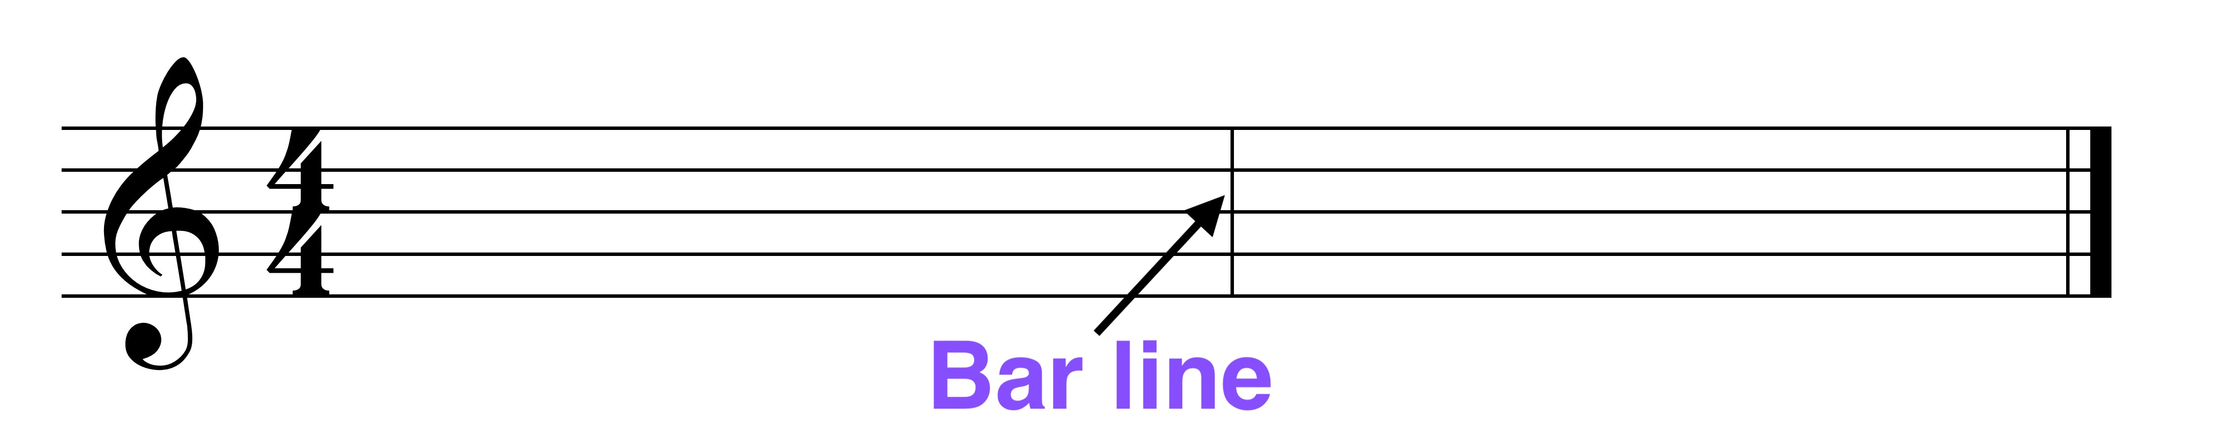

A **meter** is a pattern of stress/ weak and strong beats.

**Types of meter**

**duple** - groups of 2 beats (strong-weak)  
**triple** - groups of 3 beats (strong-weak-weak)  
**quadruple** - groups of 4 beats (strong-weak-less strong - weak)  
**quintuple** - groups of 5 beats (3+2 or 2+3)

**Divisions of beat**s  
In **simple** time, each beat divides normally into 2 parts.

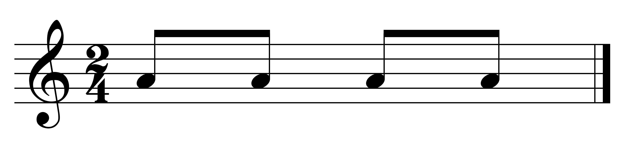

In **compound** time, each beat divides normally into 3 parts.

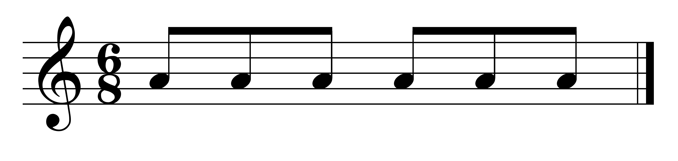

**Time classifications** -- examples are:

**duple-simple** = groups of 2 beats in which each beat normally divides into 2

**triple-compound** = groups of 3 beats in which each beat normally divides into 3

**Time signatures**

a designation of the time classification using Arabic numbers.

A time signature looks like a fraction, having a top and a bottom number, each designating something different.

**Top number**

First, the top number indicates whether the meter is simple or compound time. It is compound time if the top number is a multiple of 3 (e.g., 6,9,12,15); it is simple time if the top number is 3 or a non-multiple of 3.

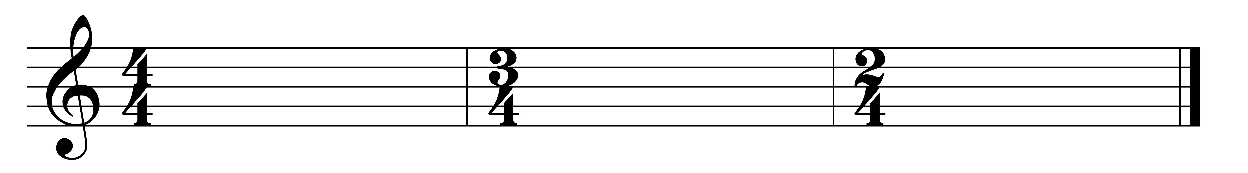

If the meter is simple time, the top number indicates the number of beats in the measure. (top number = 3; number of beats is 3)

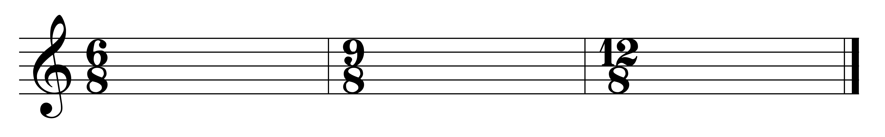

If the meter is compound time (the top number is a 6, 9, 12, or 15), the top number indicates the number of divisions of the beats. Therefore, the number of beats is the top number divided by 3. (top number = 6; number of beats is 6 / 3 = 2)

**Bottom number**

If the meter is simple time, the bottom number is the unit of beat (4 = quarter, 2 = half).



If the meter is compound time, the bottom number indicates the division of the beat; add 3 of the indicated value to get the unit of beat (4 = quarter + quarter + quarter = dotted half)



**Common time (C)**

from Philippe de Vitry's (1291-1361) *Ars Nova*

C represents imperfect time (2 beats) with imperfect division of the beat (into 2); now represents 4/4 time

**Cut time ()** - represents cutting common time (4/4) in half resulting in 2/2 time (2 beats in ms and half note gets the beat)

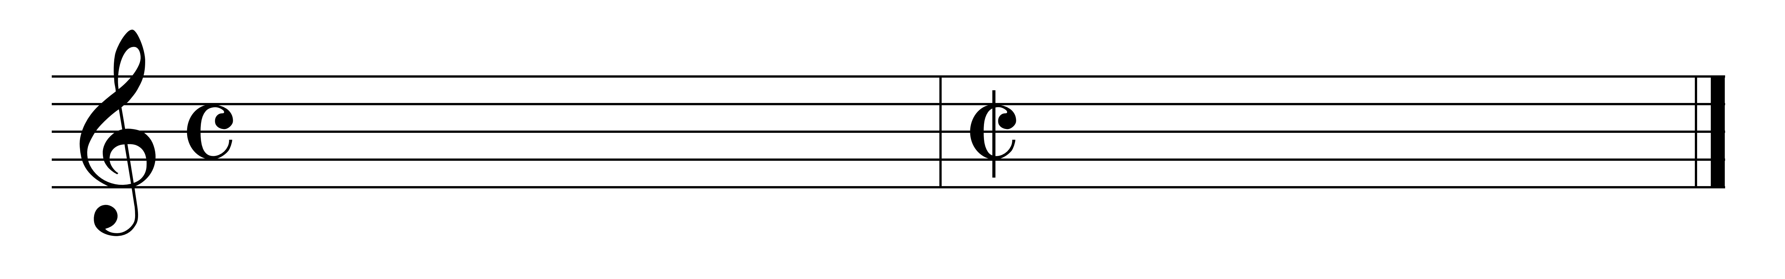

Common time Cut time

*borrowed divisions:*

**duplet** -- 2 notes occupying the time normally taken by 3 notes. Duplets occur in compound time meters.

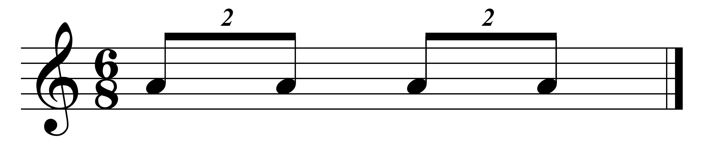

**triplet** -- 3 notes occupying the time normally taken by 2 notes. Triplets only occur in simple time meters.

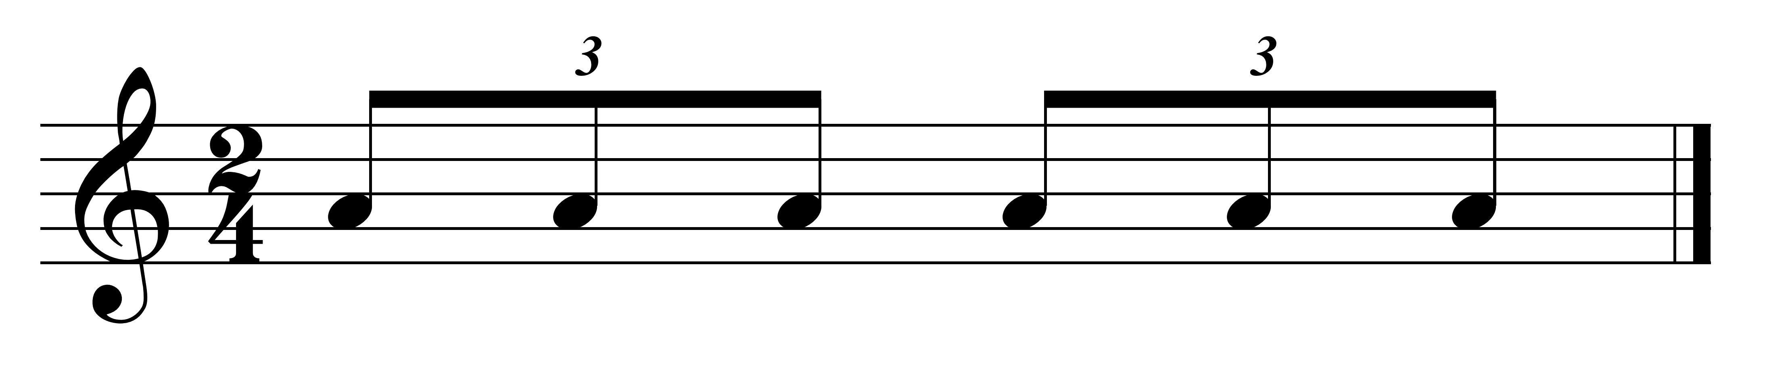

*SYNCOPATION:*

**syncopation** -- the accenting (by length or emphasis) of a normally unaccented beat or portion of the beat.

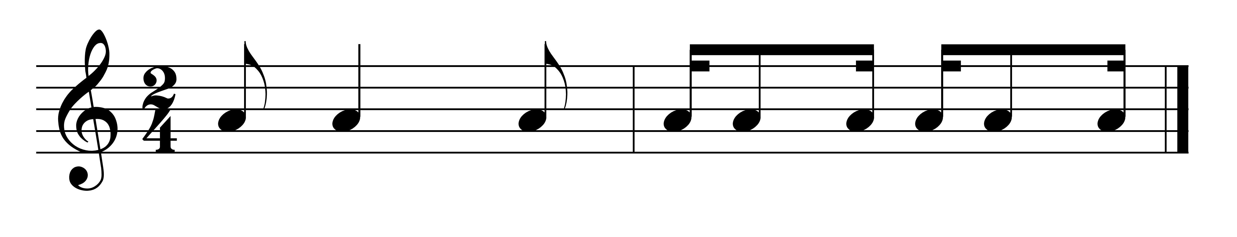

*TEMPO:*

**Terms that express tempo --**

At first, the only way for the composer to indicate speed of the composition to the performer was to indicate a relative speed, such as:

andante - walking tempo

allegro - fast

lento - slow

vivo - very fast

presto - very fast

But these terms are very subjective.

**metronome indication** -- a more precise method of conveying the speed of music.

e.g., MM= 120

M.M. - Maezel's metronome (the man who invented it).

The number indicates number of beats per minute.