**Musical Notation**

**Staff:**

Music is notated on a **staff** -- a group of 5 lines and 4 spaces on which we write music (shown below).

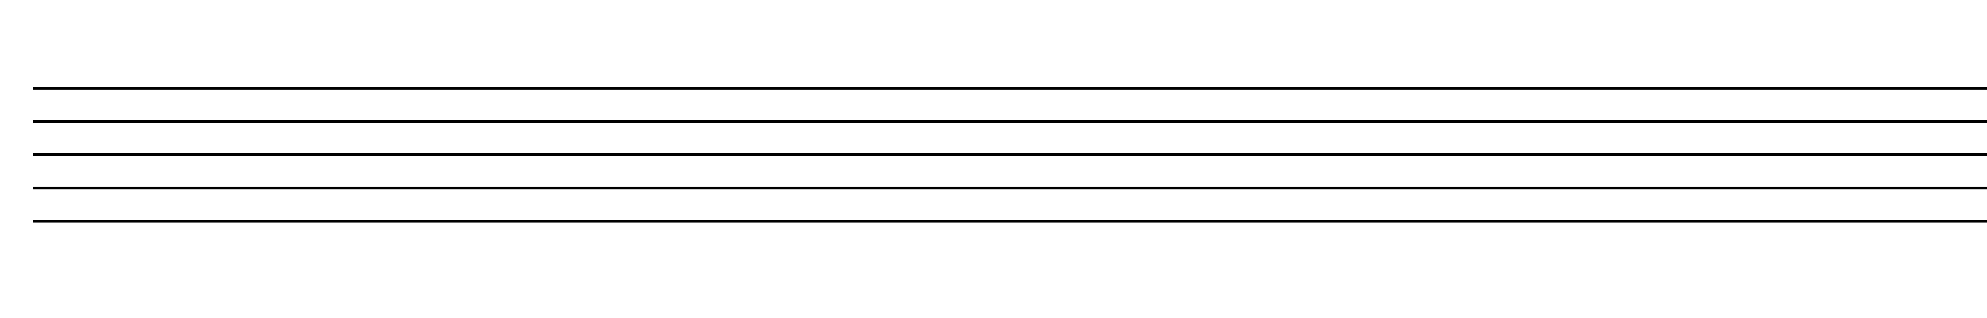

**Ledger Lines:**

The lines and spaces of a staff may be extended by means of **ledger lines** (circled below).

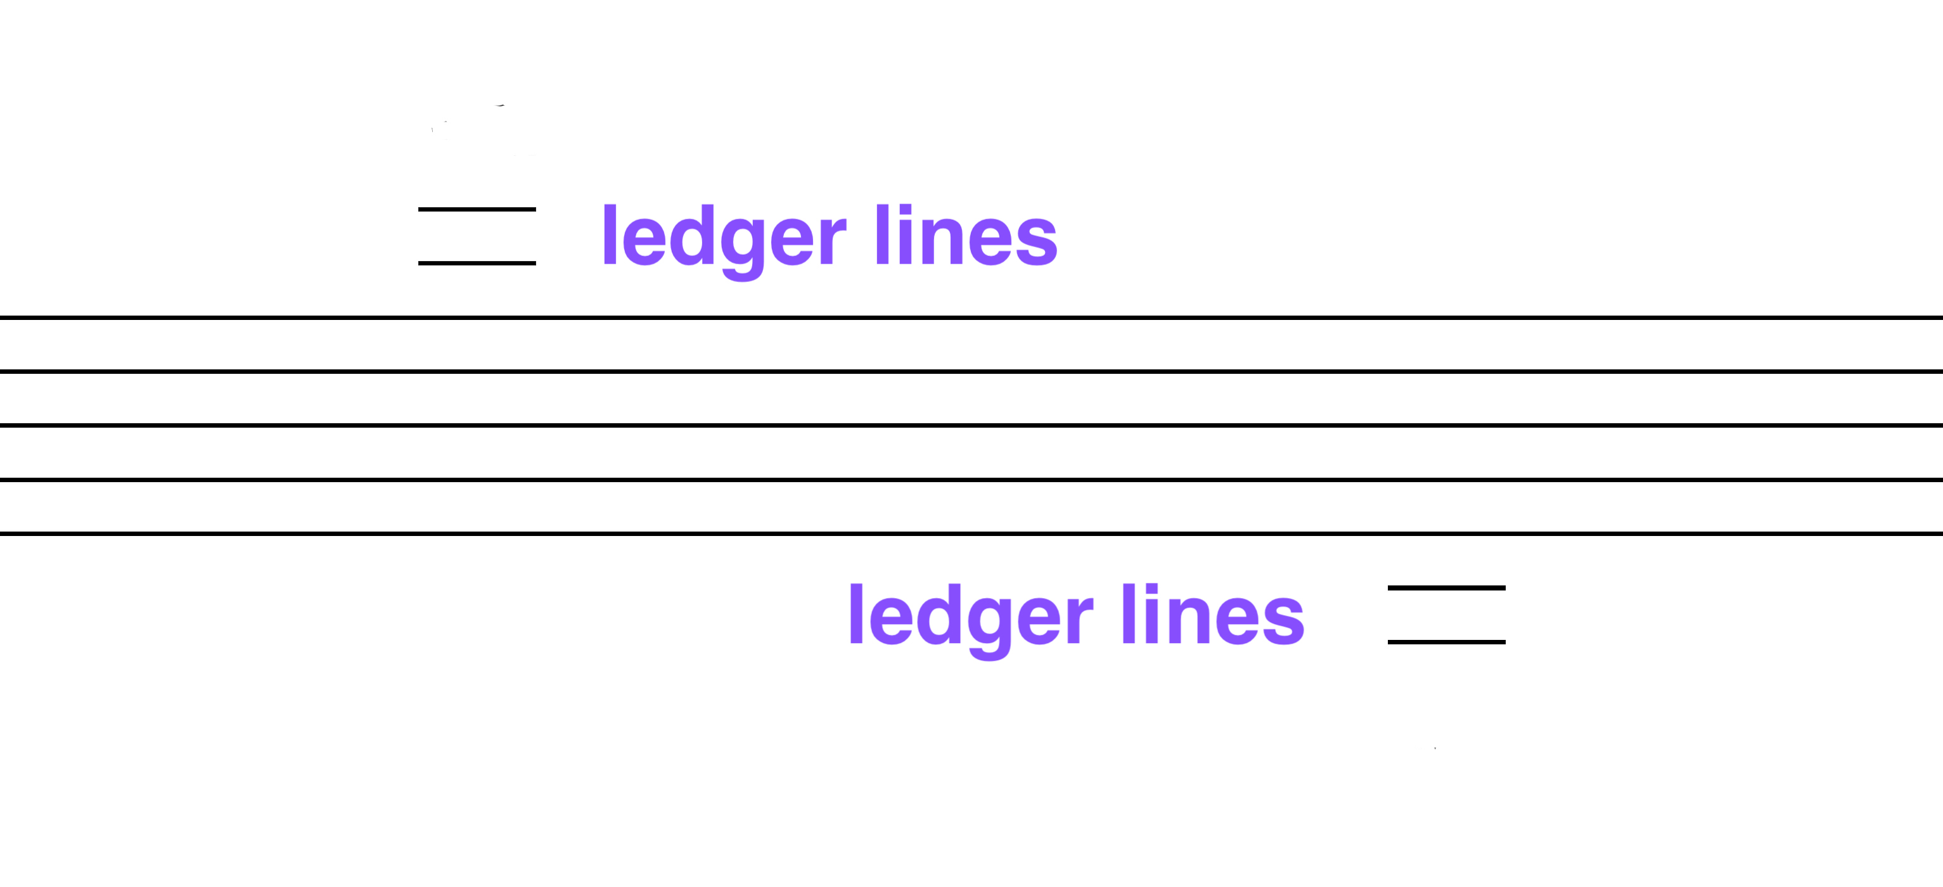

**Clef:**

The word “clef” is French for “key”; the clef is the key to understanding the notes.

We know which line or space is a particular note by the **clef** at the beginning of the staff.

The three most common types of clefs are the

* **treble or G-clef,**
* **bass or F-clef**
* **C-clefs**

treble clef bass clef C-clef (alto)

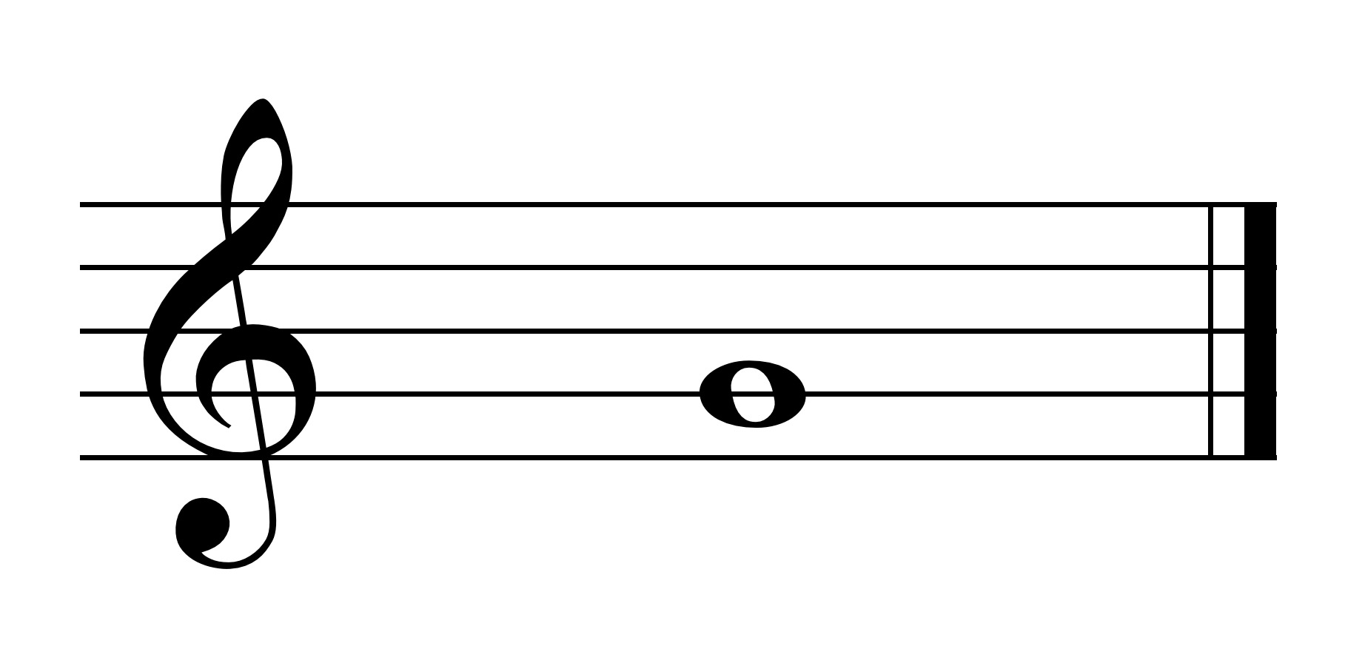 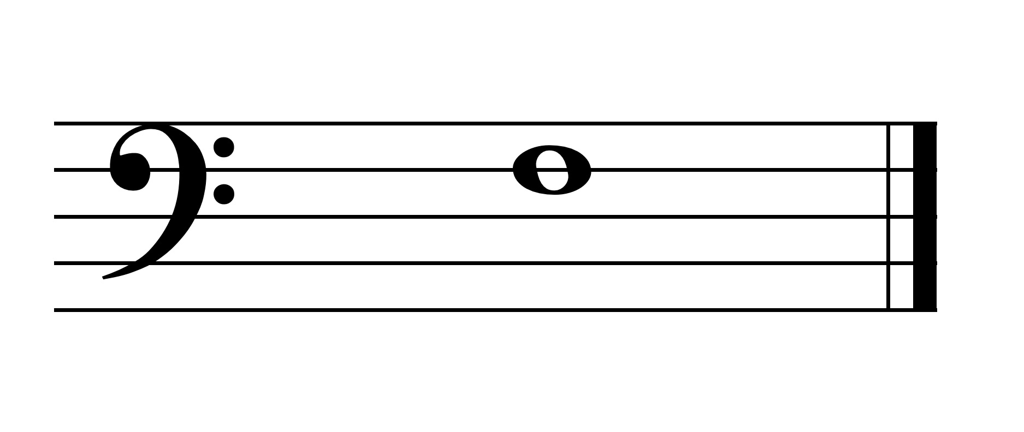 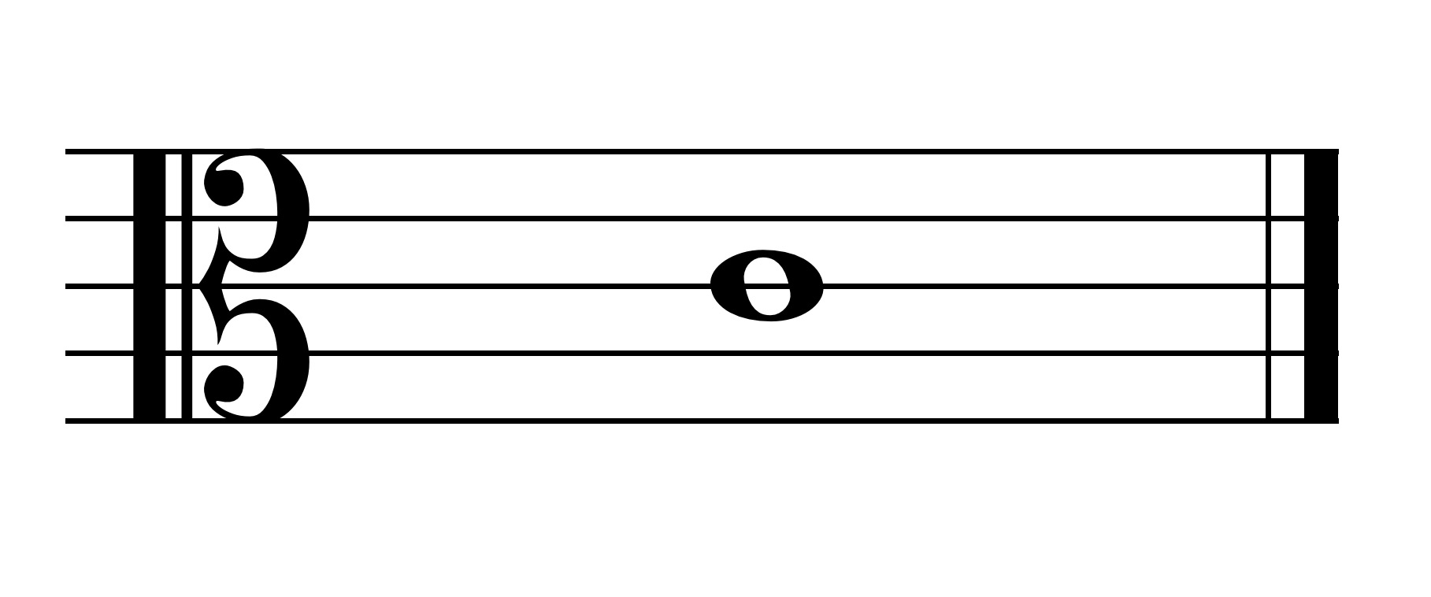

G F C

The curl of the treble clef circles the line that is G on the staff.

The dots of bass clef are around the line that is F.

The middle of C-clef surrounds the line that is middle C.

The treble and bass clefs originated from decorated G's and F's in early music.

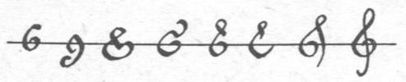

By Koobak [GFDL (http://www.gnu.org/copyleft/fdl.html), CC-BY-SA-3.0 (http://creativecommons.org/licenses/by-sa/3.0/) or CC BY 2.5

(https://creativecommons.org/licenses/by/2.5)], from Wikimedia Commons

All clefs started as movable clefs; now only C-clefs are movable. The two most used c-clefs are the alto and tenor clefs.

Soprano clef Mezzo-soprano clef

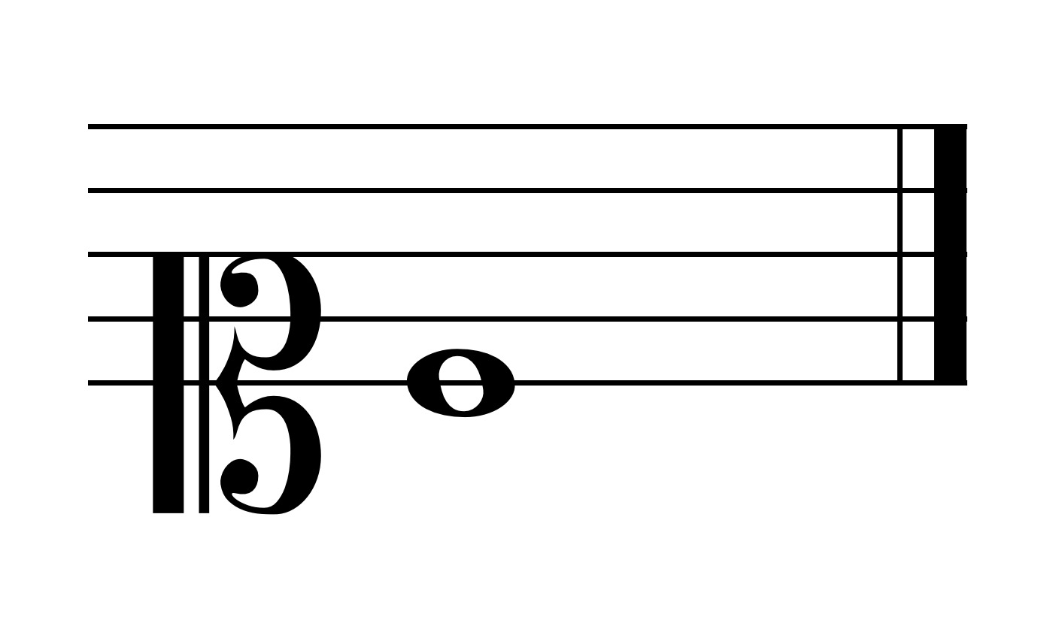 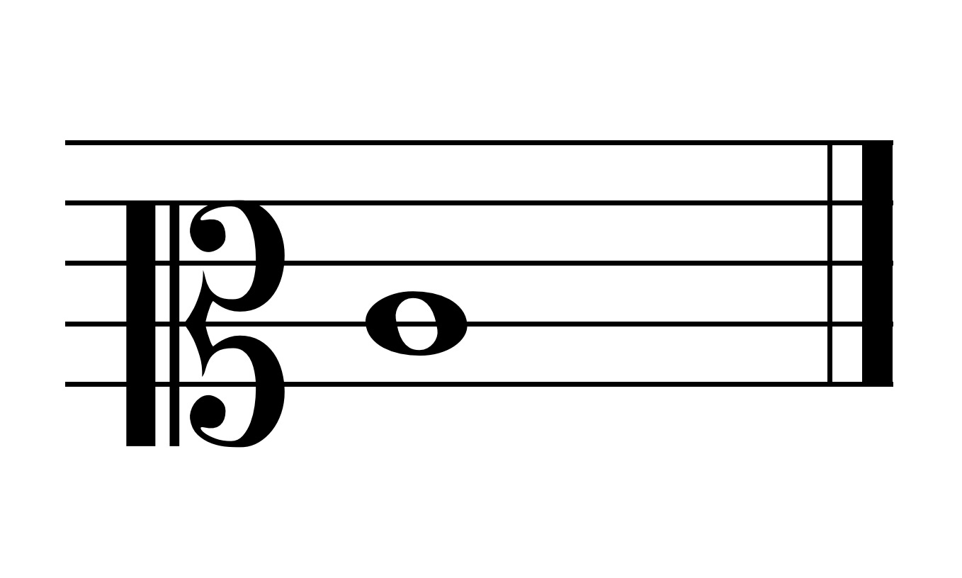

Alto clef Tenor clef Baritone clef

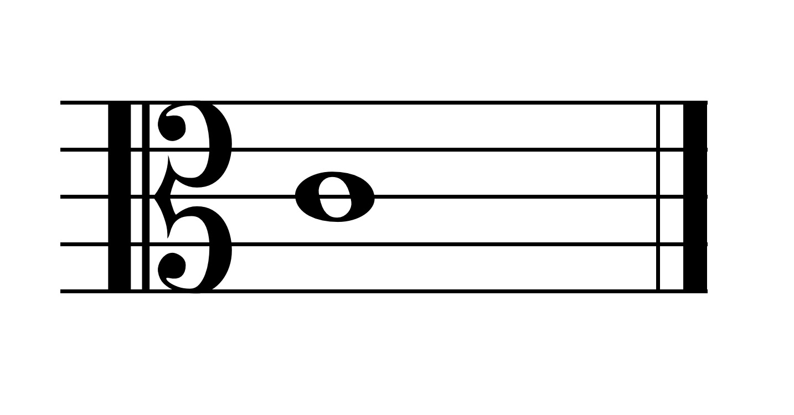 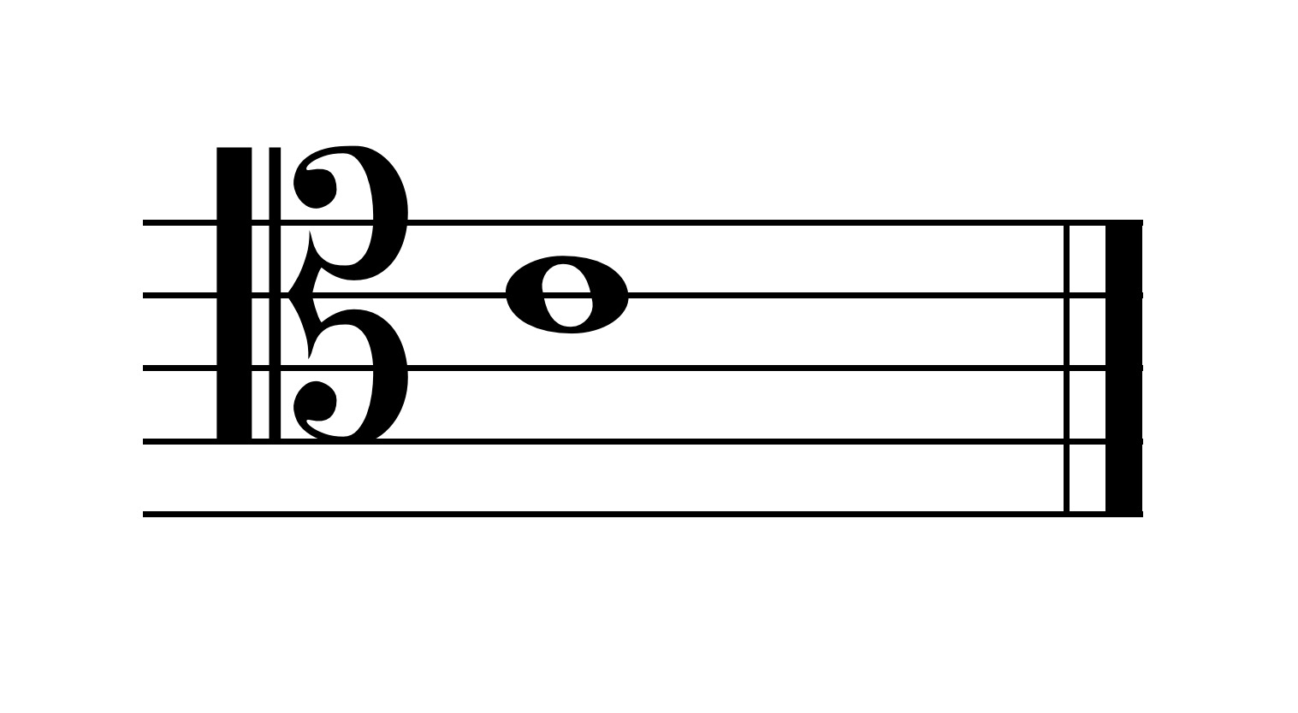 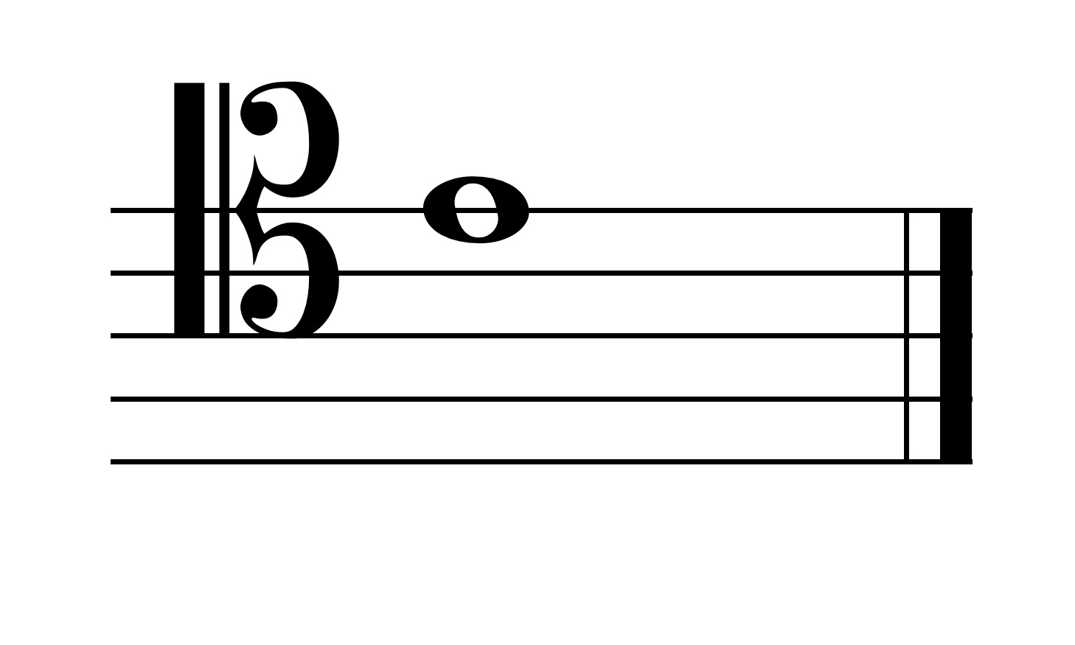

**Note Names:**

The other lines and spaces represent other notes and always follow in order of the alphabet using only the first seven letters (and then repeating them).

For example, in treble clef, we have:

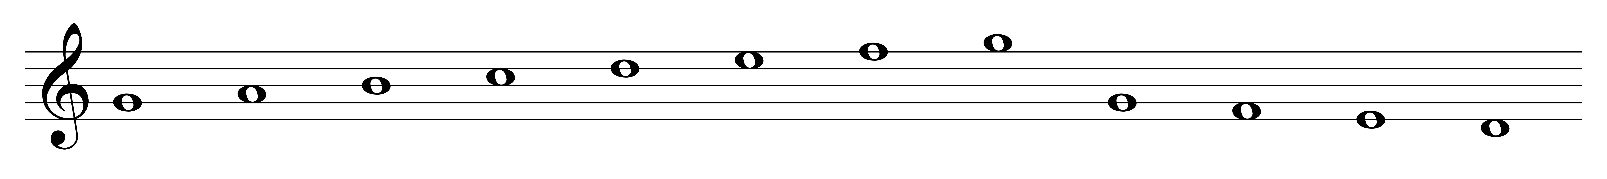

G A B C D E F G G F E D

**Grand Staff:**

We can combine of treble and bass staff into a **grand staff**. An example of the grand staff with middle C marked is shown below.

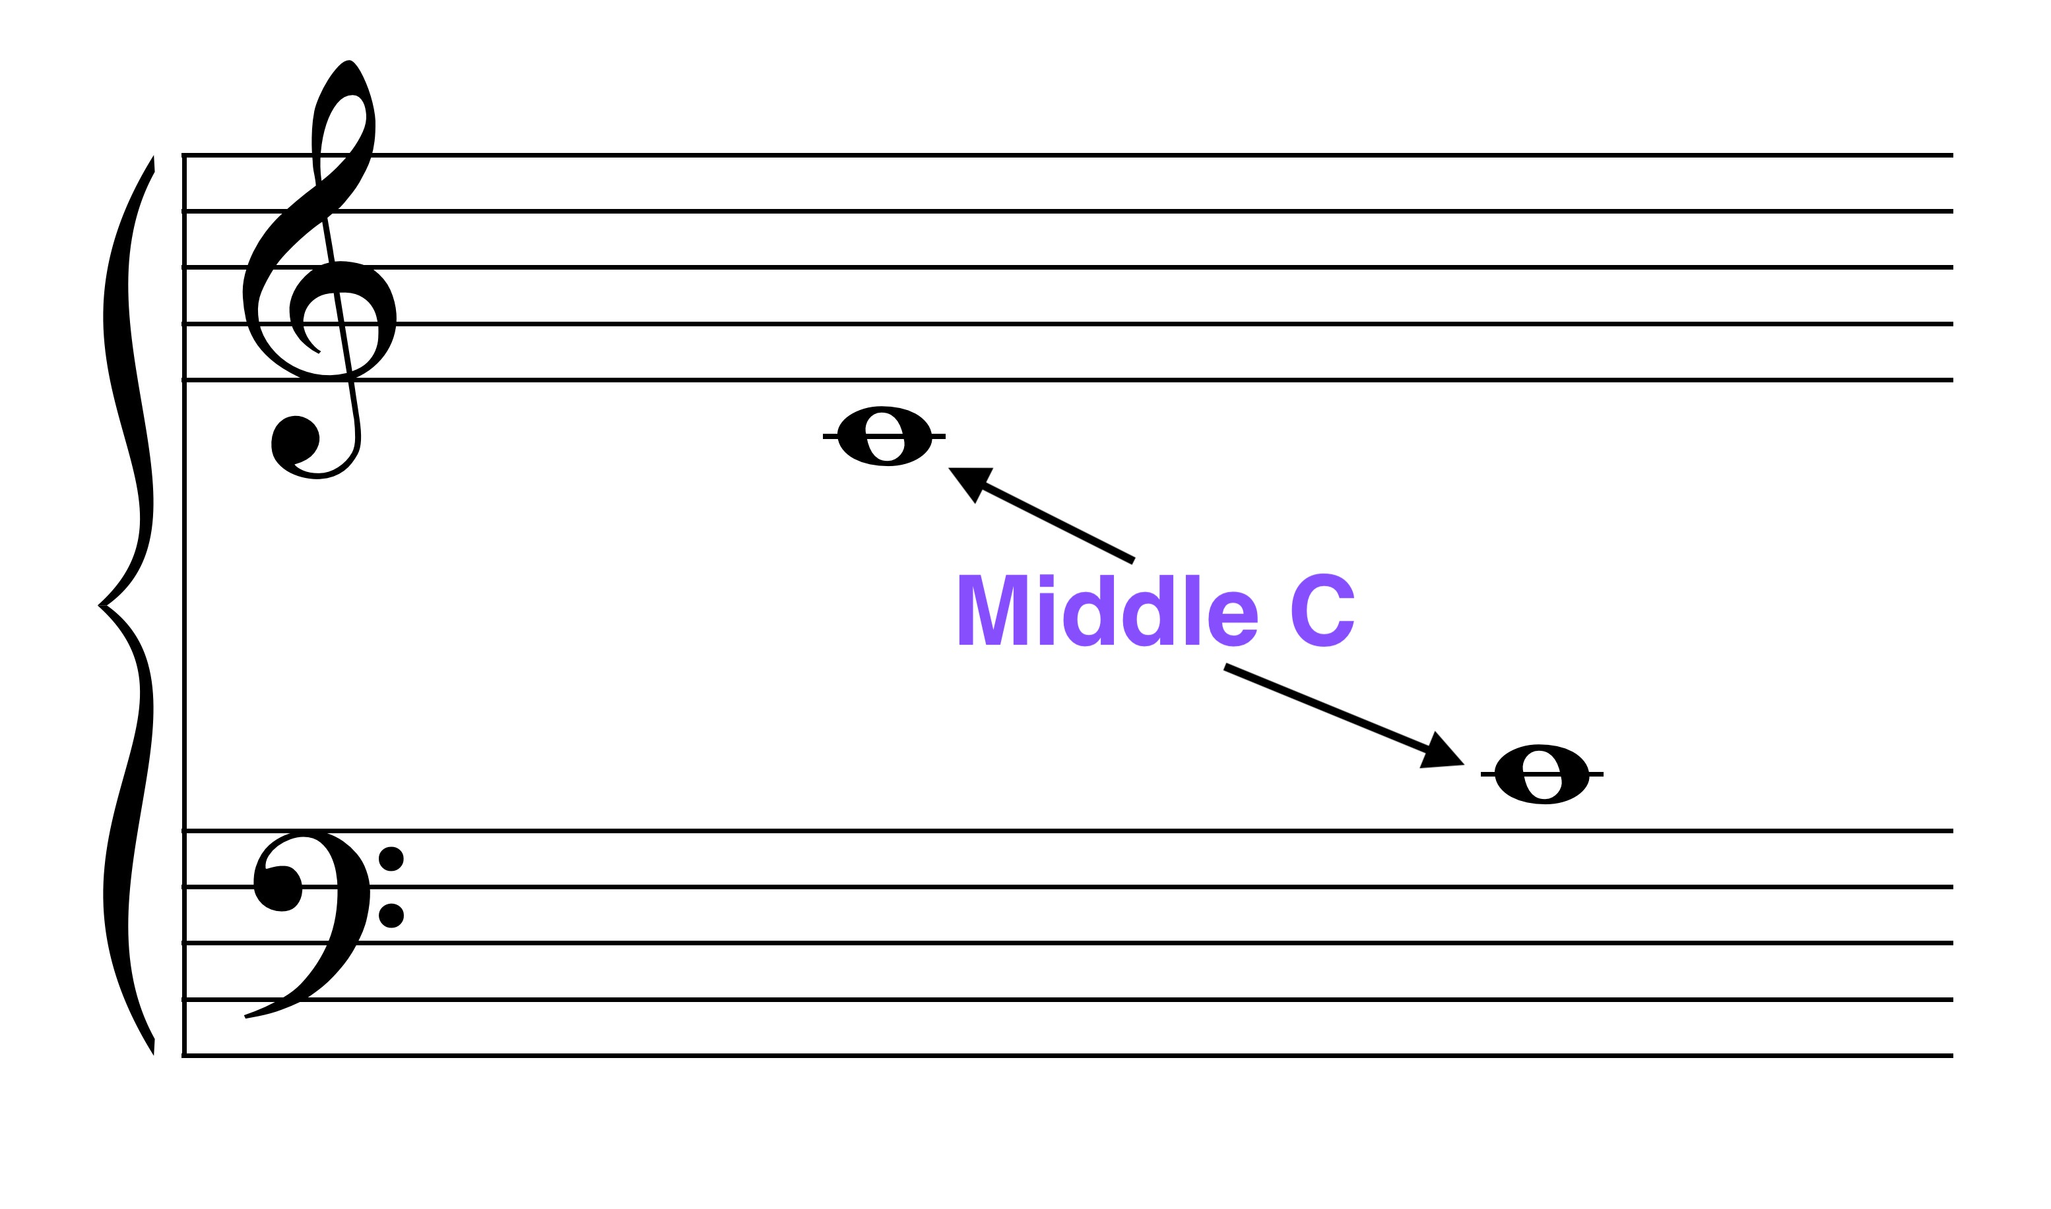

**Middle C** is the C that is in the middle of the grand staff -- above the bass clef and below the treble clef -- and in the center of the piano keyboard.

**Notes and Piano Keyboard:**

On the piano keyboard, the key that is C is the white key to the left of the group of two black notes.

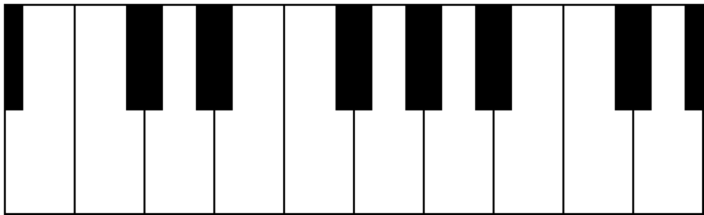

B C D E F G A B C D

The other white keys are, to the right of C, D-E-F-G-A-B in order. The keys repeat at the **octave** (or eight keys later).

**Half and whole steps:**

Any two notes that are represented by two adjacent piano keys (e.g., B-C and E-F) make up an interval known as a **half-step**.

Any notes that are played by two keys on the piano that have one other key in between them make up an interval called a **whole-step** (e.g., D-E, F-G, G-A, A-B).

**Accidentals:**

We can alter notes by means of accidentals:

double-sharp (x) - raises a pitch a whole-step

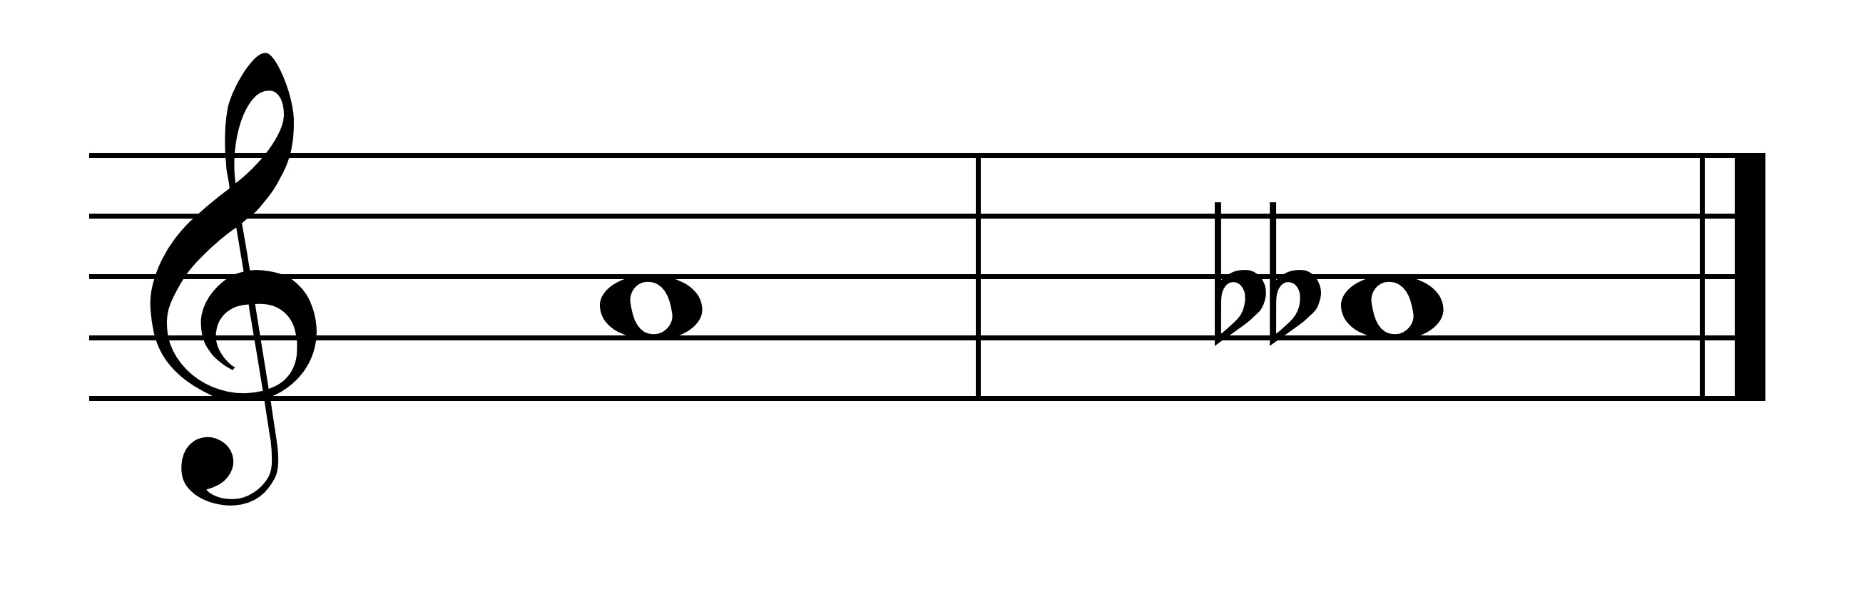

sharp (#) - raises a pitch a half step

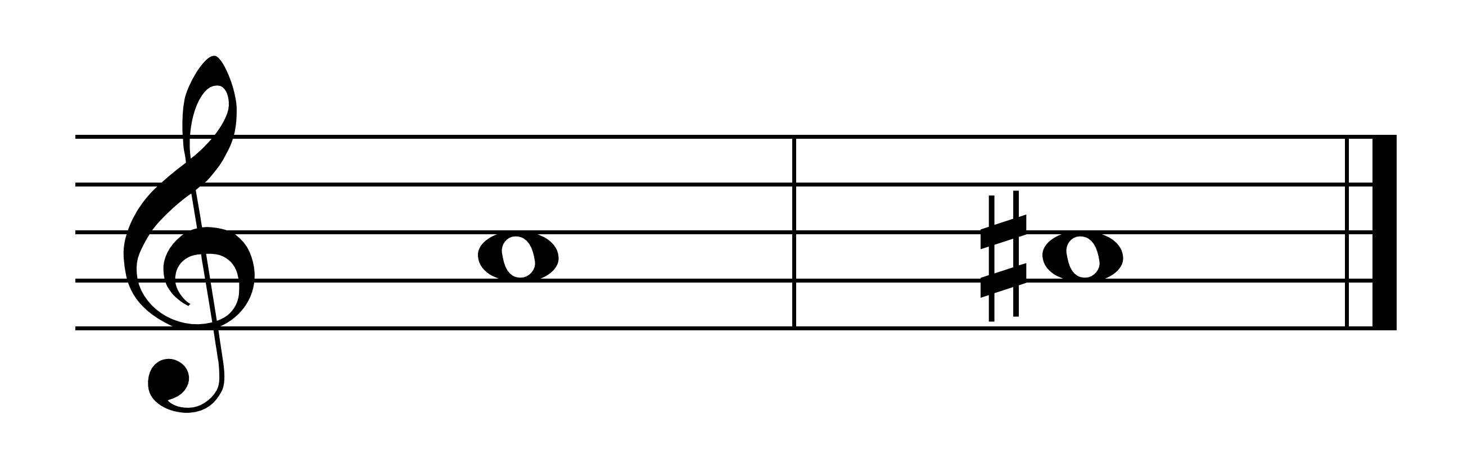

natural N- changes pitch back to the basic note; cancels a sharp or flat

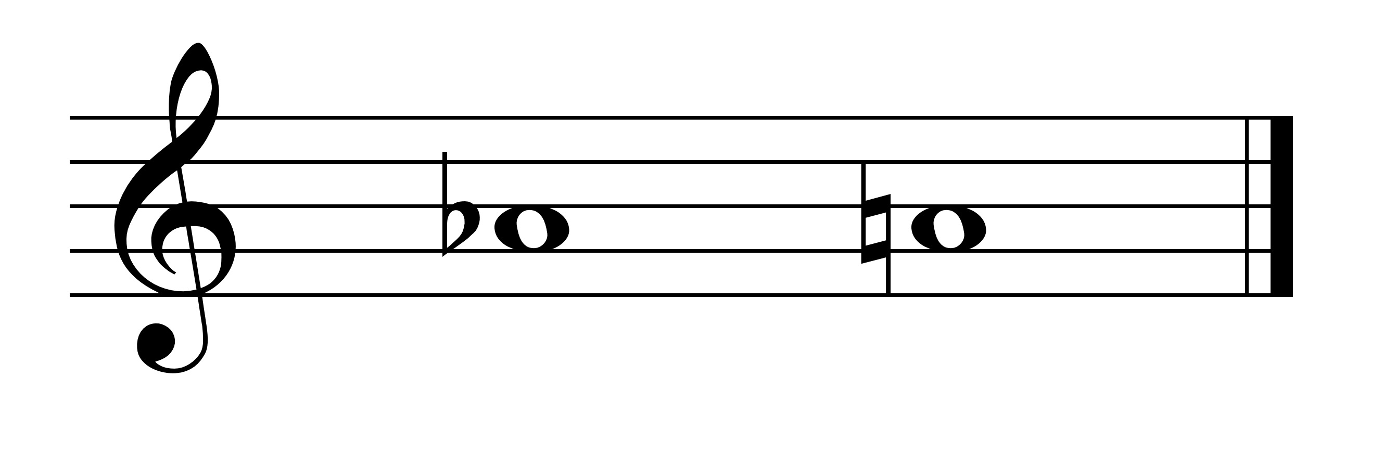

flat ( b )- lowers a pitch a half-step

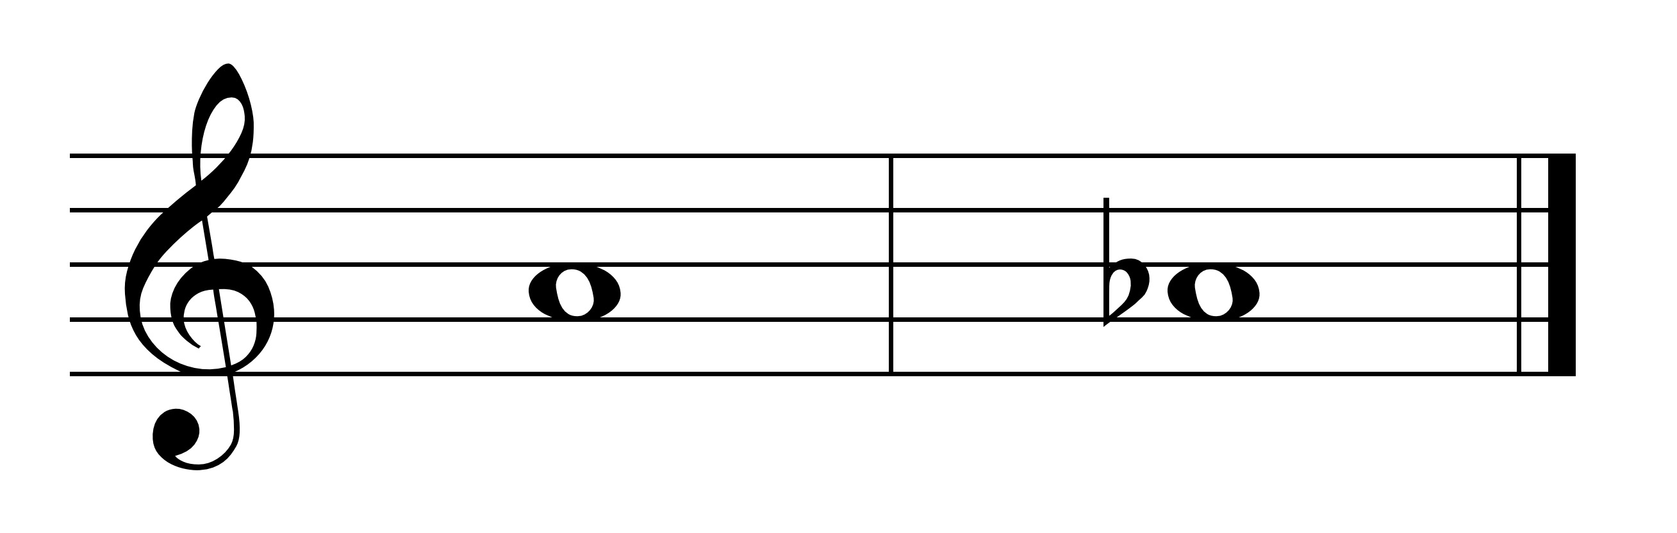

double-flat (bb) - lowers a pitch a whole-step



Some examples of these accidentals and the notes they correspond to on the piano keyboard are shown below:

C C# Cx Fb F F# Fx Bbb Bb B

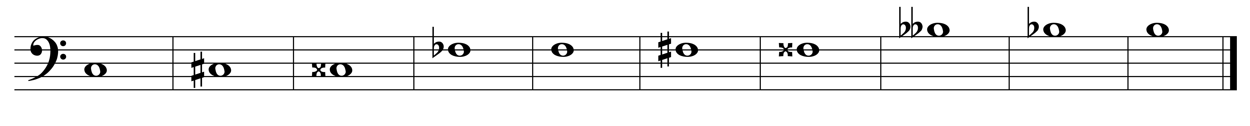

C# F# Bb



C Cx Fb F Fx Bbb B

**Enharmonic notes:**

Some keys have two names (e.g., Cx = D, Fb = E, Fx = G, Bbb = A). These notes are known as **enharmonic notes** - two notes/pitches that sound alike but are written differently.

**Tone, note, pitch:**

Please keep in mind the difference between a tone, pitch and note.

* A **tone** is a sound.
* A **pitch** is a sound that we can name (e.g., A, G#).
* A **note** is the written symbol.