**The Neapolitan Chord**

**(Phrygian II)**

**Definition**

The Neapolitan chord is a major triad built on the lowered second scale degree (b2). It is indicated in analysis as N.

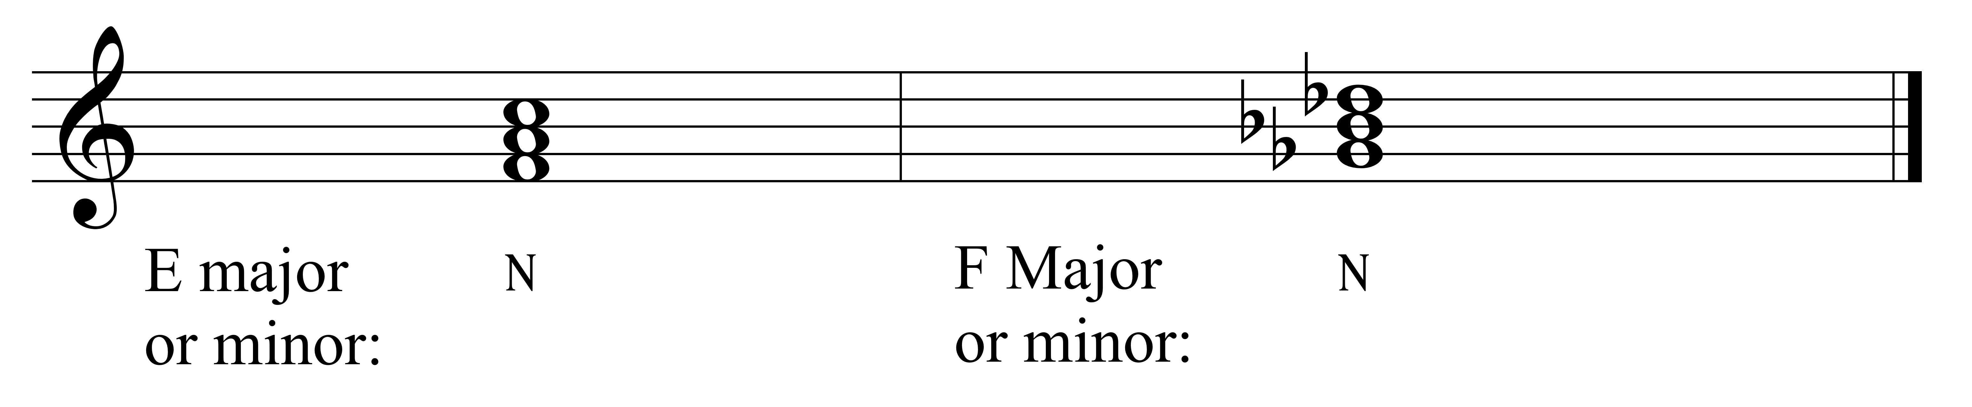

It is often found in minor mode but may also be found in major. It most often appears in first inversion, so is most often referred to as the Neapolitan (N) sixth (for ).

It can be thought of as a borrowed chord; borrowed from Phrygian mode on the same tonic as the key.

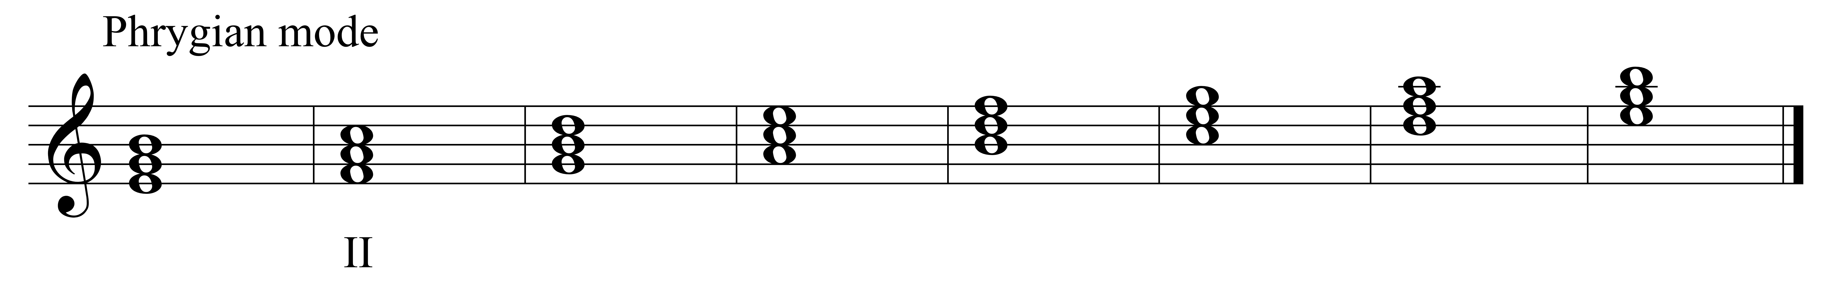

**Function**:

The Neapolitan chord is a pre-dominant chord (i.e., it leads to a dominant function chord).

It may also serve as a pivot chord in modulations where it is the N in one key and a major triad in the other key.

**Resolution**:

Being a pre-dominant chord, the N proceeds to a dominant functioning chord.

Direct to V:

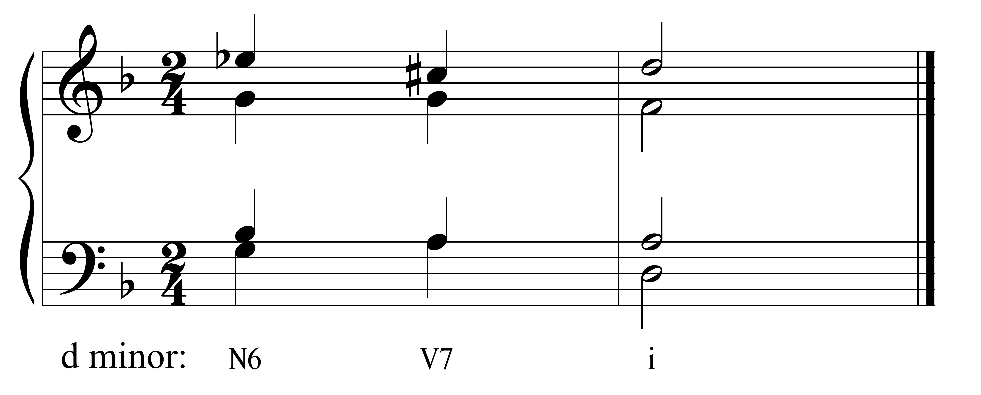

To V $\left(\begin{matrix}6 & 5 \\ 4 & 3\end{matrix}\right)$:

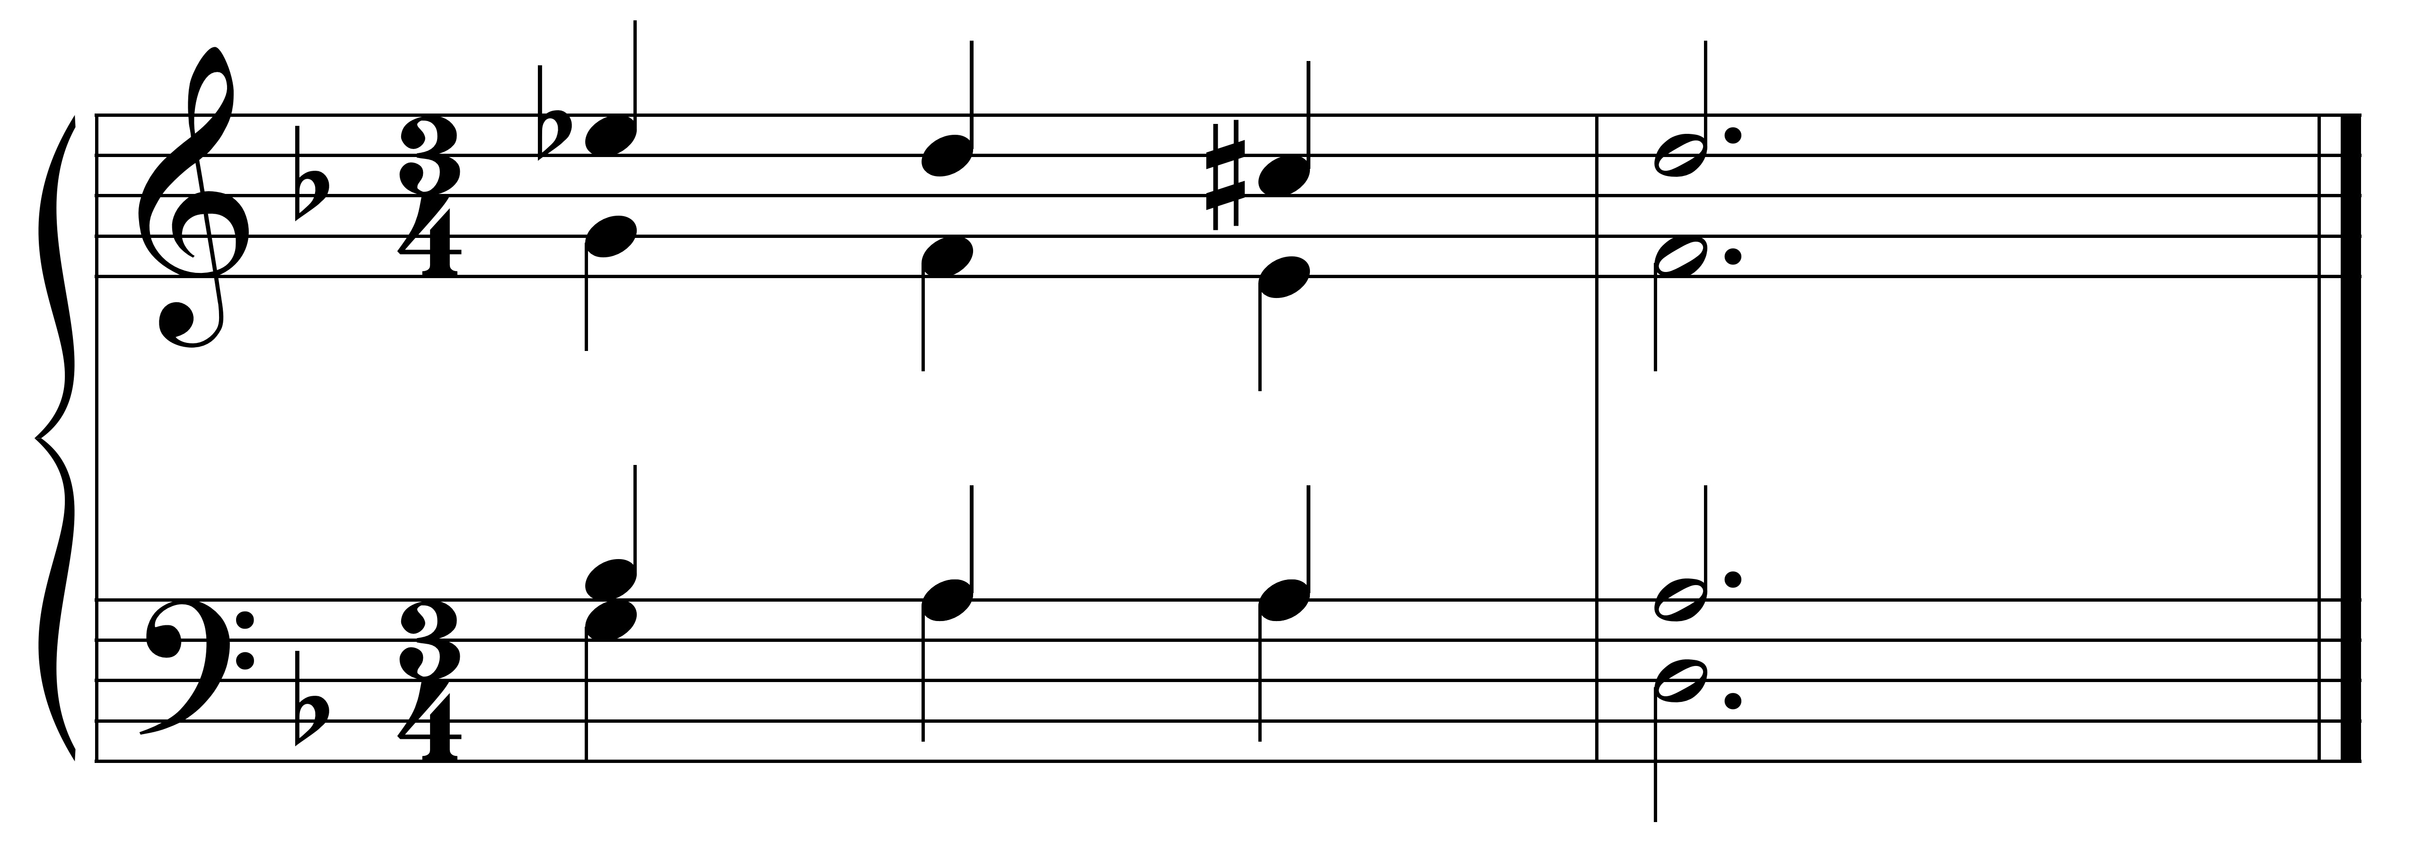

D minor: N6 V $\left(\begin{matrix}6- & 5 \\ 4- & 3\end{matrix}\right)$ i

Less often, it resolves to other chords as part of a chromatic line.

It may be followed by a dominant of the dominant (viio7/V or V7/V).

**Part-Writing**:

* Always double the third of the chord, since it is the unaltered tone.
* Try to use the chord in first inversion, so an unaltered tone is in the bass voice.
* Resolve the b2 down by step (in the direction of its inflection).

*If resolving to the Cadential 6/4:*

* Keep the root of the Neapolitan higher than the fifth of the chord in order to avoid parallel fifths.



D minor: N6 V $\left(\begin{matrix}6- & 5 \\ 4- & 3\end{matrix}\right)$ i

*If resolving directly to the V:*

* It is permitted to write a diminished 3rd interval between the b2 and the 7 in the key; it is best to put this motion in an outer voice.



Be careful to avoid the A2 interval when approaching or leaving this chord. The N is usually preceded by a VI, IV, or II.

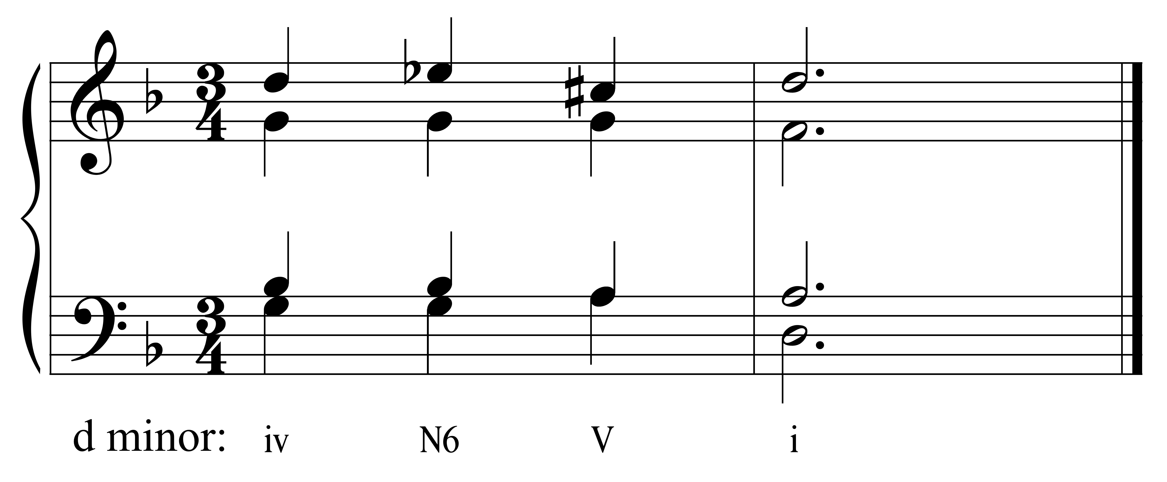

It may also be preceded by a secondary dominant (V/N = bVI).