**Modulation**[1]

**Definition:**

Modulation is the process of changing keys or the result of the change in keys.

Modulation takes places within a composition or a movement of a composition.

A modulation requires that the new key is established (i.e., the old key does not return right away; usually more than a phrase in length). There needs to be a cadence in the new key.[2]

**Background:**

Modulation became practical with the advent of the equal temperament system of tuning.

Modulation requires the ability of the listener to remember the old key and be able to compare it with the current key.

**Key Relationships:**

***Enharmonically Equivalent Keys:***

Two keys that sound the same but are written differently.

A change of key between two enharmonically equivalent keys is not a modulation since the tonic has not changed.

***Parallel Keys:***

A change between major and minor modes with the same tonic.

Since the tonic has not changed, no modulation has taken place. This is called a change of mode.

***Relative Keys:***

A change of key between major and minor keys with the same key signature.

Since the tonic has changed, this is called a modulation.

***Closely Related Keys:***

Keys that differ by no more than one sharp or flat from the original key.

There are five closely related keys to any given key.

Given a major key (think of this key as I / tonic), the closely related keys can be thought of as ii, iii, IV, V, vi.

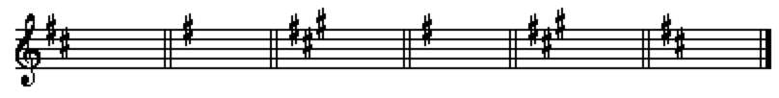

D: (I) e: (ii) f#: (iii) G: (IV) A: (V) b: (vi)

Given a minor key (think of the given key as vi of a major key), the closely related keys can be thought of as V, IV, iii, ii, I of the major key.

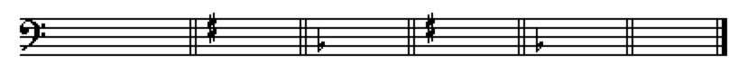

a: (vi) G: (V) F: (IV) e: (iii) d: (ii) C: (I)

The most common modulations that occur are from a major key to its dominant (I-V) and from a minor key to its relative major (i-III).

***Foreign Keys:***

All key relationships that are not enharmonic, parallel, relative, or closely related are called foreign relationships. Such key relationships are usually distantly related.

**Types of Modulation:**

***Pivot / Common Chord Modulation:***

Pivot or common chord modulation is the most frequent type of modulation.

This type of modulation is accomplished by means of a chord that is spelled the same in both the old and new keys but has one function in the old key and another function in the new key -- the common chord or pivot chord.

The pivot chord is usually the chord prior to the first chromatic alteration indicating the new key.

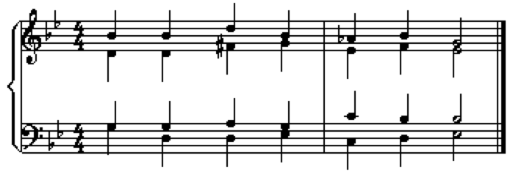

Most common chord modulations are between closely related keys.

Common chord modulations to foreign keys often require the use of an altered chord as a pivot chord (eg., a V/V in one key and a V in the other key).

**Chord Search**:

A chord search can be used to list all the possible ways a given chord can function as a pivot chord.

To perform a chord search:

1. Determine the quality of the given chord.

2. List all the functions of that quality of chord in both major and minor keys.

3. Determine the keys in which the given chord would have these functions.

Sample chord searches for each quality triad are shown below.

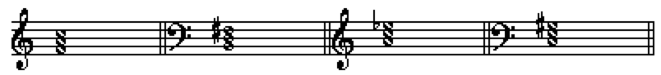

F: I A: ii Bb: viio a: III+

C: IV G: iii bb: viio

Bb: V D: vi g: iio

bb: V b: i

a: VI f#: iv

d: III

***Pivot tone modulation:***

Similar to the pivot / common chord modulation except that the pivot consists of a single tone instead of a chord.

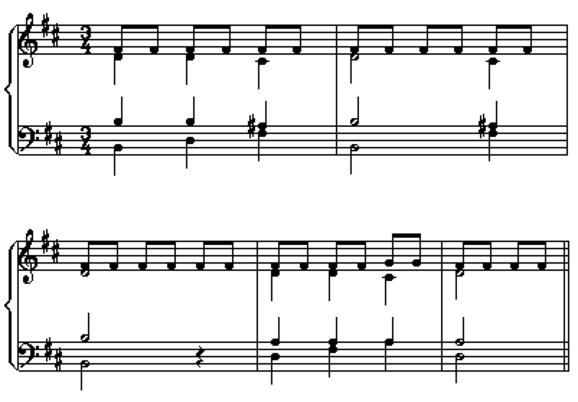

***Phrase / Direct modulation (Shift):***

A phrase or direct modulation is an abrupt change of key.

It is called a phrase modulation when the modulation occurs at the end/beginning of a phrase (the most usual case); one phrase ends in the old key and the next phrase begins in a new key.

In a phrase / direct modulation there is no pivot chord.

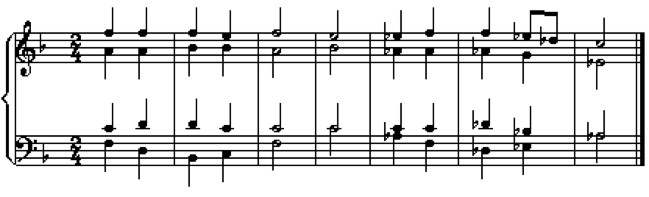

***Sequential Modulation:***

A modulation that comes about through the use of a sequence (def: a repetition of melodic, harmonic, or rhythmic material at a different pitch level).

May be analyzed with a common chord, but the sequence is equally important in establishing the new key.

Many sequential modulations are short and so can be thought of as tonicizations.

***Chromatic Modulation:***

A chromatic modulation is a change of key brought about through a chromatic alteration of a note between two chords.

In a chromatic alteration, there is no pivot chord; neither the chord without or with the chromatic alteration can be analyzed in both the old and the new key.

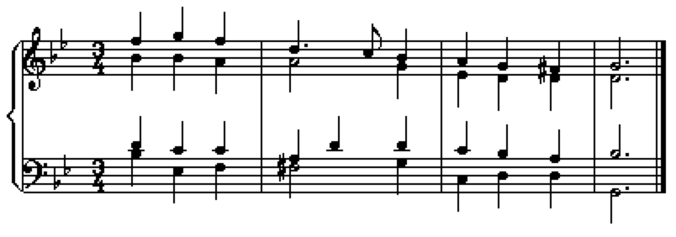

Chromatic modulation are used when the two keys involved are not closely related (i.e., remote keys).

1. Information for this handout was taken from: "Modulation," The New Harvard Dictionary of Music , Don Randel ed., Cambridge, Mass: Belknap Press of Harvard University Press, 1986, 503-505; "Chapter 14: Harmony: Modulation," Benward, Bruce and Gary White. Music in Theory and Practice, 5th ed. Vol 1, Madison, WI: Brown and Benchmark Publishers, 1993, 275-301, Chapter 18-19 of Kostka, Stefan and Dorothy Payne. Tonal Harmony with an Introduction to Twentieth-Century Music, 2nd ed. New York: Alfred A Knopf, 1989, 289-322.
2. A "modulation" that occurs within a phrase is called a tonicization; a modulation a phrase in length is called a false or intermediate modulation.