**OTHER SCALES**

*Chromatic Scale*

The scale consisting of all twelve notes occurring between any two pitches an octave apart.

The ascending form of the chromatic scale is usually written using sharps, and the descending version is usually written using flats.

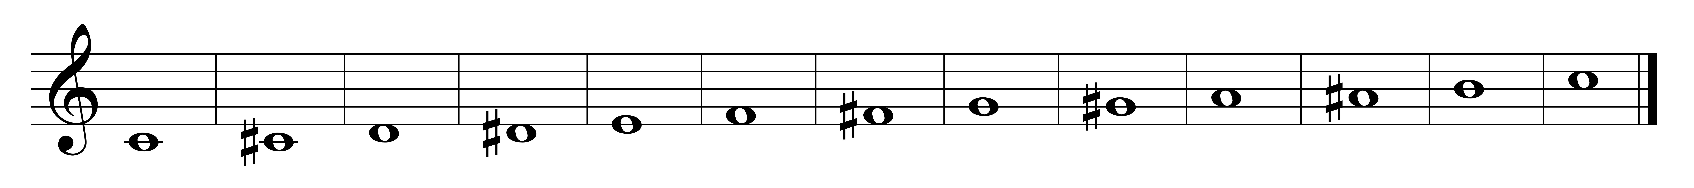

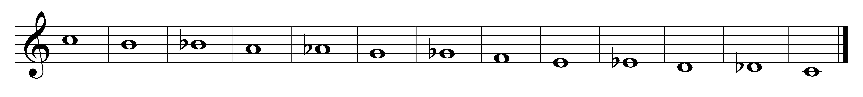

*MODES*

A selection of tones, arranged in stepwise motion, that form the basic tonal substance of a composition; basic scales (scales without any accidentals).

There are 7 modes:

Ionian

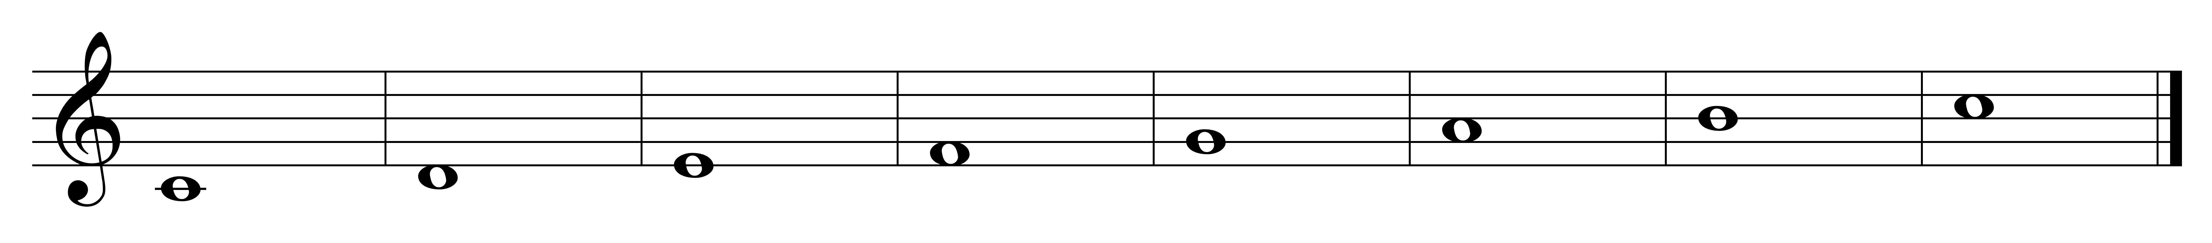

Dorian

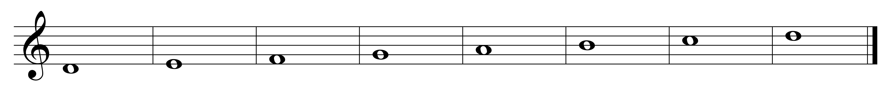

Phrygian

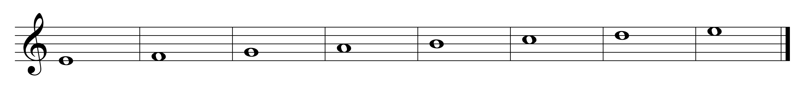

Lydian

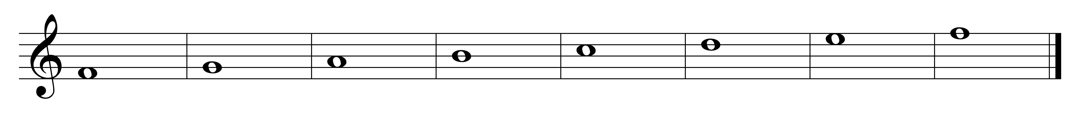

Mixolydian

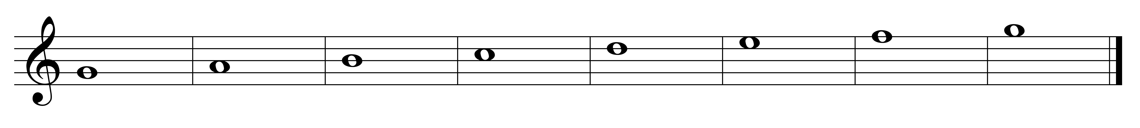

Aeolian

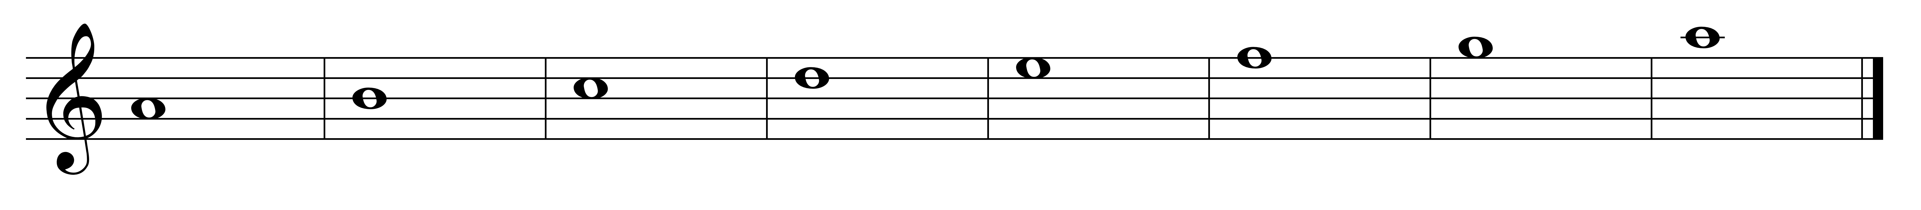

Locrian

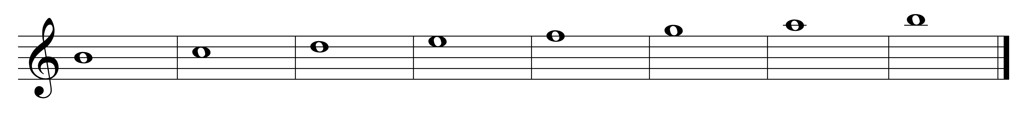

**History:**

The names of the modes are derived from the Church modes. Dorian, Phrygian, Lydian, and Mixolydian date from about the 8th century. Ionian and Aeolian were added to the system by the theorist Glareanus in his treatise, *Dodekachordon* (1547). Locrian mode was only a theoretical possibility and not used because of the tritone between the final (tonic) and the fifth. The Church modes served as the tonal basis of Western music until about 1600, after which time the major and minor scales were used more extensively.

**Content:**

Modes may be thought of in 3 ways:

*by their half- and whole- step content:*

Ionian: W-W-H-W-W-W-H

Dorian: W-H-W-W-W-H-W

Phrygian: H-W-W-W-H-W-W

Lydian: W-W-W-H-W-W-H

Mixolydian: W-W-H-W-W-H-W

Aeolian: W-H-W-W-H-W-W

Locrian: H-W-W-H-W-W-W

*as variations of the major and minor scales:*

Ionian: same as major

Dorian: minor with #6

Phrygian: minor with b2

Lydian: major with #4

Mixolydian: major with b7

Aeolian: same as natural minor

Locrian: minor with b2 and b5

*as a major scale degree to its octave:*

Ionian: 1-1

Dorian: 2-2

Phrygian: 3-3

Lydian: 4-4

Mixolydian: 5-5

Aeolian: 6-6

Locrian: 7-7

The Solfege Syllables for the modes are --

Dorian = do-re-me-fa-sol-la-te-do

Phrygian = do-ra-me-fa-sol-le-te-do

Lydian = do-re-mi-fi-sol-la-ti-do

Mixolydian = do-re-mi-fa-sol-la-te-do

Locrian = do-ra-me-fa-se-le-te-do

*MODE COMBINATION*

Debussy particularly interested in the Lydian-Mixolydian mode: a major scale with a #4 and a b7.

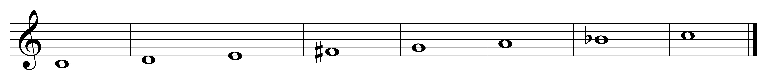

This scale results from the juxtaposition of 2 Mm7 chords with roots a whole step apart.

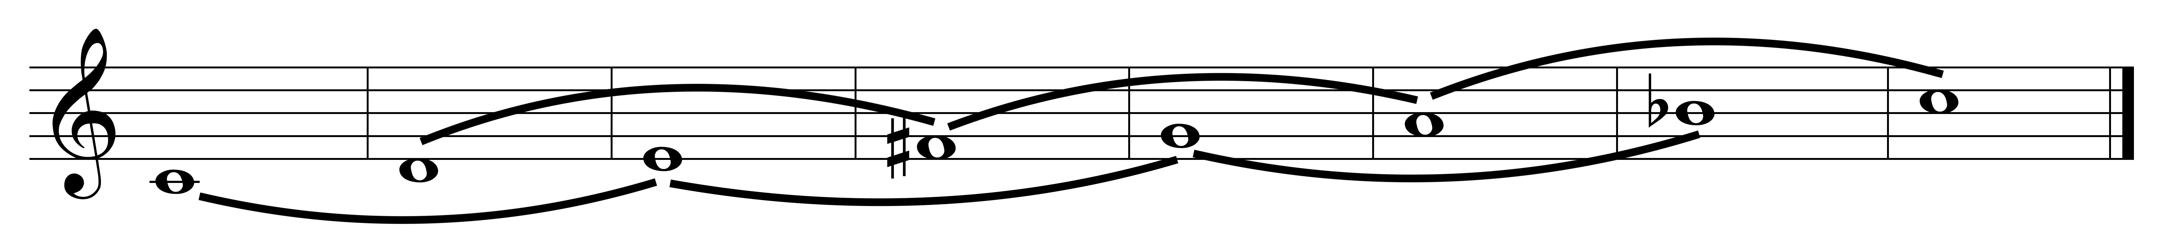

*PENTATONIC (5-note) SCALES*

**Diatonic (anhemitonic):** five note scale with no semi-tones. Example: black notes on a piano keyboard; 1, 2, 3, 5 6 of a major scale

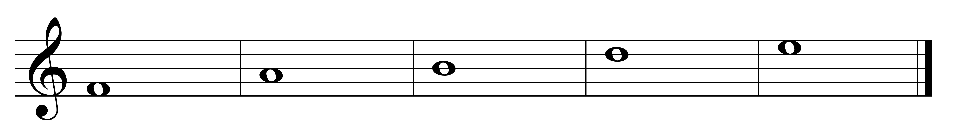

**Semitonal (hemitonish, Hirajoshi):** results from omitting the 2 and 6 or 2 and 5 degrees of the diatonic scale; 1, 2, 3, 5, 6 of a minor scale

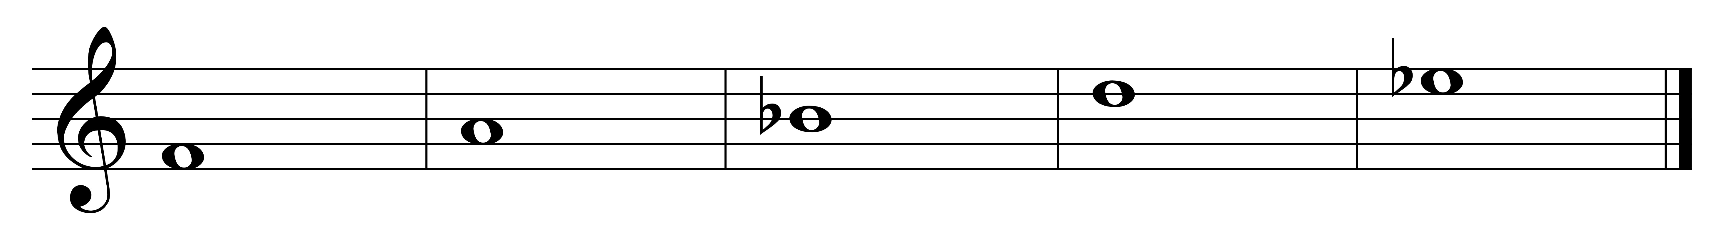

*WHOLE-TONE SCALE*

a six-note scale consisting of whole-tones only. Only 2 such scales exist. One example is given below:

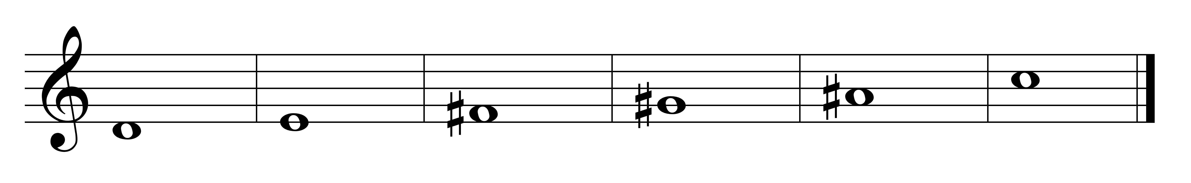

*OCTATONIC (DIMINISHED) SCALE*

May be thought of as altering half and whole steps.

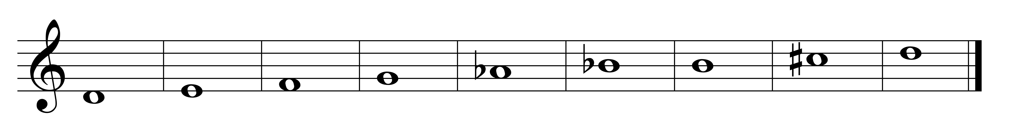

Derived from the superimposition of 2 diminished 7th chords at the interval of a half or whole-step.

*MYSTIC SCALE*

derived from the notes of Scriabin's mystic chord.

