**MAJOR AND MINOR SCALES**

*Half and Whole steps:*

**half-step** - two keys (and therefore notes/pitches) that are adjacent on the piano keyboard

**whole-step** - two keys (and therefore notes/pitches) that have another key in between

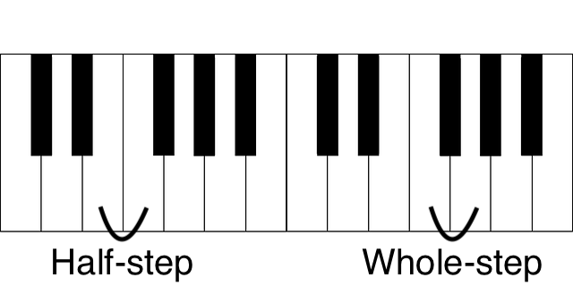

**chromatic half-step** -- a half step written as two of the same note with different accidentals (e.g., F-F#)

**diatonic half-step** -- a half step that uses two different note names (e.g., F#-G)

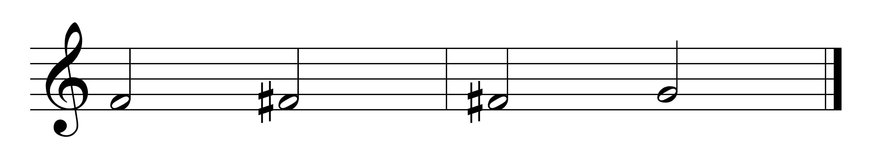

chromatic half step diatonic half step

*SCALES:*

A **scale** is a stepwise arrangement of notes/pitches contained within an octave.

Major and minor scales contain seven notes or scale degrees.

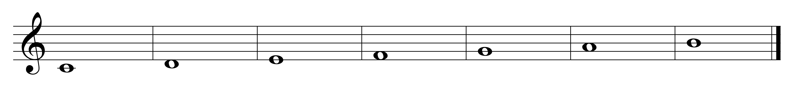

A **scale degree** is designated by an Arabic numeral which indicates the position of the note within the scale.

Each scale degree also has a name and solfege syllable:



1 2 3 4 5 6 7

*do re mi fa sol la ti*

Tonic Supertonic Mediant Subdominant Dominant Submediant Leading

Tone

|  |  |  |
| --- | --- | --- |
| **scale degree** | **name** | **solfege** |
| 1 | tonic | do |
| 2 | supertonic | re |
| 3 | mediant | mi |
| 4 | subdominant | fa |
| 5 | dominant | sol |
| 6 | submediant | la |
| 7 | leading tone | ti |

*major scales:*

A major scale is a scale that has half steps (H) between scale degrees 3-4 and 7-8 and whole steps between all other pairs of notes.

1 2 3 4 5 6 7 8

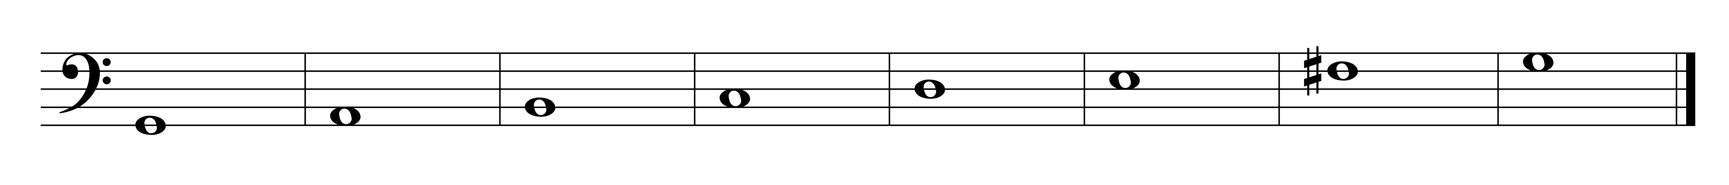

W W H W W W H

*tetrachords:*

A **tetrachord** is a group of four notes in a scale.

There are two tetrachords in the major scale, each with the same order half- and whole-steps (W-W-H).

Therefore, a tetrachord consisting of W-W-H can be the top tetrachord or the bottom tetrachord of a major scale. For example, G-A-B-C can be the bottom tetrachord of the G major scale or the top tetrachord of the C major scale.

Tetrachord:

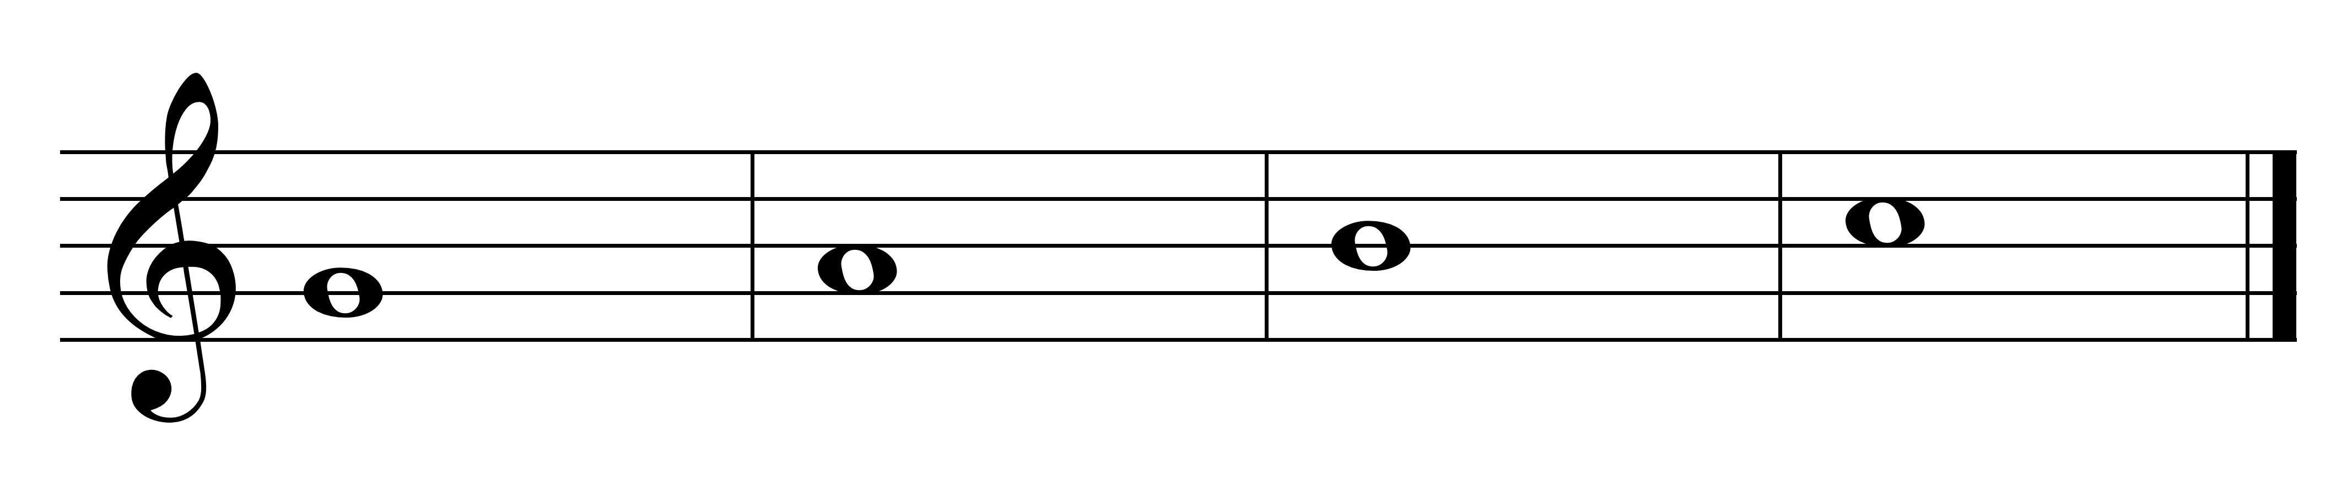

G A B C

Scales:

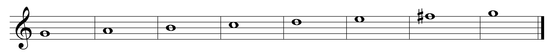

G A B C

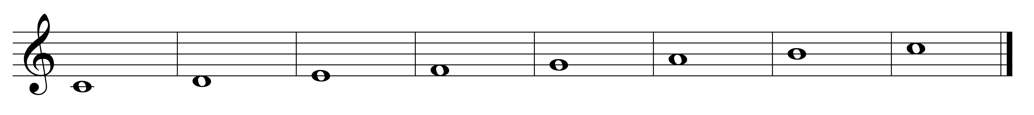

G A B C

*minor scales:*

There are 3 forms of minor scales: natural, harmonic and melodic.

**Natural Minor scale** -- a scale that contains half-steps between 2-3 and 5-6 scale degrees (the natural form).

1 2 3 4 5 6 7 8

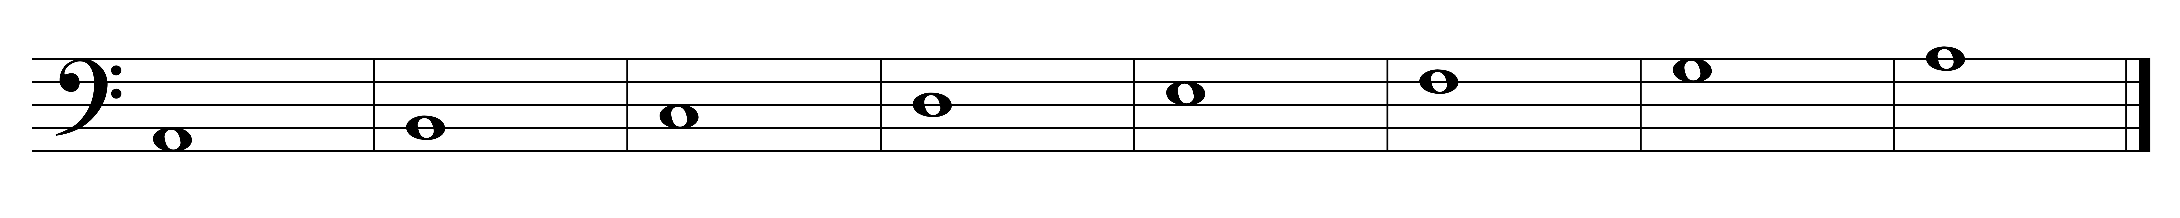

W H W W H W W

You can think of the natural minor scale as the 6th degree to the 6th degree of a major scale.

As with the major scale, each note has name/solfege syllable. The names/solfege syllables of the third, sixth and seventh degrees are different from major.

|  |  |  |
| --- | --- | --- |
| **scale degree** | **name** | **solfege** |
| 1 | tonic | do |
| 2 | supertonic | re |
| 3 | mediant | **me** |
| 4 | subdominant | fa |
| 5 | dominant | sol |
| 6 | submediant | **le** |
| 7 | **subtonic** | **te** |

**Harmonic minor scale** -- a form of a minor scale with half steps between 2-3, 5-6 and 7-8. Its unique interval is that between 6-7 -- the whole plus half step (or augmented 2nd).

1 2 3 4 5 6 7 8



W H W W H W+H H

It can be thought of as a natural minor scale with a raised 7 scale degree.

The 7th scale degree is raised to have a leading tone in the key; makes V-i sound as we expect.

It is called the harmonic minor scale since the seventh scale degree is changed to make the harmony V-i sound correct.

7th scale degree is called leading tone (ti) -- just as in the major scale.

|  |  |  |
| --- | --- | --- |
| **scale degree** | **name** | **solfege** |
| 1 | tonic / keynote | do |
| 2 | supertonic | re |
| 3 | mediant | me |
| 4 | subdominant | fa |
| 5 | dominant | sol |
| 6 | submediant | le |
| 7 | **leading tone** | **ti** |

**Melodic minor scale -** has 2 forms: ascending and descending.

This type of minor scale is called "melodic" because is it easier to sing; there is no augmented 2nd interval.

The ascending form has half steps between 2-3 and 7-8.

1 2 3 4 5 6 7 8

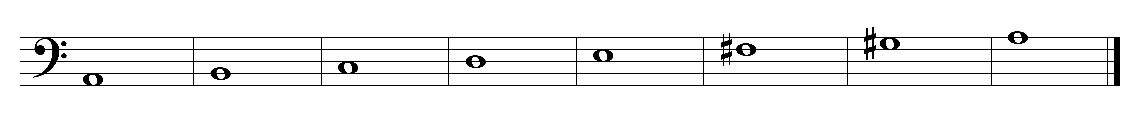

W H W W W W H

Its bottom tetrachord is the same as that from the natural minor scale, and the top tetrachord is the same as that from the major scale.

It can be thought of as harmonic minor with a raised 6th. The 6th scale degree is raised to alleviate the W+H step interval between 6-7 in harmonic minor.

The 6th scale degree is the submediant (la); the 7th scale degree is the leading tone (ti).

|  |  |  |
| --- | --- | --- |
| **scale degree** | **name** | **solfege** |
| 1 | tonic | do |
| 2 | supertonic | re |
| 3 | mediant | me |
| 4 | subdominant | fa |
| 5 | dominant | sol |
| 6 | submediant | **la** |
| 7 | **leading tone** | **ti** |

The descending form:

8 7 6 5 4 3 2 1

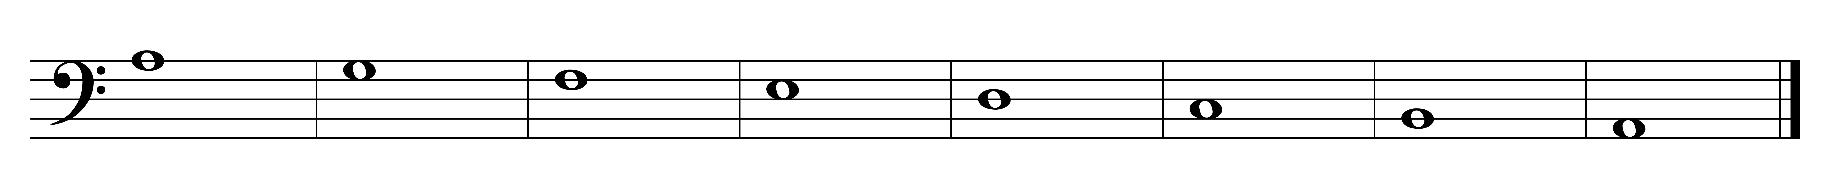

W W H W W H W

has half steps between 2-3, 5-6 (the same as the natural minor scale).

The 6th scale degree is the submediant (le); the 7th scale degree is subtonic (te).

|  |  |  |
| --- | --- | --- |
| **scale degree** | **name** | **solfege** |
| 1 | tonic | do |
| 2 | supertonic | re |
| 3 | mediant | me |
| 4 | subdominant | fa |
| 5 | dominant | sol |
| 6 | submediant | **le** |
| 7 | **subtonic** | **te** |

*Scale relationships:*

Major and minor scales may be relative or parallel.

**Relative major and minor scales** share the same key signature but start on different notes. (e.g., C major and a minor)





Key signature for both C major and A minor:

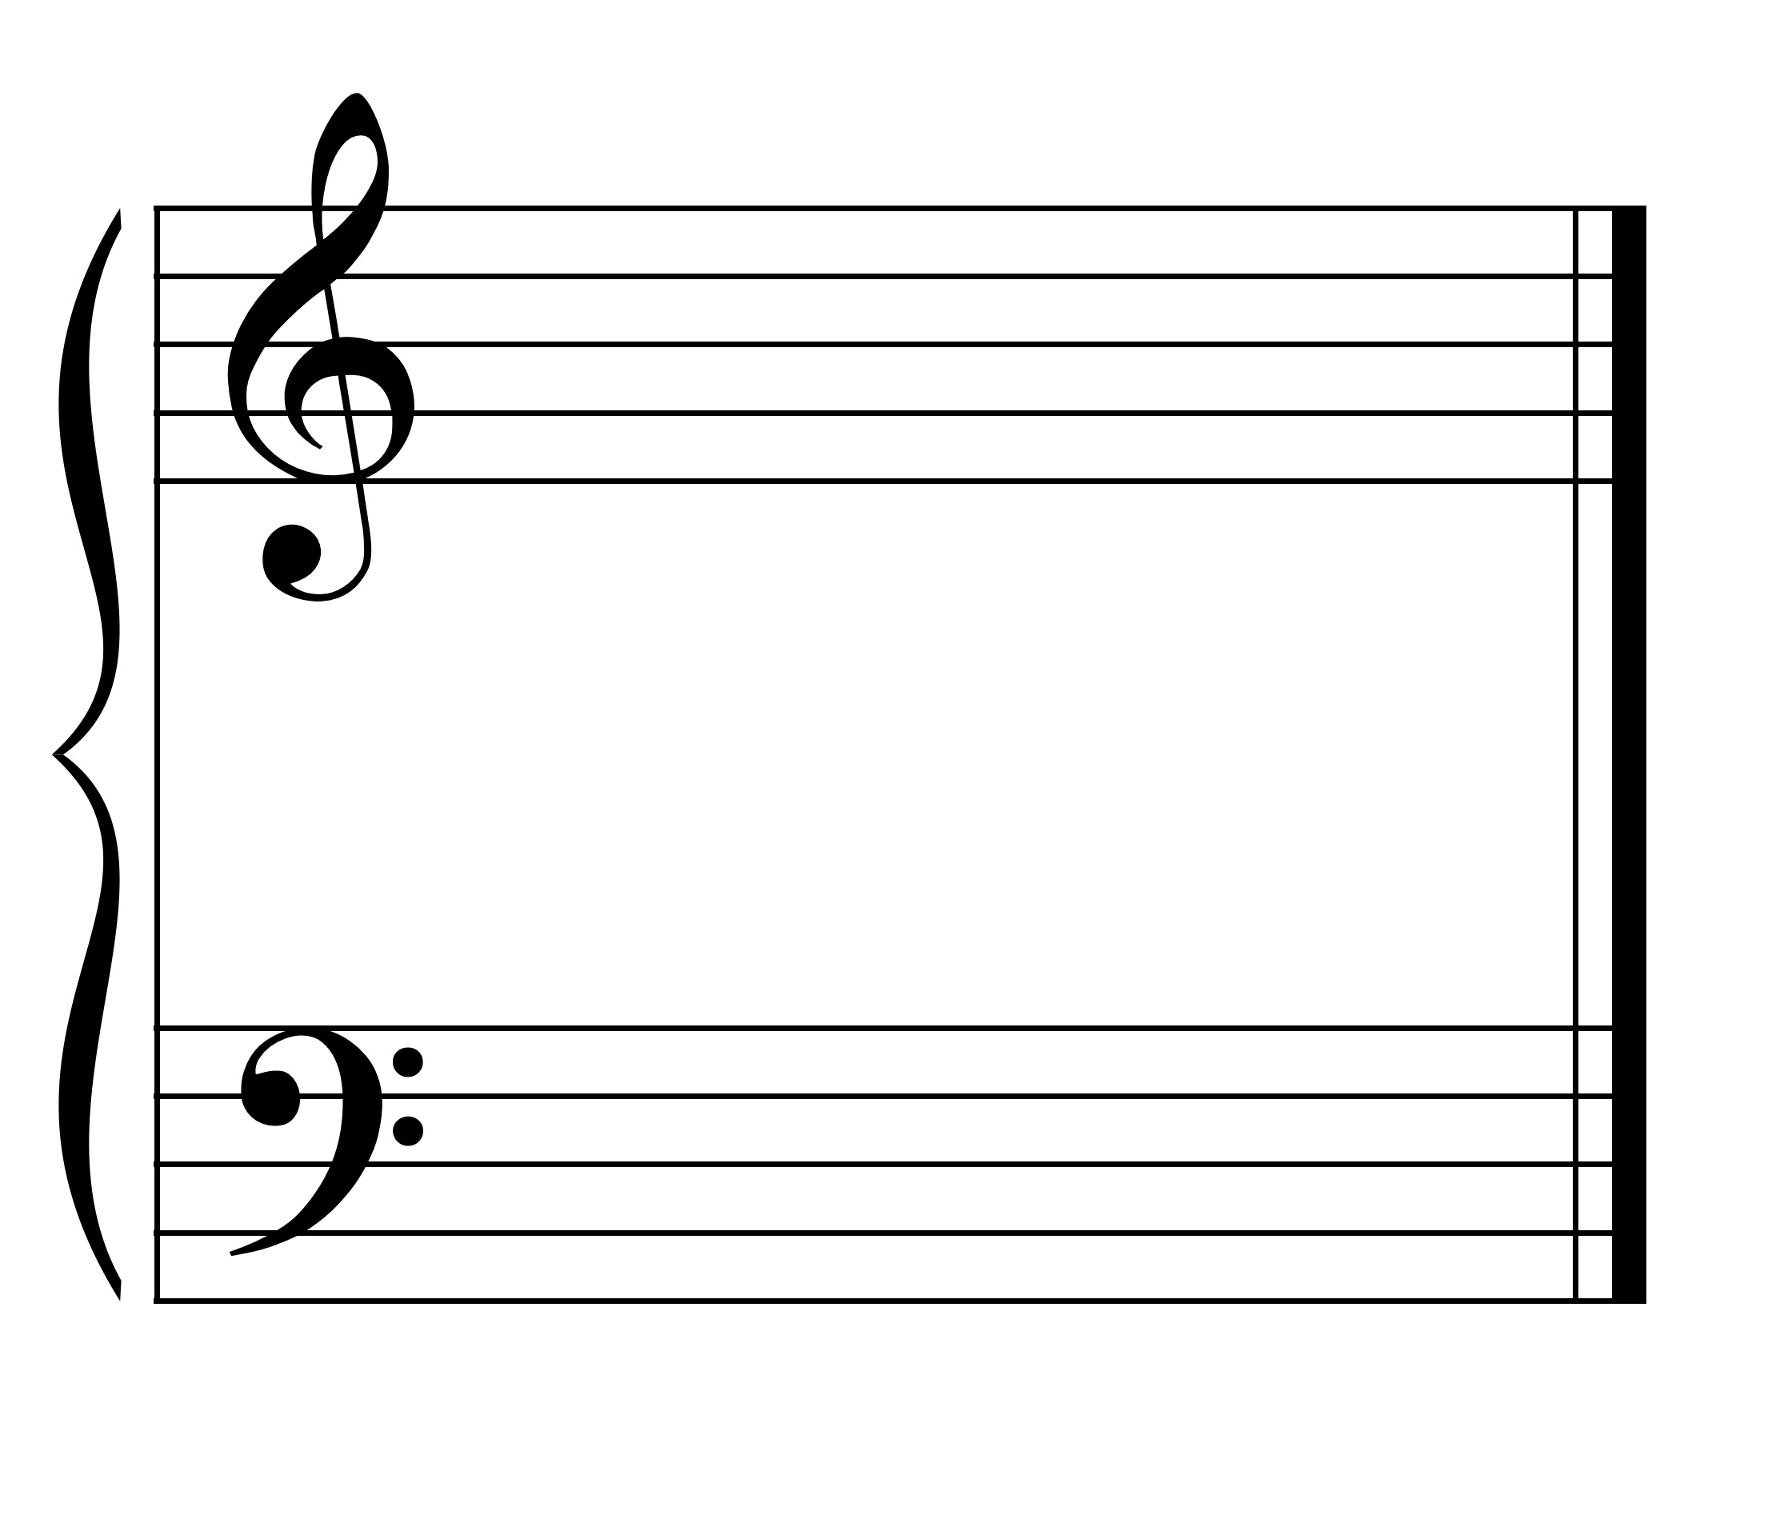

**Parallel major and minor** scales have the same starting note but different key signatures. (e.g., C major and c minor)



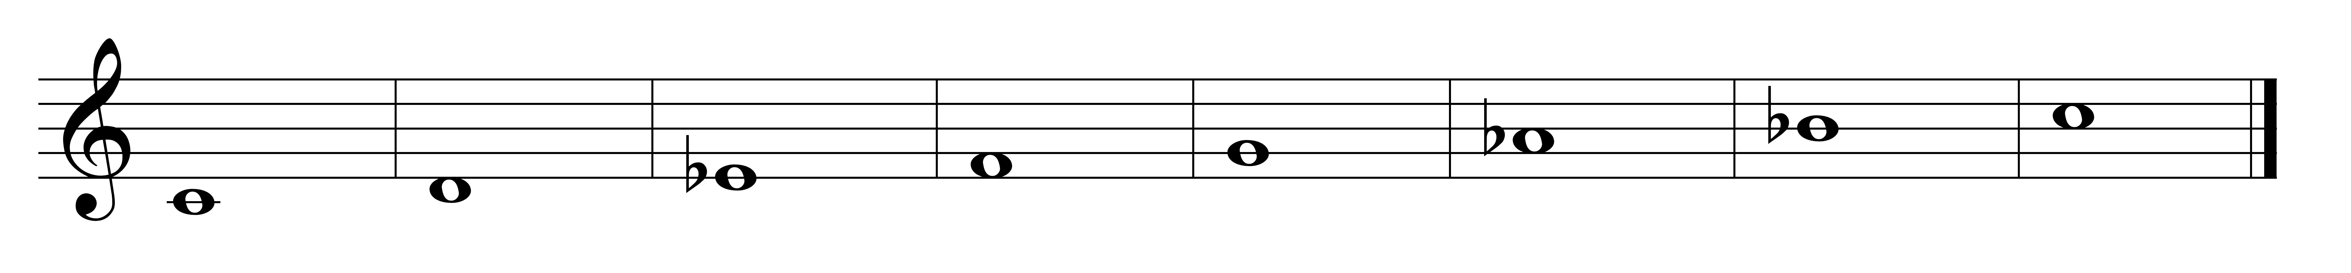

Key signature for C major:



Key signature for C minor:

