**KEY SIGNATURES**

*key signatures:*

Are used to eliminate the need for repeated accidentals within a composition.

The **key signature** is that group of sharps and flats (or lack thereof) after the clef on the staff; indicates the tonal center of the piece.

The **tonal center** is the pitch to which the piece gravitates.

To make the key signature, take the accidentals in the major or natural minor form of the scale and put them at the beginning of the staff.

The sharps or flats in the key signature are always in the same order:

**Order of sharps**: FCGDAEB

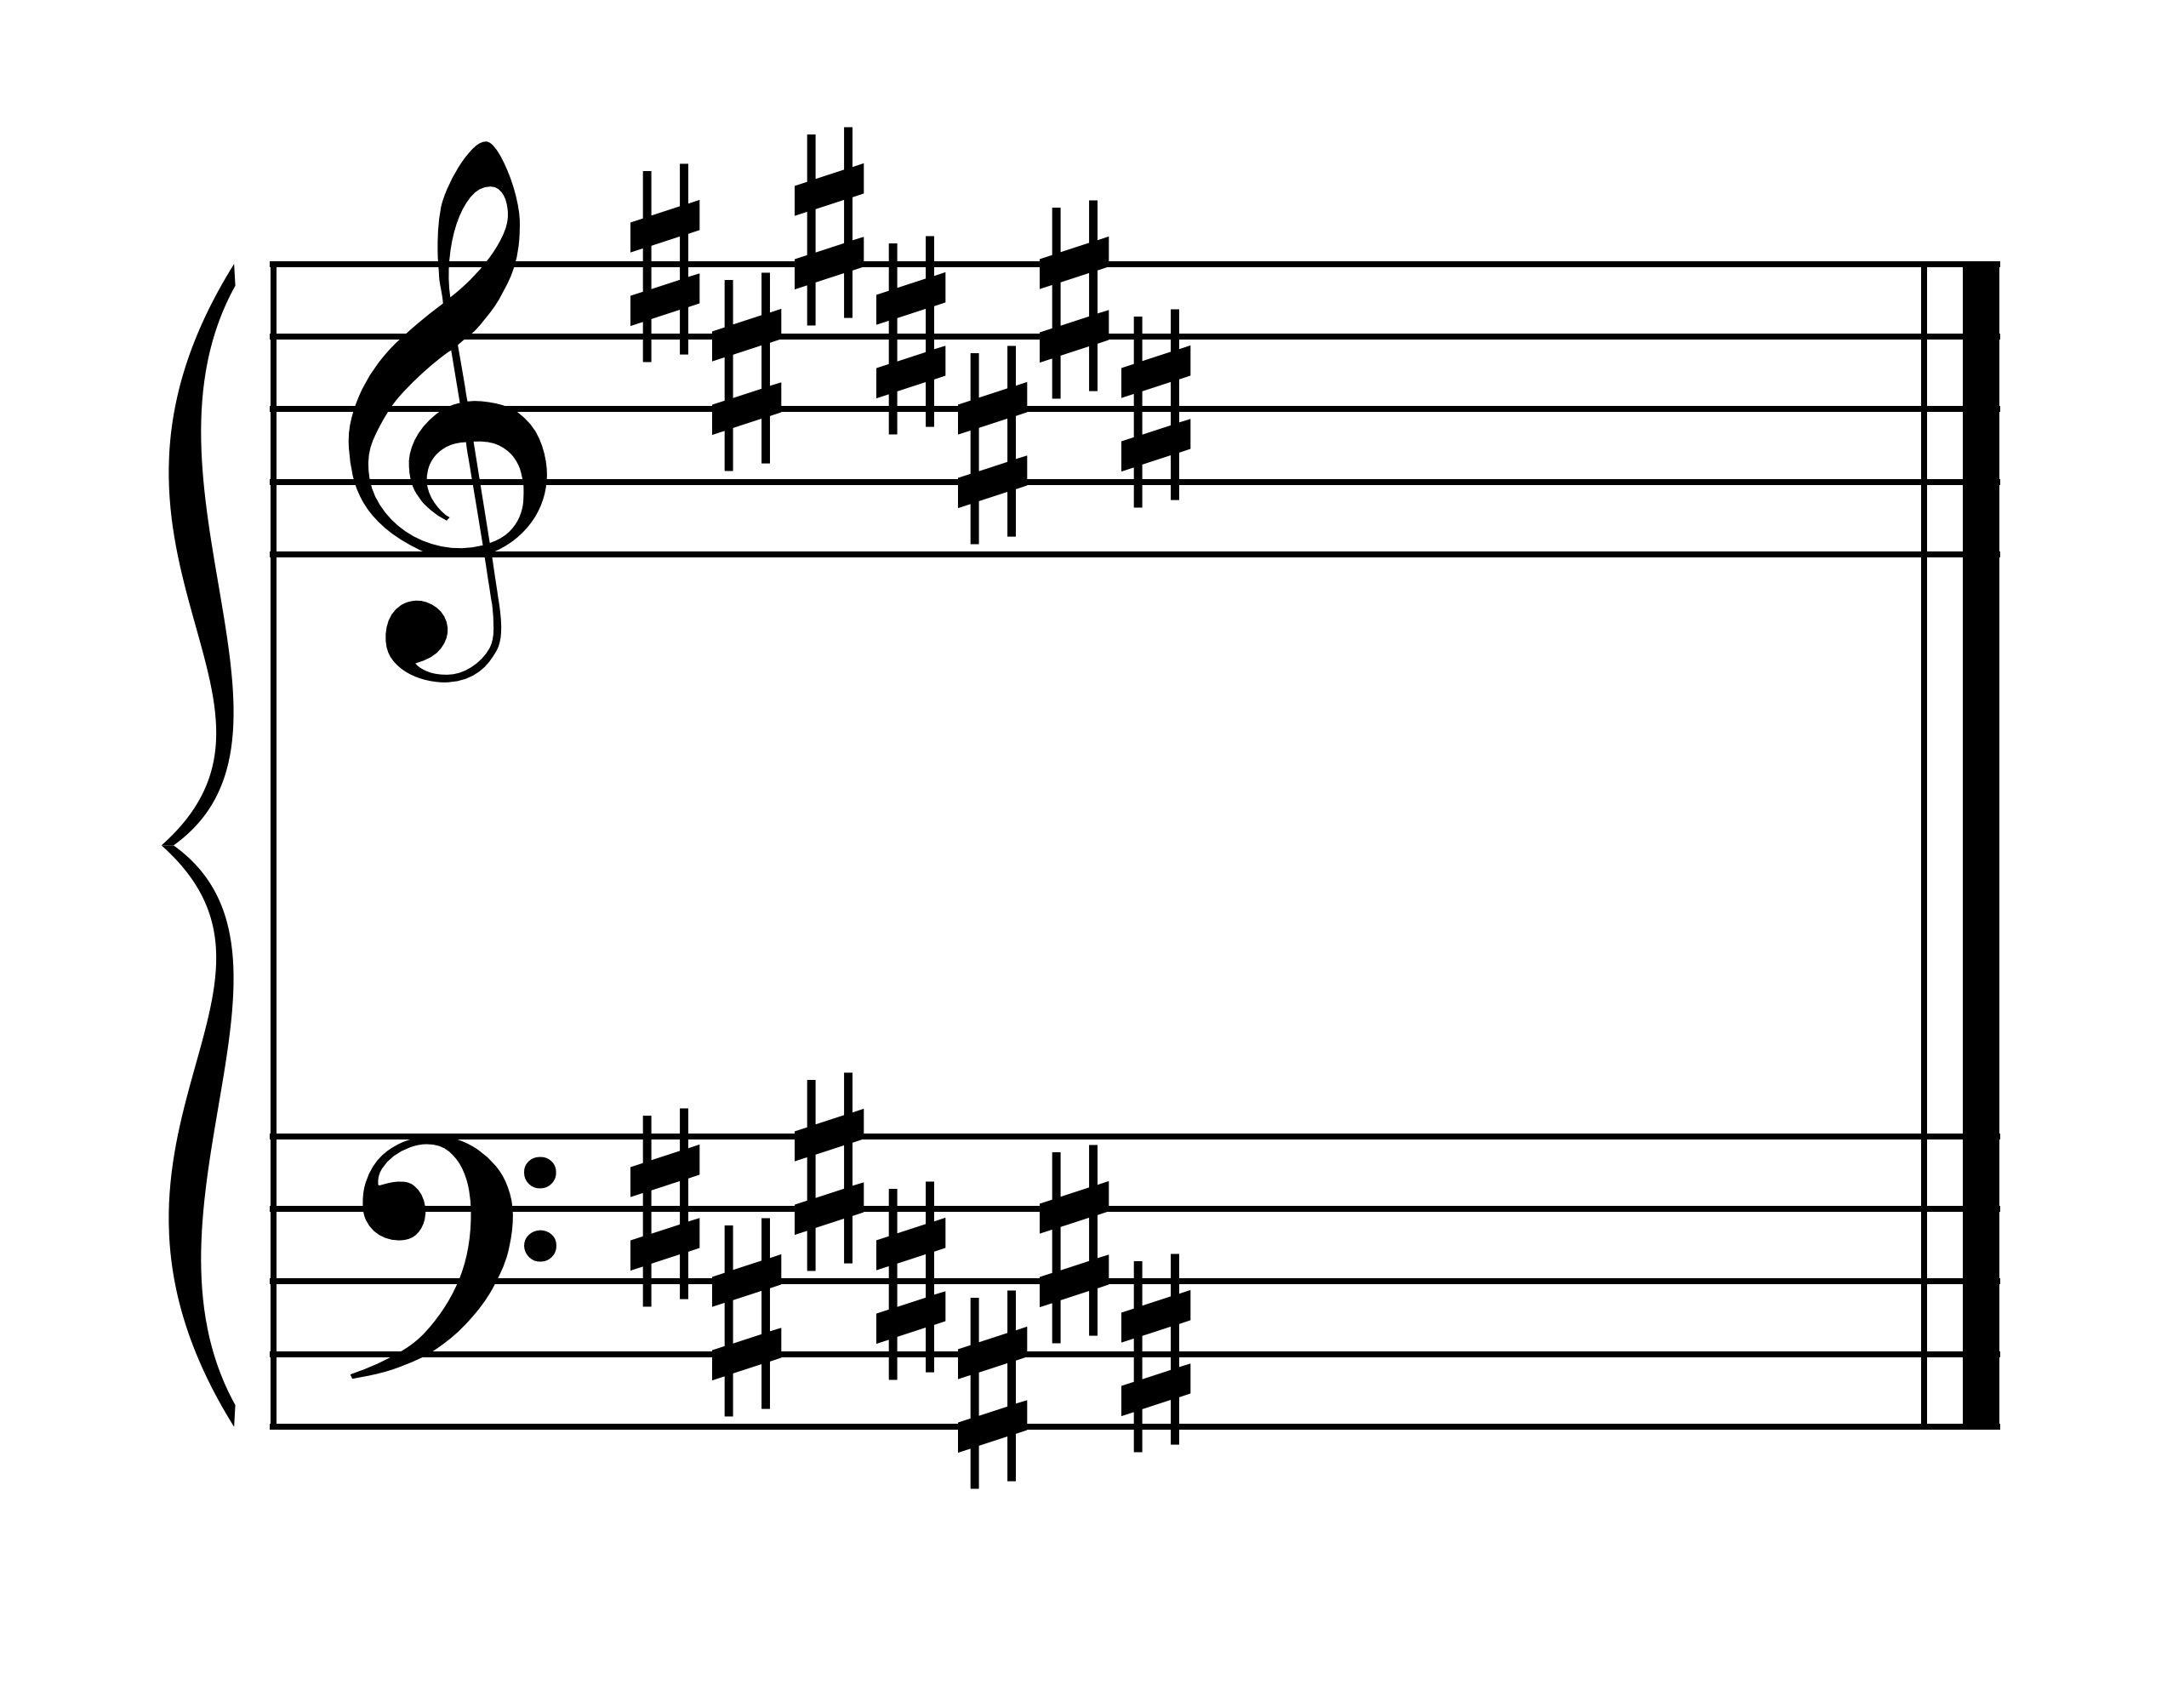

**Order of flats**: BEADGCF (order of sharps backwards)

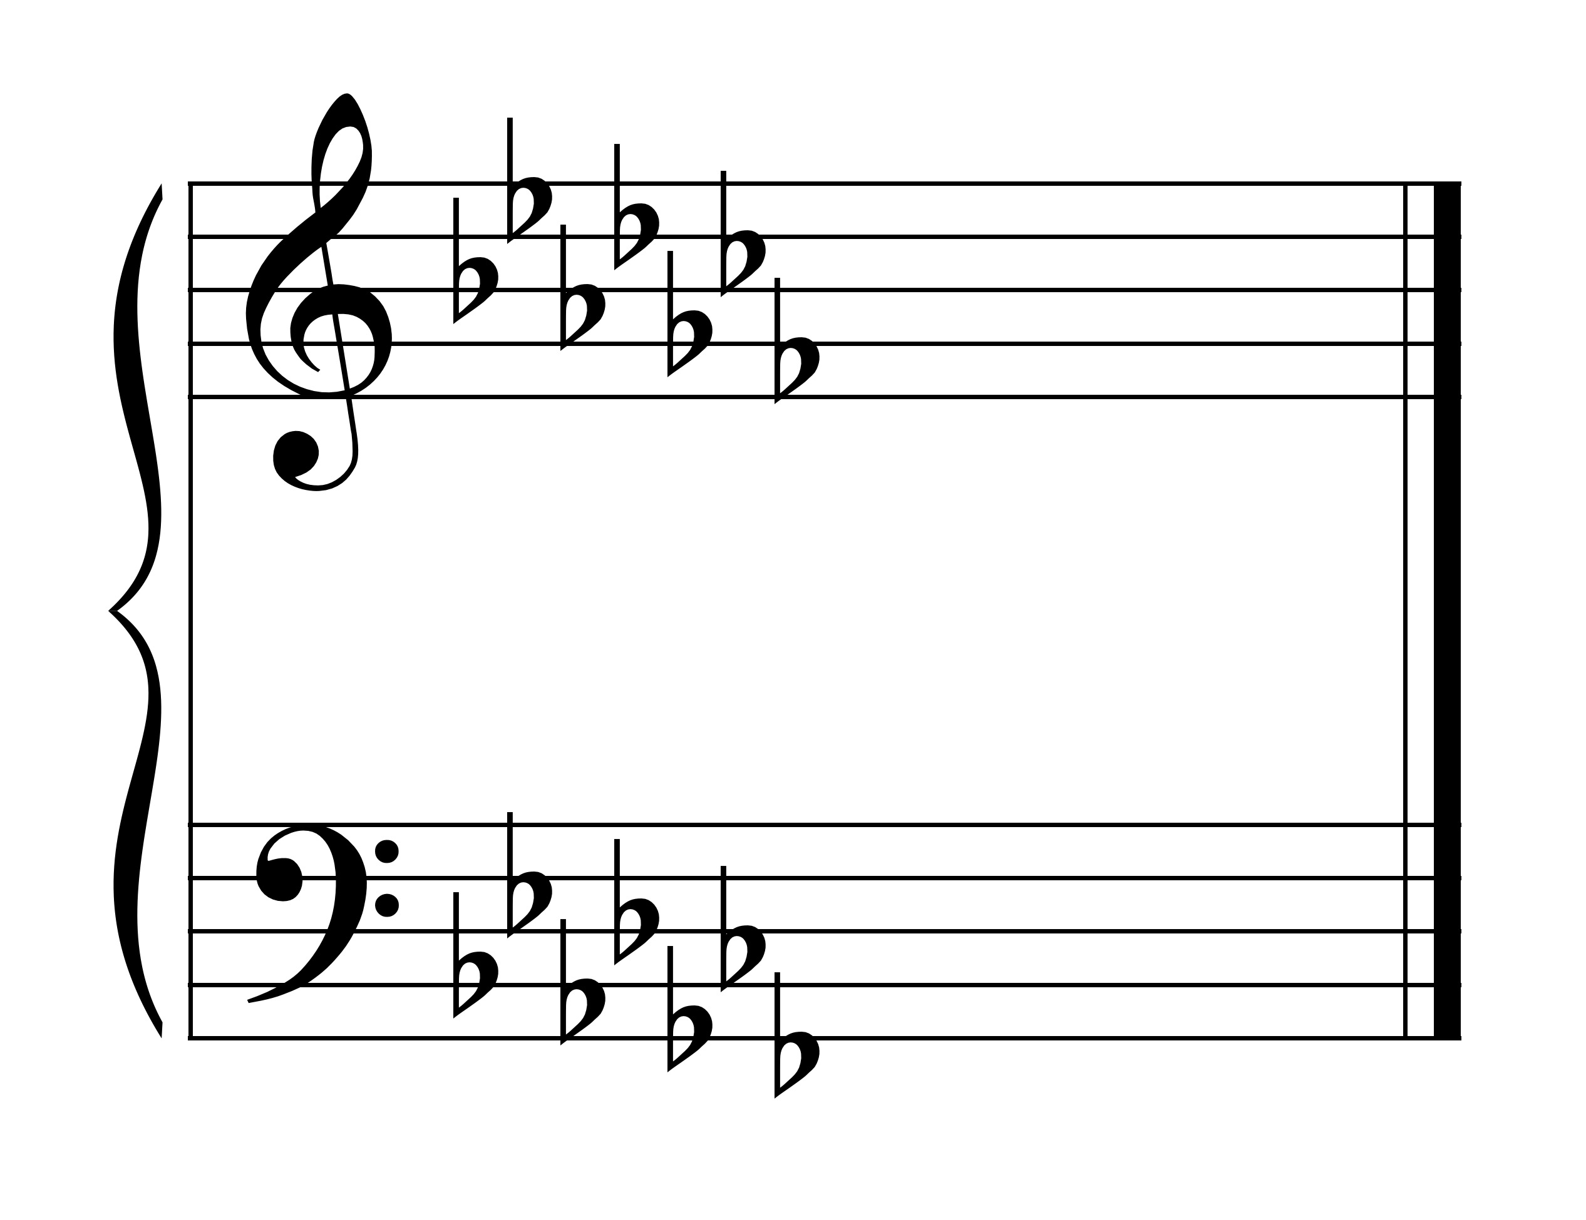

Note the position of the sharps and flats on the lines and spaces of the staff. They should always be in these positions -- no others.

**If you are given the key signature and want to determine the MAJOR key:**

For sharp keys: the key is one half-step up from the last sharp.

For example:

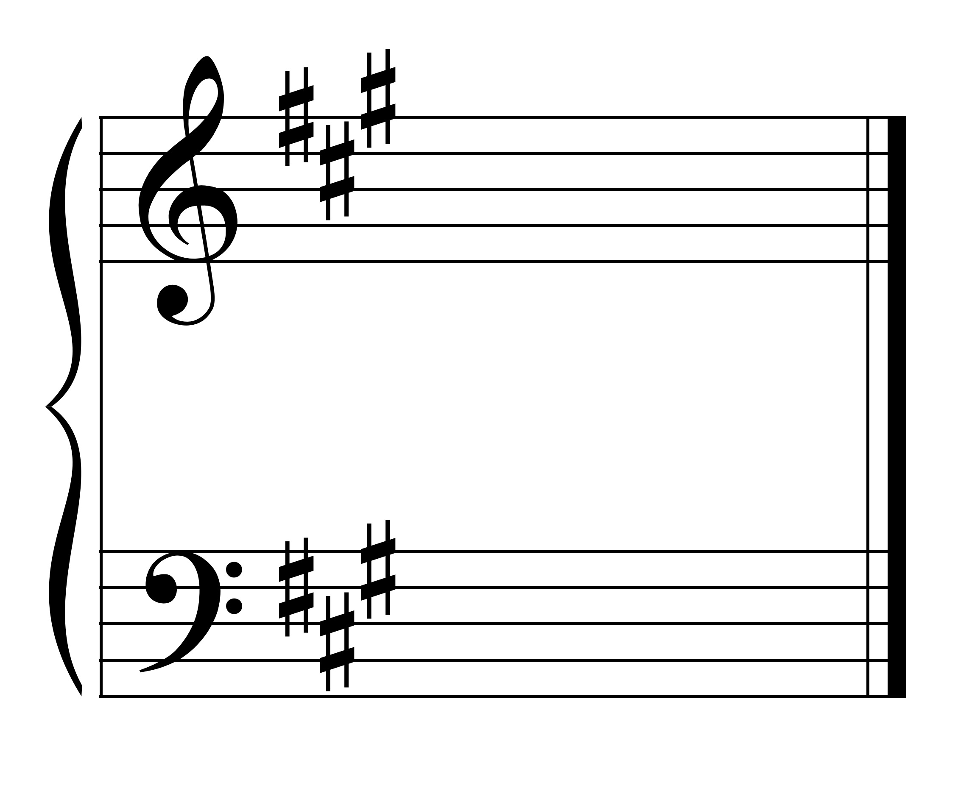

Last sharp is G#. Go up half step to A.

3 sharps is the key signature for **A major**.

For flat keys: the key is the same as the next to the last flat or down 4 steps from the last flat.

Example:

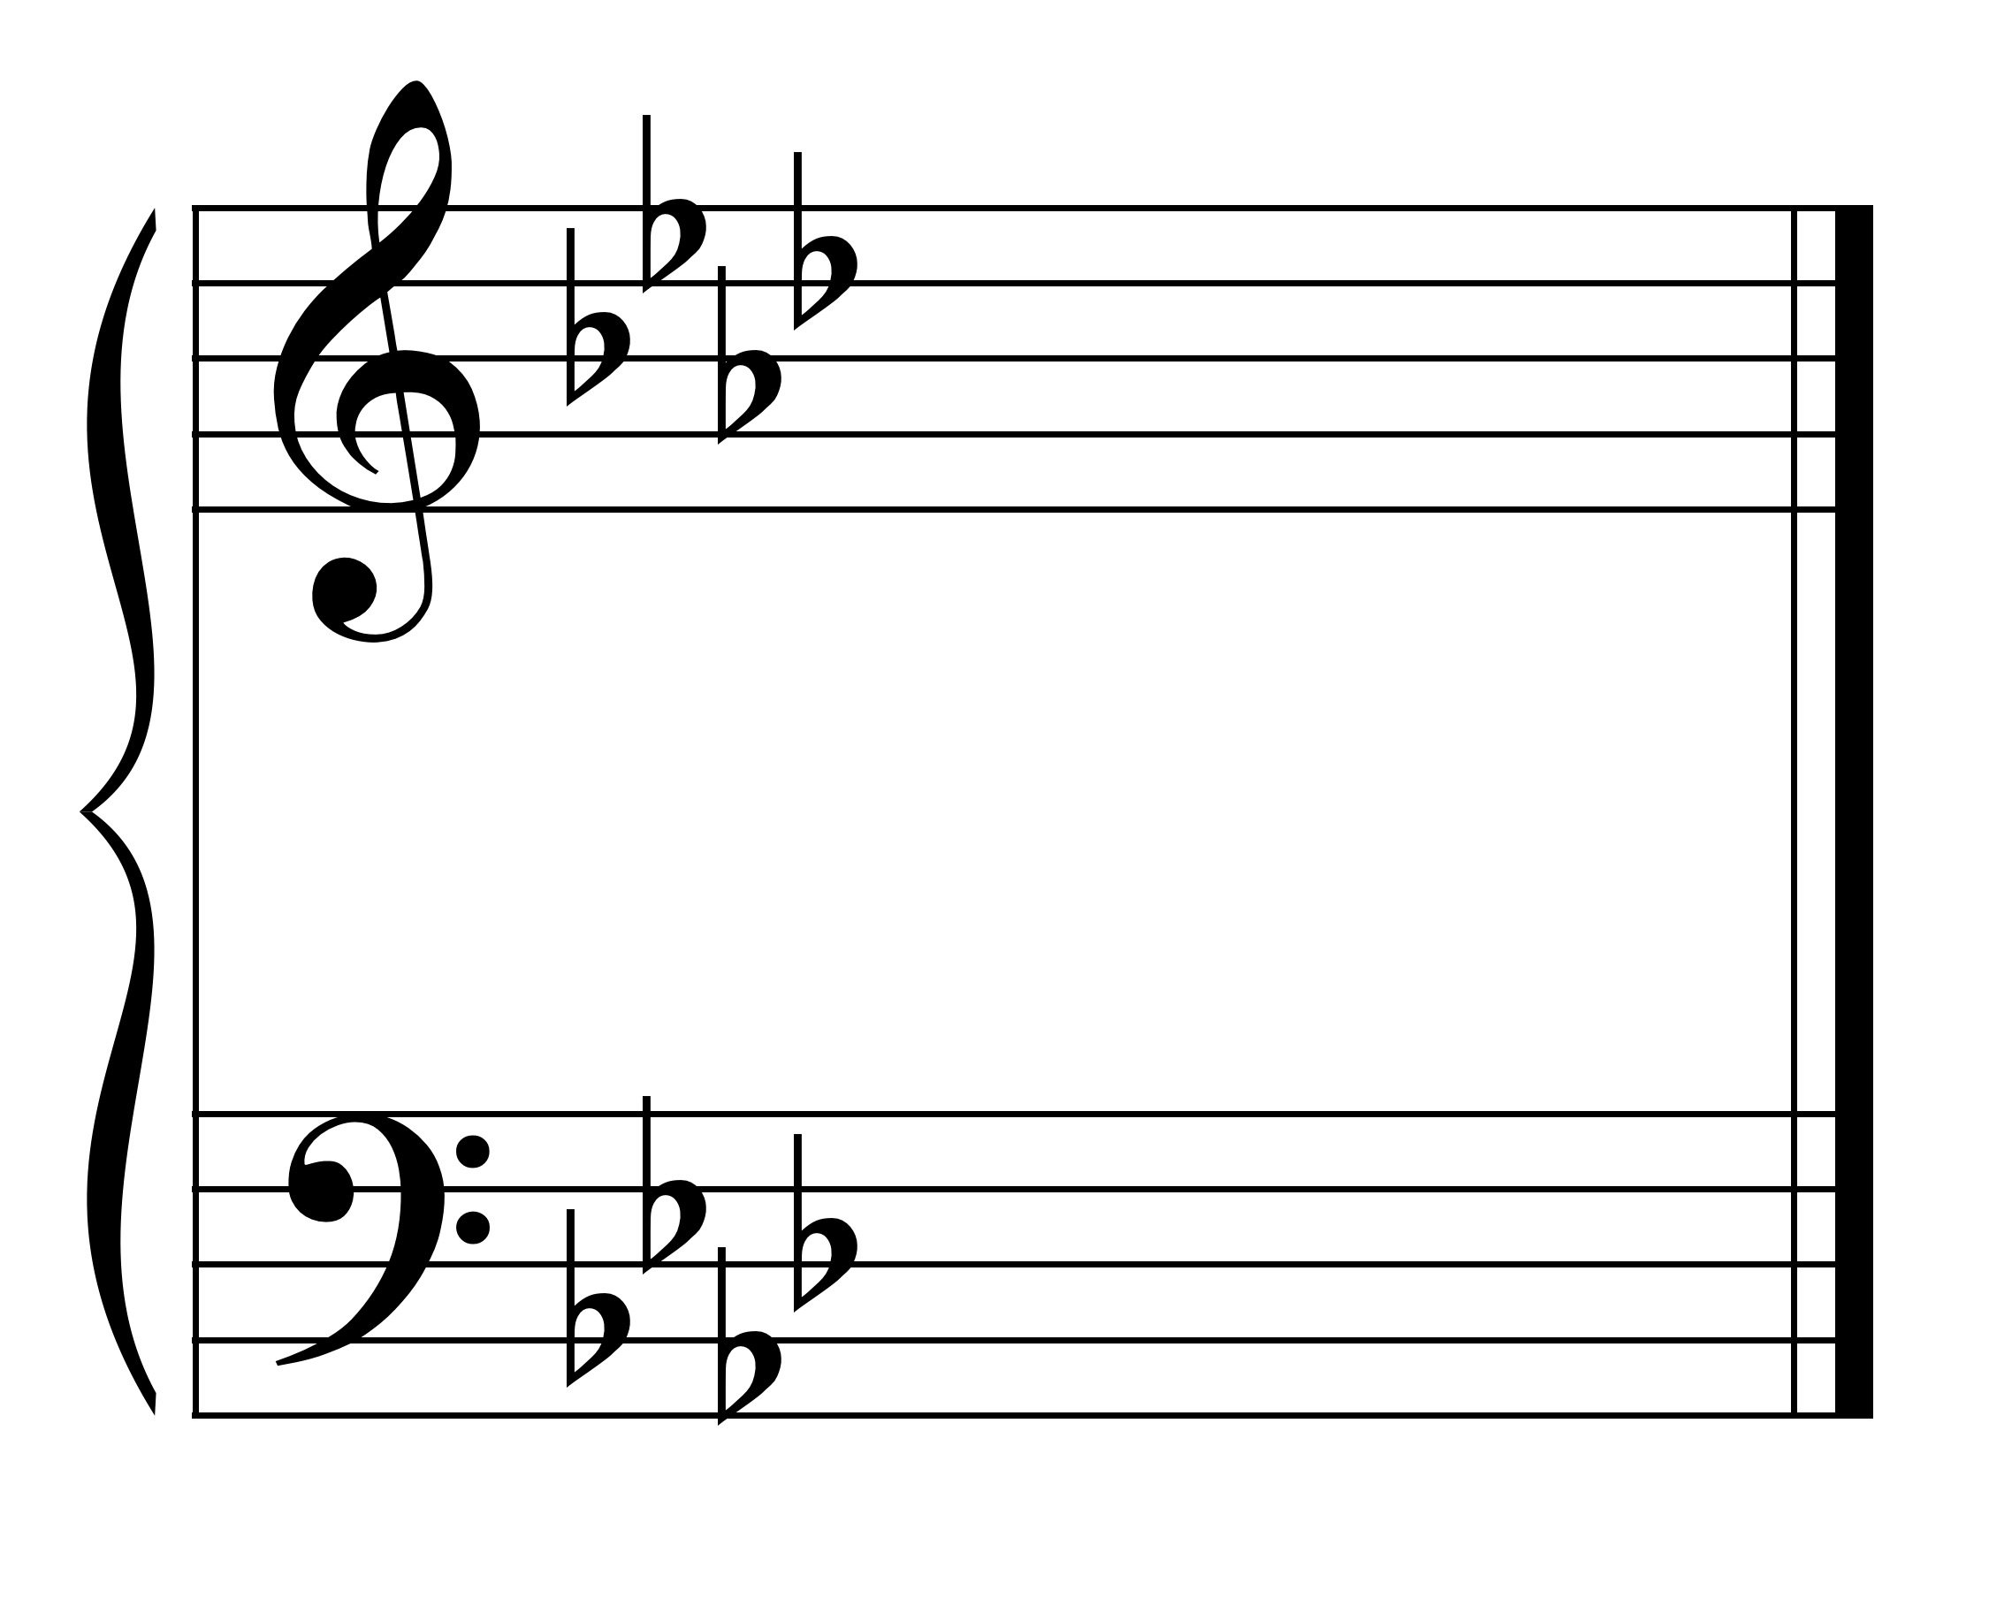

Next to the last flat is Ab.

OR

Last flat is Db. Down four steps (Db-C-Bb-Ab) is Ab.

4 flats is the key signature for Ab major.

**If you are given the key signature and want to determine the MINOR key:**

First determine the major key.

Then go down a whole step and a diatonic half step (a minor 3) to get the name of the key.

Examples:

 

3 sharps is A major. 4 flats is Ab Major.

Down a minor 3 is f# minor. Down a minor 3 is f minor

**If you are given the key and want the key signature:**

Determine if the key is a flat key or a sharp key. Flat keys have “flat” in the name of the key except for the key of F.

F major = 1 flat

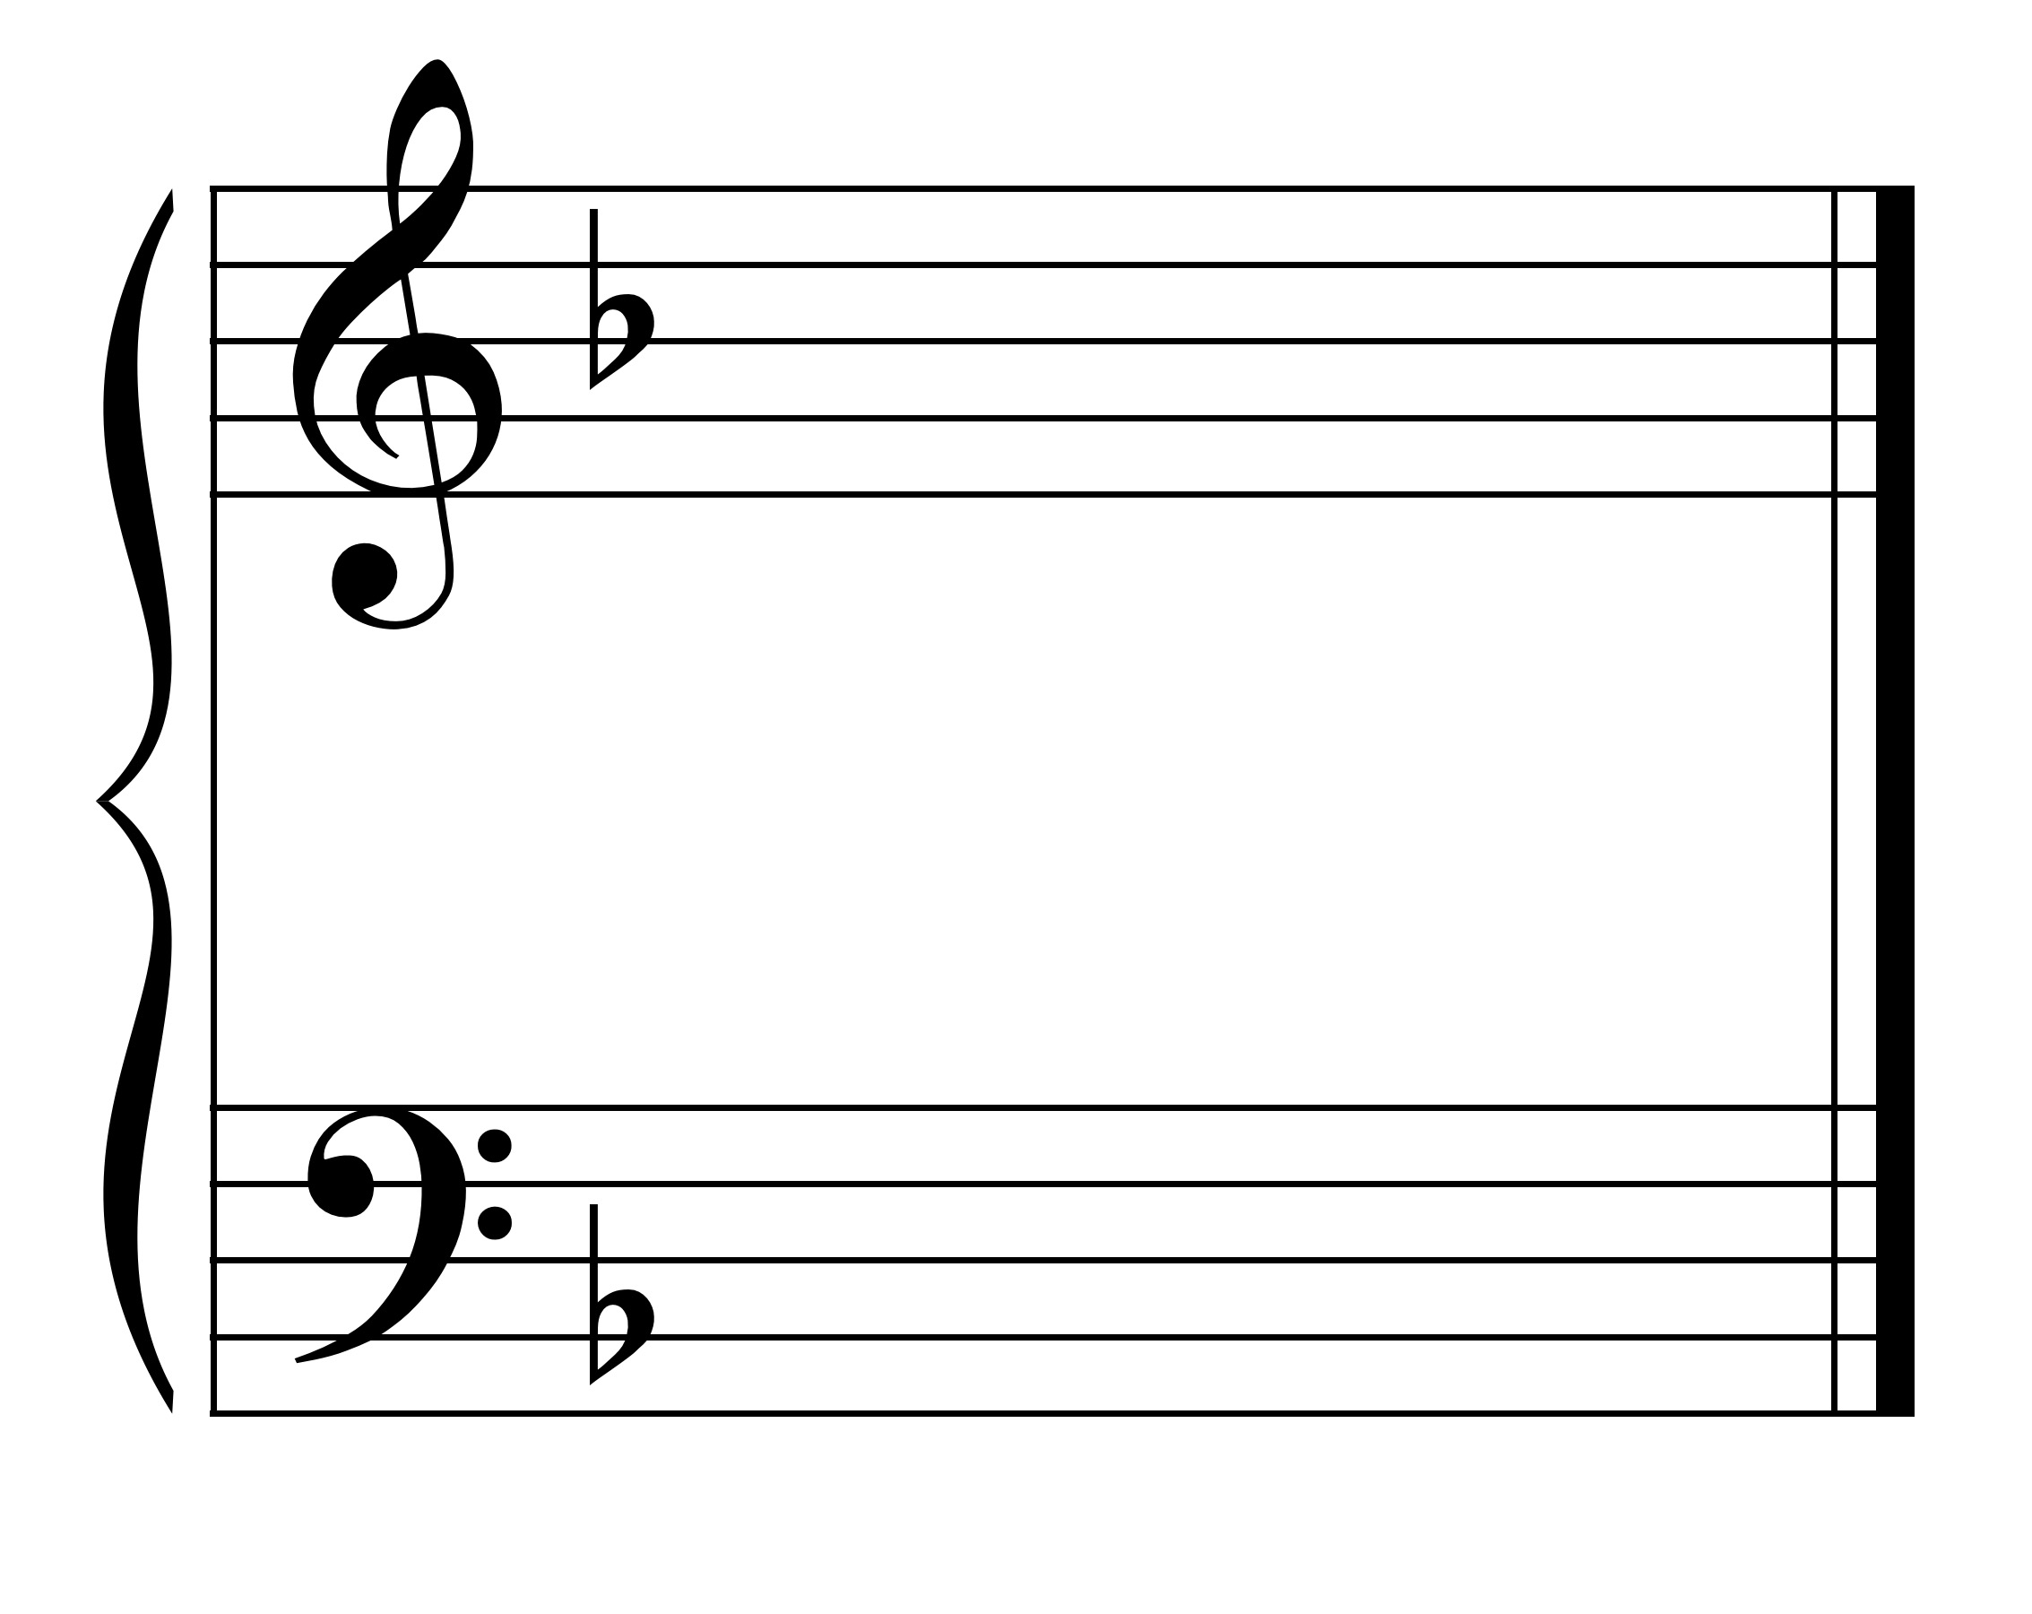

**For flats keys:**

If the key signature has flats in it, it is a flat key. Therefore, go through the order of flats to the flat after the name of the key. The flats you have named are the flats in the key signature.

Example: Provide the key signature for Eb Major.

Process:

* There is a flat in the name of the key so it is a flat key.
* Go through flats in order (order = BEADGCF) until get to the name of the key, then go one more flat.
* For Eb, name BE. Go one more (A). Therefore, Eb Major has Bb, Eb, and Ab in the key signature.

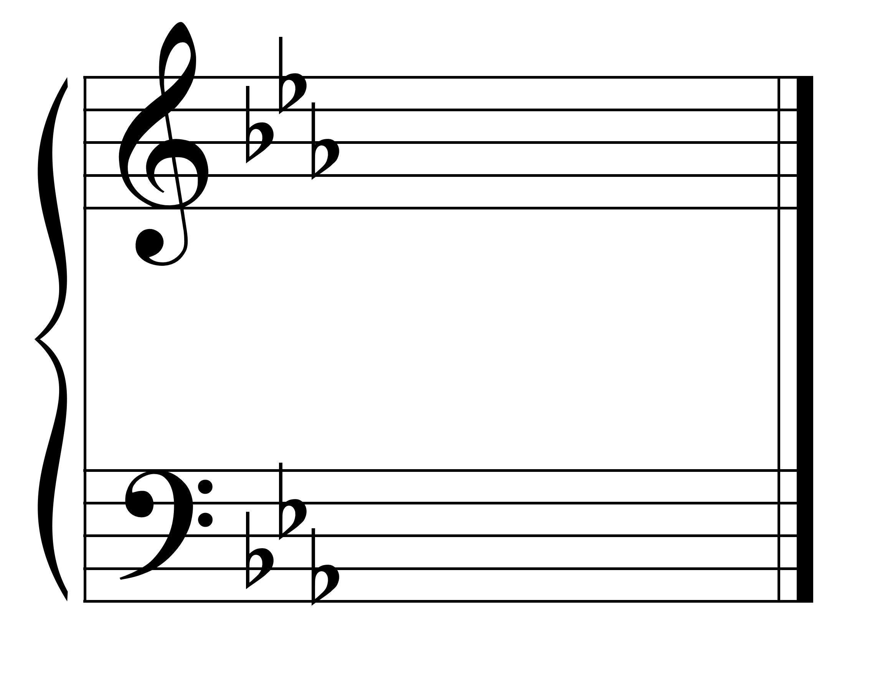

Eb major

**For sharp keys:**

If the key is a sharp key, go through the order of sharps to the note a step below the name of the key (e.g., A major -- go through G). The sharps named are the sharps in the key signature.

Example: Provide key signature for E major.

Process:

* Key is not F (1 flat) or C (no flats or sharps) and does not have flat in the name of the key, so it must be a sharp key.
* Go one step below E = D.
* Go through order of sharps until that note. FCGD.
* E major has 4 sharps.

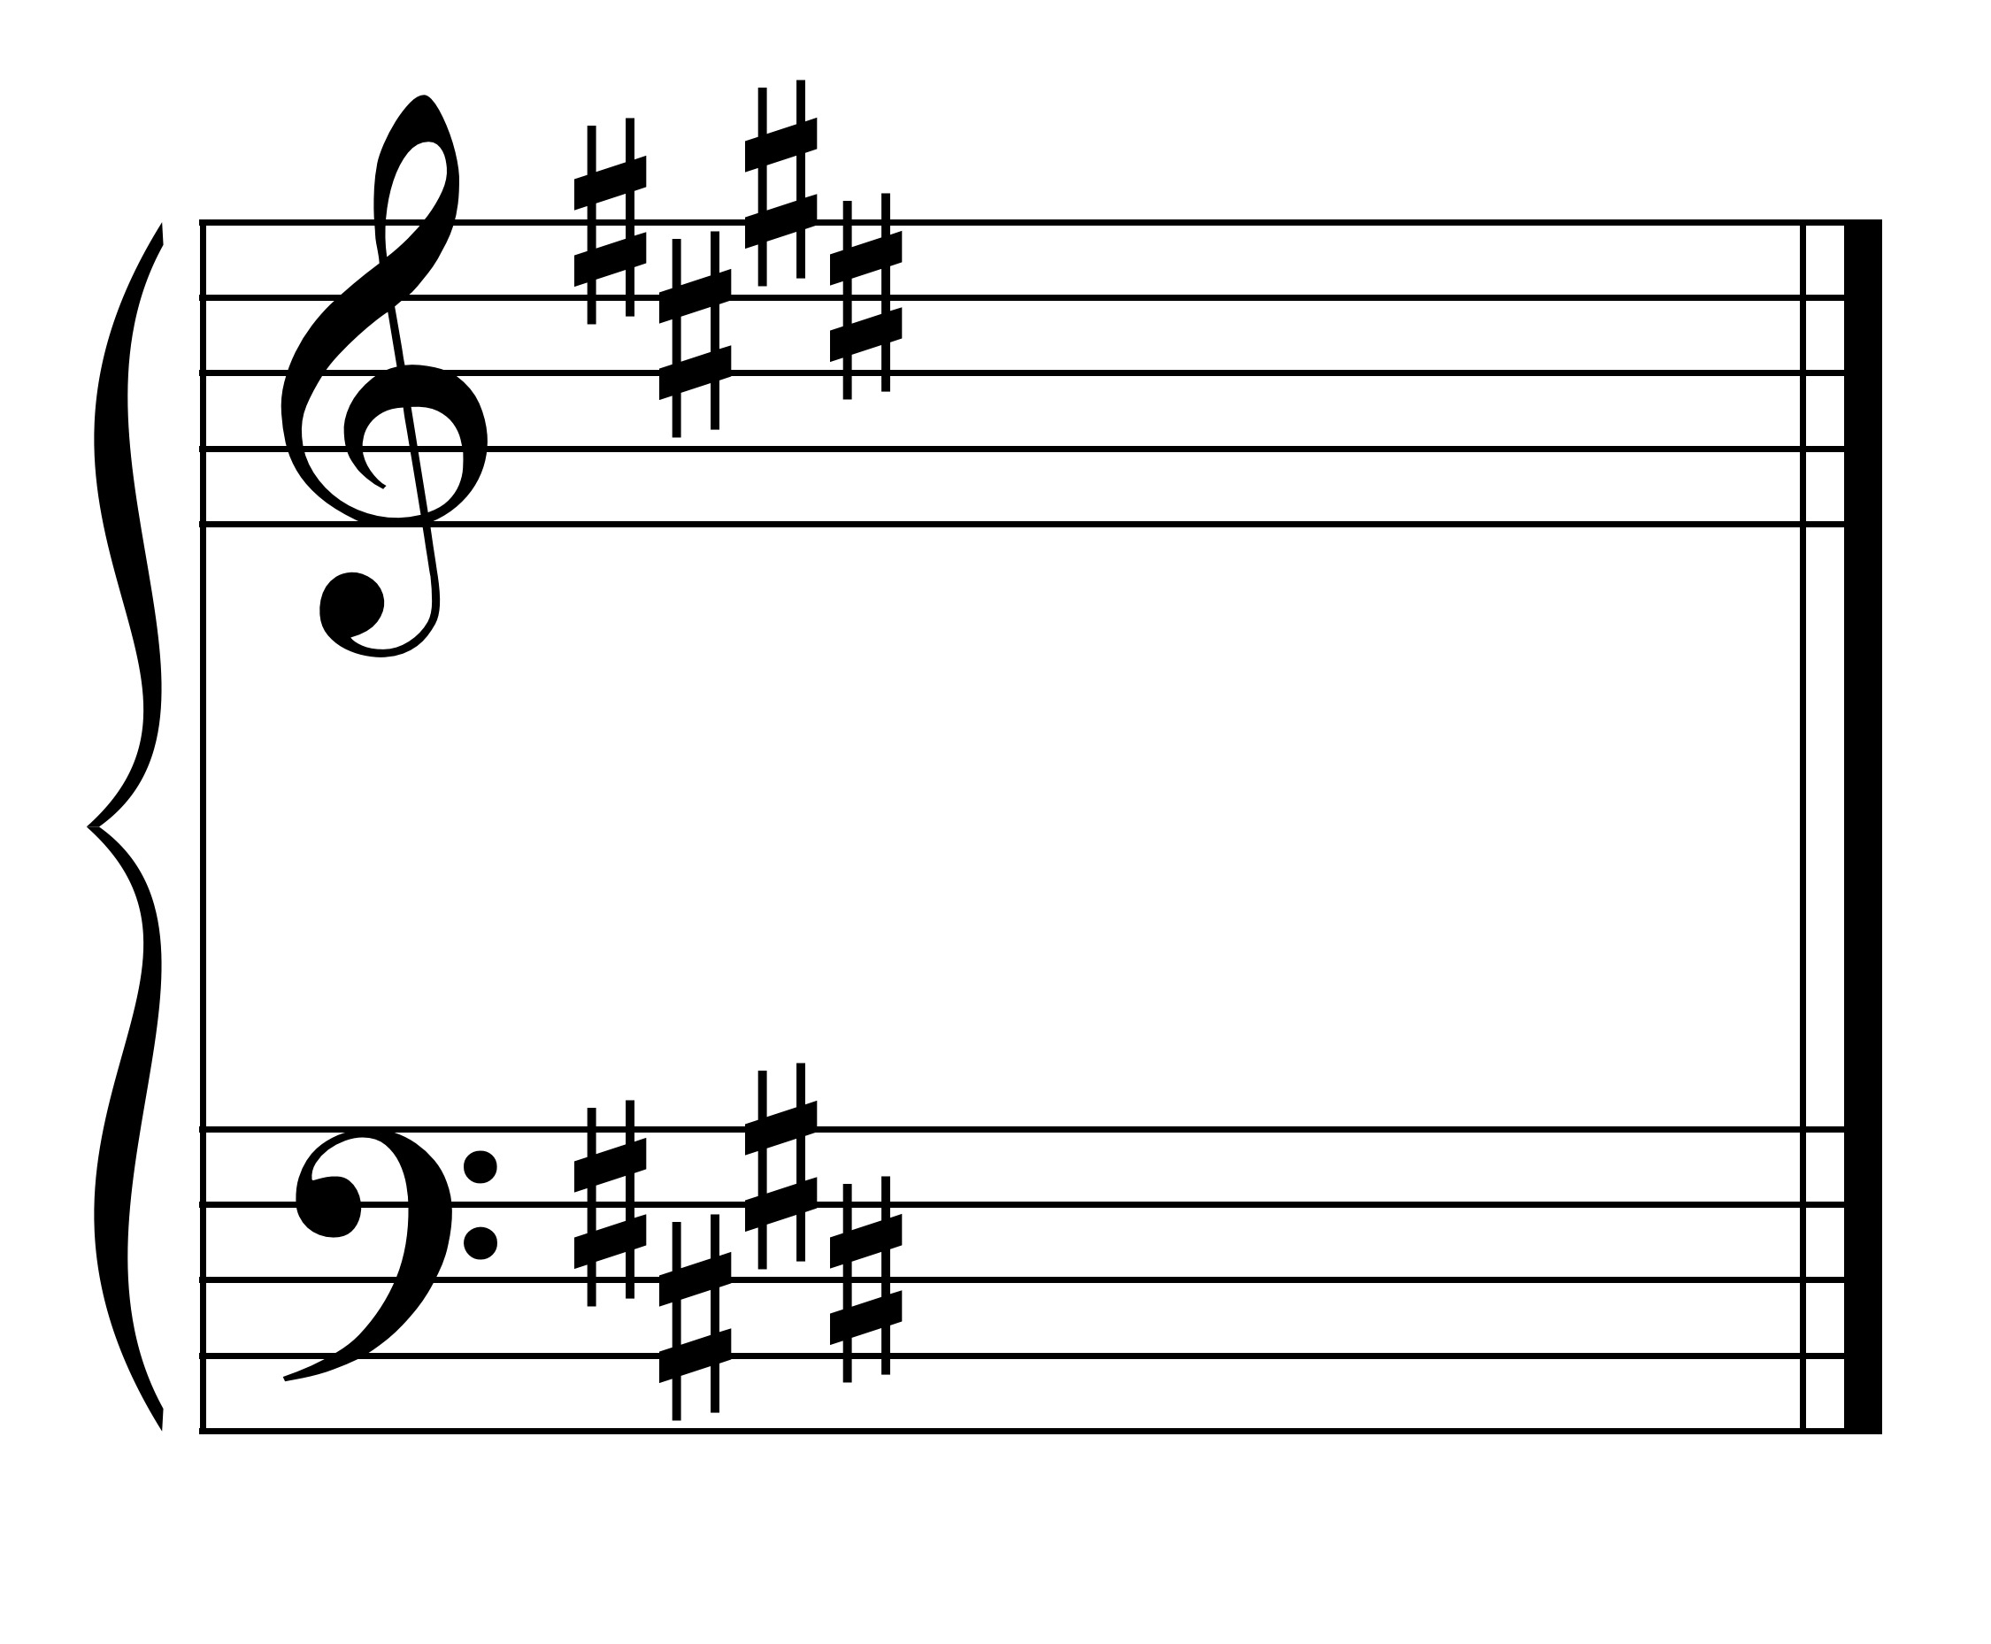

E Major

OR to find the key signature, use the circle of fifths to help you.

The **circle of 5ths** is a graphic way to see all the key signatures - both major and minor.

