**INTERVALS**

An **INTERVAL** is the distance between two notes /pitches.

Intervals are named by **size and quality**:

***Interval Size****:*

The size is an Arabic number. (e.g., 1, 2, 3, 4)

To determine the size, count the note names between the two notes given (inclusive). Be sure to count the beginning and ending notes.

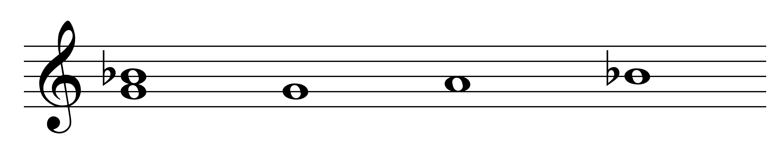

3 = 1 2 3

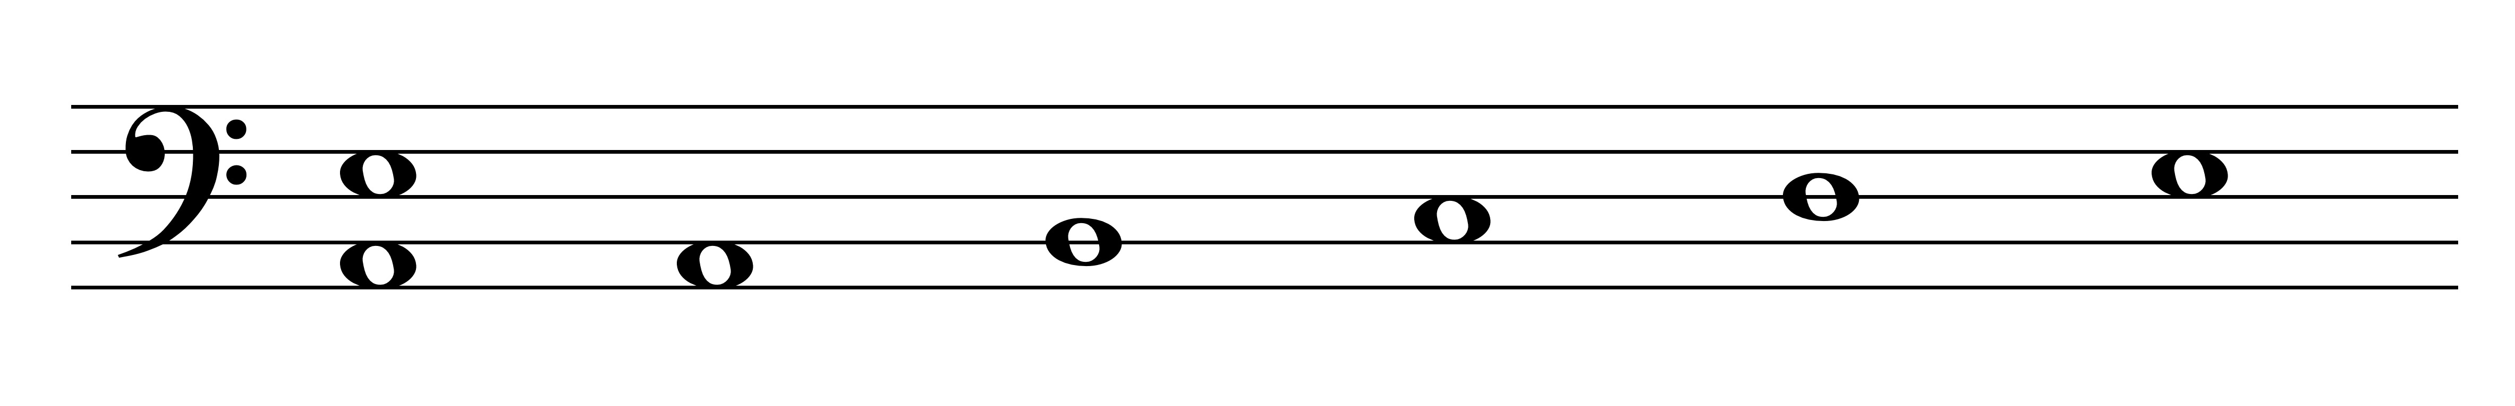

5 = 1 2 3 4 5

***Interval Quality****:*

The possible qualities are major, minor, perfect, diminished, and augmented.

Intervals that are 2, 3, 6, or 7 in size (or their multiples) can be major (M), minor (m), diminished (d) or augmented (A). These intervals can never be perfect.

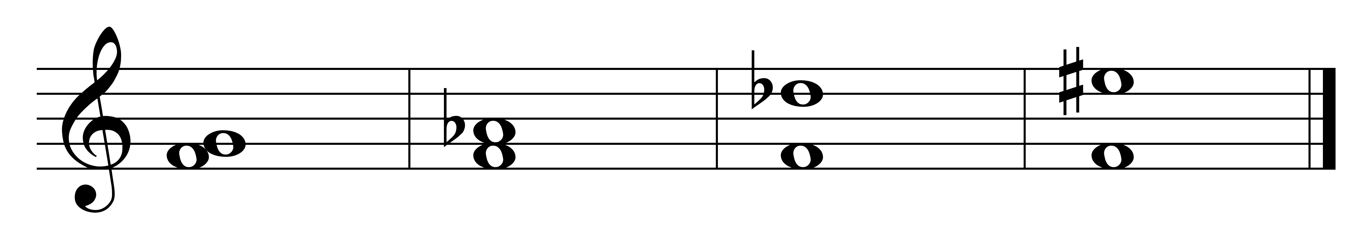

M2 m3 d6 A7

Intervals that are 1, 4, 5, or 8 (or their multiples) in size can be perfect (P), diminished (d)`or augmented (A). These intervals can never be major or minor.

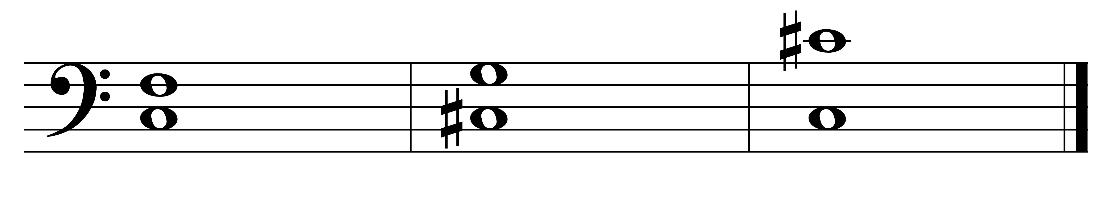

P4 d5 A8

Intervals are:

**perfect** if: (1) the top note is in the major key of the bottom note AND (2) the bottom note is in the major key of the top note.

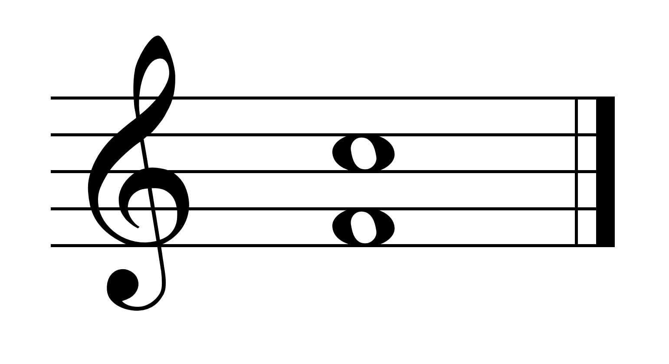

**major** if the top note is in the major key of the bottom note.

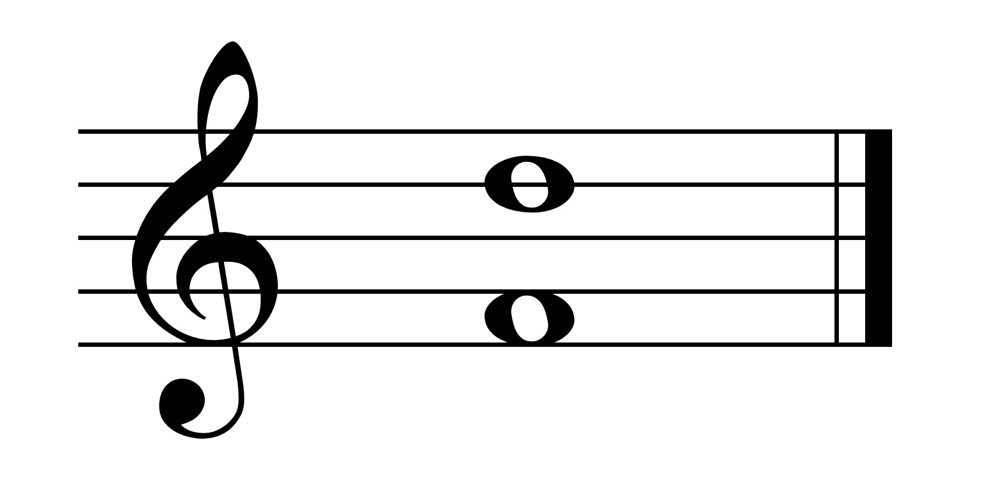

**minor** if it is a half step smaller than major.

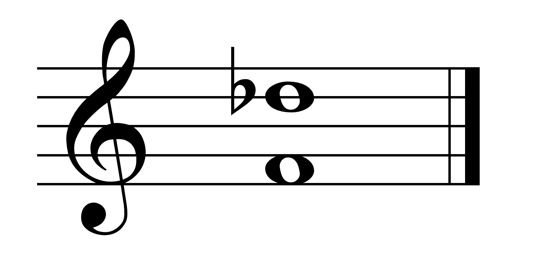

**diminished** if it is a half-step smaller than minor or perfect.

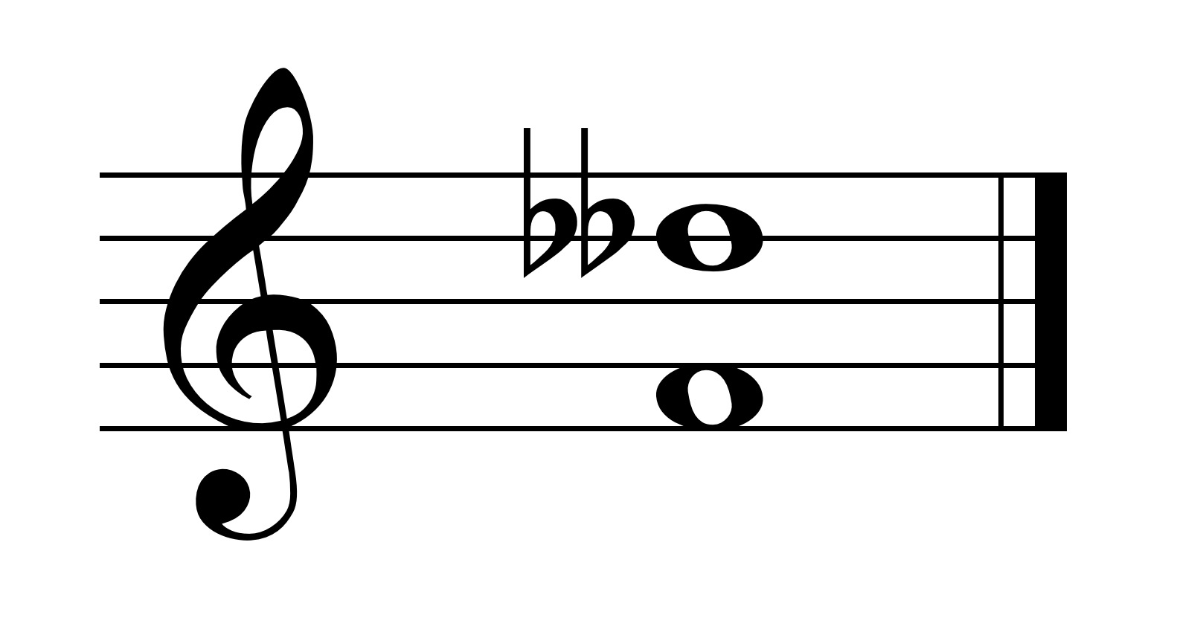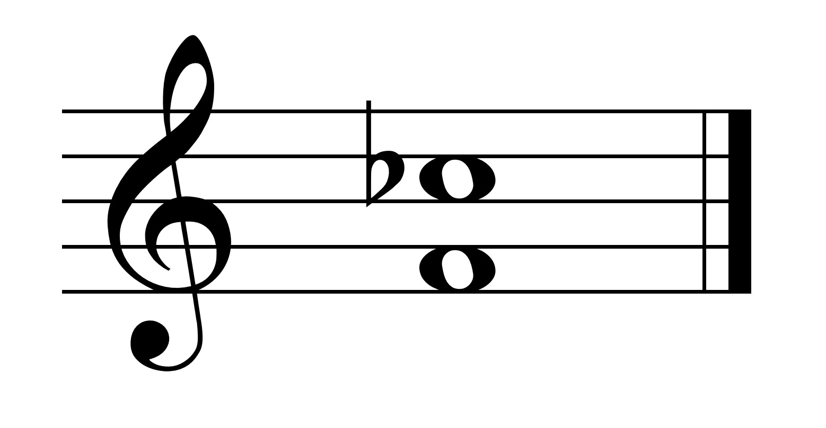

**augmented** if it is a half-step larger than major or perfect.

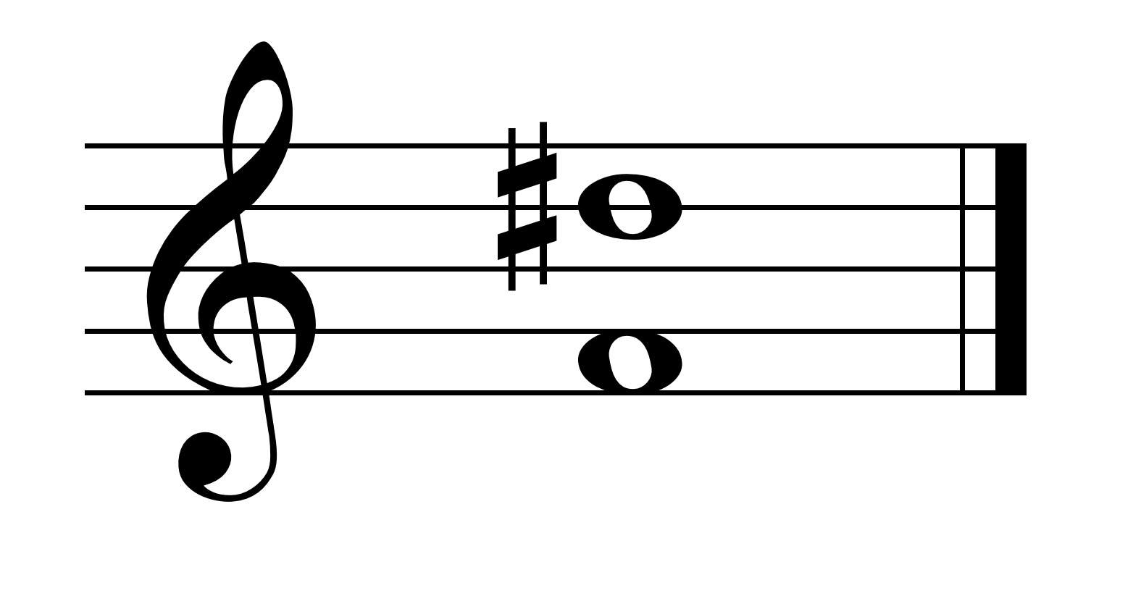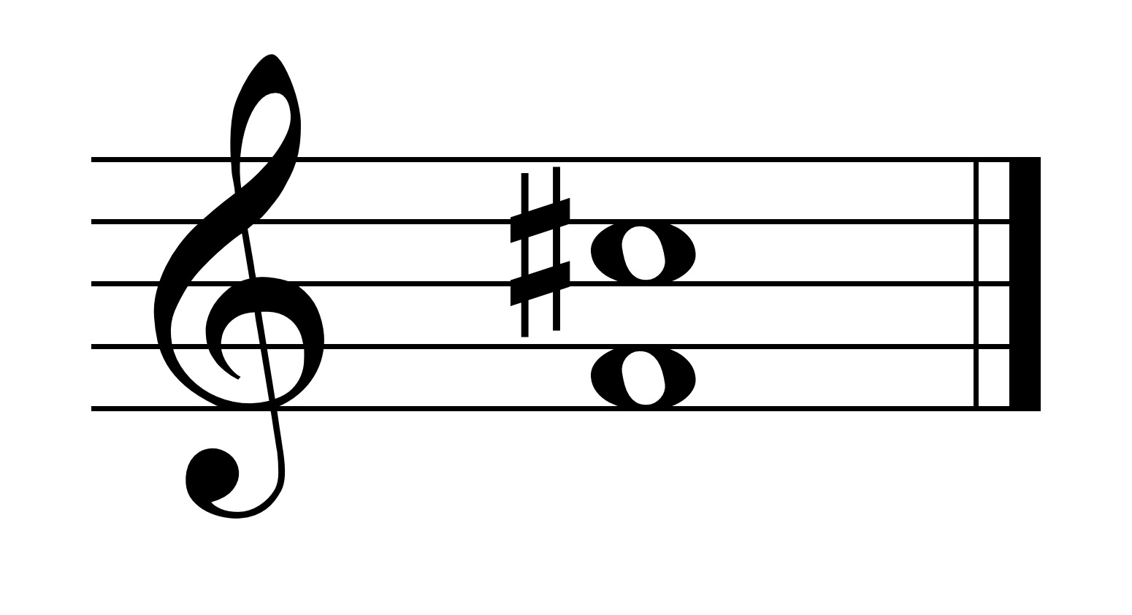

*Compound Intervals:*

Compound intervals are intervals larger than an octave.

Compound intervals are functionally the same as the corresponding simple intervals (those an octave or less in size).

Thus, a 9th is a compound 2nd, a 10th is a compound 3rd, an 11th is a compound 4th, a 12th is a compound 5th, etc.

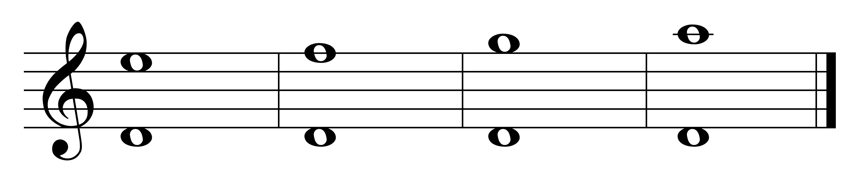

M9 M10 P11 P12

We normally refer to only 9th through 12ths as compound intervals. Beyond that, we refer to compound intervals by their corresponding simple interval name.

*Inversions of intervals:*

An interval of an octave (8th) or less can be inverted.

To invert an interval, either make the top note the new bottom note or the bottom note the new top note.

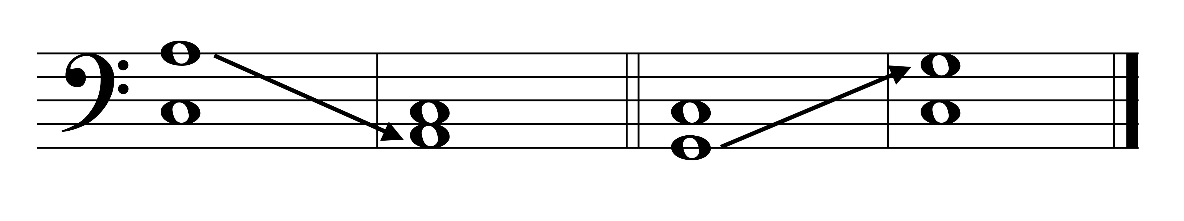

M6 m3 P4 P5

When an interval is inverted the size and quality change:

The size of the original and the inverted interval will always adds to 9:

1 inverts to 8 (and the reverse)

2 inverts to 7 (and the reverse)

3 inverts to 6 (and the reverse)

4 inverts to 5 (and the reverse)

The quality will change as follows:

major inverts to minor

perfect inverts to perfect

diminished inverts to augmented

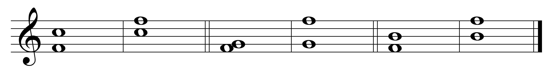

P5 <-> P4 M2 <-> m7 A4 <-> d5

*Consonance and dissonance*

**Consonant intervals** are those intervals that sound stable and usually pleasant.

**Dissonant intervals** are those that sound harsh and unstable; they feel as if they want to resolve.

*The consonant intervals*

The **consonant intervals** are P1, P8, P5, M3, m3, M6, m6, P4 (sometimes).

These intervals (besides unison and octave) are the intervals contained in major and minor triads.

The P1, P8, and P5 are known as **perfect consonances**.

M3, m3, M6 and m6 are known as the **imperfect consonances**.

The perfect consonances are the more stable consonances and are used at points of articulation, e.g. beginnings and endings of phrases, sections, pieces.

The **imperfect consonances** are less stable and are used in places where music needs to continue.

*The dissonant intervals*

The rest of the intervals -- M2, m2, M7, m7, augmented and diminished intervals, P4 (sometimes) -- are the **dissonant intervals**.

They arise from melodic activity in a voice and the need to resolve.

*The Perfect 4th (P4)*

The P4 is sometimes consonant and sometimes dissonant.

In early music, P4 was a consonance and with other perfect intervals made up most of music compositions.

Later, when using complete triads, the 4th tended to lose some of its stability and consonance (sounded like active tone between 5th and 3rd). If it appeared near a 5th (its inversion), then it was stable.

SO -- the P4 is a consonant when it functions as an inverted 5th (as part of the chord); otherwise, it is dissonant.

*Intervals in a Key*

Every scale generates a unique collection of intervals; so each tone has its own character.

***Tritone****:*

The most unique interval is the interval of the tritone (scale degrees 4-7 or 7-4 in major) -- the A4 (or its inversion, the d5).

The tritone is an active interval; it wants to resolve. Its tones want to go to the nearest chord tone, that which is a half-step away – 4 wants to move to 3 (fa-mi) and 7 wants to move to 8 (ti-do).

So, if the tritone is written an A4, it resolves out to a 6th; if written as a d5, it resolves in to a 3rd.

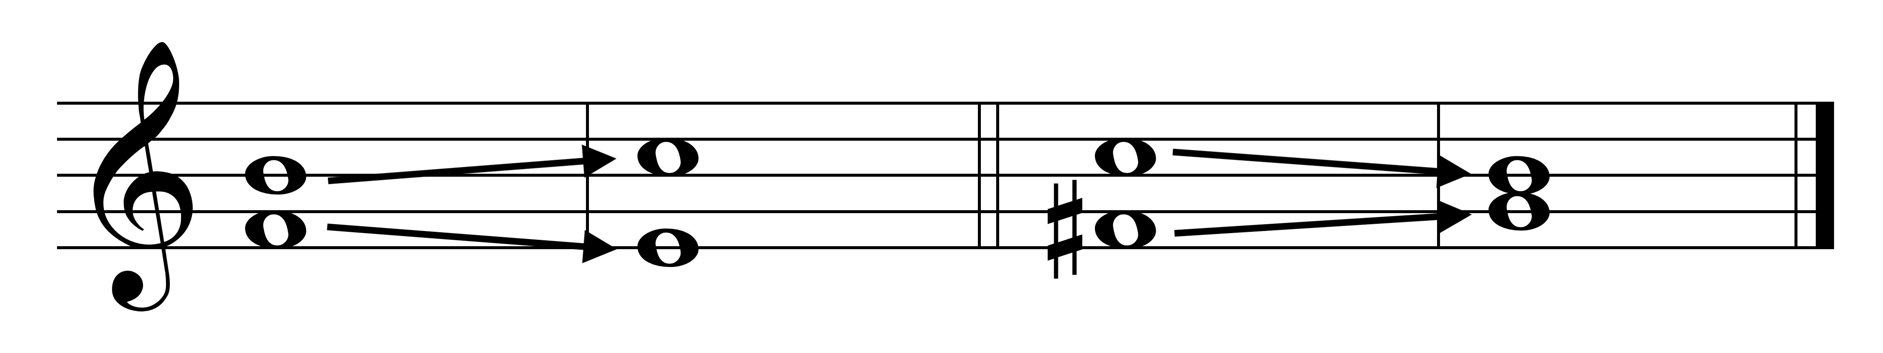

A4 🡪 6 d5 🡪 3

The tritone is a key-defining interval; you know what the tonic is from the resolution of the tritone.



Key is C Key is G

*Augmented 2 and Diminished 7*

Between the submediant and the leading tone in a harmonic minor scale, is the interval of an A2 (or its inversion, a d7).

These tones have the tendency to resolve to tonic and dominant and so this interval is also a key-defining interval.

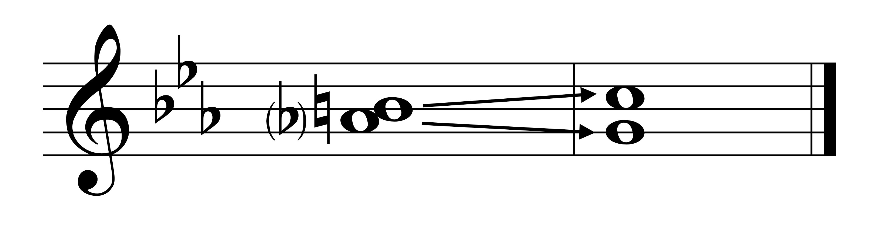

A2 🡪 C is tonic

*Enharmonic intervals*

Enharmonic intervals are those intervals that sound alike but are written differently.

They are:

A1 = m2 d2 = P1 A2 = m3 d3 = M2 A3 = P4

d4 = M3 A4 = d5 d5 = A4 A5 = m6 d6 = P5

A6 = m7 d7 = M6 A7 = P8