**Figured Bass**

**Figured bass symbols** indicate intervals above the bass. They come from the old practice of thorough bass: composers wrote bass line and figures. The part was played by the cello player and the keyboard (continuo) player who realized the chords, filling in the harmonies.

**Rules**:

1. Figures (the Arabic numbers below the bass note) tell the intervals above the bass note.

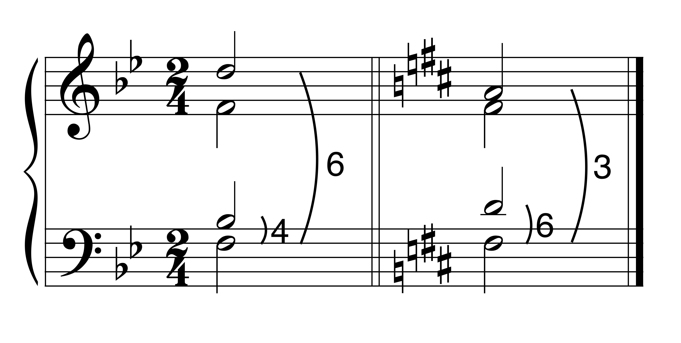

6 6

4 3

2. Key signatures apply to figures as well as notes.

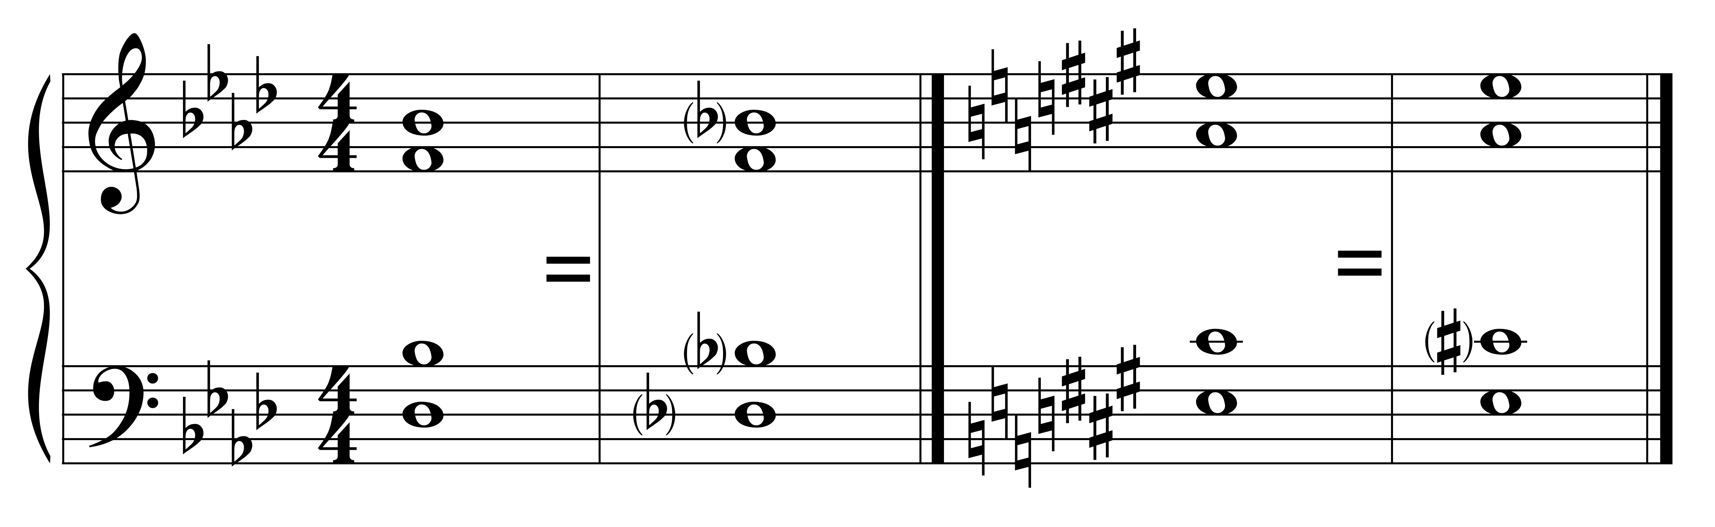

6 6

3. Modifications to the key signature appear next to the figures.

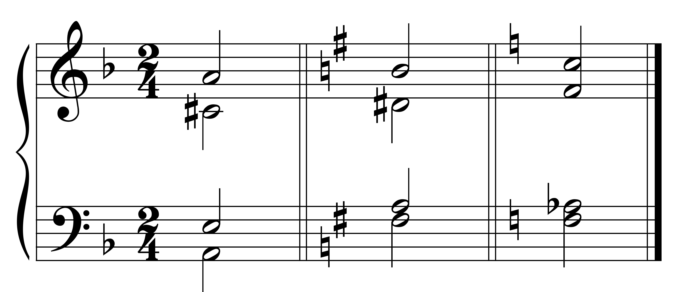

d: 5 e: #6 C: 5

#3 4 b3

3

4. An accidental standing alone affects the note a third above the bass.

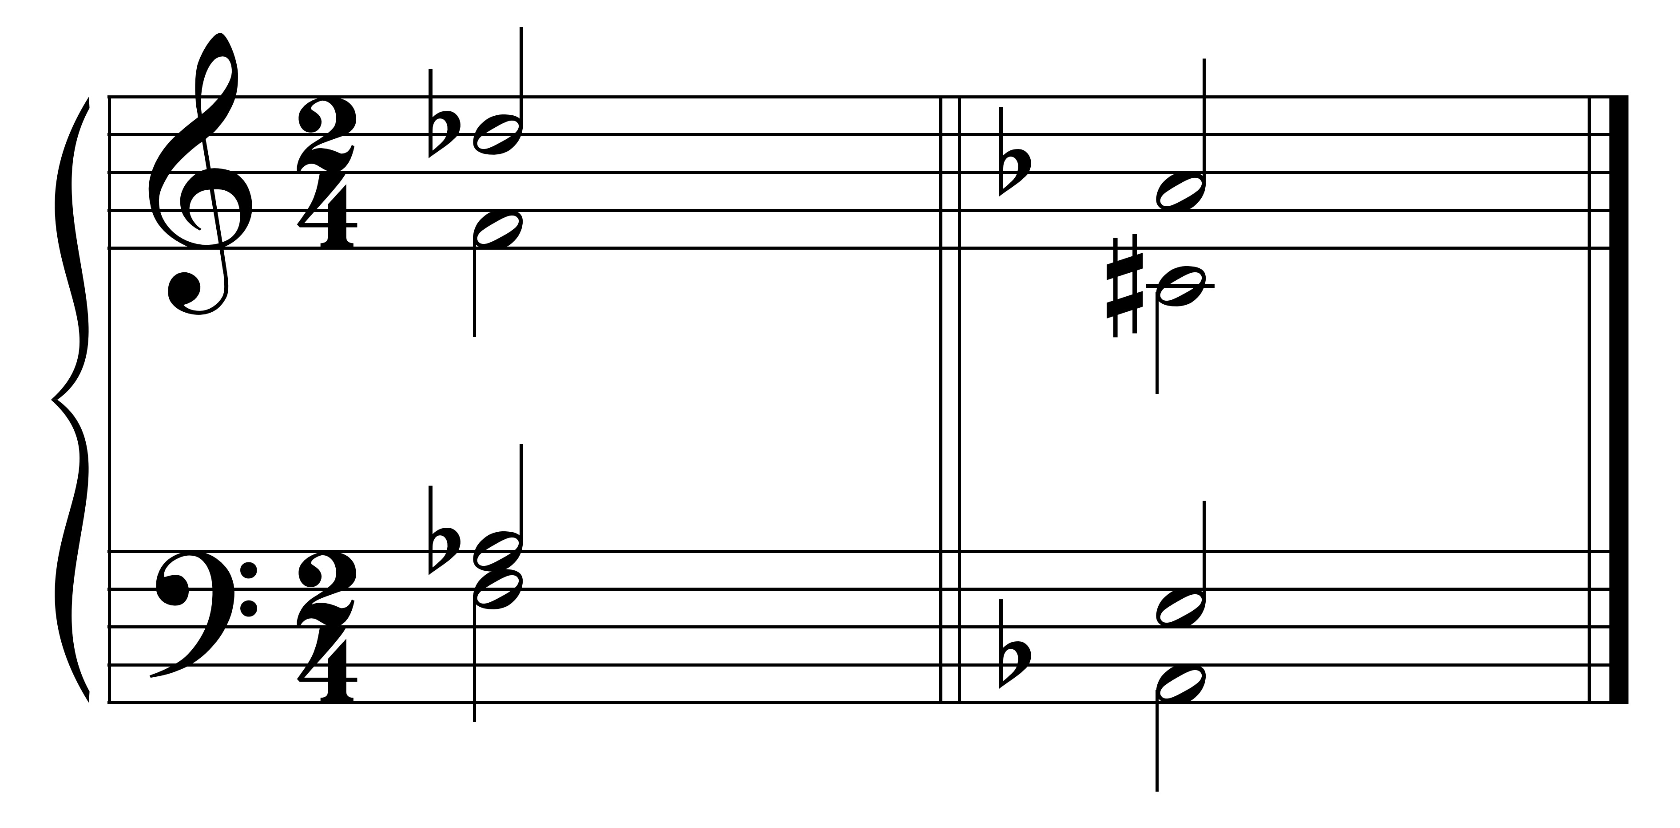

C: b6 d: #

b

5. The raising of a tone may be indicated by a sharp or natural next to the figure or a slash through the figure.

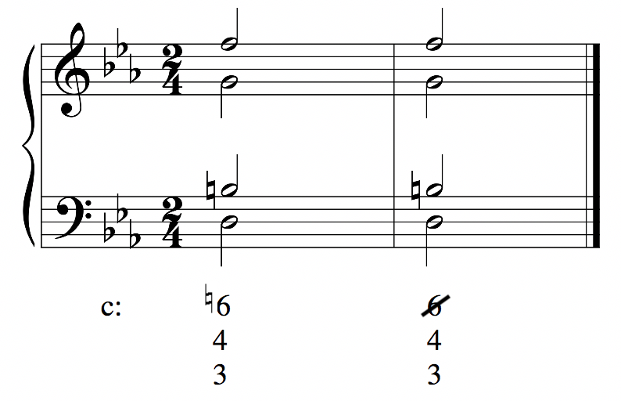

6. Figures do not specify the arrangement of the tones above the bass. They just tell you which tones are present. For example, all of the following arrangements would be correct:

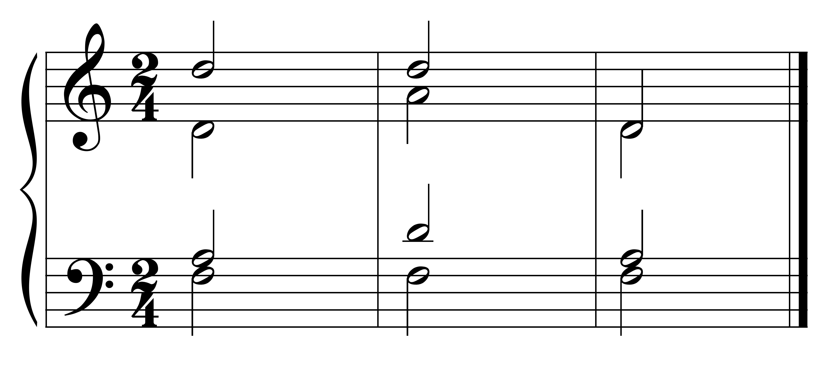

C: 6 6 6

3 3 3

7. Two figures arranged horizontally under one bass note indicate movement in the same voice above the given bass note.

For example, in the following, the note an octave above the bass note is to move to the note a seventh above the bass. The movement is usually accomplished by notes of equal value. In the example below, the 8-7 movement is indicated by 8-7 under one bass note and is realized in quarter notes -- note values half the length of the bass note.

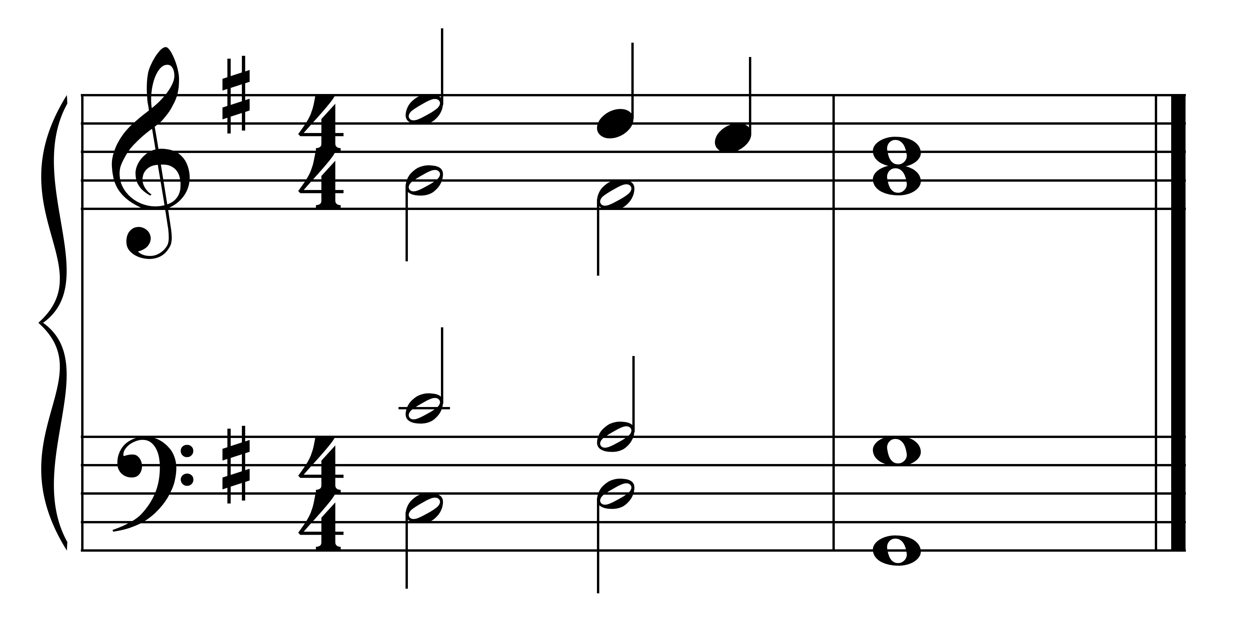

G: 8 - 7