**Cadences**

A **cadence** is a resting point in music.

Cadences occur at the end of phrases (statements of music).

Some cadences are more conclusive than others; some cadences are **final**—they signal the end of a part of music—and some are **non-final**—they are temporary resting points.

In all of music, there are four basic kinds of cadences:

|  |  |
| --- | --- |
| **Final Cadences** | **Non-final Cadences** |
| Authentic | Half |
| Plagal | Deceptive |

**Authentic cadences:**

* Authentic cadences contain a dominant functioning chord followed by a tonic chord.
* The dominant functioning chord may be a V, V7, viio, and vii fully diminished or half-diminished seventh, and any other their inversions.

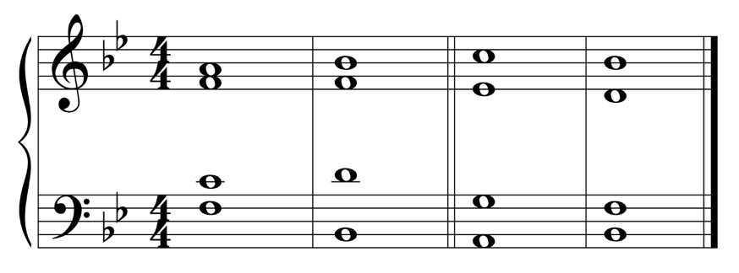

Bb: V I vii~~o~~7 I

* A V(7)-I cadence is the strongest cadence since the roots moves down by 5th – the strongest root movement.
* Authentic cadences may be perfect or imperfect.

**Perfect Authentic cadence:**

* The bass must have scale degree 5 followed by scale degree 1.
* Must have scale degree 1 in soprano in the tonic chord.

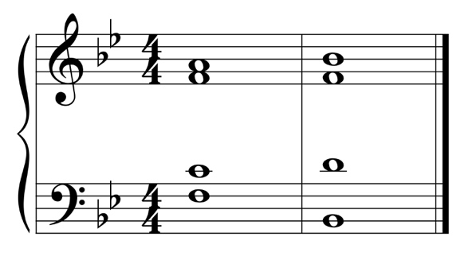

Bb: V I

**Imperfect authentic cadence:**

* Either or both of the above two rules are broken. Either bass does not go from 5-1 or soprano does not end on 1.
* The progression could involve an inversion of the V chord, and inversion of the I chord, or both chords in inversion.

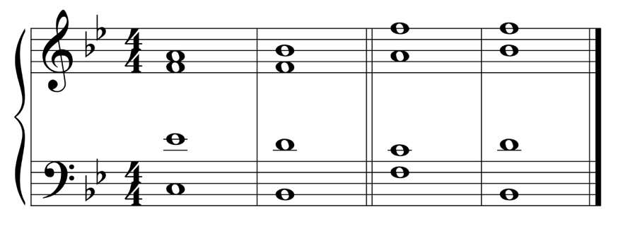

Bb: V $\begin{matrix}4 \\ 3\end{matrix}$ I V I

* The progression could also be a leading tone chord to tonic (viio-I); this progression will always be an imperfect authentic since 5-1 can never be the bass.

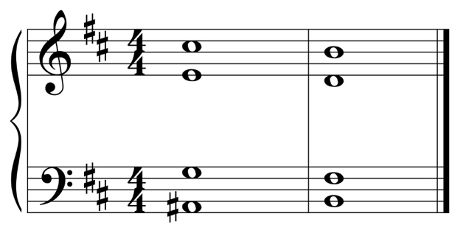

Bb: viio7 i

**Plagal Cadence**

* Usually consists of IV-I.
* Sometimes called the “Amen cadence” since this is the progression used for the word Amen at the end of hymns.

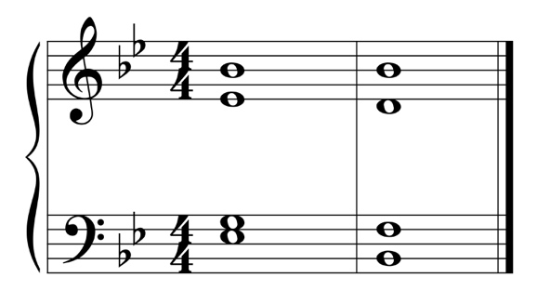

Bb: IV I

**Half cadence**

* Any cadence that end on a V chord.
* Sounds incomplete. A phrase ending on a half cadence usually has another phrase after it to complete the thought.

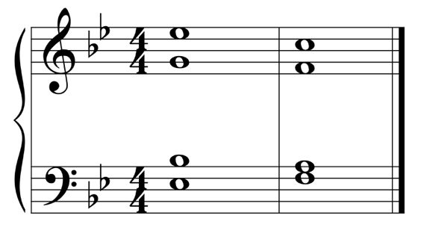

Bb: IV V

**Phrygian Cadence**

* A type of half cadence that is a iv6-V in a minor key.
* Called a Phrygian half cadence due to the half step in the bass – the same interval between scale degrees 2-1 in the Phrygian mode.

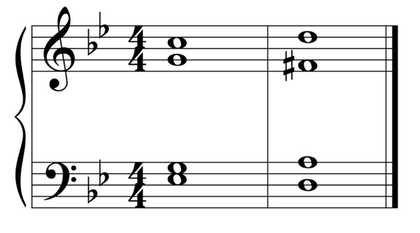

g: iv6 V

**Deceptive Cadence**

* Any progression that takes that dominant functioning chord to a chord other than the expected tonic chord.
* Most times, it is a V-vi chord progression.

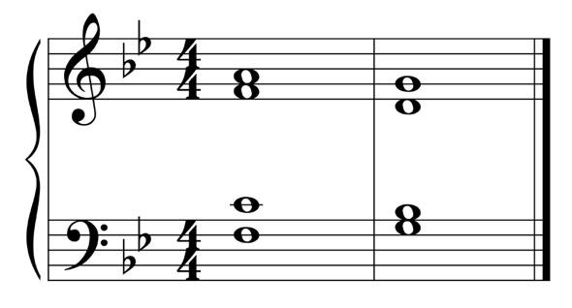

Bb: V vi

* In a minor key, the third of the VI chord must be doubled in order to prevent parallel fifths, parallel octaves or moving a voice an A2 interval melodically.

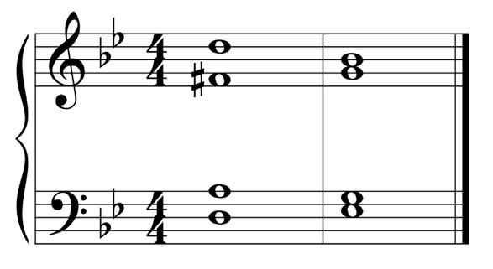

g: V VI