**Augmented Sixth Chords**

**Definition:**

A chord that contains the interval of an augmented sixth.

**Description:**

There are 3 such chords: the German 6th (Gr6), the French 6th (Fr6) and the Italian 6th (It6). The chords consist of the following intervals:

Italian 6: M3, A6

German 6: M3, P5 (or DA4), A6

French 6: M3, A4, A6

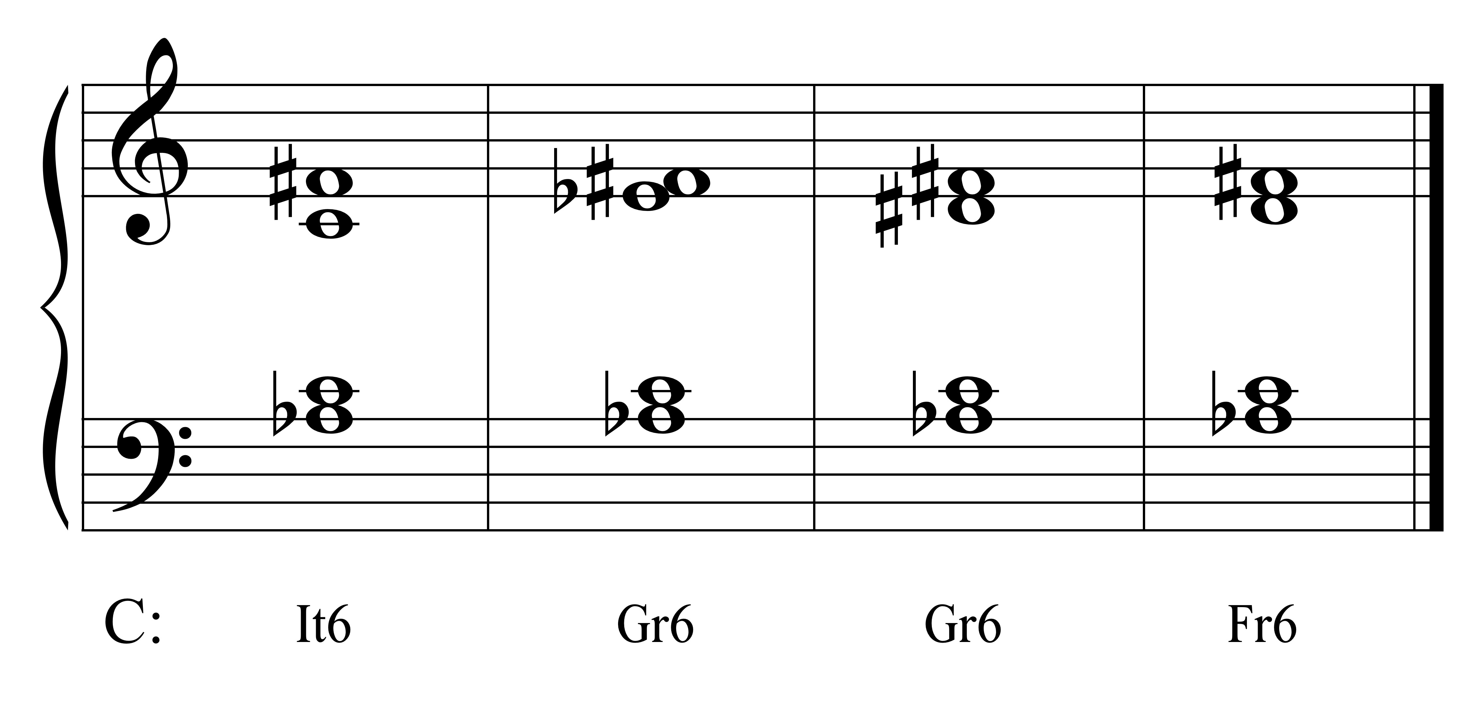

The Gr6 in major may be spelled with a doubly augmented fourth instead of a perfect fifth to show the resolution of the pitches in the direction of the inflection (see part-writing below).

A6 chords are most often built on the note a half step above the dominant (b6) of the scale in both major and minor keys (as the above examples in the key of C).

A6 chords may also be built on the note a half step above the tonic (b2) (see below for examples).

**Sound:**

It6 sounds like an incomplete V7 chord (i.e., with the fifth omitted).

Gr6 sounds like a complete V7 chord.

Fr6 has its own unique sound.

**Function:**

A6 chords are used for color and tension.

They can also be used in chromatic modulations.

**Resolution:**

When built on the b6, A6 chords usually resolve to V or a V $\left(\begin{matrix}6- & 5 \\ 4- & 3\end{matrix}\right)$ progression.

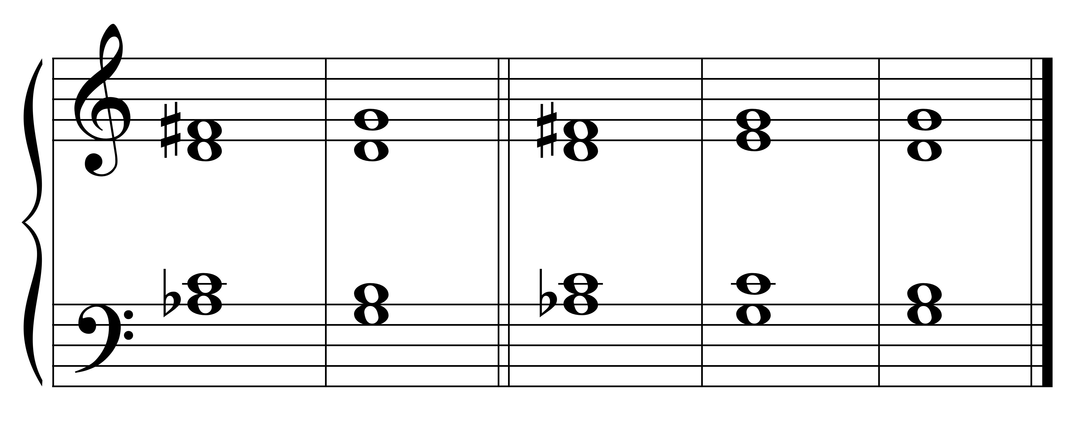

C: Fr6 V Fr6 V $\left(\begin{matrix}6- & 5 \\ 4- & 3\end{matrix}\right)$

When built on the b2, A6 chords will resolve to I.

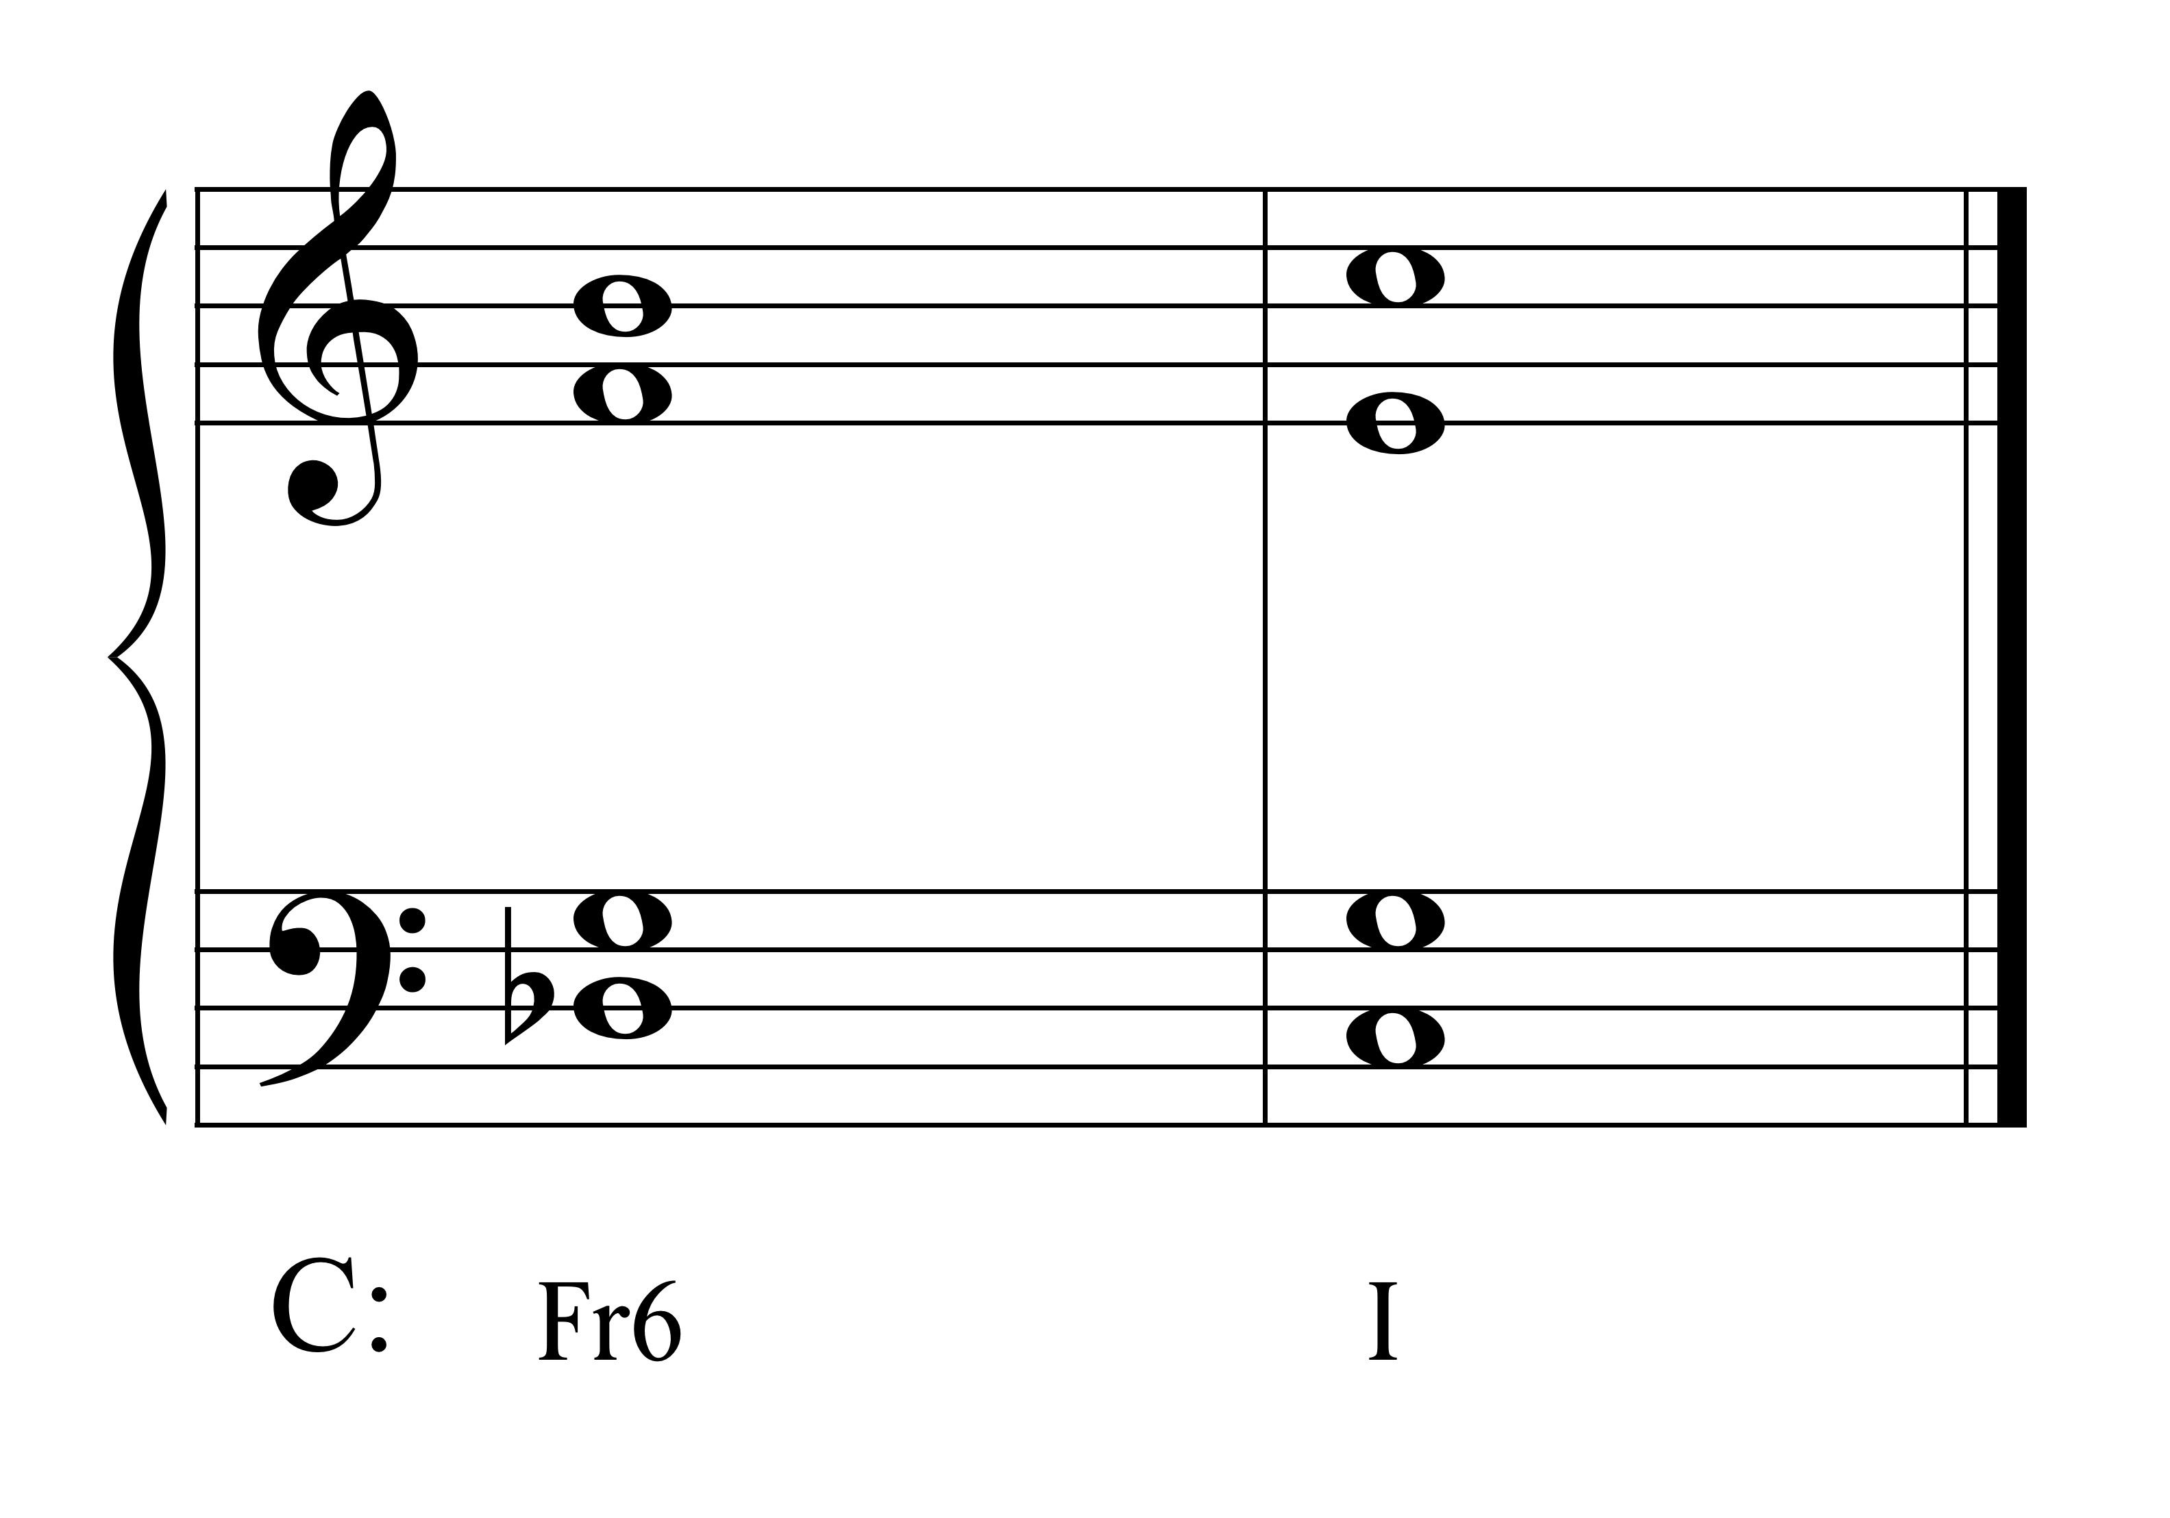

**Part-Writing:**

**Italian 6:**

In the Italian sicth chord, double the note that is a third above the bass; double the unaltered/non-tendency tone.

Resolve the interval of the A6 to the octave; resolve the altered notes in the direction of their inflection/tendency.

Take other notes to the nearest chord tone following part-writing rules.

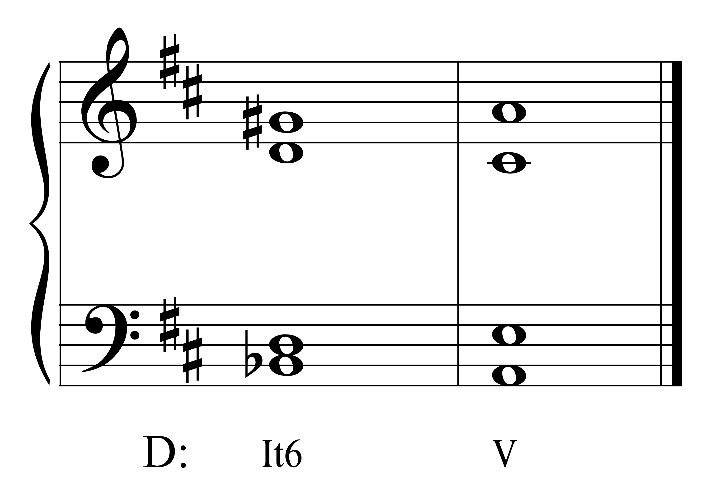

**French 6:**

The French 6 has four notes, so put one note in each voice. Do not leave any notes out.

Resolve the interval of the A6 to an octave; resolve the notes in the direction of their inflection/tendency.

Keep the common tone.

Take the other note to the nearest chord tone.

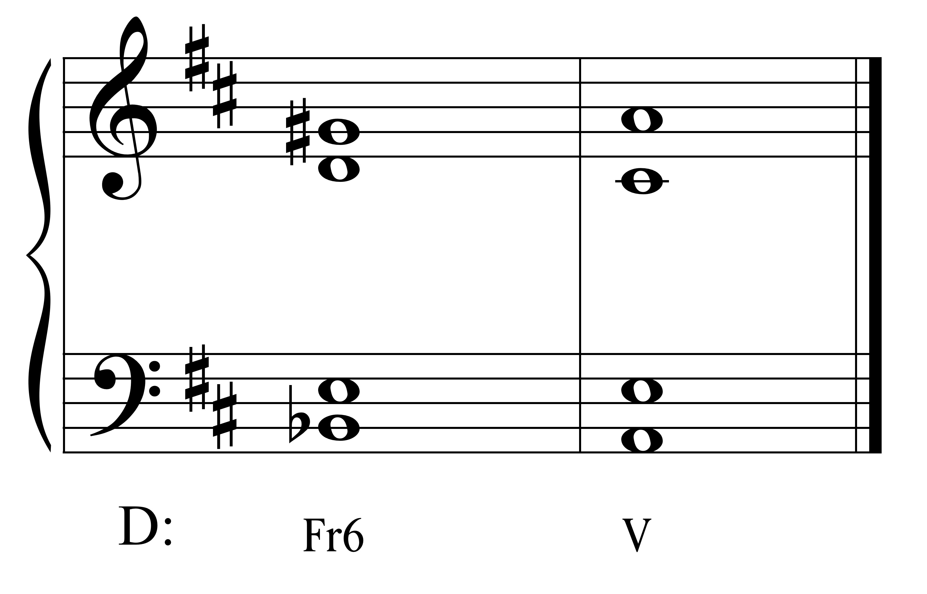

**German 6:**

The German has four notes; put one not in each voice. Do not leave out notes. Resolve the interval of the A6 to an octave.

Resolve the interval of the A6 to an octave; resolve the notes in the direction of their inflection/tendency.

Take the notes to the nearest chord tone.

*Problem – Parallel Fifths:*

Resolving a Gr6 (on b6) directly to V or Gr6 (on b2) directly to I will result in parallel perfect fifths (see below).

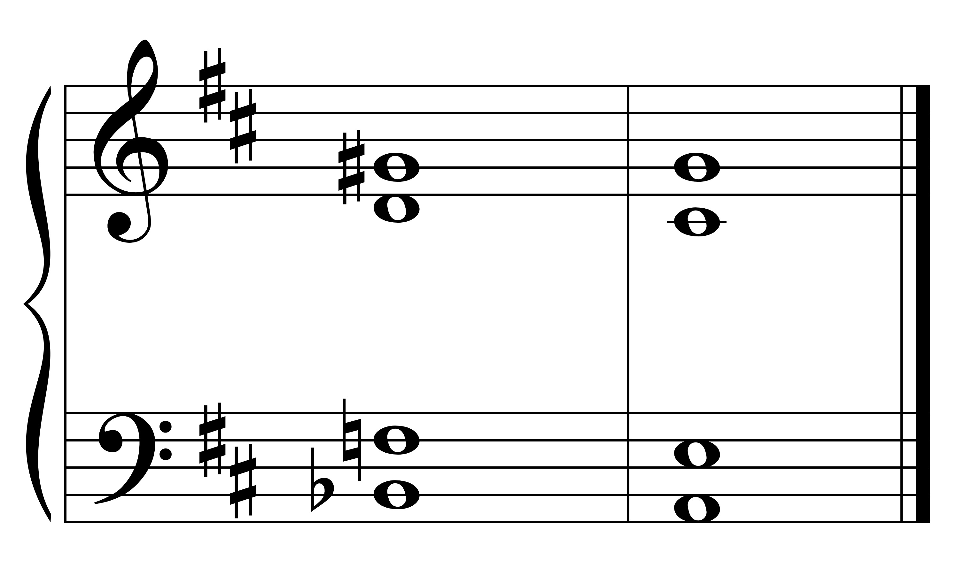

D: Gr6 V

In order to avoid the P5s, resolve the German to another chord (e.g., a cadentialor a Fr6 or It6) before resolving to the V (see second and third examples below).

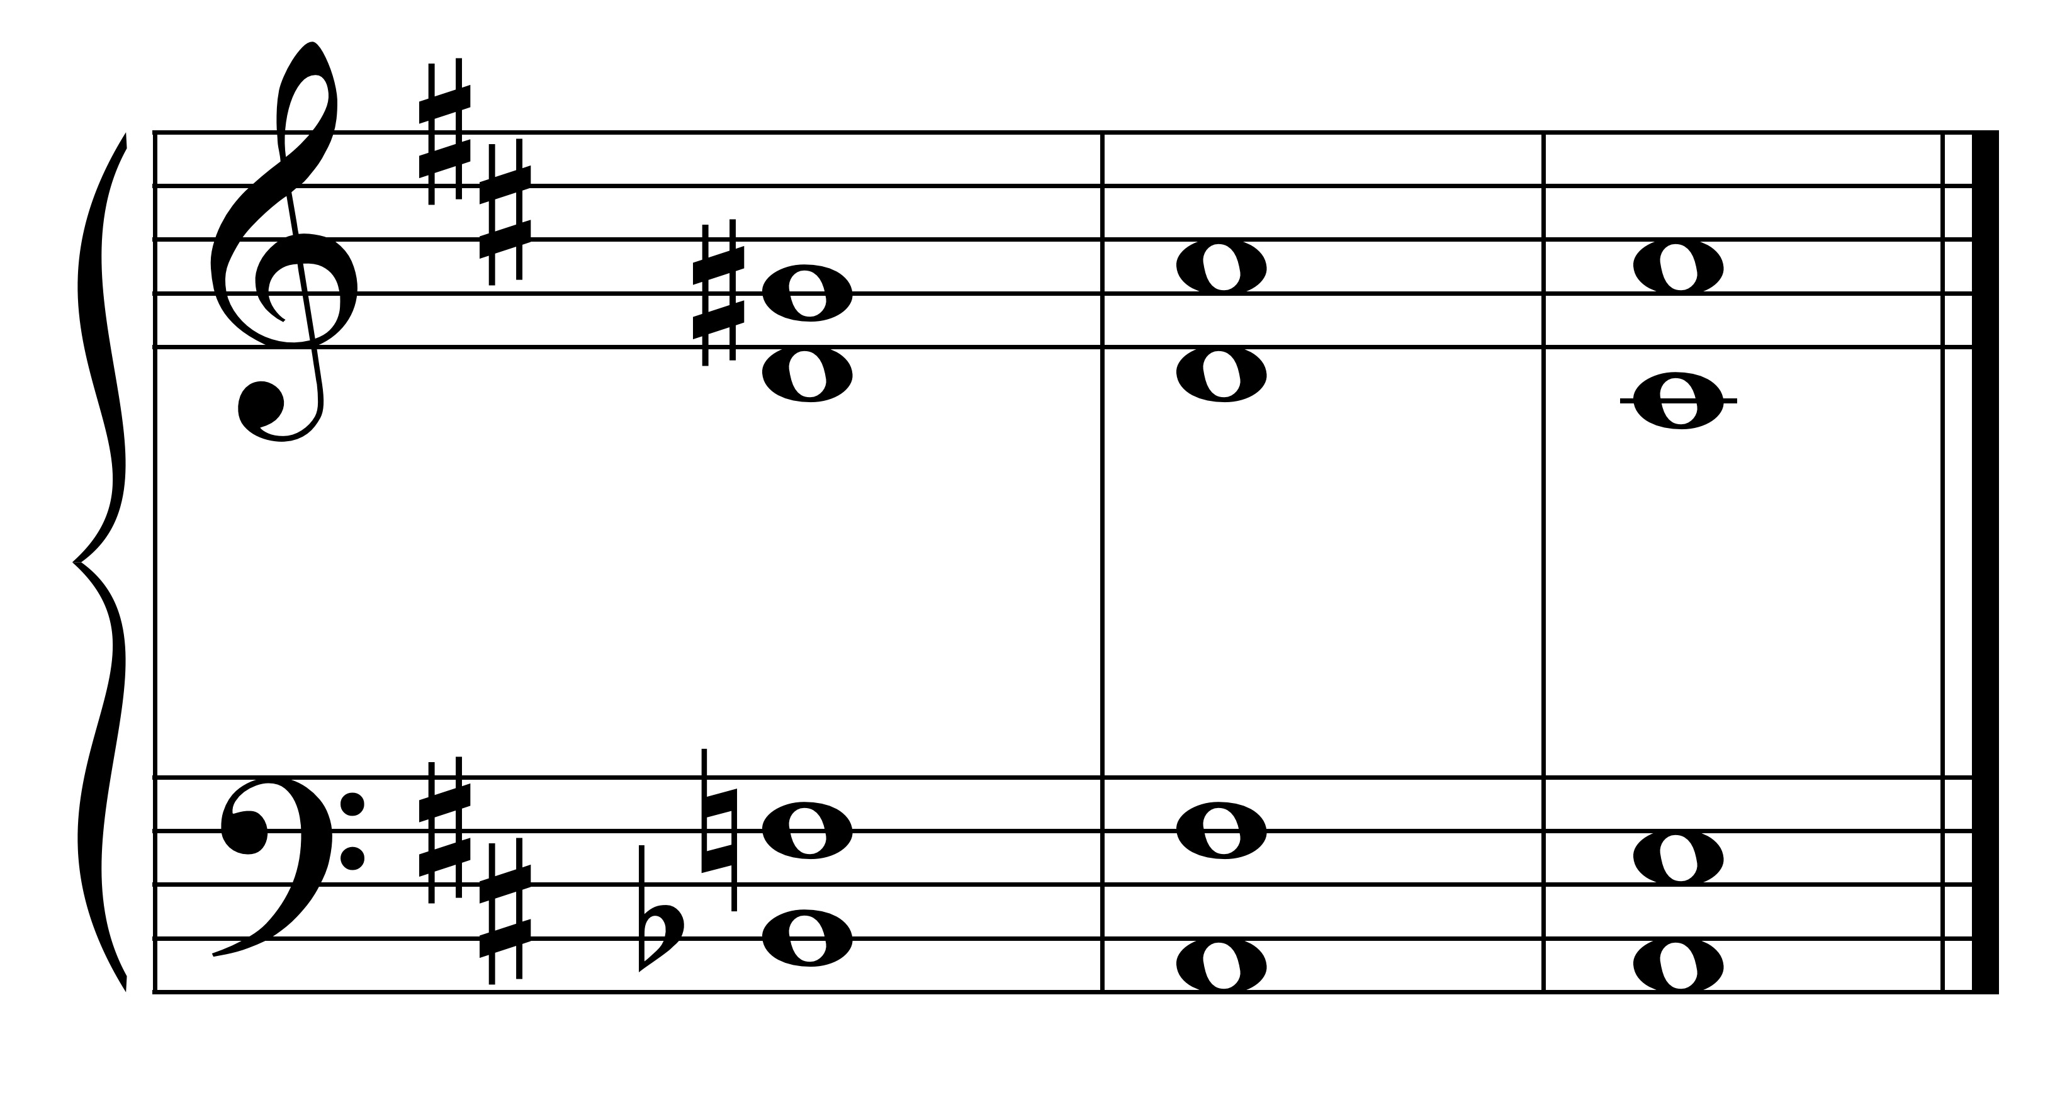

D: Gr6 V $\left(\begin{matrix}6- & 5 \\ 4- & 3\end{matrix}\right)$

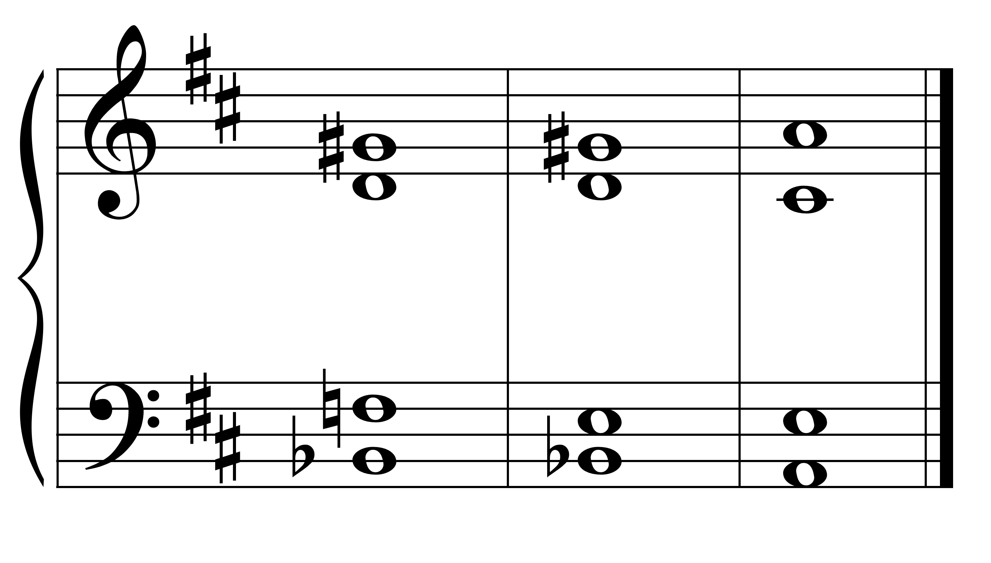

D: Gr6 Fr6 V

*Problem:* In a major key, spell the Gr6 with the DA4 spelling to show the resolution of that tone to the third of the V $\left(\begin{matrix}6- & 5 \\ 4- & 3\end{matrix}\right)$.

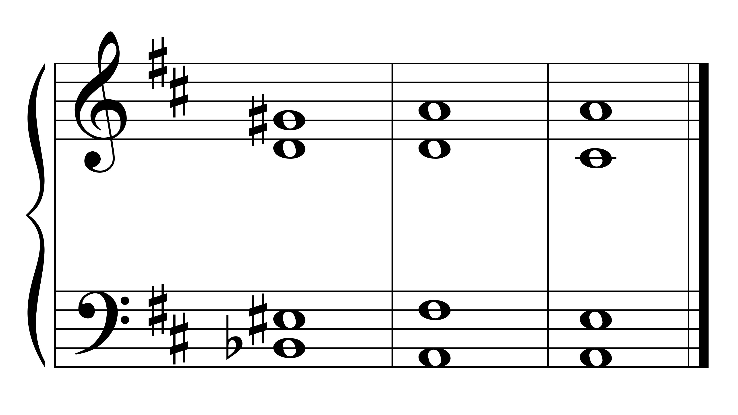

D: Gr6 V $\left(\begin{matrix}6- & 5 \\ 4- & 3\end{matrix}\right)$

**Other:**

Augmented 6th chords can be created by scale degrees other than b6 and b2. They may be built on the note a half-step above the note of resolution creating a secondary function. See the example below.

