$\begin{matrix}6 \\ 4\end{matrix}$**(Second inversion) Chords**

**Explanation:**

$\begin{matrix}6 \\ 4\end{matrix}$ chords are triads in second inversion.

They should be used in four-part writing and in music in general with extreme caution because they are unstable chords since they contain the interval of the fourth above the bass (a dissonance).

**Second inversion triads should be used only in the following ways:**

***Cadential***:

Even though the chord looks like a tonic chord, it really is a dominant chord. As such, it is labeled as a V chord with a 6 and 4 above the bass that move to a 5 and 3 above the bass.

Since the chord is a V chord, the bass is doubled.

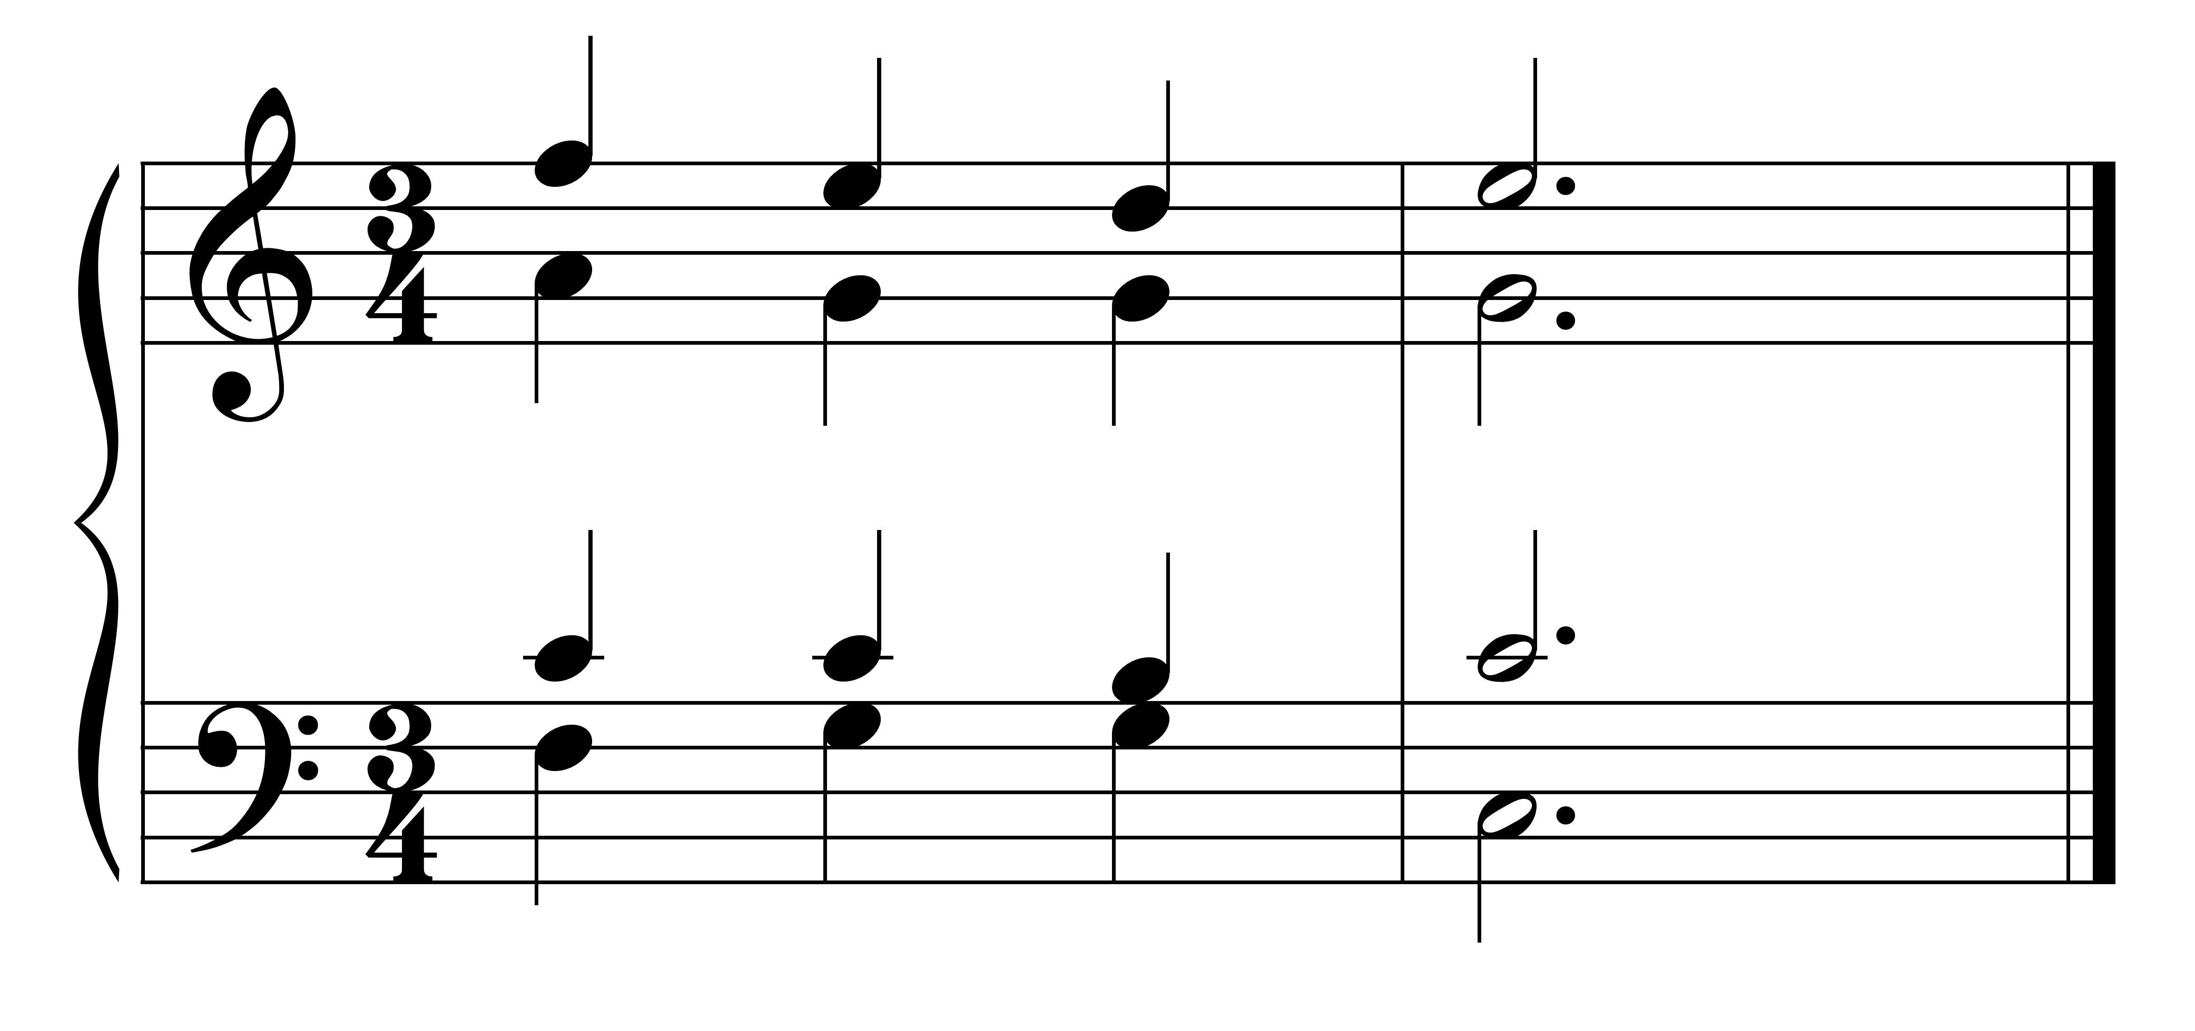

C: IV V $\left(\begin{matrix}6- & 5 \\ 4- & 3\end{matrix}\right)$ I

***Passing bass:***

The bass note of the chord acts as a passing note in the bass (see examples below).

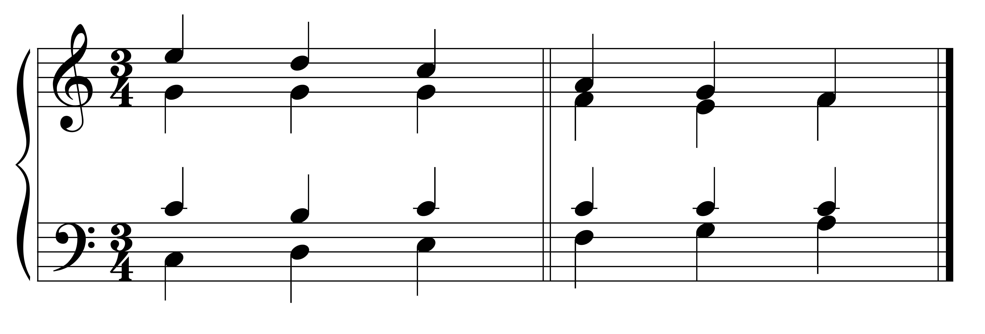

C: I V $\begin{matrix}6 \\ 4\end{matrix}$ I6 C: IV I $\begin{matrix}6 \\ 4\end{matrix}$ IV6

The bass note of the chord is doubled.

***Pedal or neighbor (or static bass):***

In this type of chord, the bass note is approached and left by the same tone and is between two root position triads that are the same.

The bass note of the chord is doubled.

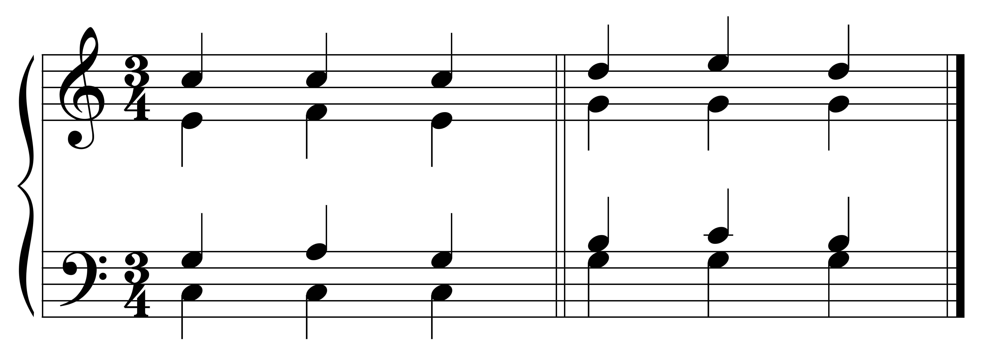

C: I IV $\begin{matrix}6 \\ 4\end{matrix}$ I C: V I $\begin{matrix}6 \\ 4\end{matrix}$ V

***Arpeggio:***

The bass note of this chord participates in an arpeggiation of the same chord.

This type of chord use may occur with any type of triad (usually major and minor chords).

The bass note of the chord is doubled.

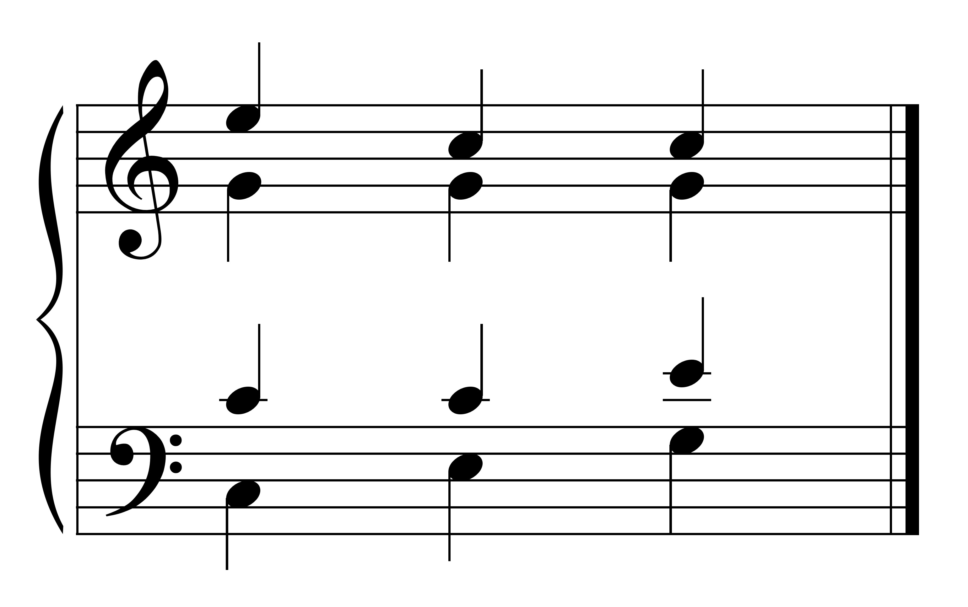

C: I I6 I $\begin{matrix}6 \\ 4\end{matrix}$