**seventh chords**

Every triad can be extended by adding another third above the fifth of the chord. The resulting chord is known as a **seventh chord** since it contains the interval of a seventh above the bass.

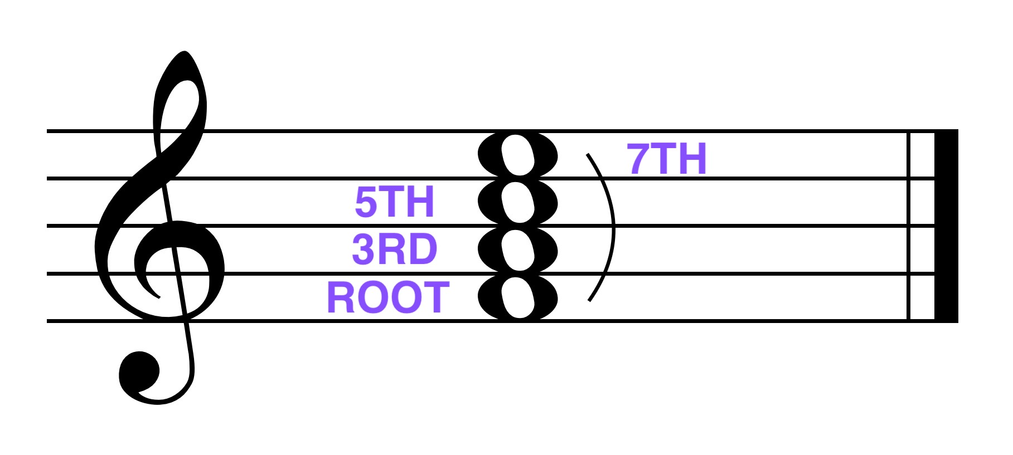

*Qualities:*

Seventh chords will be of various qualities.

The quality of the seventh chord is designated by the quality of the triad and the quality of the seventh:

|  |  |  |  |
| --- | --- | --- | --- |
| **Seventh chord** | **triad** | **Seventh** | **Example** |
| major (M) | major | major |  |
| minor (m) | minor | minor |  |
| dominant (Mm) | major | minor |  |
| [fully] diminished (o) | diminished | diminished |  |
| half-diminished () | diminished | minor |  |
| augmented (A) | augmented | major |  |
| minor - major (mM) | minor | Major |  |

The dominant seventh chord (the Mm seventh chord) is by far the most common seventh chord. The fully and half diminished seventh chords are the next most common chords.

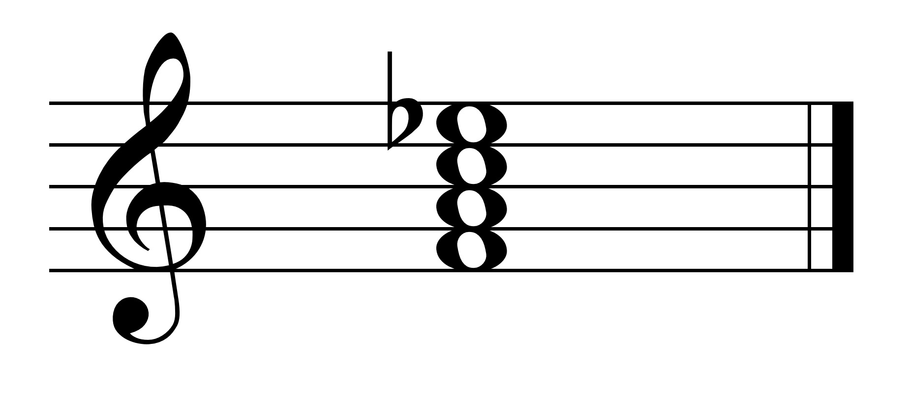 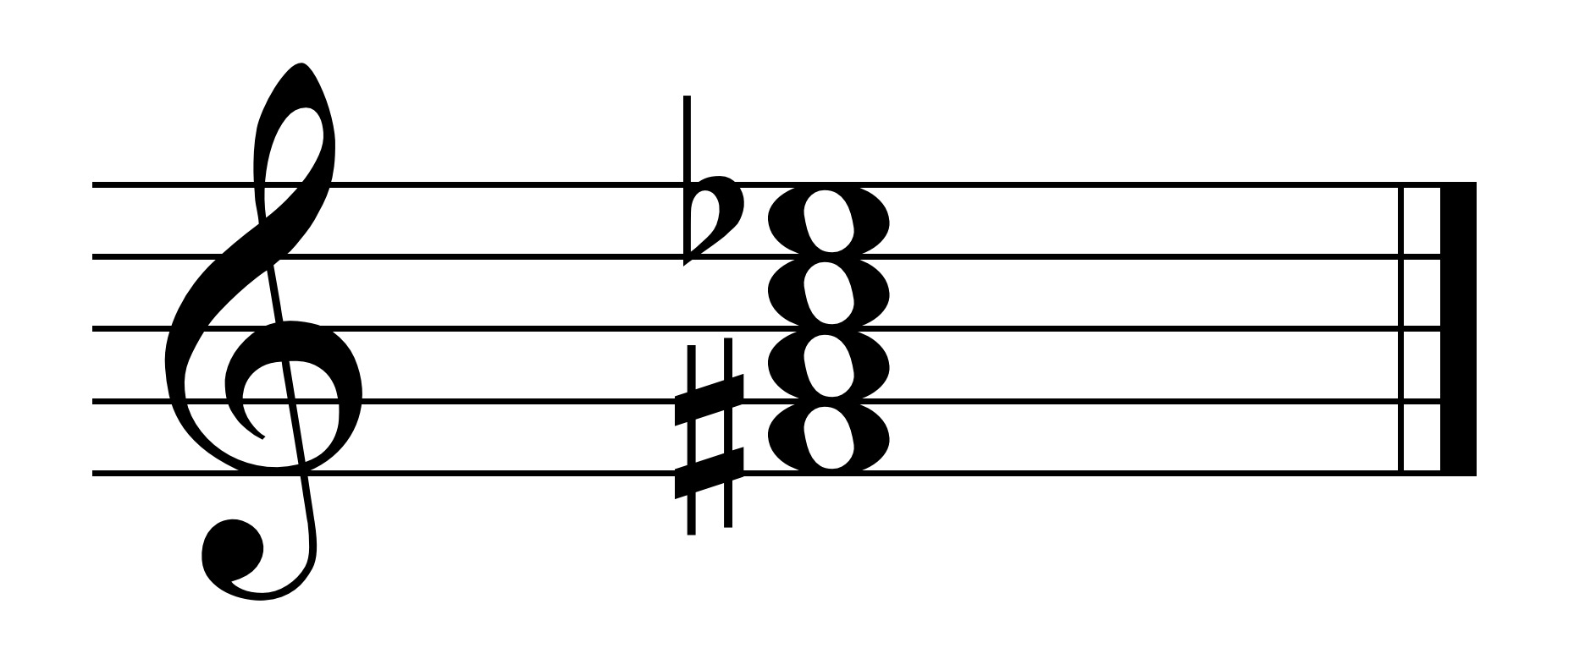 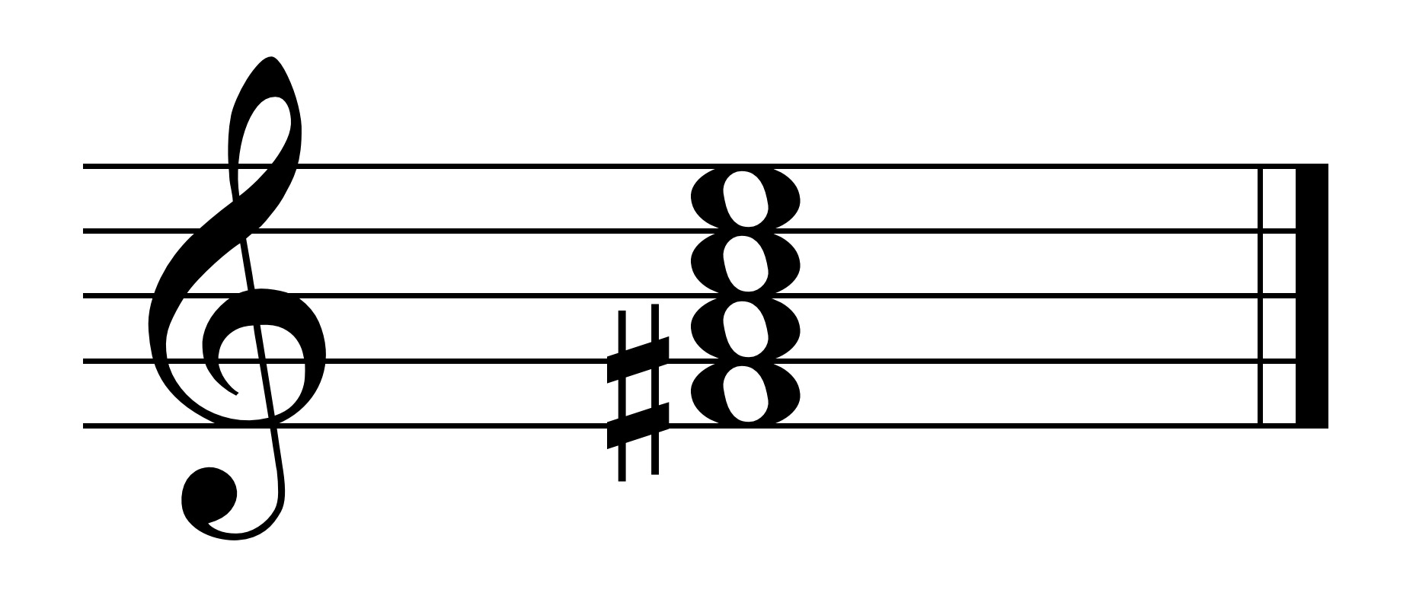

Dominant 7 fully diminished half diminished

Major-minor dim-dim dim-minor

*Inversions*

Seventh chords can be inverted. A seventh chord is inverted if the bottom-most note, the bass, is not the root of the chord.

Since there are four notes (instead of 3 in a triad), there is a root position and first, second and third inversion of a seventh chord.

*Root Position:*

A seventh chord is said to be in root position when all the intervals are types of thirds.

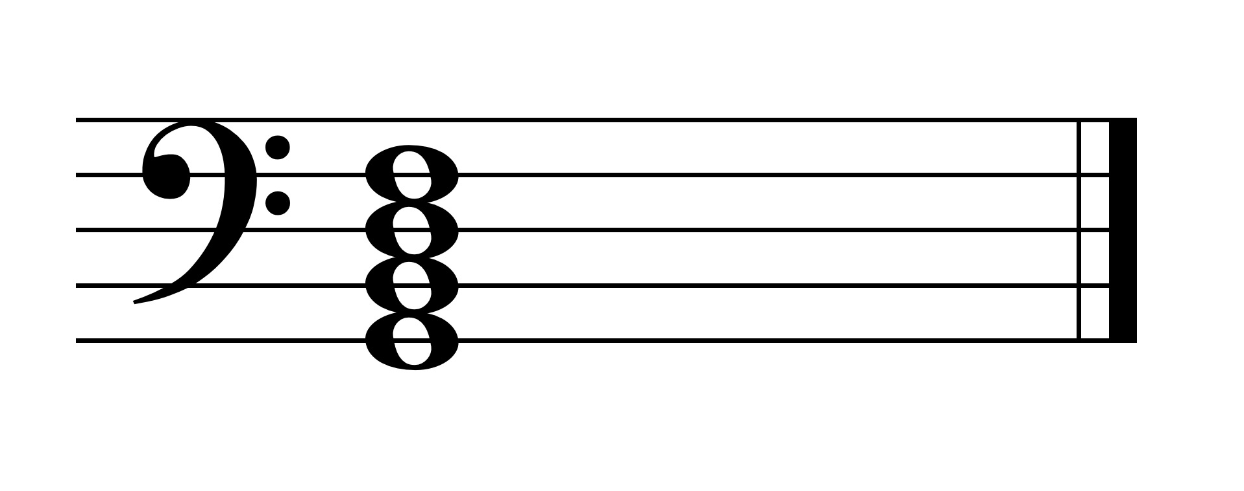

7

Root position is designated simple by a 7, meaning there is a third, fifth and seventh above the bass. (The third and the fifth above the bass are understood in the Arabic numeral designation.)

*First inversion:*

A seventh chord is said to be in first inversion if the third of the chord is in the bass (the bottom-most voice).

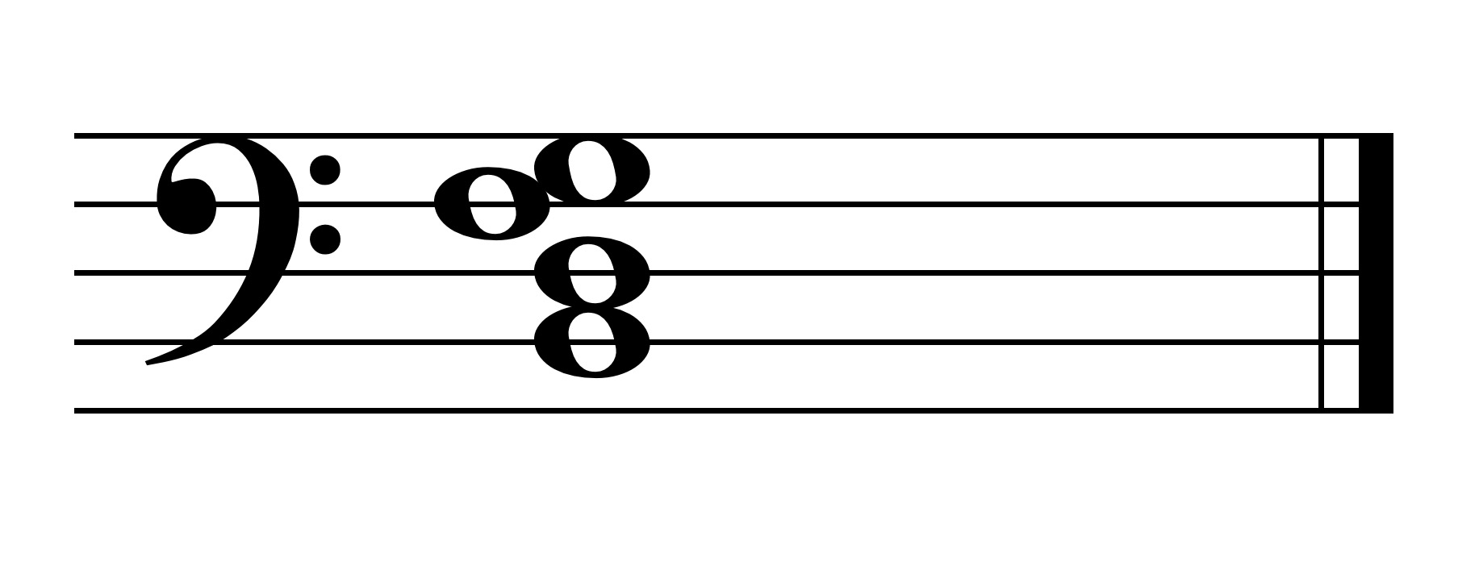

6

5

3

In first inversion, all seventh chords contain the intervals of a 3rd, 5th, and 6th. The shortened Arabic designation is . The note a third above the bass is assumed to be present.

*Second inversion:*

A seventh chord is said to be in second inversion if the fifth of the chord is in the bass (the bottom-most voice).

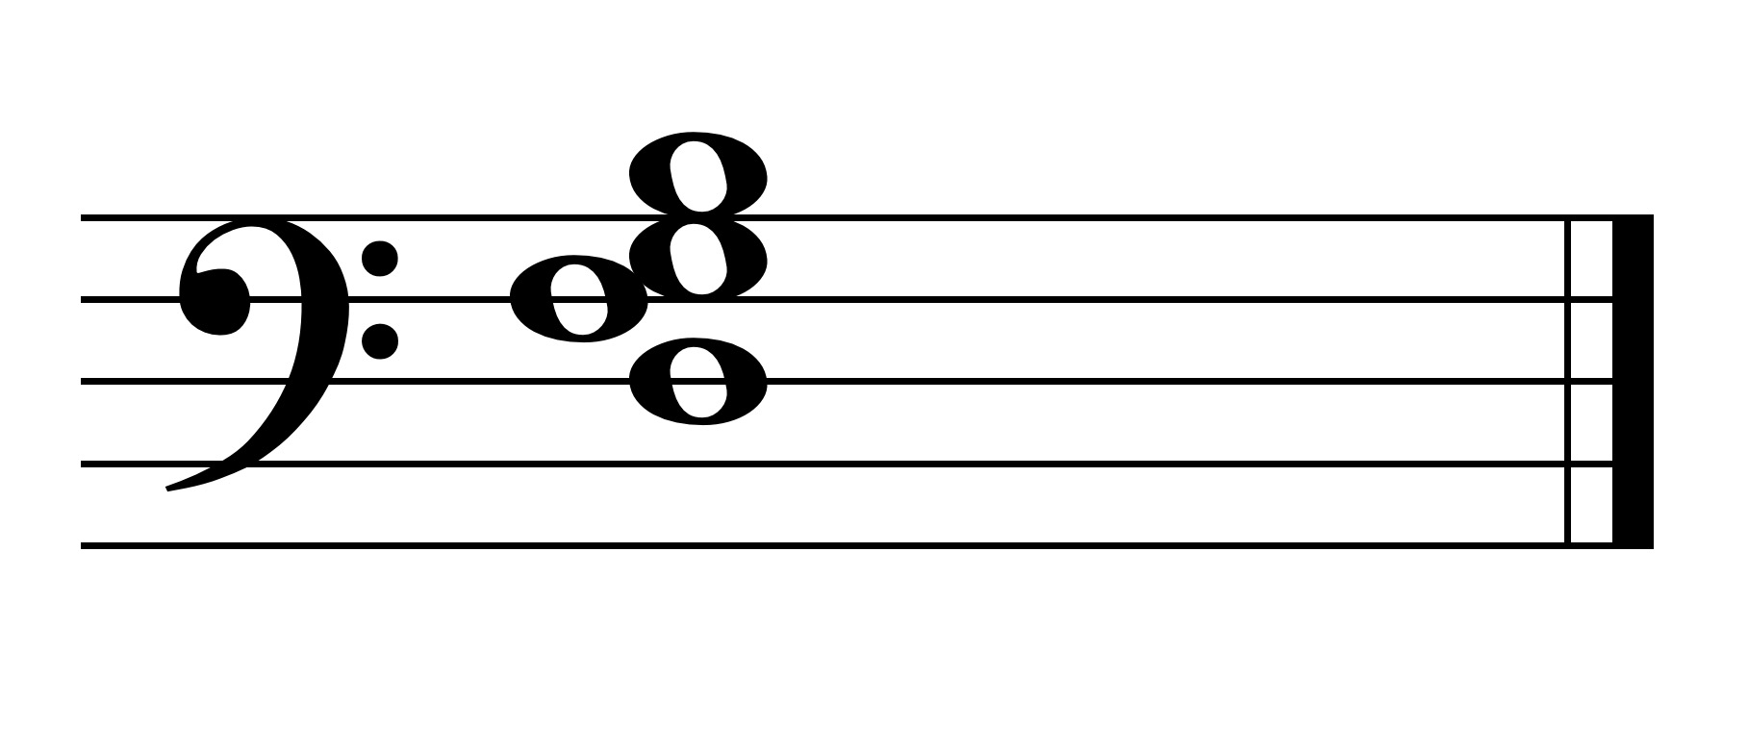

6

4

3

In second inversion, all seventh chords contain the intervals of a 3rd, 4th, and 6th. The shortened Arabic designation is . The note a sixth above the bass is assumed to be present.

*Third inversion:*

A seventh chord is said to be in third inversion if the seventh of the chord is in the bass (the bottom-most voice).

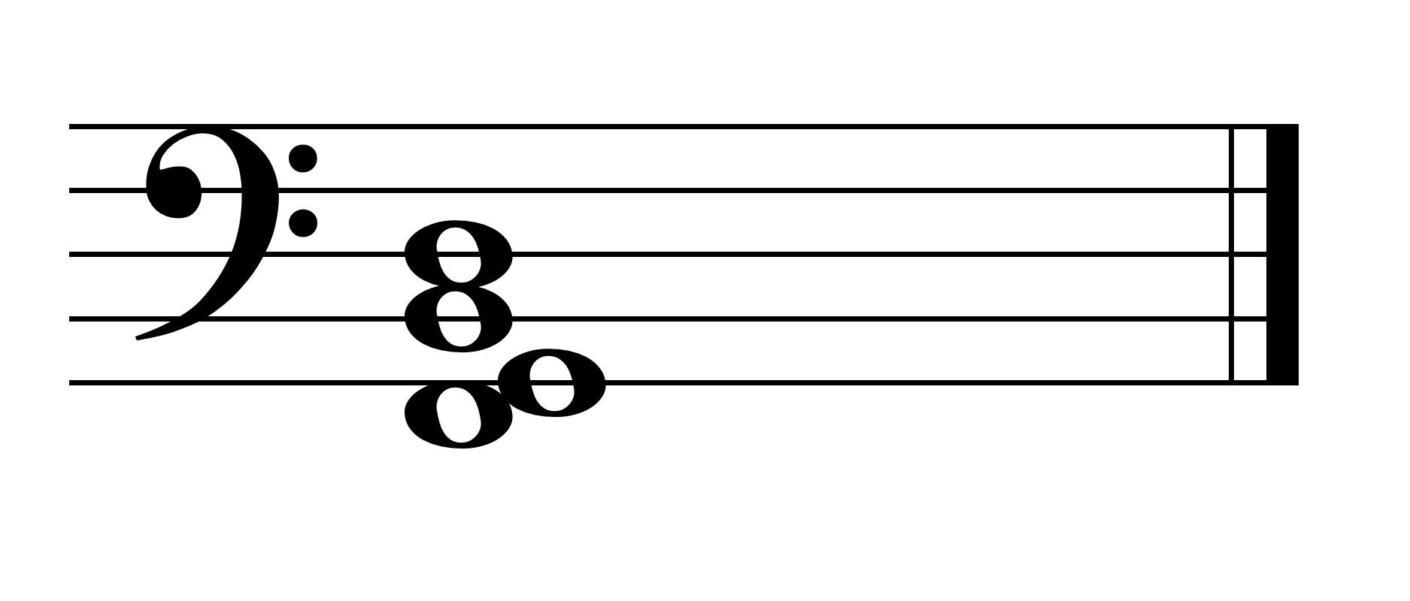

6

4

2

In third inversion, all seventh chords contain the intervals of a 2nd, 4th, and 6th. The shortened Arabic designation is . The note a sixth above the bass is assumed to be present.