Part-Writing
(SATB style)

• Use proper notation.

Notate the Soprano (S) on the treble clef staff with stems up.
Notate the Alto (A) on the treble clef staff with stems down.
Notate the Tenor (T) on the bass clef staff with stems up.
Notate the Bass (B) on the bass clef staff with stems down.

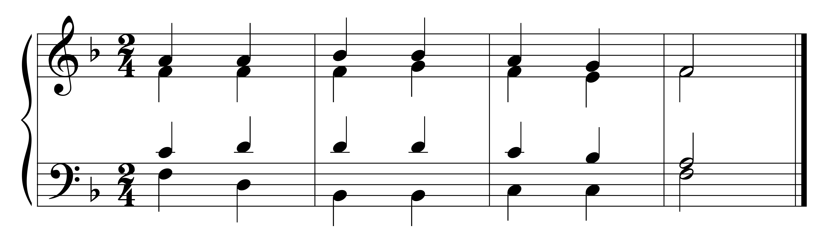
Soprano
Alto

Tenor
Bass

Chords may be in open or close spacing.
Chords are in close spacing when no chord tone can be placed between the SA or AT voices.
Chords are in open spacing when you can put another chord tone in between the S and A and/or between the A and T voices.

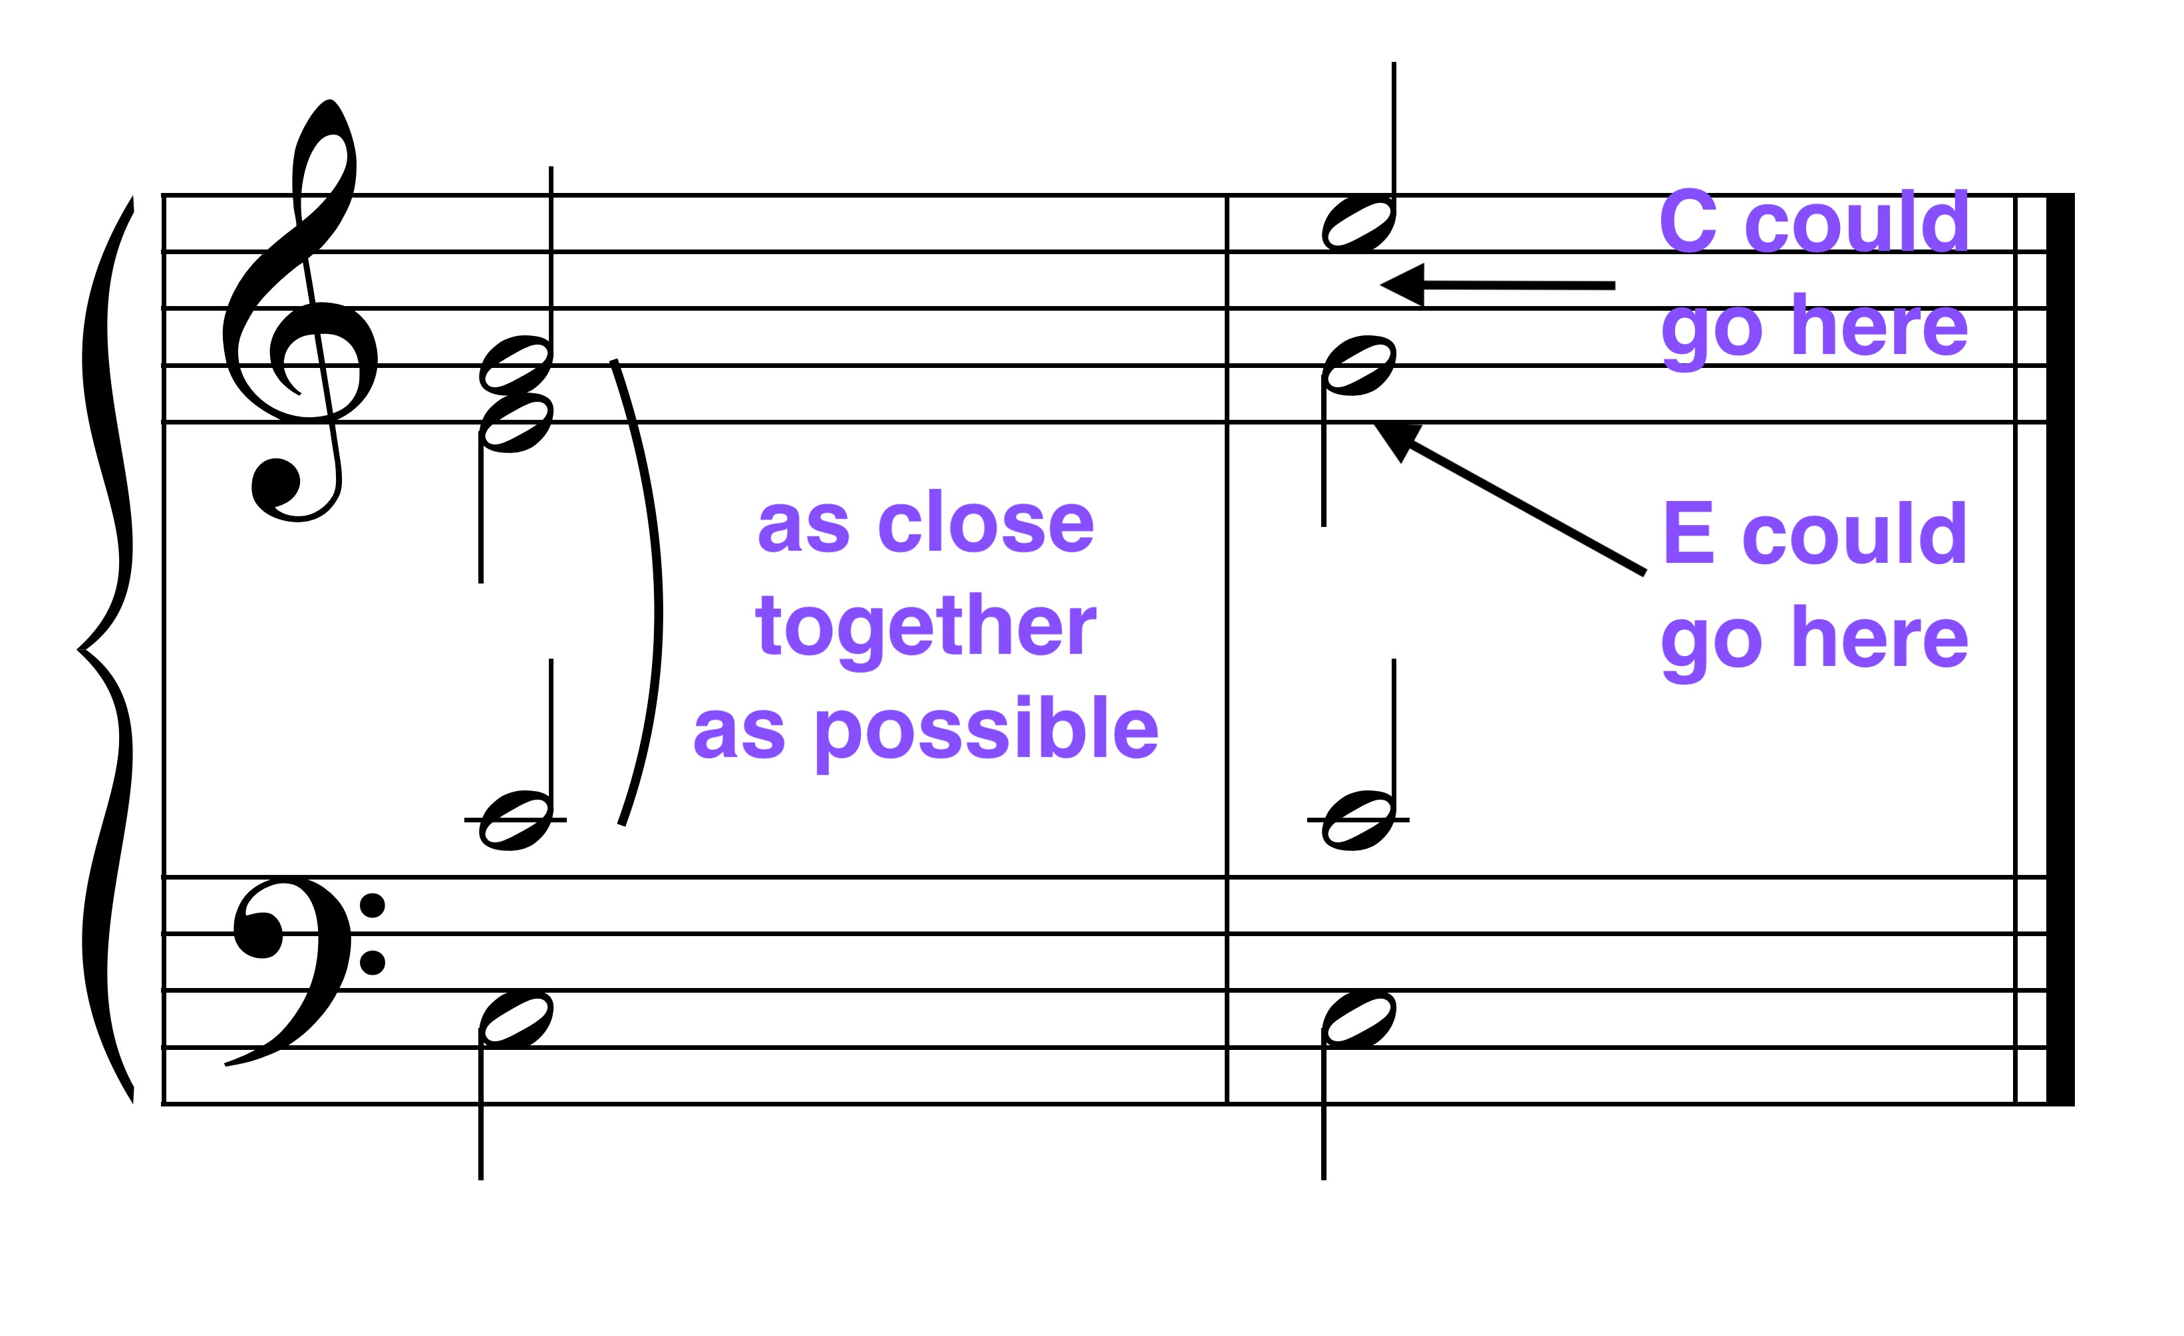
Close Spacing Open Spacing

• Maintain 4 distinct voices; maintain the individuality of the voices.

Keep the voices in their proper ranges.

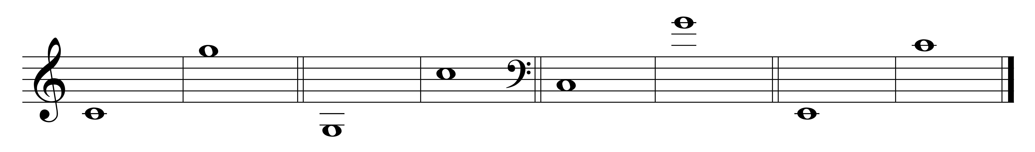
Soprano (S) Alto (A) Tenor (T) Bass (B)

The maximum distance between S and A and A and T is a P8.
The maximum distance between T and B is 2 P8s.

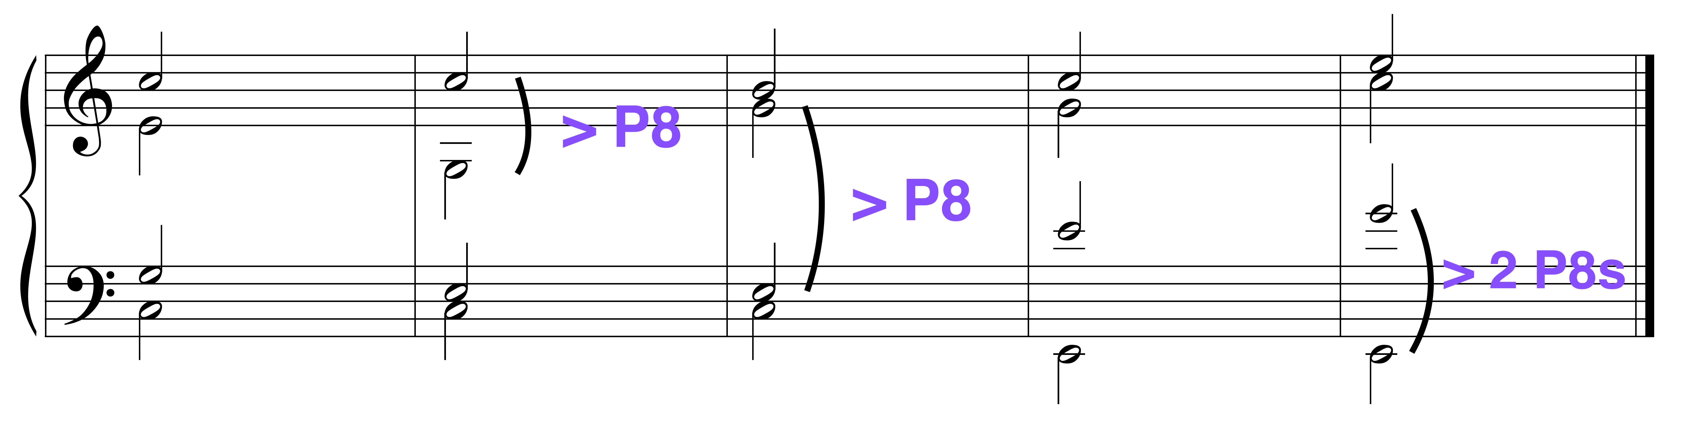
Good No No Good No

Do not cross voices in the same chord or overlap voices between two adjacent chords.

Crossed voices Overlapped voices
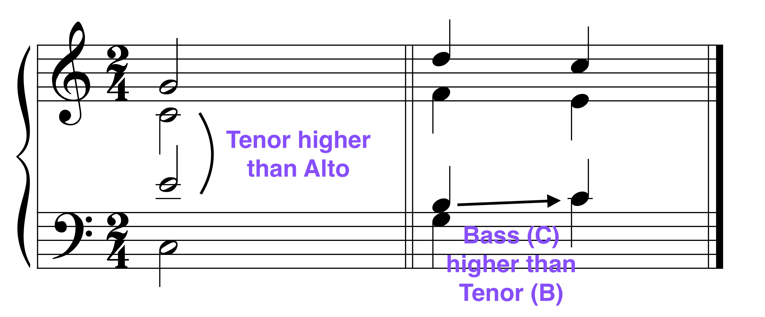

Use contrary or oblique motion to the bass more frequently than similar motion. Use parallel motion only when necessary.

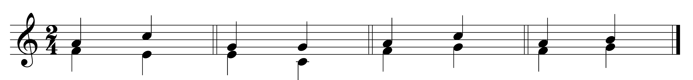
Contrary Oblique Similar Parallel

* Contrary motion -- voices move in opposite directions.
* Oblique motion -- one voice remains on the same note while the other voice moves.
* Similar motion -- voices move in the same direction by different intervals.
* Parallel motion -- voices move in the same direction by the same interval.

NEVER write parallel P1, P5 or P8. (Parallel 5ths shown below.)

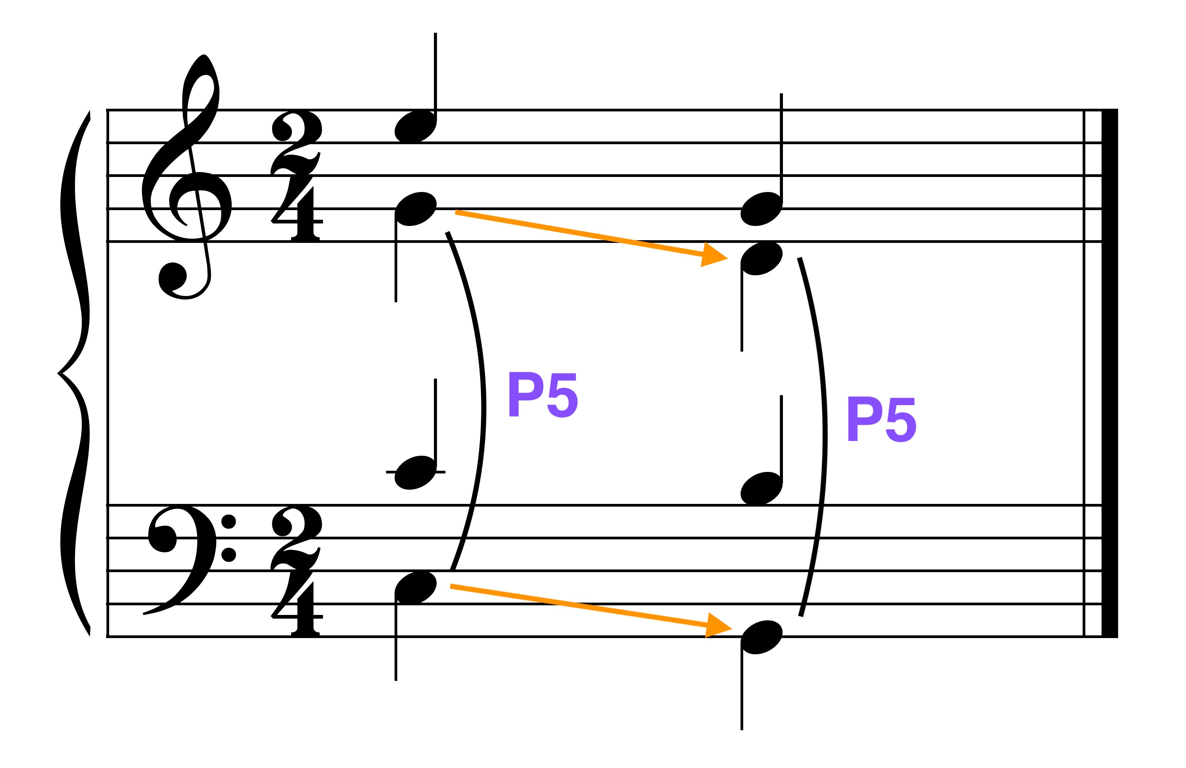
• Double the stable tone in a chord.

In root position triads, double the root (the most stable tone).

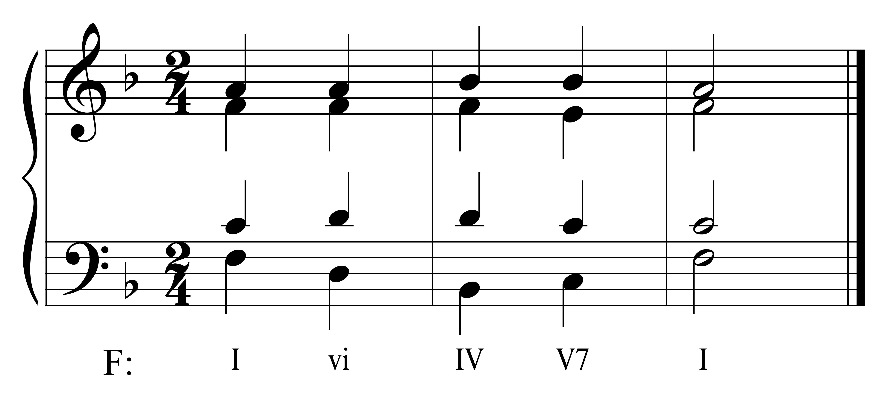
EXCEPT:

In diminished triads, double the 3rd (not a note of the tritone).
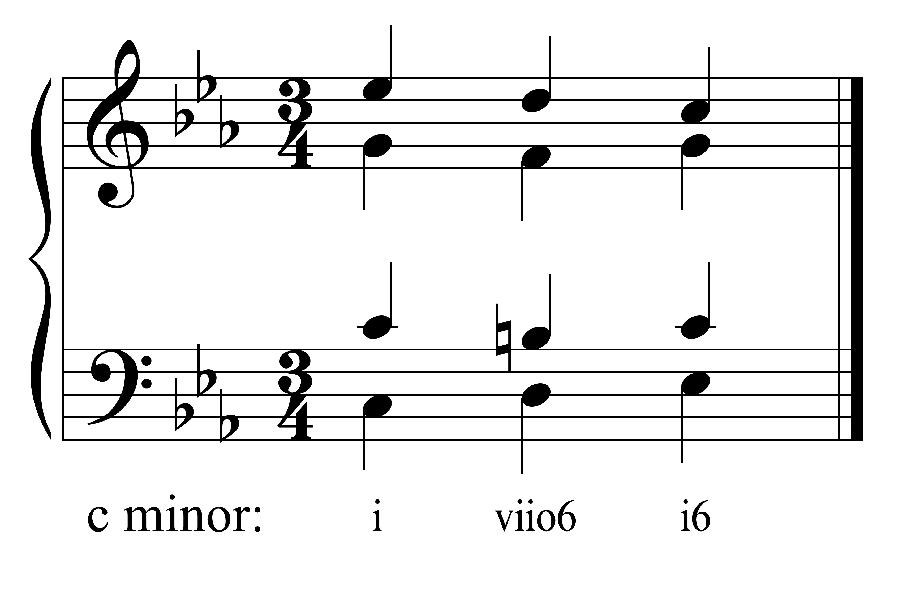
In V-VI in minor keys, double the 3rd of the VI chord.

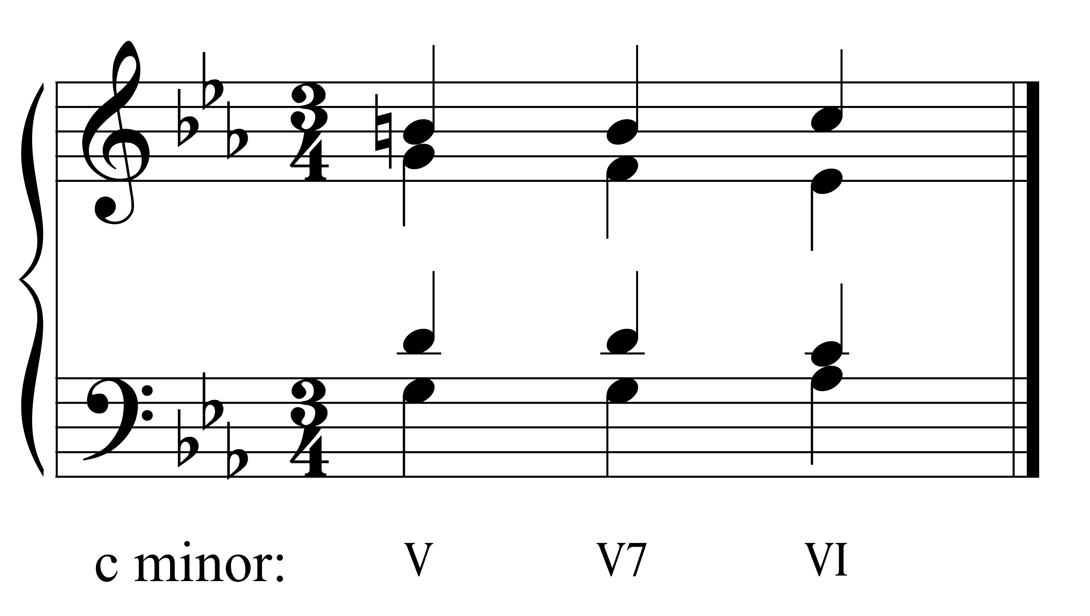

In first inversion triads, double a stable tone. OR: double the soprano. OR: double the 1, 4, or 5 scale degree.

In the example below: In the viio6 chord, the D is doubled since the other two notes in this chord (B and F) form a tritone – a very unstable interval. In the I6 chord, the C, the tonic or scale degree 1, is doubled; this note is also the soprano tone in the chord.

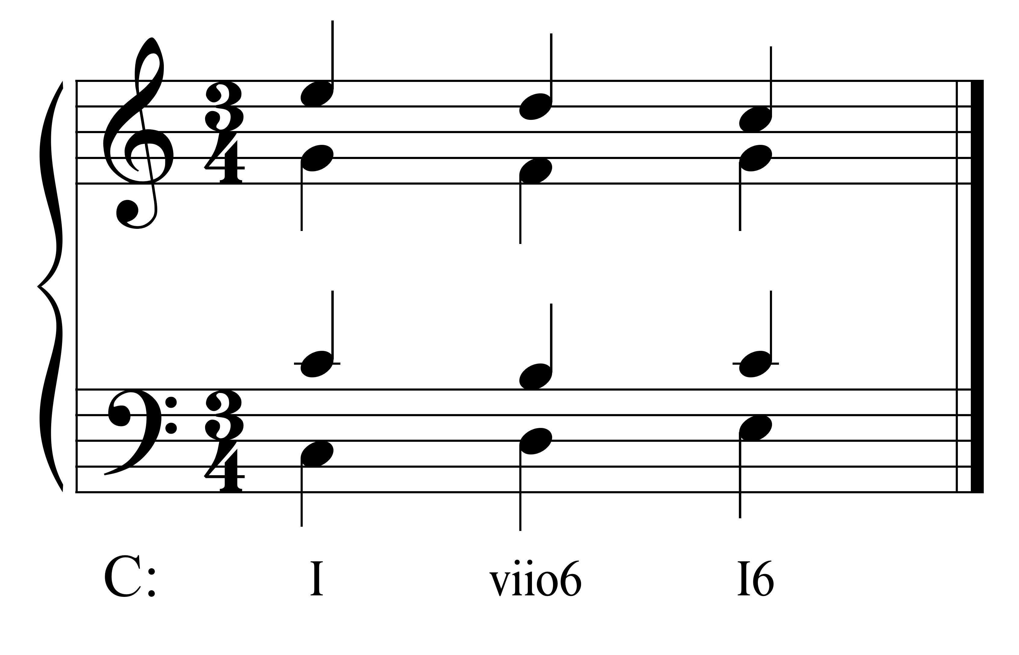
In the example below: In the ii6 chord the third of the chord, the bass and scale degree 4, is doubled. In the V6 chord, the G, scale degree 5, is doubled.

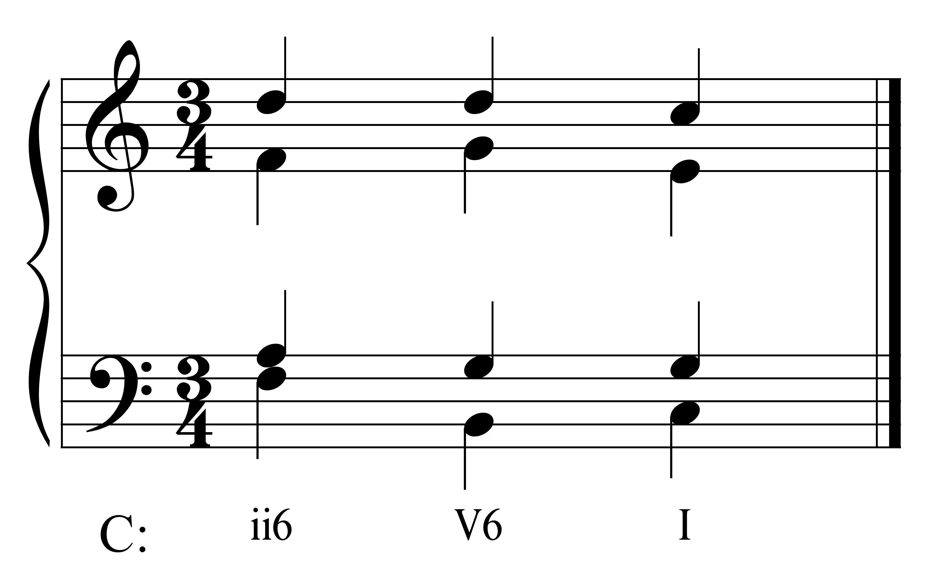

In second inversion triads, always double the bass.

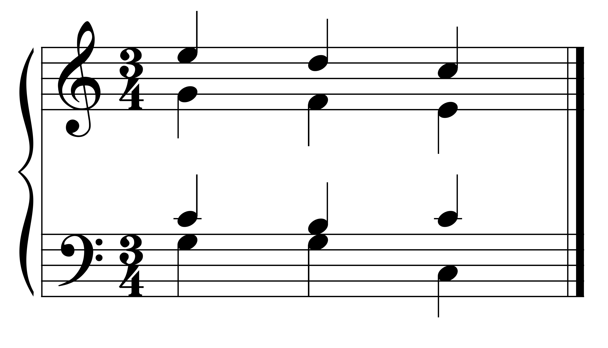
C: I V7 I

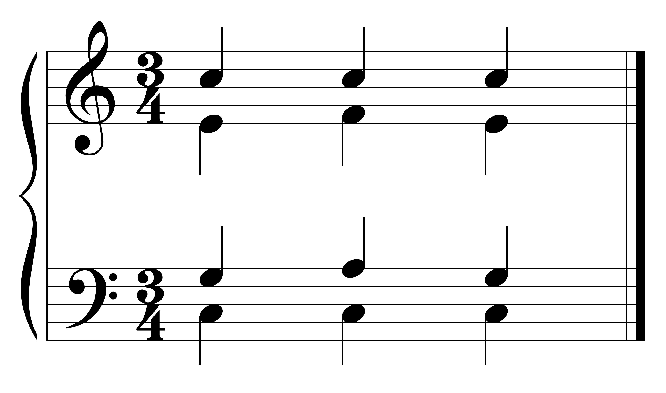
C: I IV$\begin{matrix}6 \\ 4\end{matrix}$ I

In Incomplete triads, triple the root, include the third, and omit the fifth.
In the example below, the I chord is incomplete; it has 3 roots (C) and 1 third (E).

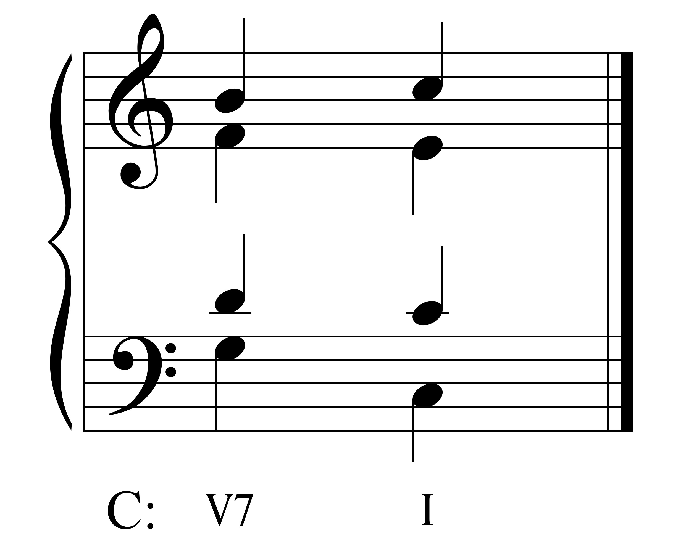

In Incomplete seventh chords, double the root, include the third and the seventh.
In the following example, the V7 chord is incomplete; it has 2 roots (G), 1 third (B), and 1 seventh (F).

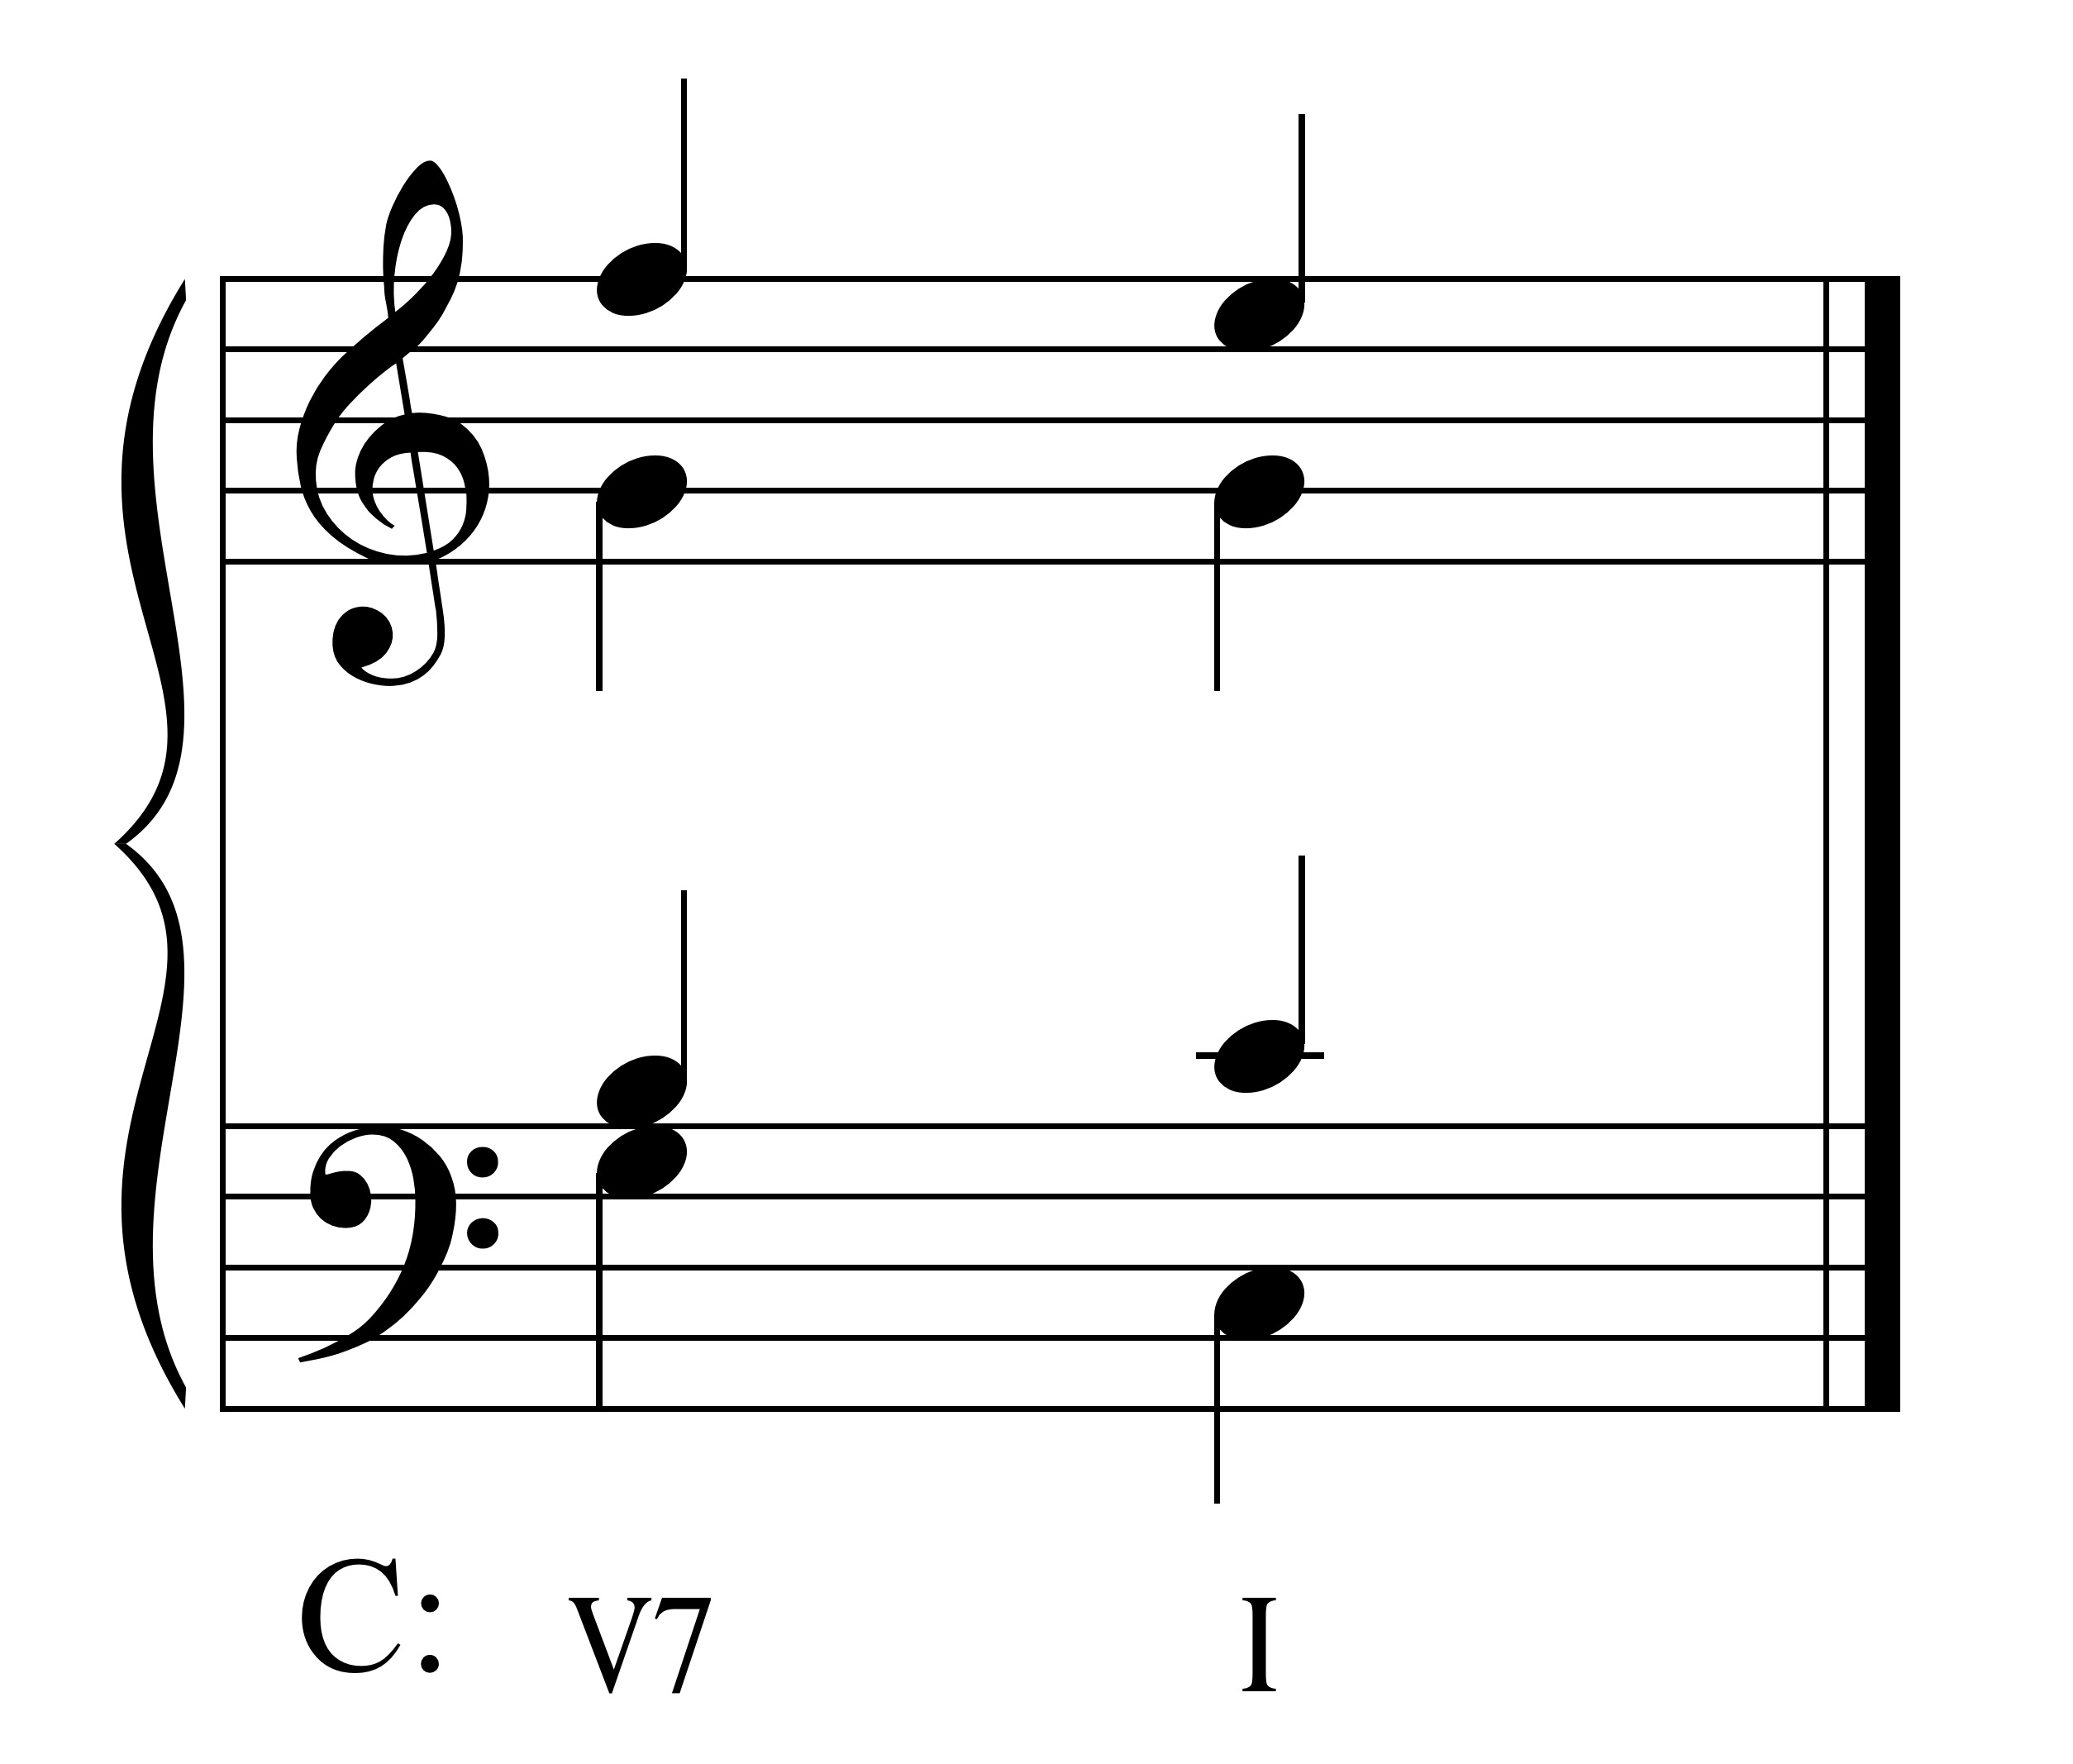

Never double the leading tone. When both resolved to tonic, it creates parallel octaves.

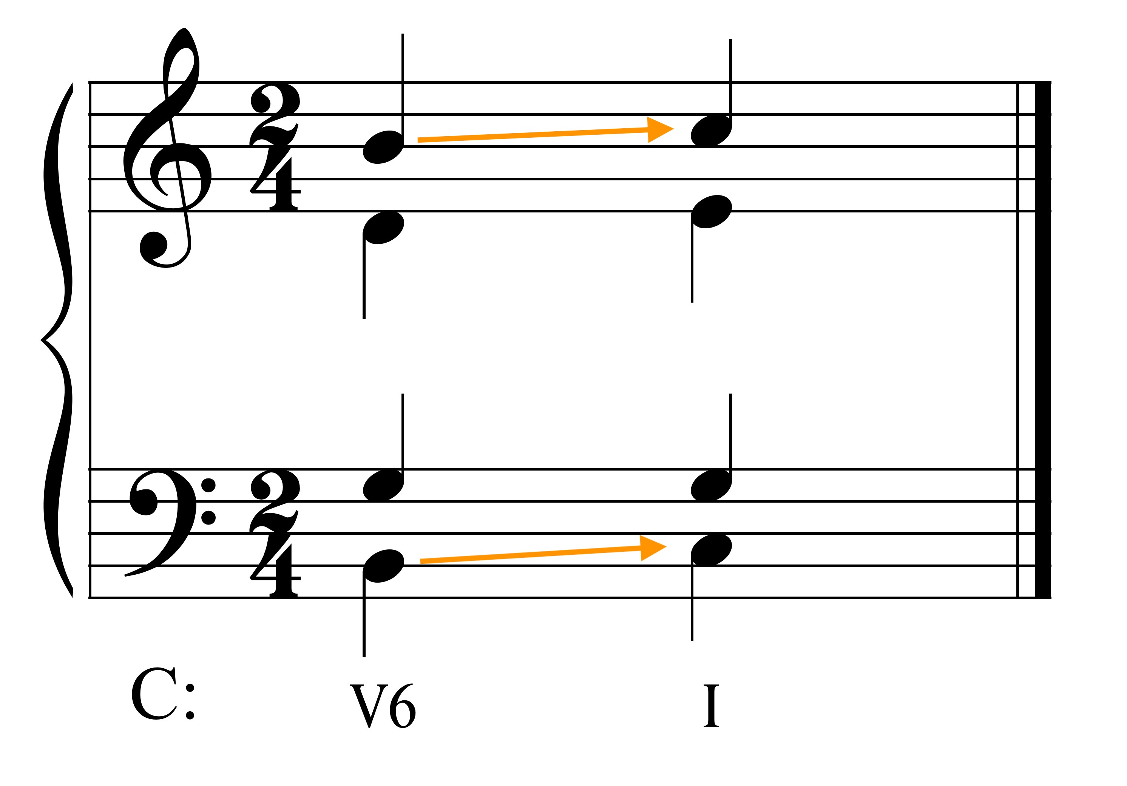

• Move to the nearest chord tone at all times.

Use conjunct motion (stepwise) as much as possible.

Do not leap in a voice (melodically) more than a P8. Try to limit leaps in the soprano to a M6, in the tenor and alto to a P4.

Do not leap twice in the same direction unless outlining a triad.

Don't write hidden octaves or fifths. Don't move in the same direction in the outer voices (soprano and bass) and by leap in the soprano to an octave or a fifth.

Hidden/Direct 8:
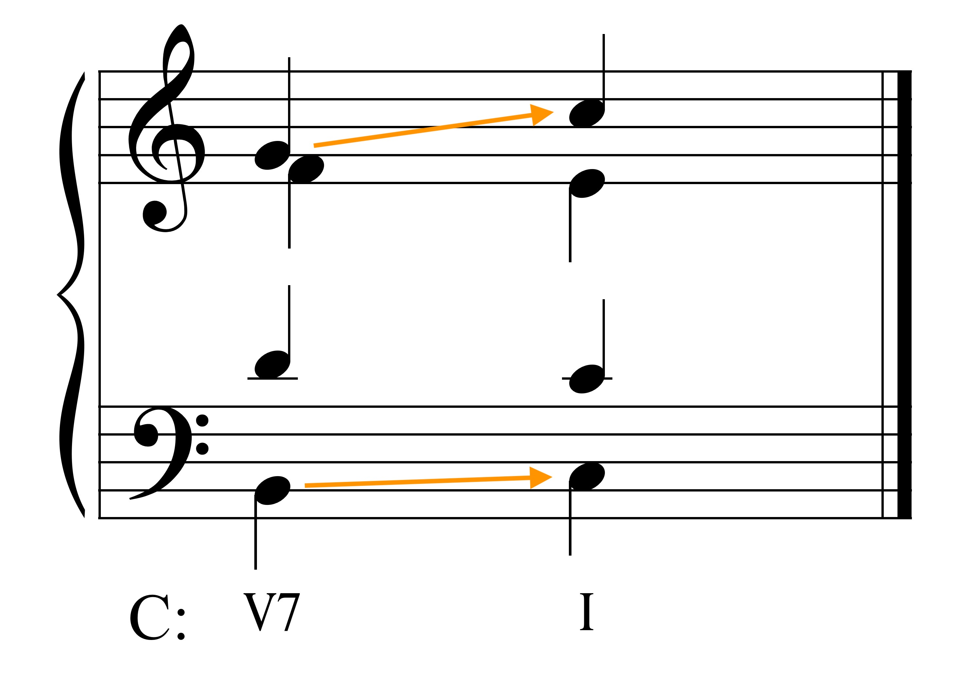

Hidden/Direct 5:
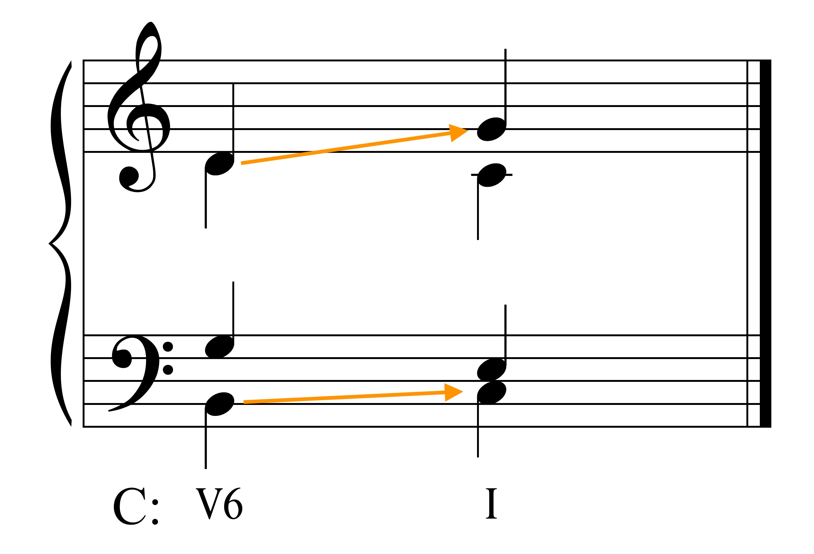

Don't use augmented or diminished intervals melodically.

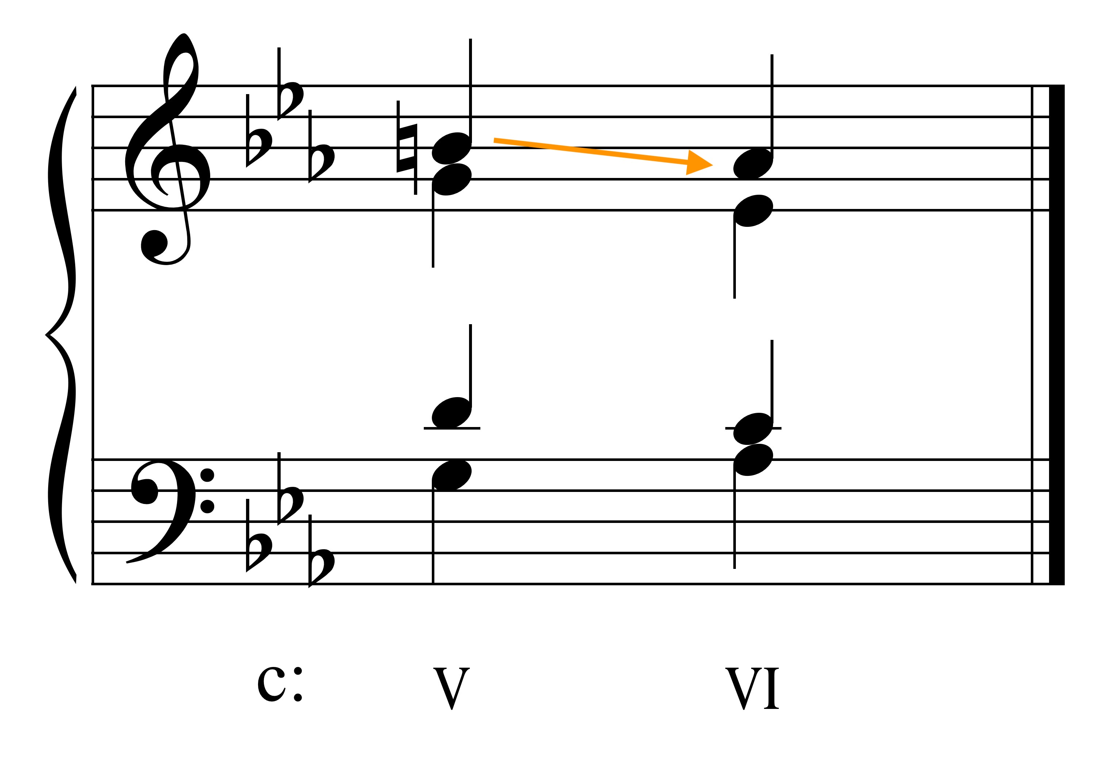
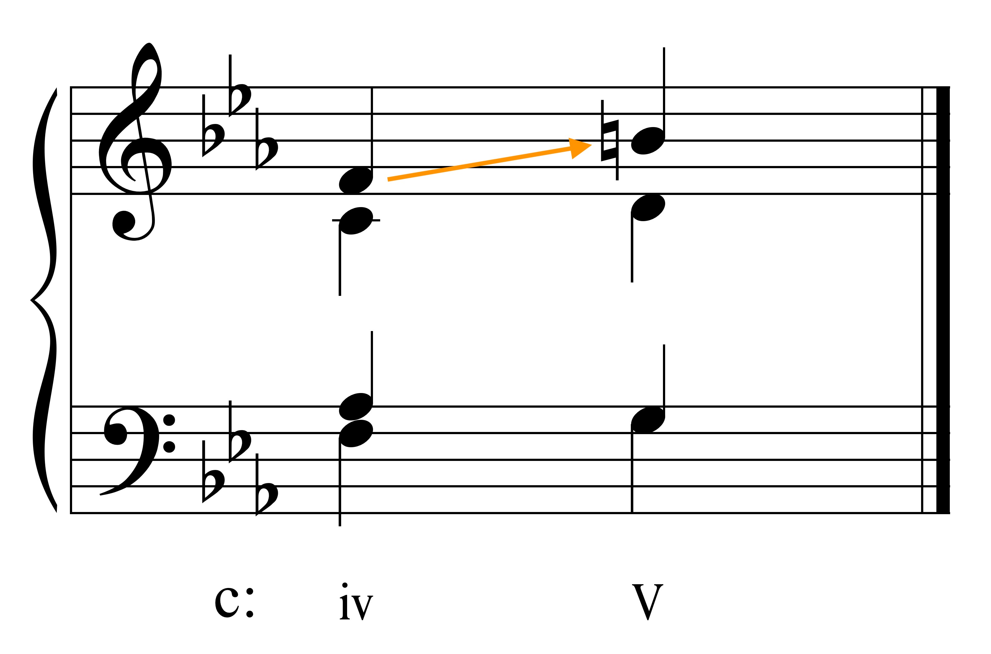

• Resolve notes in the direction of their inflection.

Resolve active tones in the direction of their tendency.

The leading tone in the Soprano or Bass must resolve to tonic.

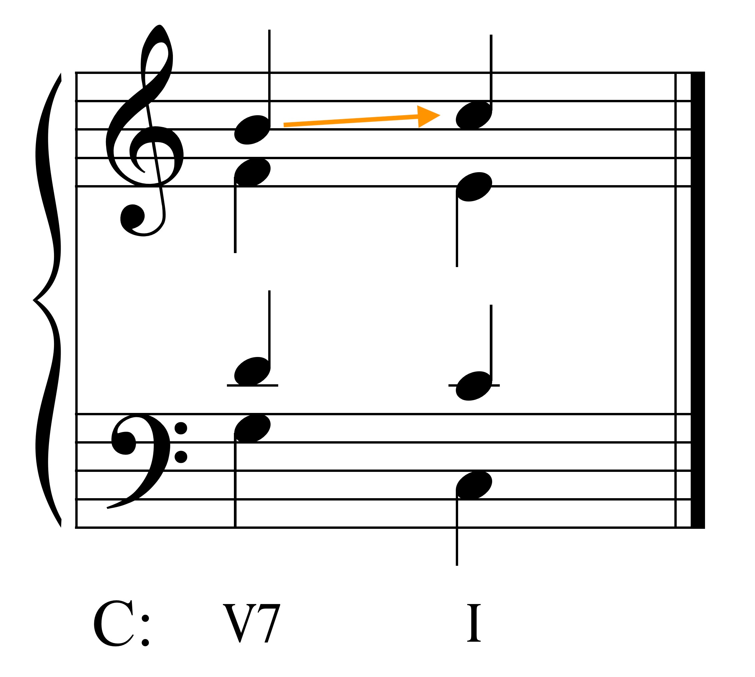

In an inner voice, it may resolve down to the 5 (frustrated leading tone).

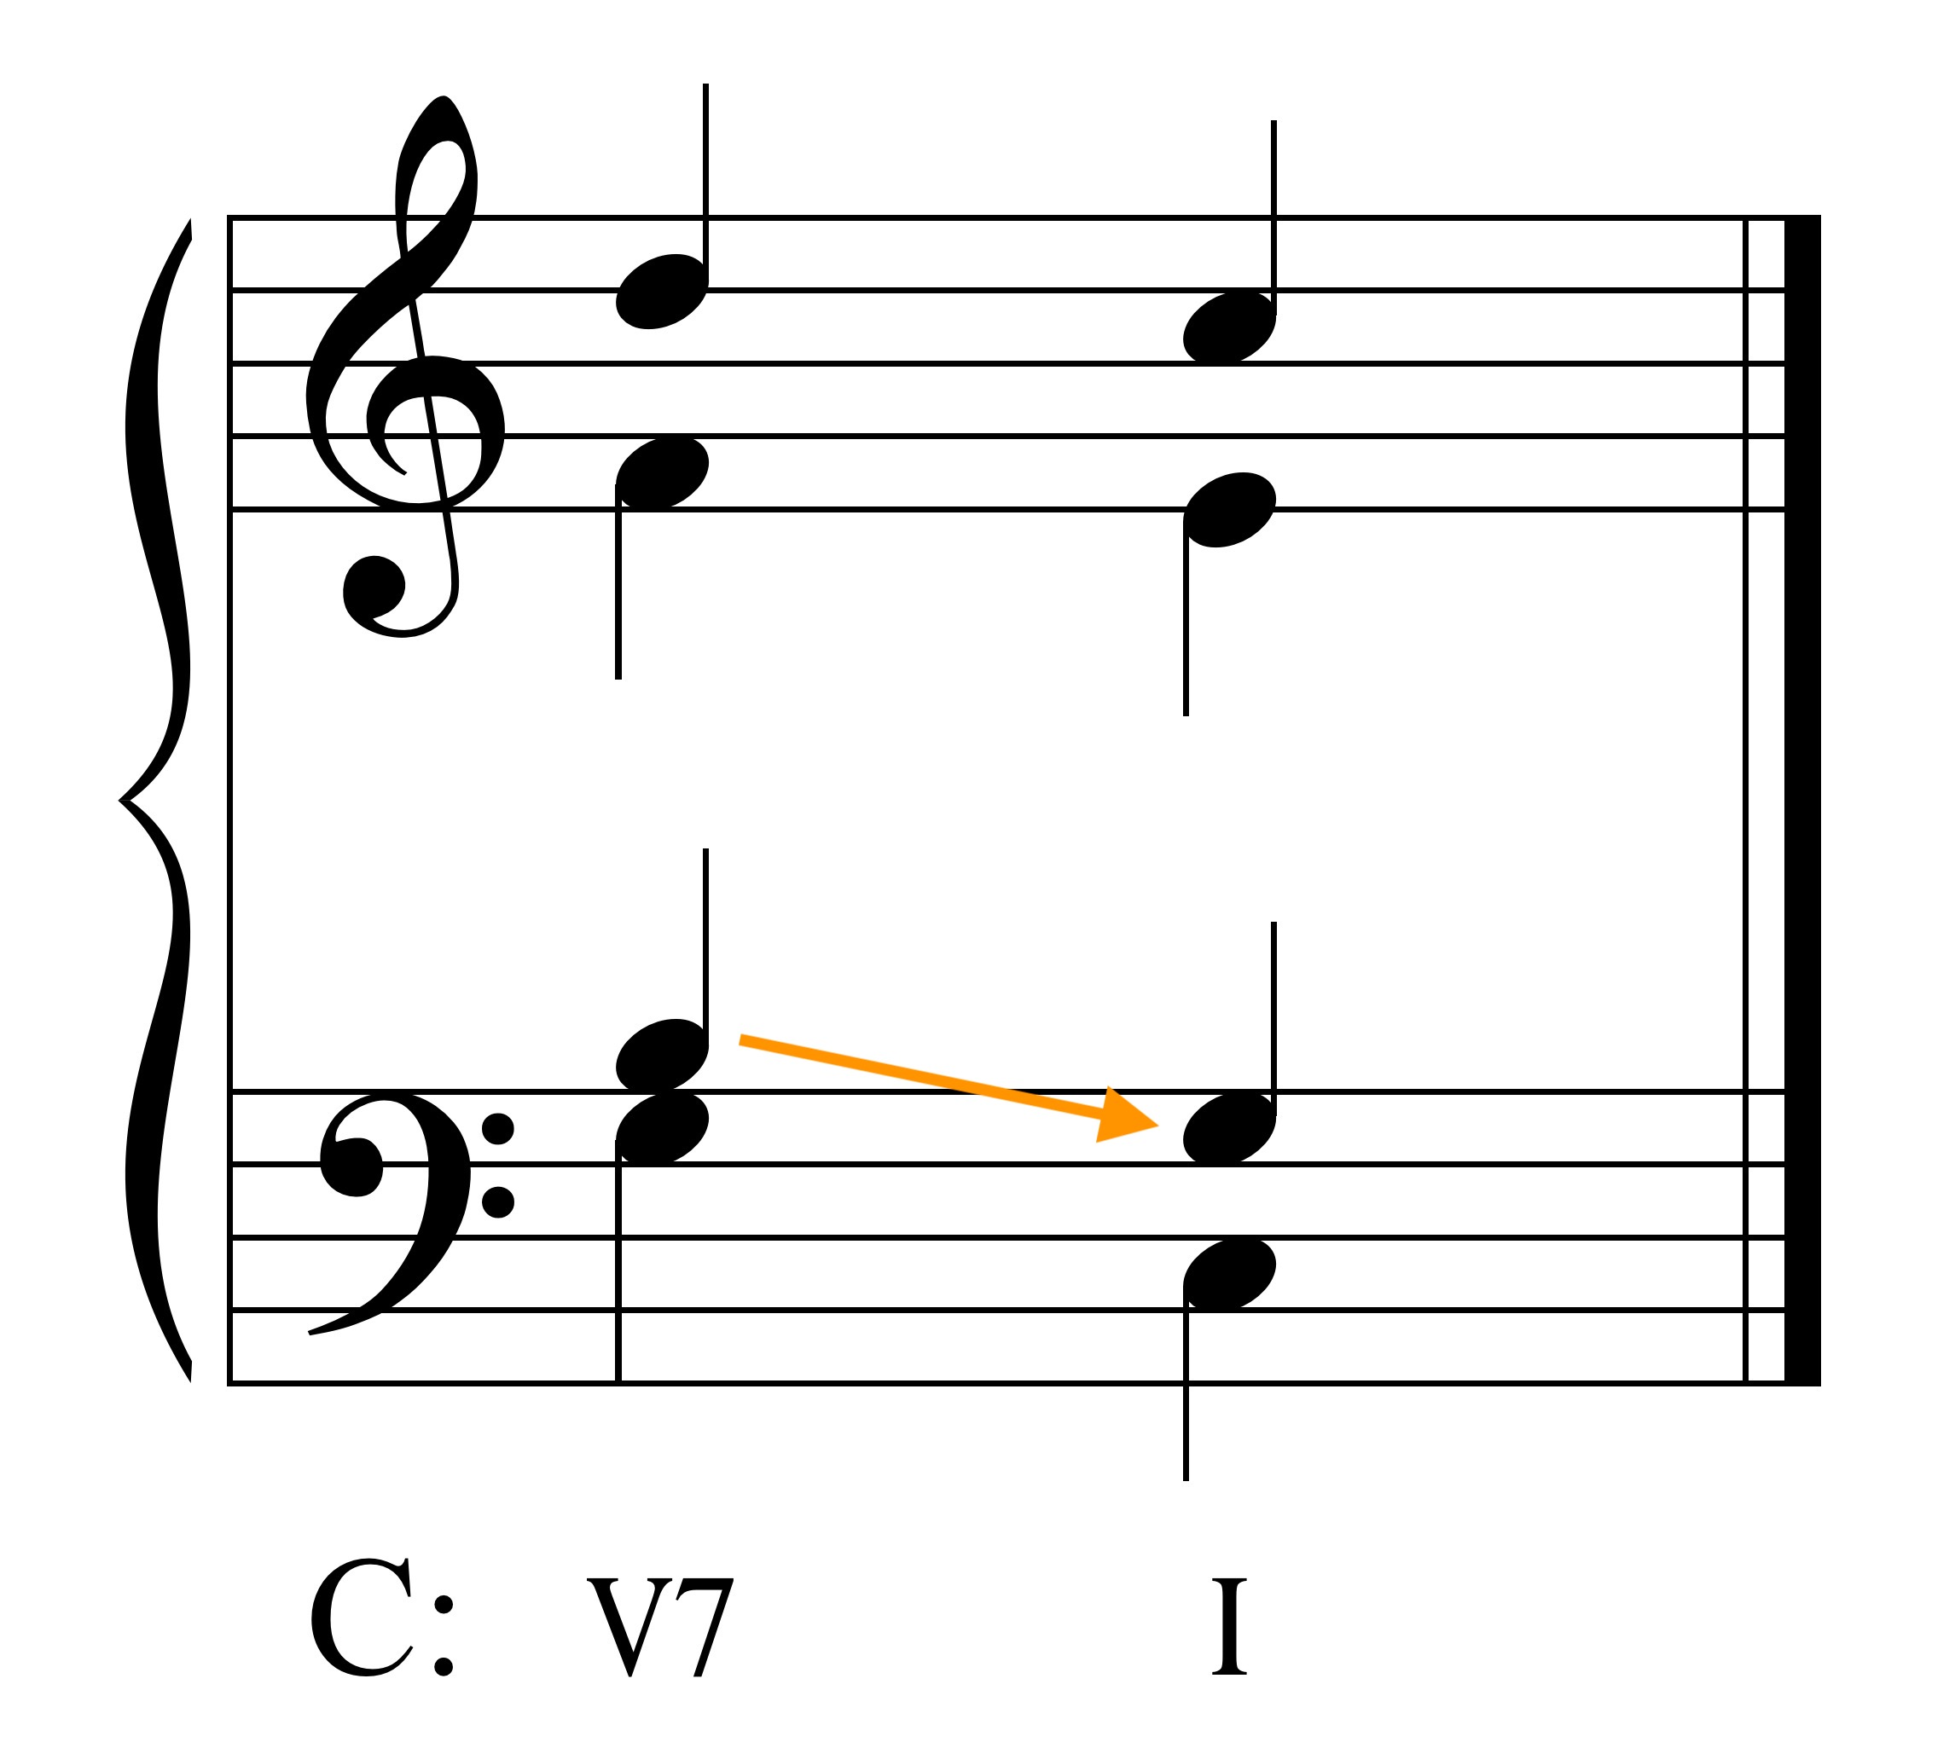

Resolve sevenths of chords down by step. Resolve the 7th of a V7 down by step.

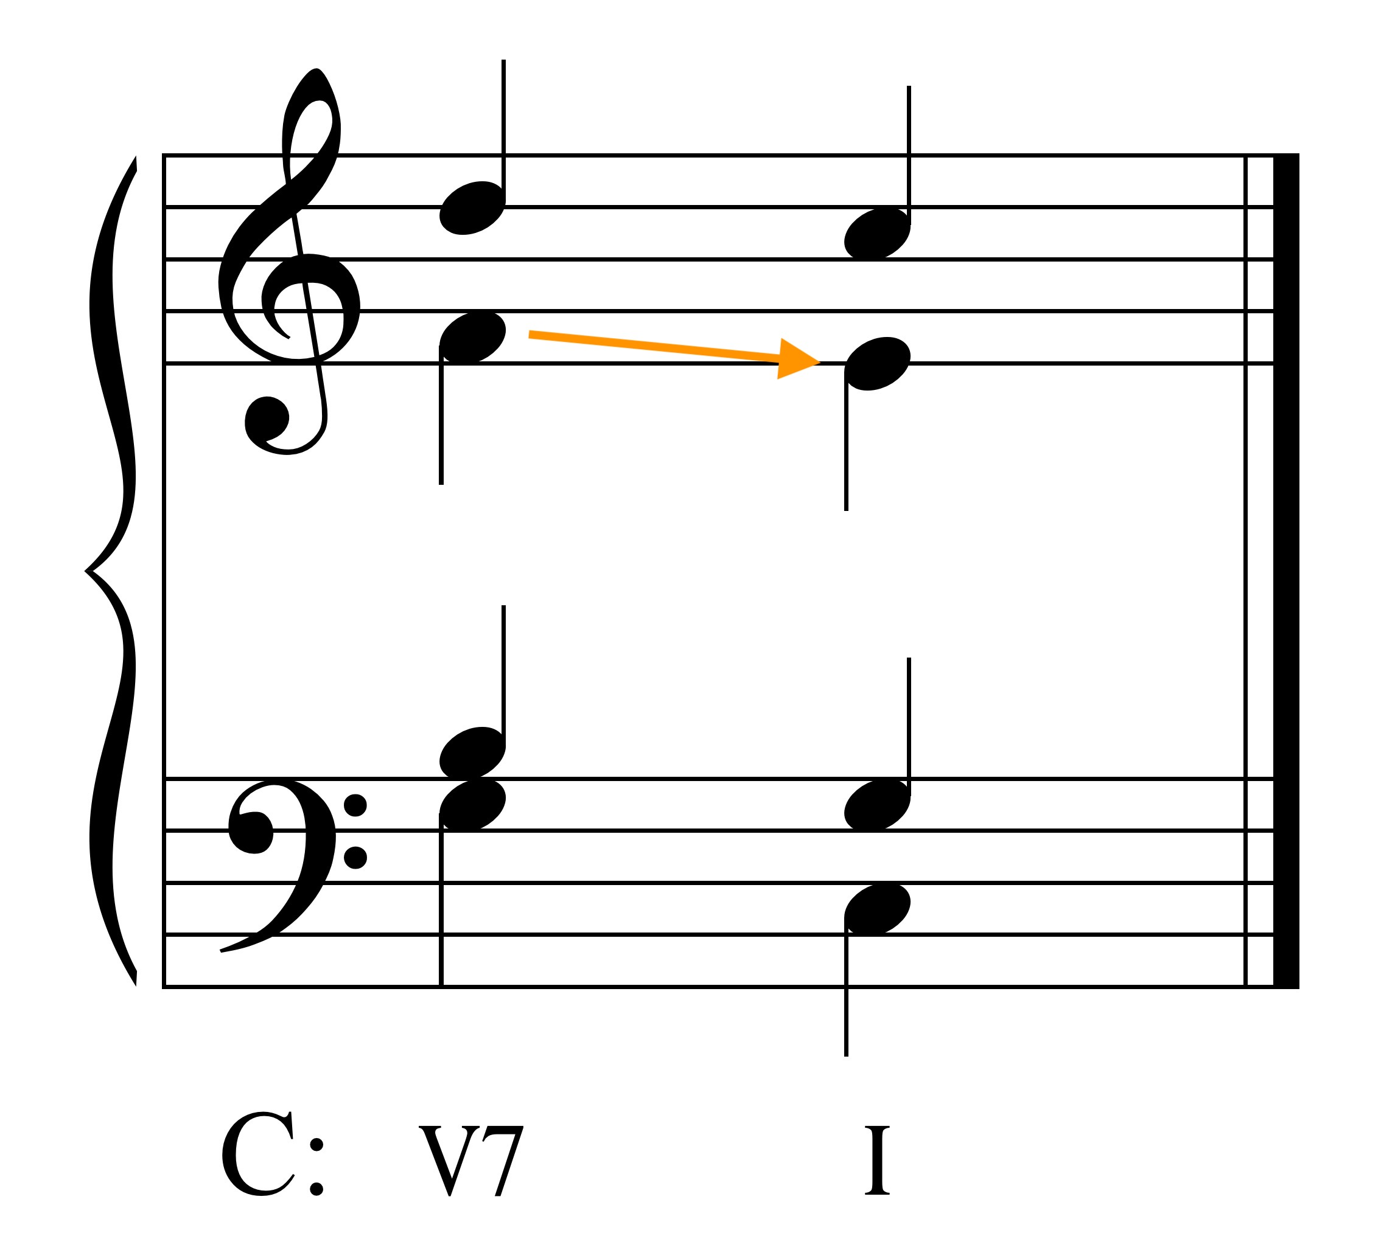

Resolve tritones as follows: A4 will resolve out, d5 in.

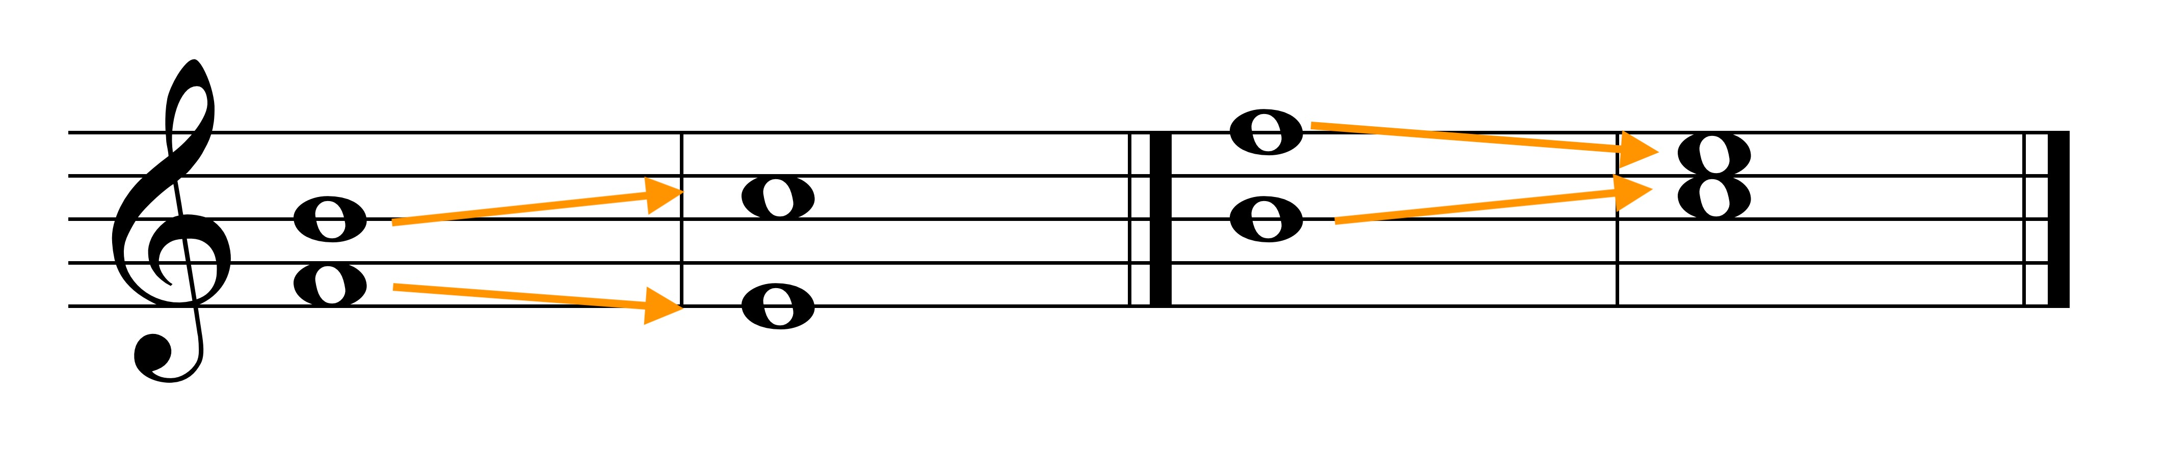
A4 moves out d5 moves in

It is OK to move from a P5 to a d5 (unequal fifths), but not from a d5 to a P5 (the tritone doesn't resolve).

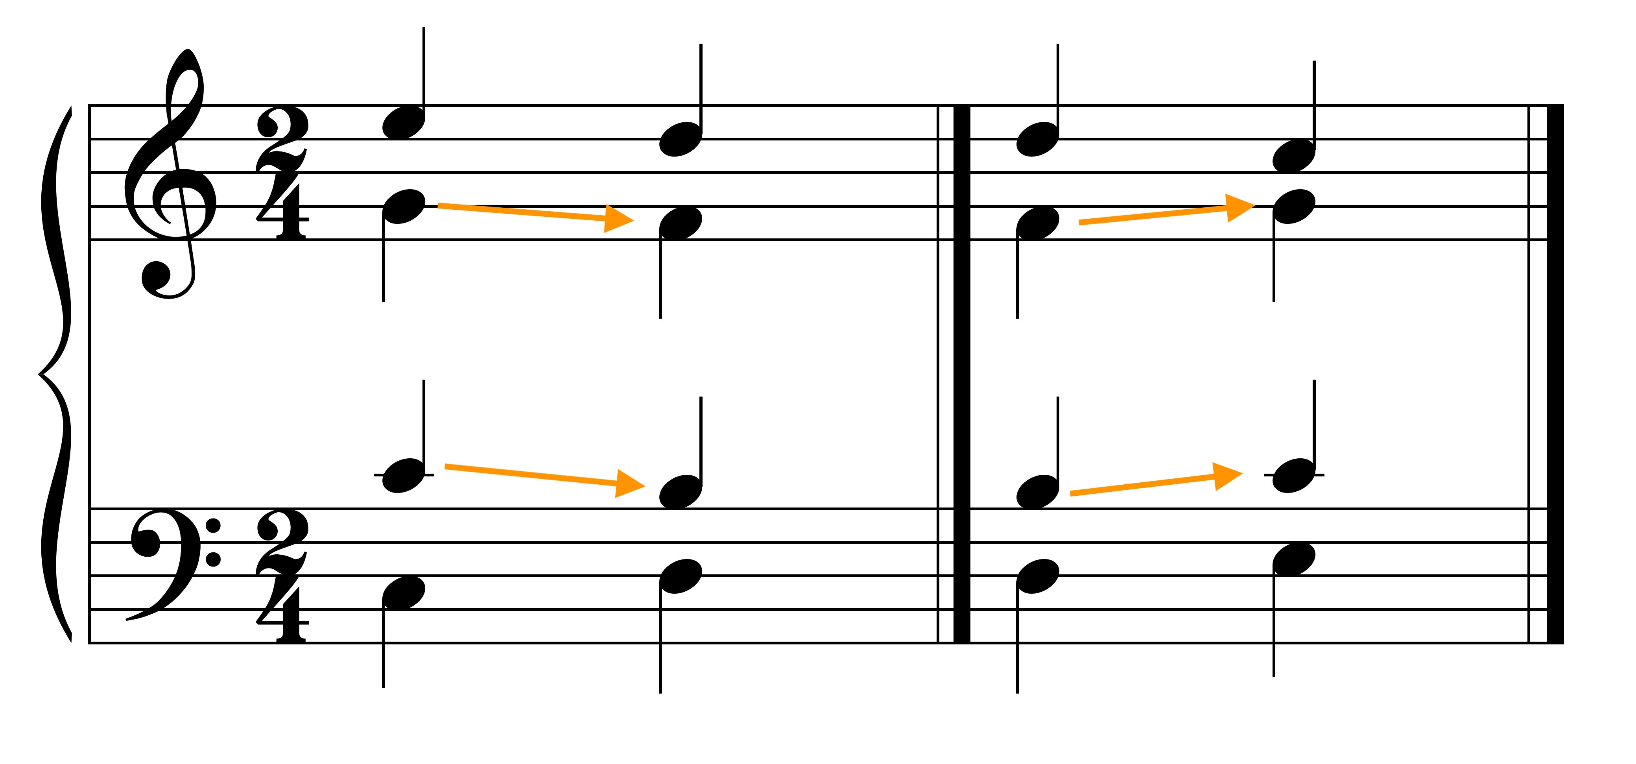
P5-d5 -> OK d5-P5 -> NOT OK

Altered notes: If note is raised, continue going up. If note is lowered, continue going down.

Keep chromatic movement of a note in the same voice; don't write cross relations especially between the outer two voices.

